**Lab-5 (Praneeth, Divya)**

We took the famous Snake game to modify it to use the gestures as input.

We used the JaHMM library for motion recognition.

Modified the onResume function in the MSnake activity class as in the picture.

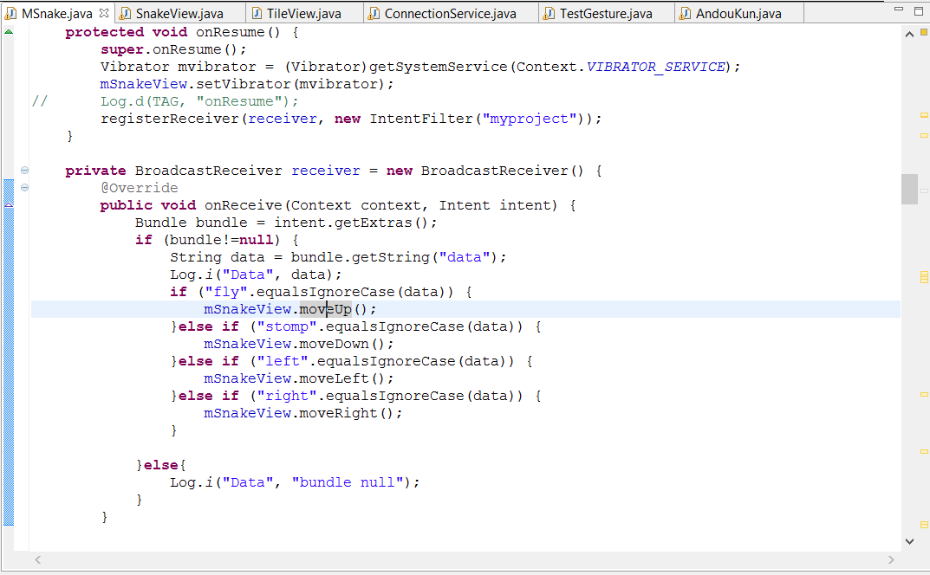

Wrote four different functions in SnakeView.java to be called to change the movement of the snake depending on the gesture.

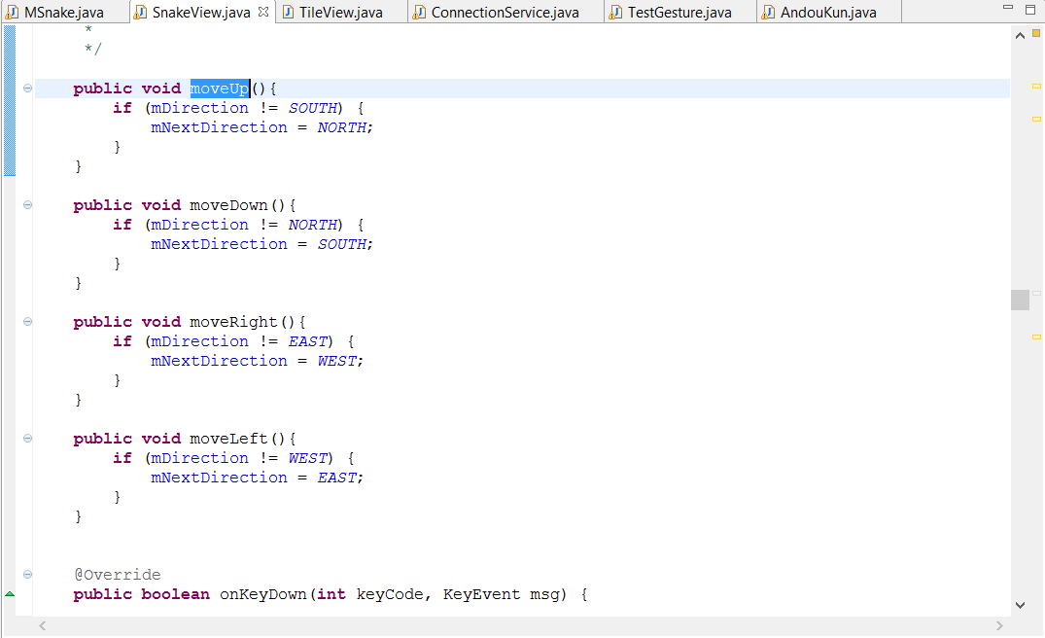

When the gesture is either of the four: left, right, up(fly) or stomp(down), the movement of the snake changes accordingly.

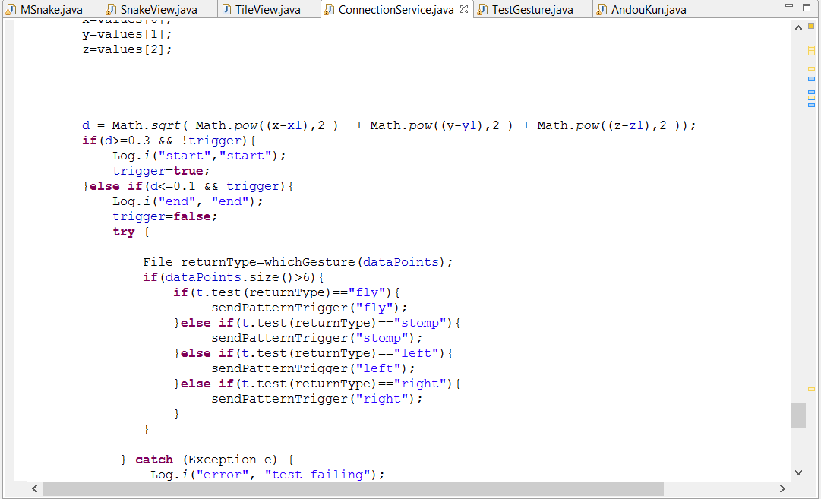

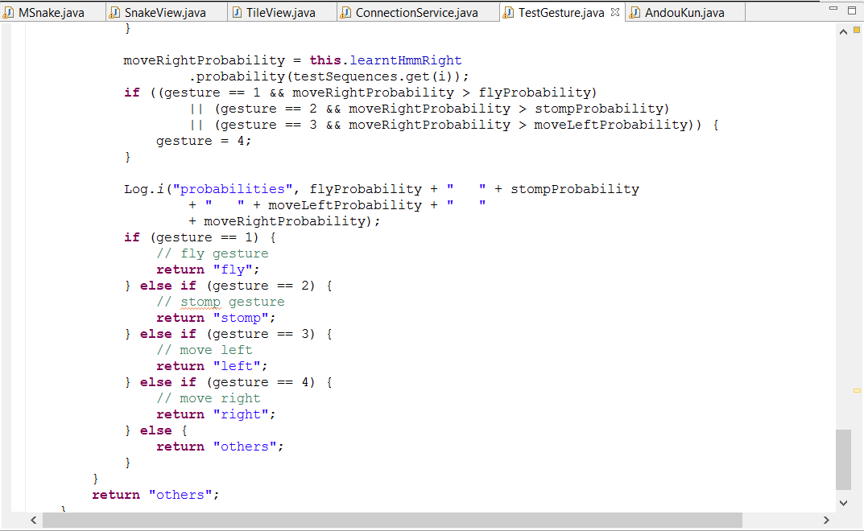

We trained each gesture for 8 or 9 times and generated the seq files. The sequence files and the modified source code is uploaded in github.