**Lab-6**

We took the snake game to play using the recognized gestures. This app requires four gestures to move up, left, right, down. We added a new button to the main UI to generate a pie chart based on the number of times a move is made.

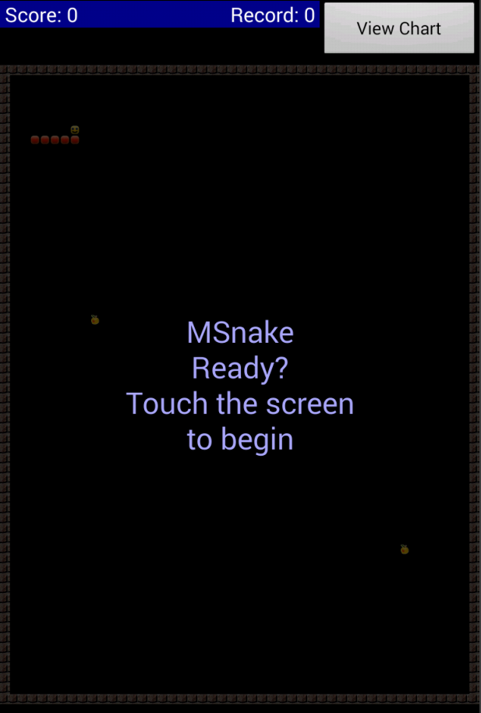

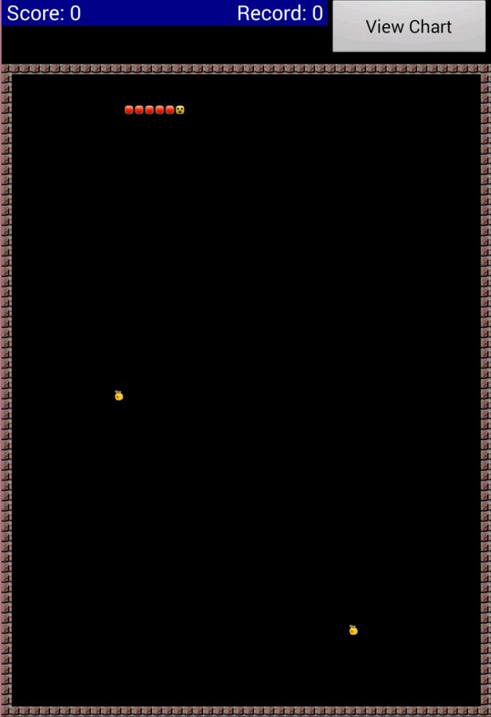

We used the aChartEngine library to generate the charts. For this we imported the aChartEngine project as a library to our game.

The generated pie chart looks like this..

