***Dedicated Pomemeon server manual***

*Version: Alpha 1.0*

*Author: Sppmacd*

**Launching Server**

1. To launch server launch executable: Server/Bin/PomemeonServer.exe
2. The Server has to print the log output:

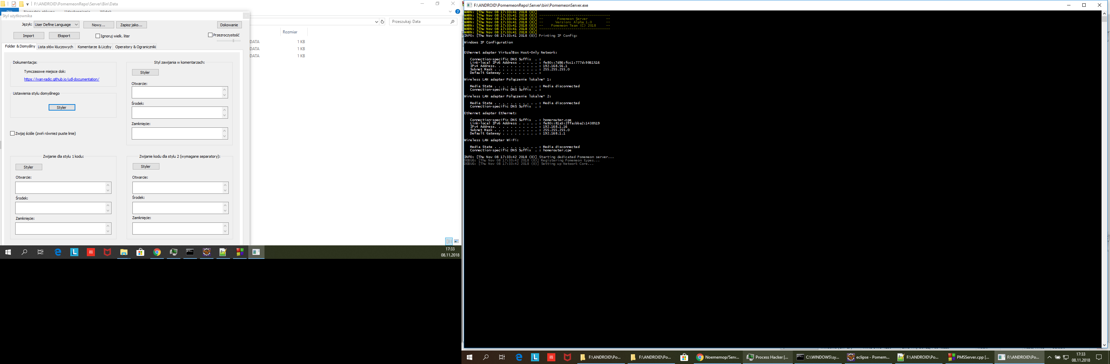

**Connecting to Server**

1. On your phone install TCP Client.
2. Write your server IP displayed on server log, and port: 12346.



**Client Commands**

Command Syntax

<command name>|<arg1>|<arg2>|…|<argN>

* **CmdSetUserID**, pmc:setuserid|<id> Sets the User ID. Setting the ID to 0 will create the new player. The User ID must be an existing player, else the player will be kicked.
* **CmdRequestPomemeons**, pmc:requestpomemeons|<centerNS>|<centerEW>|radius Sends request. The server returns pomemeons in circle with specified center and radius. The data sent is:
  + Pomemeon ID
  + Pick timer (not used)
  + name,
  + type ID,
  + description,
  + coordinates,
  + textureFile,
  + owner ID
* **CmdPick**, pmc:pick|<id> Starts picking the pomemeon <id>. The server returns Cash Stat. The pomemeon must be a valid Pomemeon ID, else the server will kick the player.
* **CmdPlace**, pmc:place|<posNS>|<posEW>|<type> Places Pomemeon at specified position. The server returns Cash Stat.
* **CmdSetPMData**, pmc:setpmdata|<id>|<name>|<description>|<texture> Sets the Pomemeon data <id> to specified. The sender must be the owner of the Pomemeon to perform this command, else the error will be thrown.
* **CmdStopServer**, pmc:stopserver {coming soon} Stops server. The player must be an Admin to perform this command, else the error will be thrown.
* **CmdUpdatePos**, pmc:setuserpos|<posNS>|<posEW> Updates the sender position.
* **CmdRequestUserData**, pmc:requestuserdata|<userID> Sends the User Data for the specified user. The data sent is:
  + cashCount,
  + currentPoints,
  + xp,
  + totalPoints,
  + leaderboardPlace,
  + level,
  + freePomemeonPlaced
  + isDailyRewardCollected
  + logCount
  + pick Timer (The time elapsed from the last Pomemeon pickup)

**Server Commands**

* **SCmdUserID**, pms:userid|<id> Returns the ID for the newly created account.
* **SCmdDisconnect**, pms:disconnect|<reason> The reason for the disconnection. The reason can be:
  + ERR_DISCONNECTED_x The client was disconnected (closed app, lost internet connection). The X can be:
    - 3-Disconnected
    - 4-Unknown Server Error
  + ERR_INVALID_USER_ID The client tried to log in by not existing userID.
  + ERR_INVALID_OBJECT_ID The client tried to refer to invalid Object ID, e. g. non-existing Pomemeon.
* **SCmdCashStat**, pms:cashstat|<statID> This is the response for commands that affects players stats such as cash, points. The Cash Stat can be:
  + Success (0), The player has successfully made the action
  + NotEnoughCoins (1), The player has not enough coins to make action.
  + TooManyCoins (2), The player has too many coins to make action.
  + CannotMake (3), The player state is invalid (e. g. the 24h time limit is exceeded)
  + InvalidState (4), Not used
* **SCmdRequestPMData**, pms:requestpmdata|<id> The request for send Pomemeon data by client. This is send only on Place action if the Pomemeon was placed successfully.
* **SCmdUserData**, pms:userdata|<data…> The response for pmc:requestuserdata.
* **SCmdPomemeon**, pms:pomemeon|<data…> The response for pmc:requestpomemeons.
* **SCmdErr**, pms:err|<message> This command contains the Error Message.