Sleep Project

### Introduction

library(readr)  
sleepdata <- read_csv("sleepdata_combined.csv")  
plot(x = 0:30, sleepdata$`Sleep Length`, type = "o", xlab = "Days", ylab = "Sleep Length (minutes)", main = "Sleep over the Month", ylim = c(100, 600))

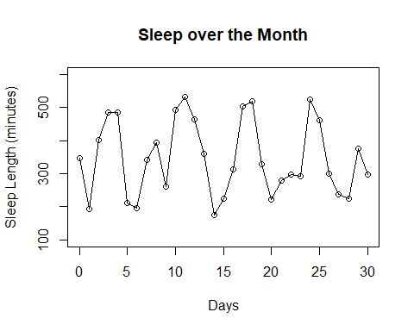

boxplot(sleepdata$`Sleep Length`, horizontal = TRUE, xlab = "Sleep Length (minutes)", ylim = c(100, 600))

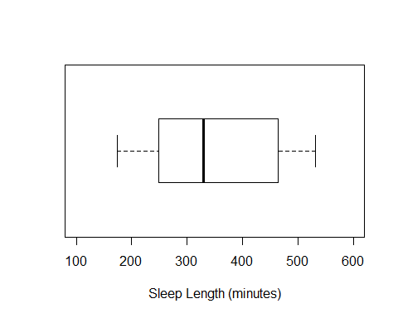

stripchart(sleepdata$`Asleep After`, method = "jitter", xlab = "Asleep After (Minutes)", xlim = c(0,60))

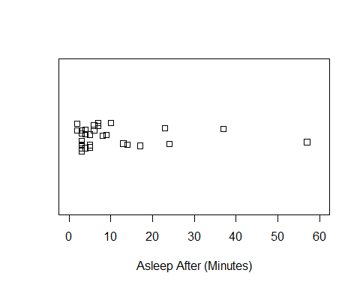

summary(sleepdata$`Sleep Length`)

## Min. 1st Qu. Median Mean 3rd Qu. Max.   
## 174.0 249.0 329.0 346.5 463.5 531.0

After a general analysis of my data I noticed that my sleep varied a lot over this month. Based on my graph of sleep length, I had positive spikes on all weekend nights. For the overall duration of my sleep my boxplot shows the median as 329 minutes. Also, the strip chart demonstrates that most days in the month I was able to fall asleep in under 10 minutes, or so Sleep Cycle claims. After finishing recording for 30 consecutive days some variables in the study did not vary. These variables include: screen time before bed (since I always look at my phone before falling asleep), spending over an hour outside (which I always do), or having an animal sleeping with you (which is not possible since I don’t have a pet with me at college). Since these did not change during the month, I decided to delete them from my final dataset since they will not present any kind of significant relationship to my sleep patterns.

### Question 1: Stress and Sleep

plot(sleepdata$`Stress level`, sleepdata$`Sleep Quality`, type = "p", xlab = "Stress Level", ylab = "Sleep Quality (%)", main = "Stress and Sleep", ylim = c(0,100), xlim = c(1,10))

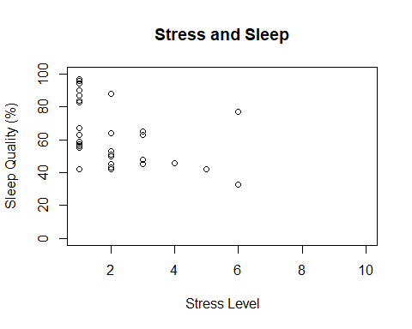

exam_night <- c(193, 401, 174, 222, 298)  
no_exam <- c(348, 484, 485, 212, 195, 341, 394, 260, 494, 531, 465, 359, 226, 313, 503, 518, 329, 280, 297, 293, 524, 462, 300, 238, 226, 376)  
boxplot(exam_night, no_exam, ylab = "Sleep Length (minutes)", xlab = "Exam vs. No Exam", ylim = c(100,600))

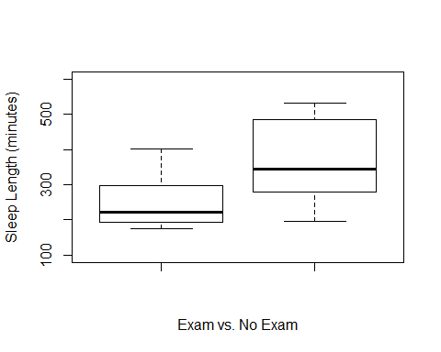

cor.test(sleepdata$`Stress level`, sleepdata$`Sleep Quality`, method = "pearson")

##   
## Pearson's product-moment correlation  
##   
## data: sleepdata$`Stress level` and sleepdata$`Sleep Quality`  
## t = -2.602, df = 29, p-value = 0.01445  
## alternative hypothesis: true correlation is not equal to 0  
## 95 percent confidence interval:  
## -0.68395451 -0.09541908  
## sample estimates:  
## cor   
## -0.4350498

During this project, a pattern arose between my length or quality of sleep and stress level over the 30 days. Whenever I was stressed (which was often due to academics), I would not sleep as long or as well. This is because usually during times of stress I will stay up later to try to get some extra work done, or study for an upcoming exam. Although this pattern is hard to see in the line graph there is a general trend that shows low sleep quality when I was stressed. After performing a linear regression, the results prove what the line graph suggests. The correlation coefficient is -0.435, which does not demonstrate a strong correlation, but because the p-value is 0.0145 which is less than 0.05, we reject the null and state that the true correlation is not 0. Therefore, the variable of stress can be correlated with my more restless nights. Another aspect of this apparent relationship shows up between the dates of my exams, stress, and consequently my sleep length. The two boxplots clearly display the difference in nights with exams and nights without exams. For example, the median sleep length for nights without an exam was higher than 75% of the sleep length on exam nights.

### Question 2: Week vs. Weekend

plot(x = 0:30, sleepdata$`Sleep Length`, type = "o", xlab = "Days", ylab = "Sleep Length (minutes)", main = "Sleep over the Month", ylim = c(100, 600))



plot(x = 0:30, sleepdata$`Asleep After`, type = "o", xlab = "Days", ylab = "Asleep After (minutes)", main = "Time Taken to Fall Asleep", ylim = c(0,60))

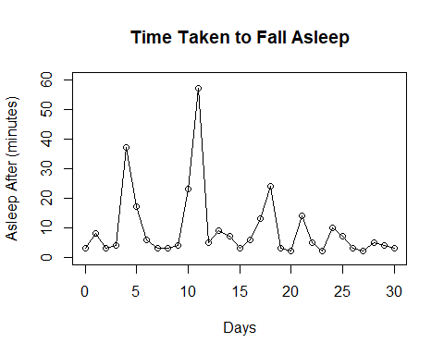

week_night <- c(64, 42, 77, 48, 50, 63, 67, 55, 88, 65, 33, 43, 57, 59, 42, 51, 45, 53, 56, 45, 42, 63, 46)  
weekend_night <- c(83, 84, 90, 97, 96, 96, 94, 87)  
stripchart(week_night, xlab = "Sleep Quality (%)", method = "jitter", xlim = c(0,100), main = "Week Nights")

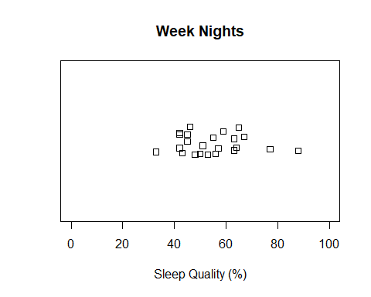

stripchart(weekend_night, xlab = "Sleep Quality (%)", method = "jitter", xlim = c(0,100), main = "Weekend Nights")

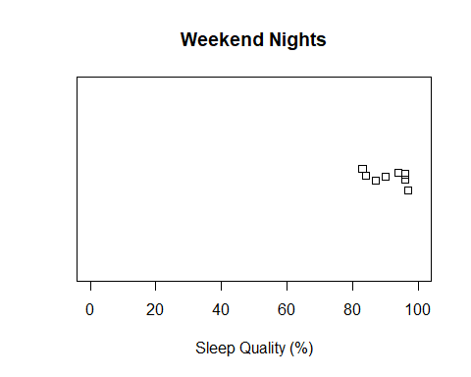

wilcox.test(week_night, weekend_night, exact = FALSE)

##   
## Wilcoxon rank sum test with continuity correction  
##   
## data: week_night and weekend_night  
## W = 3, p-value = 6.385e-05  
## alternative hypothesis: true location shift is not equal to 0

An additional variable that I decided to observe is the difference between my sleep over the week and the weekend. Overall, my sleep for Friday and Saturday nights was consistently better throughout this study. This is displayed in the line graph, as well as the two strip charts where my weekend nights had improved sleep quality and duration of sleep. This is because I can sleep in on the weekends, so I usually try to catch up on rest on those nights. I used a Wilcoxon test to examine if there was a significant difference between weekend and week night sleep quality and because the p-value is so small we reject the null, which means the difference between the two groups is not 0. Therefore, the variation between weekends and week nights is statistically significant. Also, there was a connection between weekend nights and the amount of time it took me to fall asleep. On weekends it usually took me a little longer to fall asleep. This point can be illustrated by my line graph comparing the minutes it took me to fall asleep over the month, since the jumps in the graph are consistently weekend nights. If I had to guess this is probably because I hang out with friends or go out Friday and Saturday nights so falling asleep could be a little harder after having a fun night.

### Question 3: Exercising at Nighttime

exercise_night <- c(348, 193, 484, 485, 212, 341, 394, 260, 494, 359, 174, 226, 313, 329, 280, 297, 293, 300, 226, 376, 298)  
no_exercise <- c(401, 195, 531, 465, 503, 518, 222, 524, 462, 238)  
hist(exercise_night, main = "Sleep After Exercise", xlab = "Sleep Length (minutes)", ylab = "Number of Nights", xlim = c(100, 600), ylim = c(0, 7))

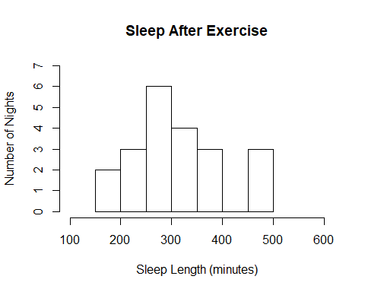

hist(no_exercise, main = "Sleep After No Exercise", xlab = "Sleep Length (minutes)", ylab = "Number of Nights", xlim = c(100, 600), ylim = c(0, 7))

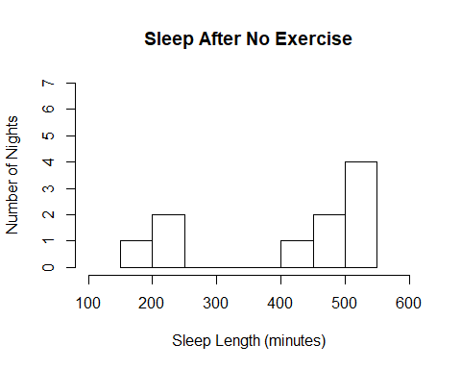

shower_night <- c(348, 193, 212, 341, 394, 260, 359, 174, 226, 313, 329, 280, 297, 293, 226, 376, 298)  
no_shower <- c(401, 195, 531, 465, 503, 518, 222, 524, 462, 238, 484, 485, 494, 300)  
boxplot(shower_night, no_shower, main = "Shower and Sleep", xlab = "Shower vs. No Shower", ylim = c(100, 600), ylab = "Sleep Length (minutes)")

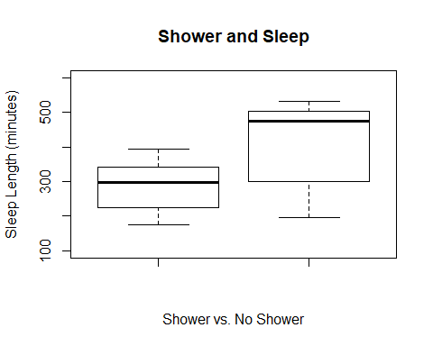

wilcox.test(no_exercise, exercise_night, exact = FALSE)

##   
## Wilcoxon rank sum test with continuity correction  
##   
## data: no_exercise and exercise_night  
## W = 148, p-value = 0.07247  
## alternative hypothesis: true location shift is not equal to 0

Another important question for this project is focused on my workout schedule. This semester I decided to work out around 7pm on Tuesdays and Thursdays, and at 10pm on Wednesdays. I usually prefer working out later in the day, but my data suggests that working out later in the day is affecting my sleep. Usually on days that I exercised late I did not sleep for as long and my sleep quality also suffered, shown by the histograms comparing the distributions for nights I exercised versus those I did not. I also performed a Wilcoxon test on the exercise and no exercise data and got a p-value greater than 0.05, 0.0725. Therefore, there is not enough evidence to reject the null. Another variable related to my exercise is showering before bed. On these days of the week I also usually showered at night which may have affected my sleep. A similar relationship with sleep is therefore displayed in the two boxplots regarding showering at night and sleep duration. Despite these possibilities and the correlation that my graphs show I do not think exercise is the cause. I believe that the week versus weekend comparison is the main variable responsible for my decreased sleep quality, which just happens to coincide with my nighttime workout and shower schedule.

### Conclusion

stripchart(sleepdata$`Asleep After`, method = "jitter", xlab = "Asleep After (Minutes)", xlim = c(0,60))

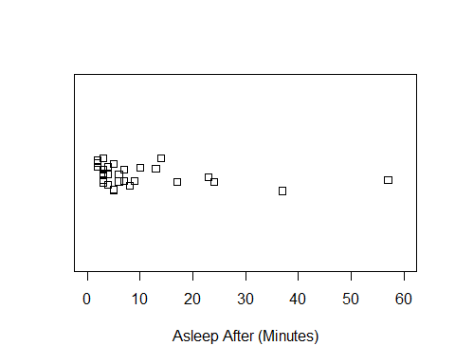

boxplot(sleepdata$`Asleep After`, xlab = "Asleep After (Minutes)", horizontal = TRUE, ylim = c(0,60))

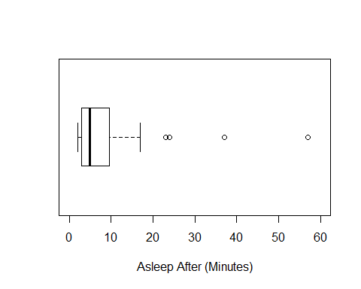

Ultimately, this project yielded some intriguing connections between the variables measured over the month. Although I enjoyed the project and found the information useful there are aspects that could use improvement. Most importantly, the app itself does not appear to be completely reliable. Sleep cycle displayed a warning multiple times during the month stating that it was picking up “very few movements.” This makes me question whether I fell asleep as quickly as the app says or if my microphone was just not picking up my movements accurately. This would make sense since most of my data in my boxplot and strip chart showed me falling asleep in 7 minutes or less, and 7 minutes is supposed to be the minimum time it takes to fall asleep. Whereas normally, people fall asleep within 10-20 minutes. Still, despite this possible flaw in the project I enjoyed the study and will most likely continue to measure my sleep using the app.