Task 4: To create repository and clone to local system

Step 1: Created the repository Advanced Software Engineering

<https://github.com/sujitha93/Advanced-Software-Engineering>

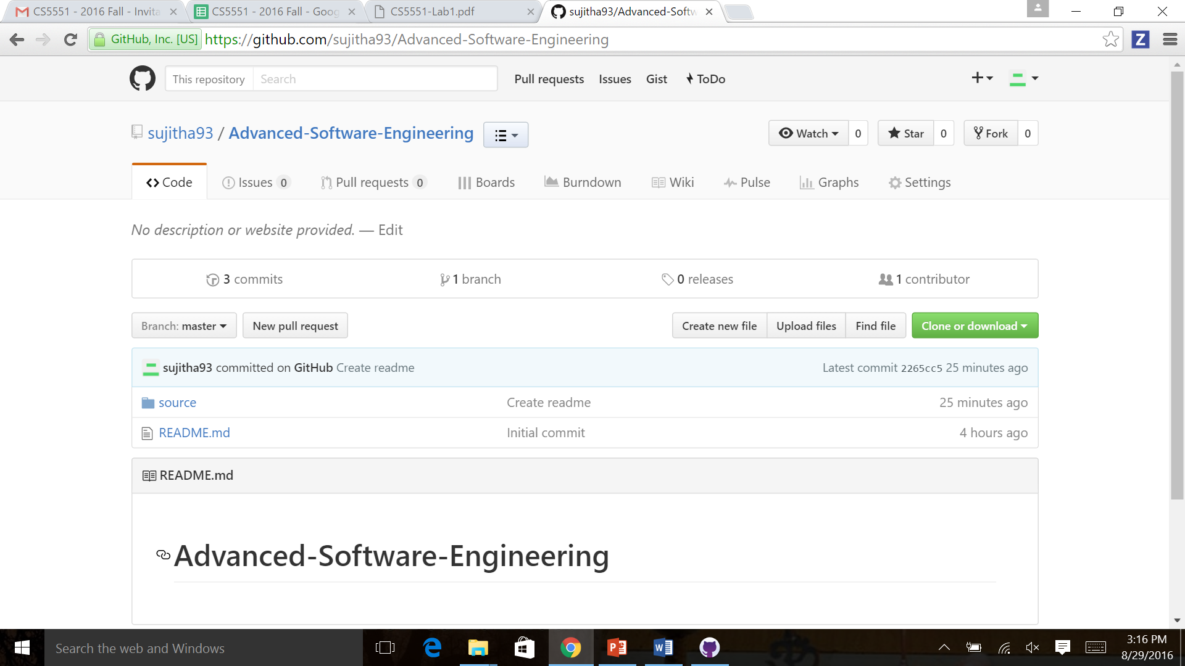

Step 2: Cloning to local system by clicking on clone or download

Cloned using web URL <https://github.com/sujitha93/Advanced-Software-Engineering.git>

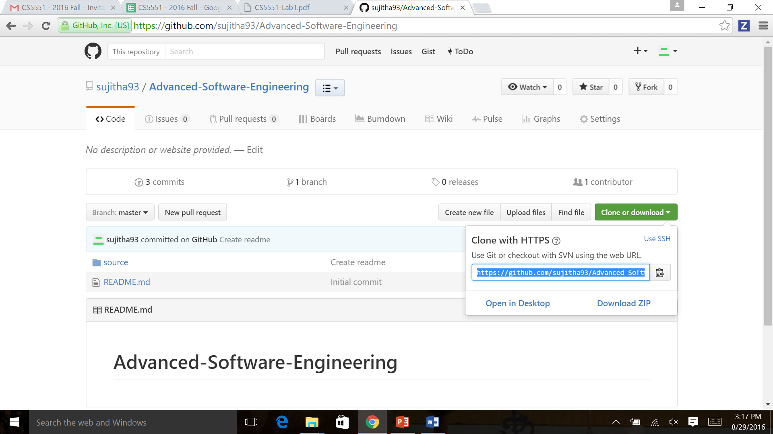

Step 3: Launching application on desktop

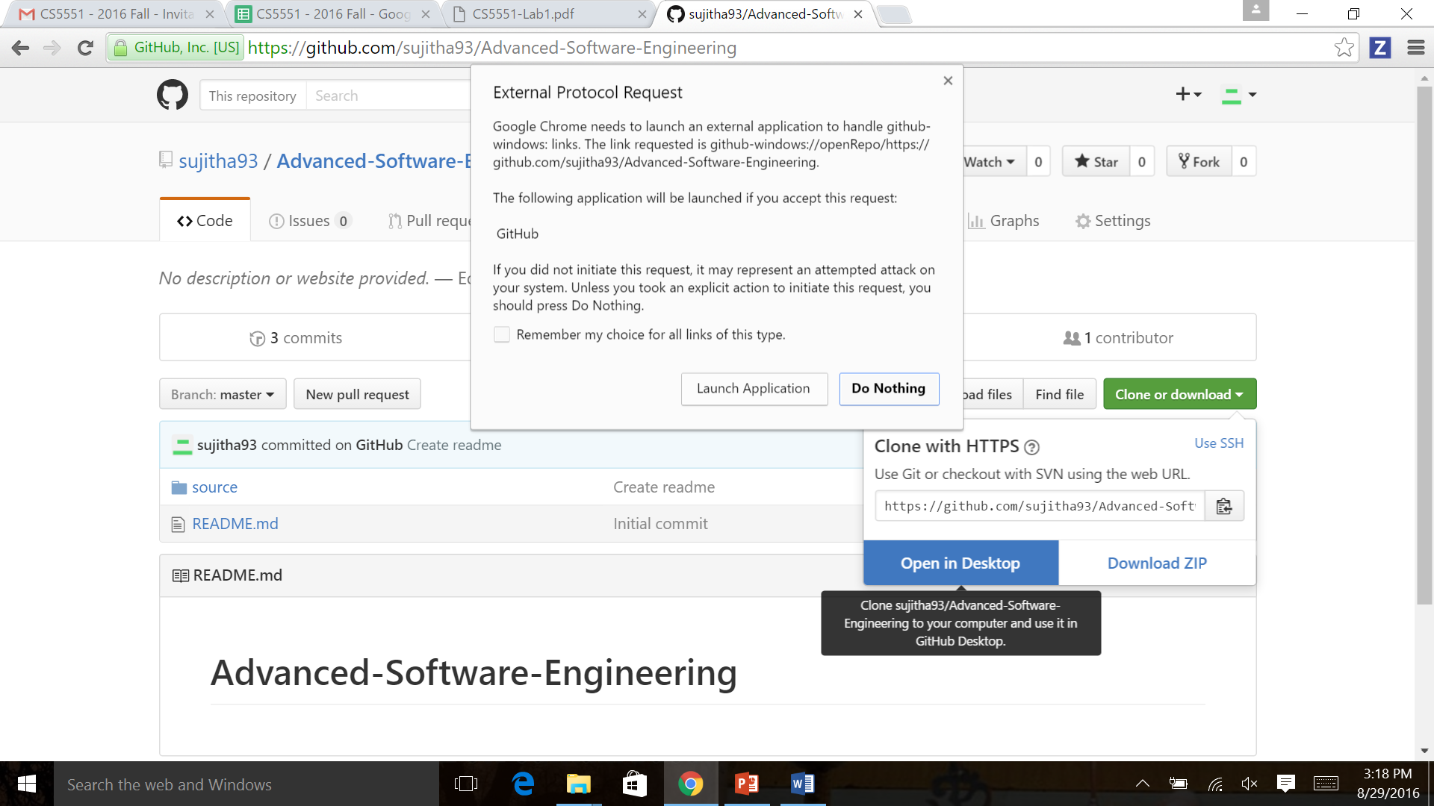

Step4: Cloned to desktop

