Task Description: Create ZenHub Tool Account.

Step1: To create a board

Step2: To create 3 Interactions with at least 5 milestone

Step3: To show the analytic diagram

Step1: Creating a board

Initial screenshot of board

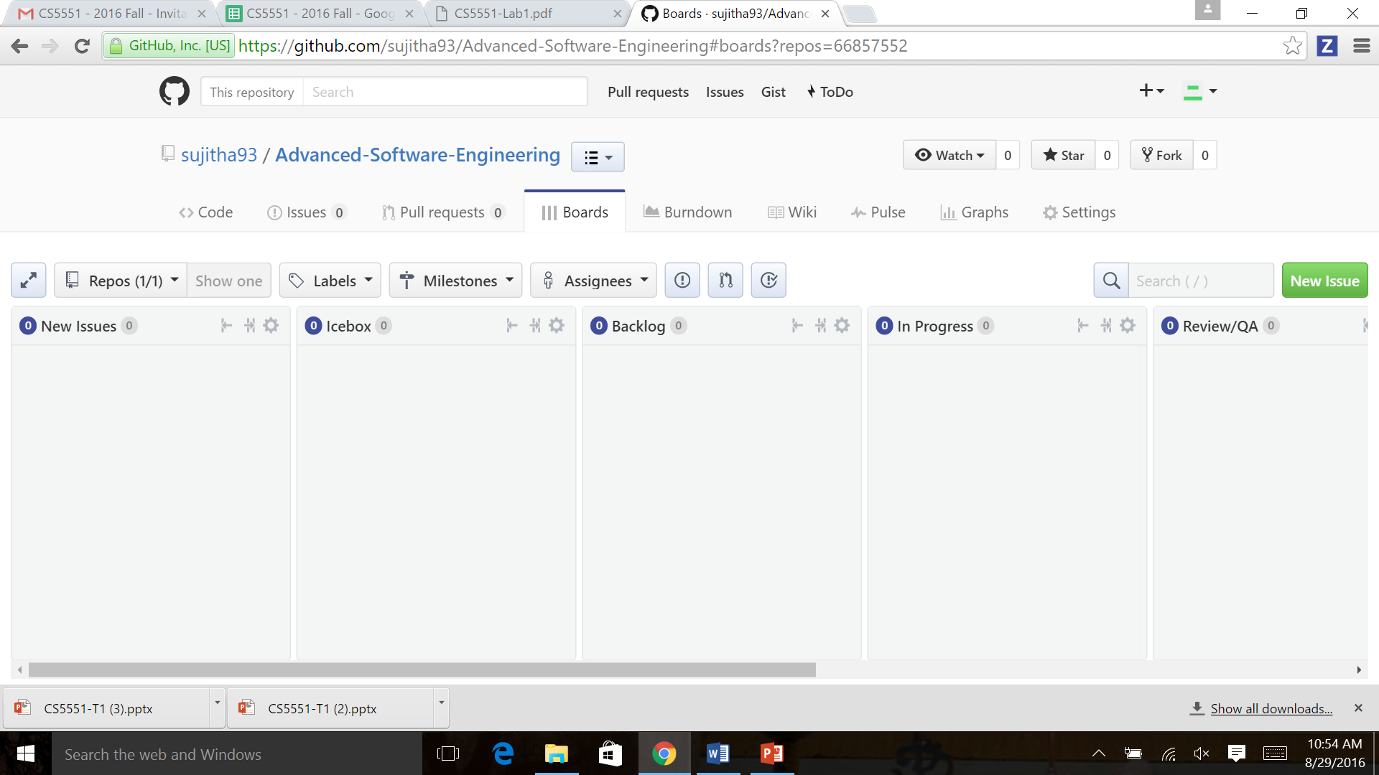

Step2: To create 3 Interactions with at least 5 milestone

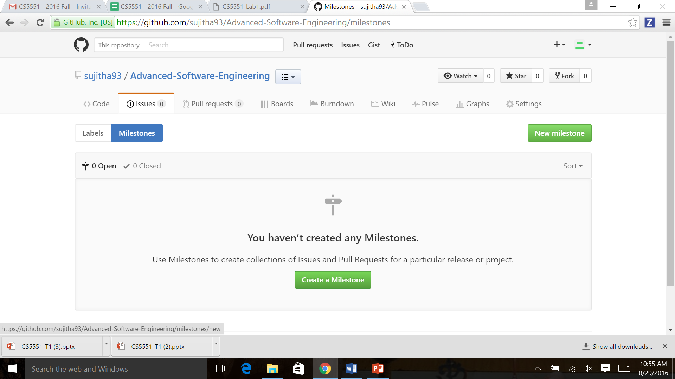

Creating Iteration1

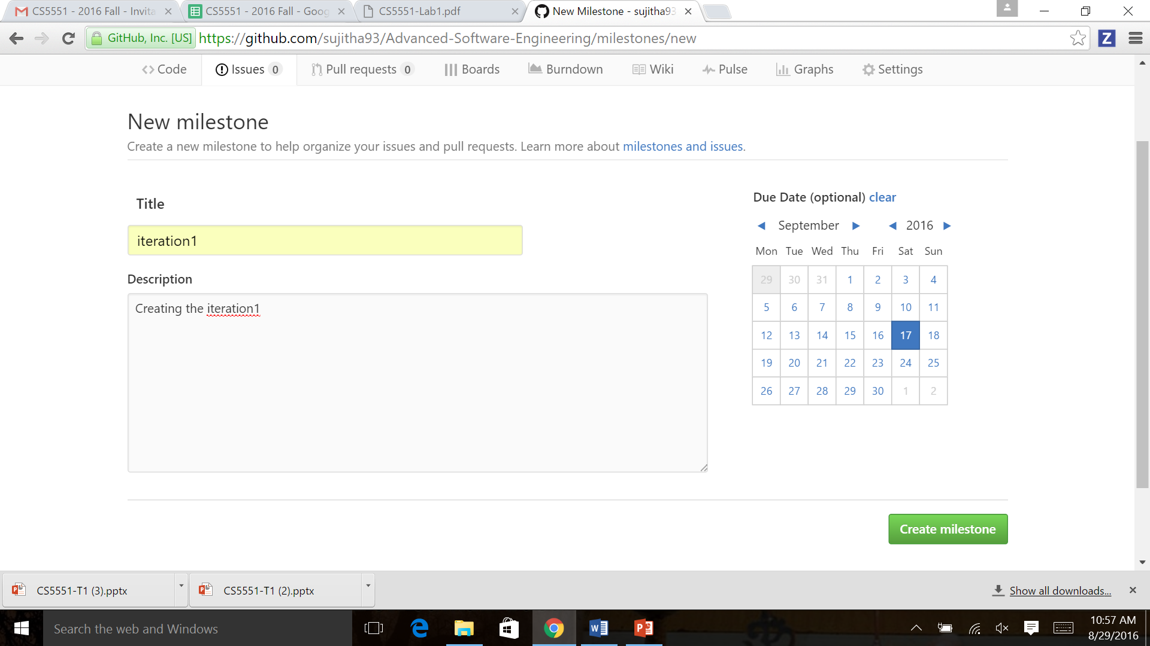

Creating milestone1 in interation1

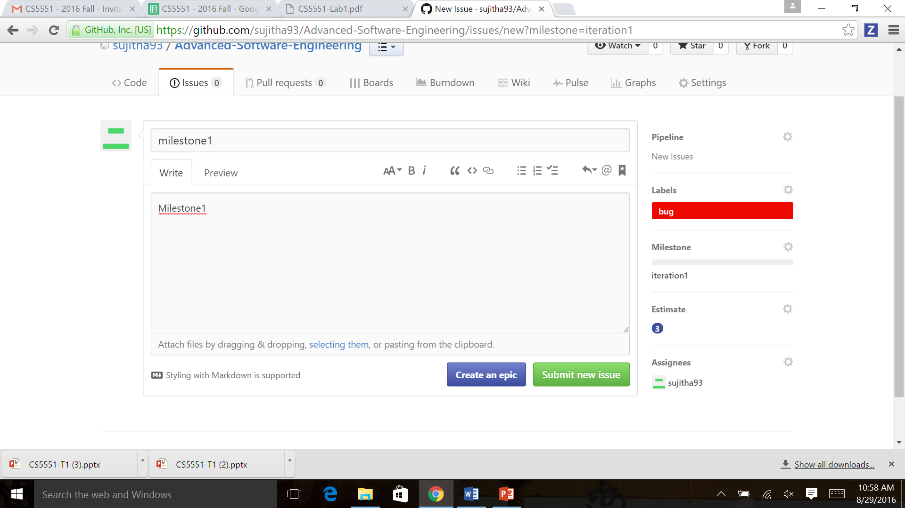

Created Iteration 1 with 5 milestone with all in Open status

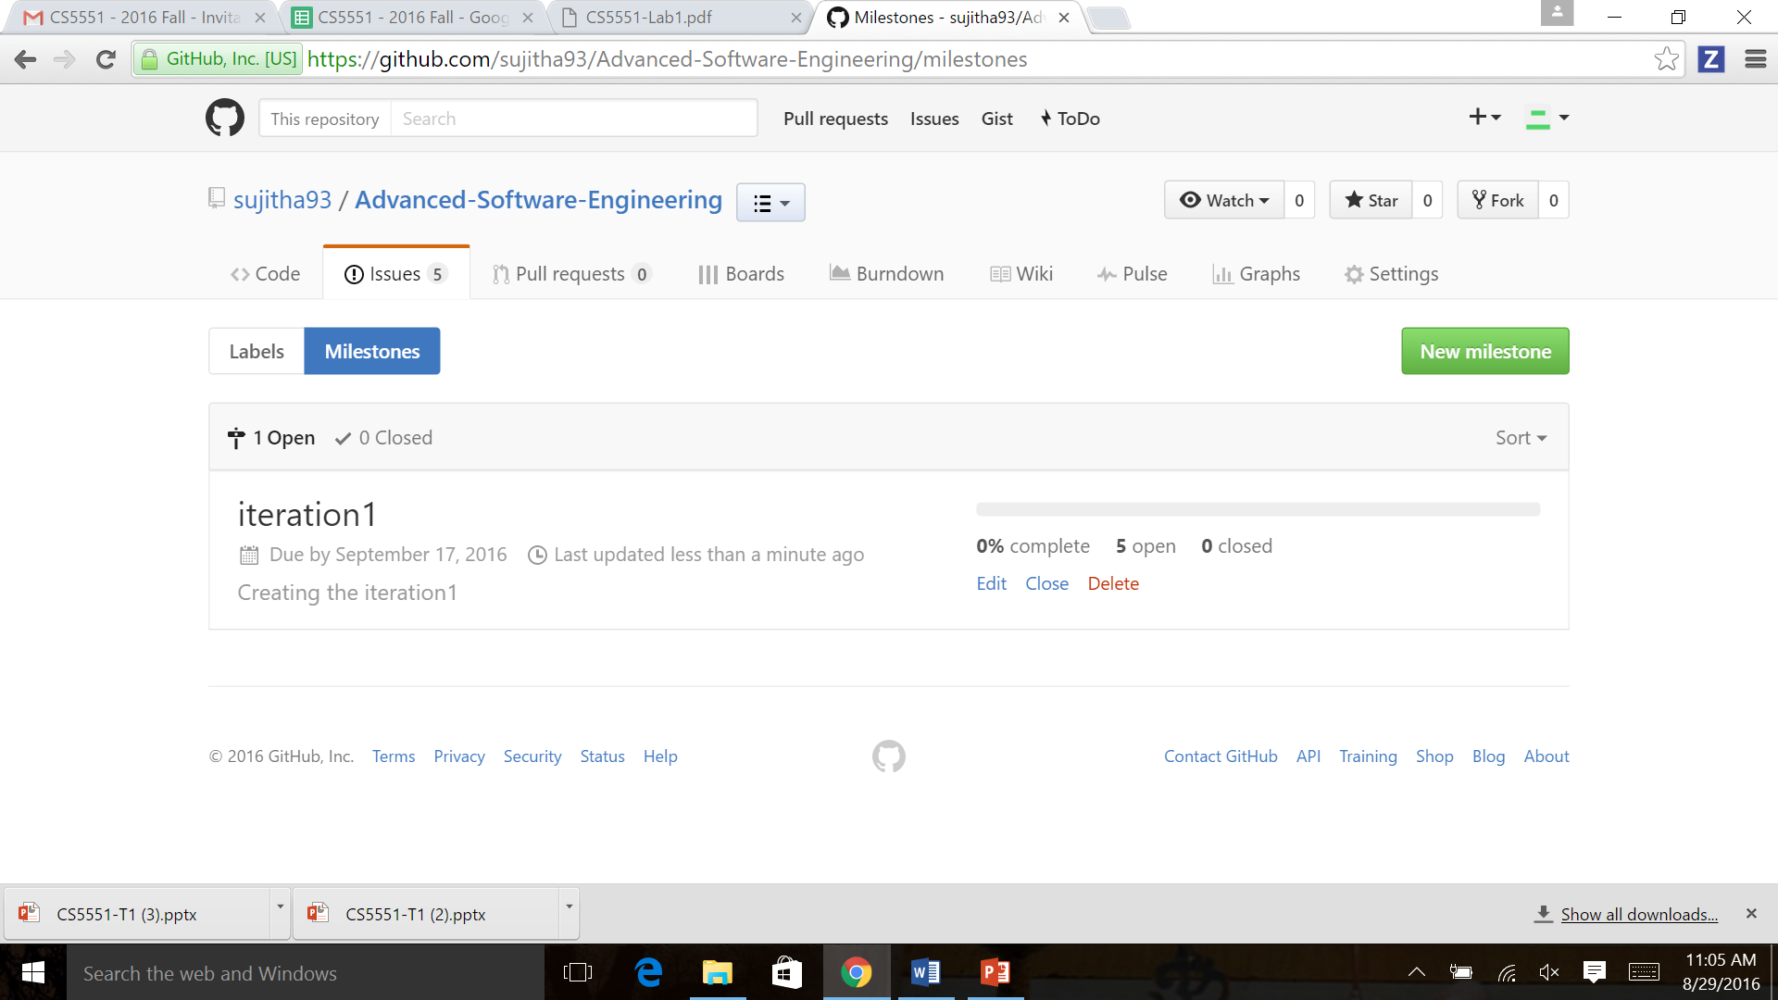

Board after Iteration1

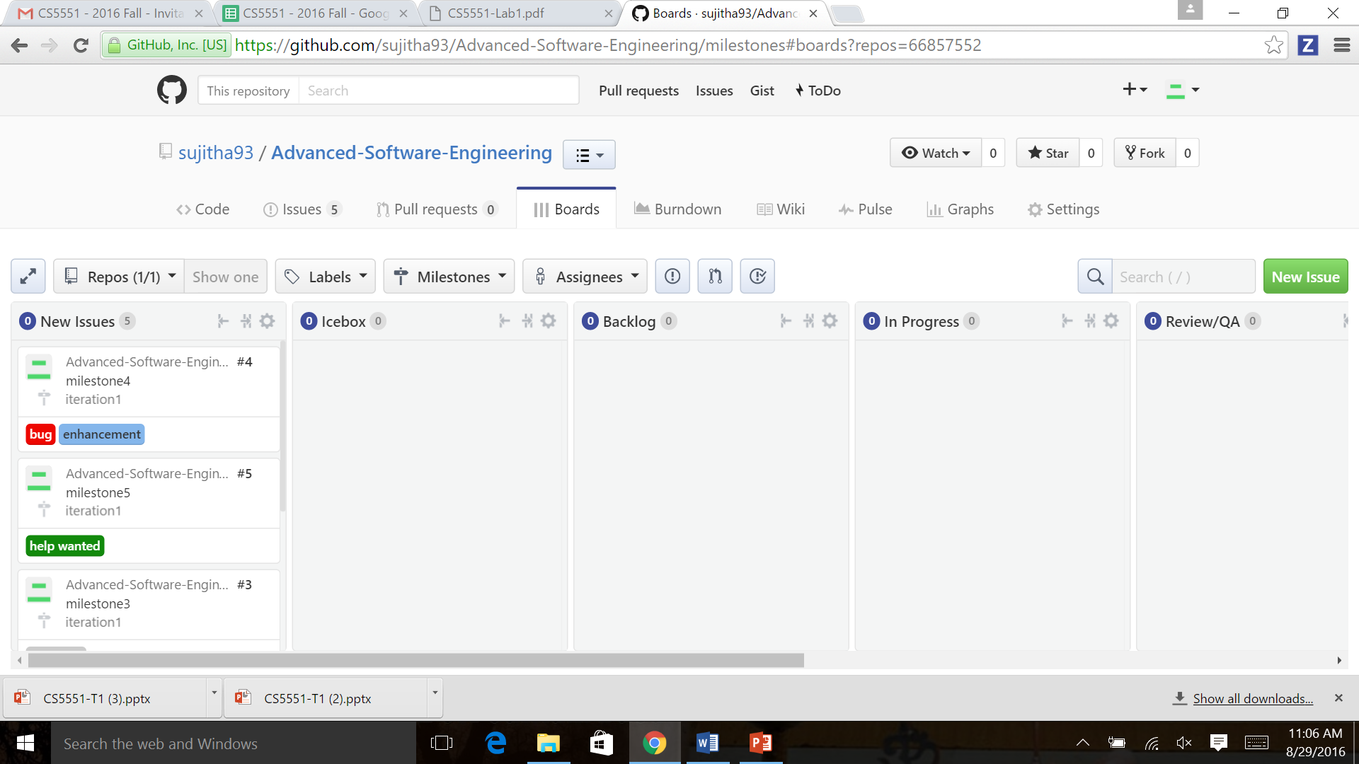

Creating Iteration 2

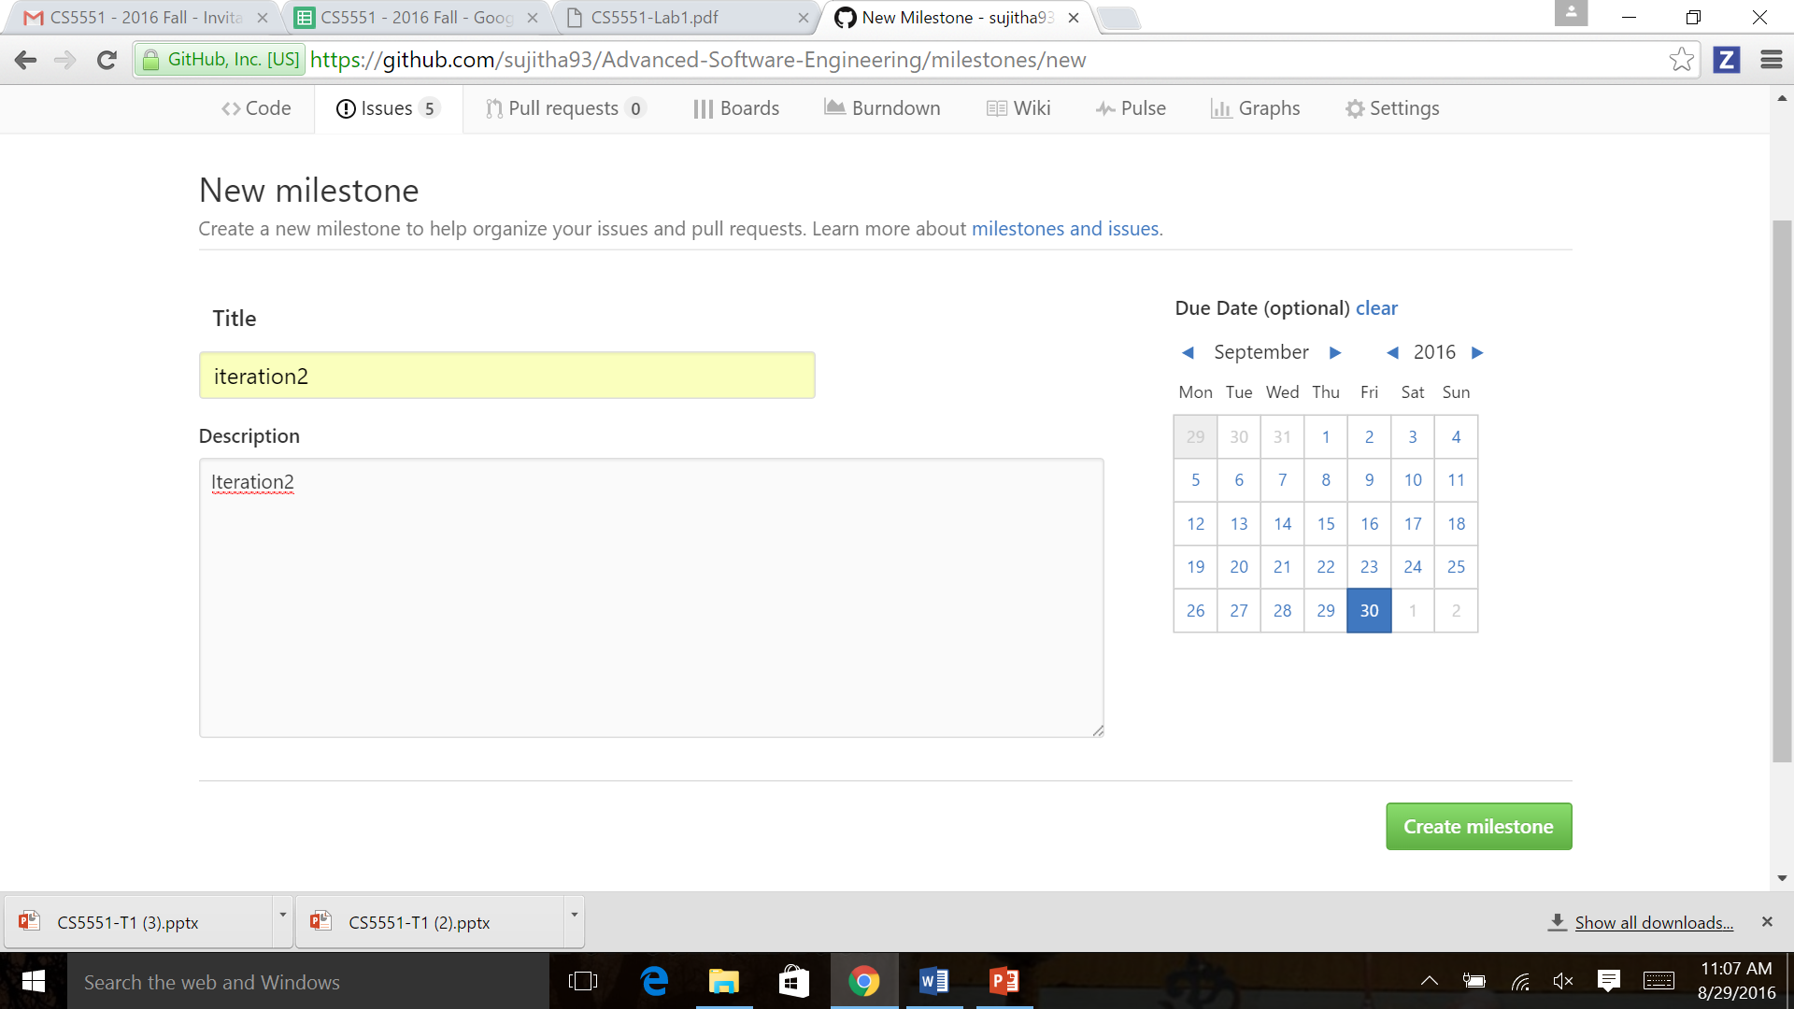

Created 3 iterations with milestones

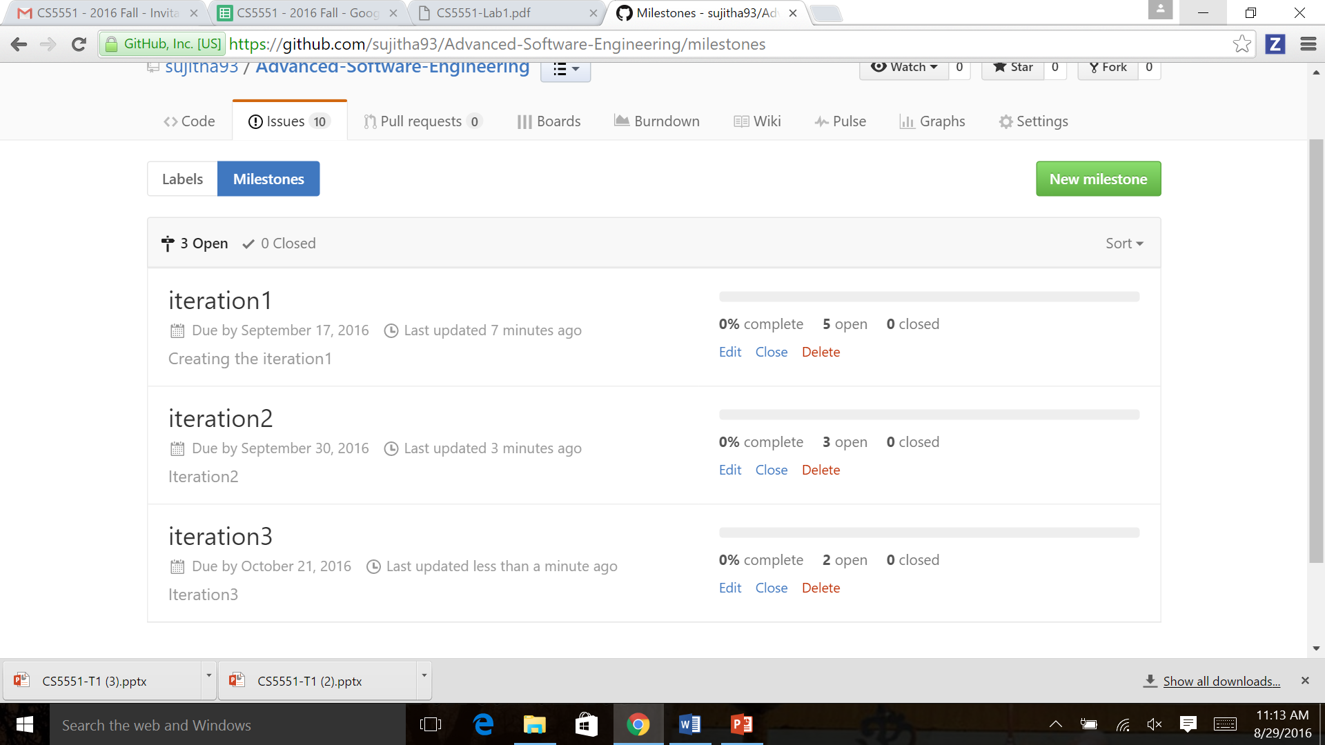

Board after creating of iterations with milestones

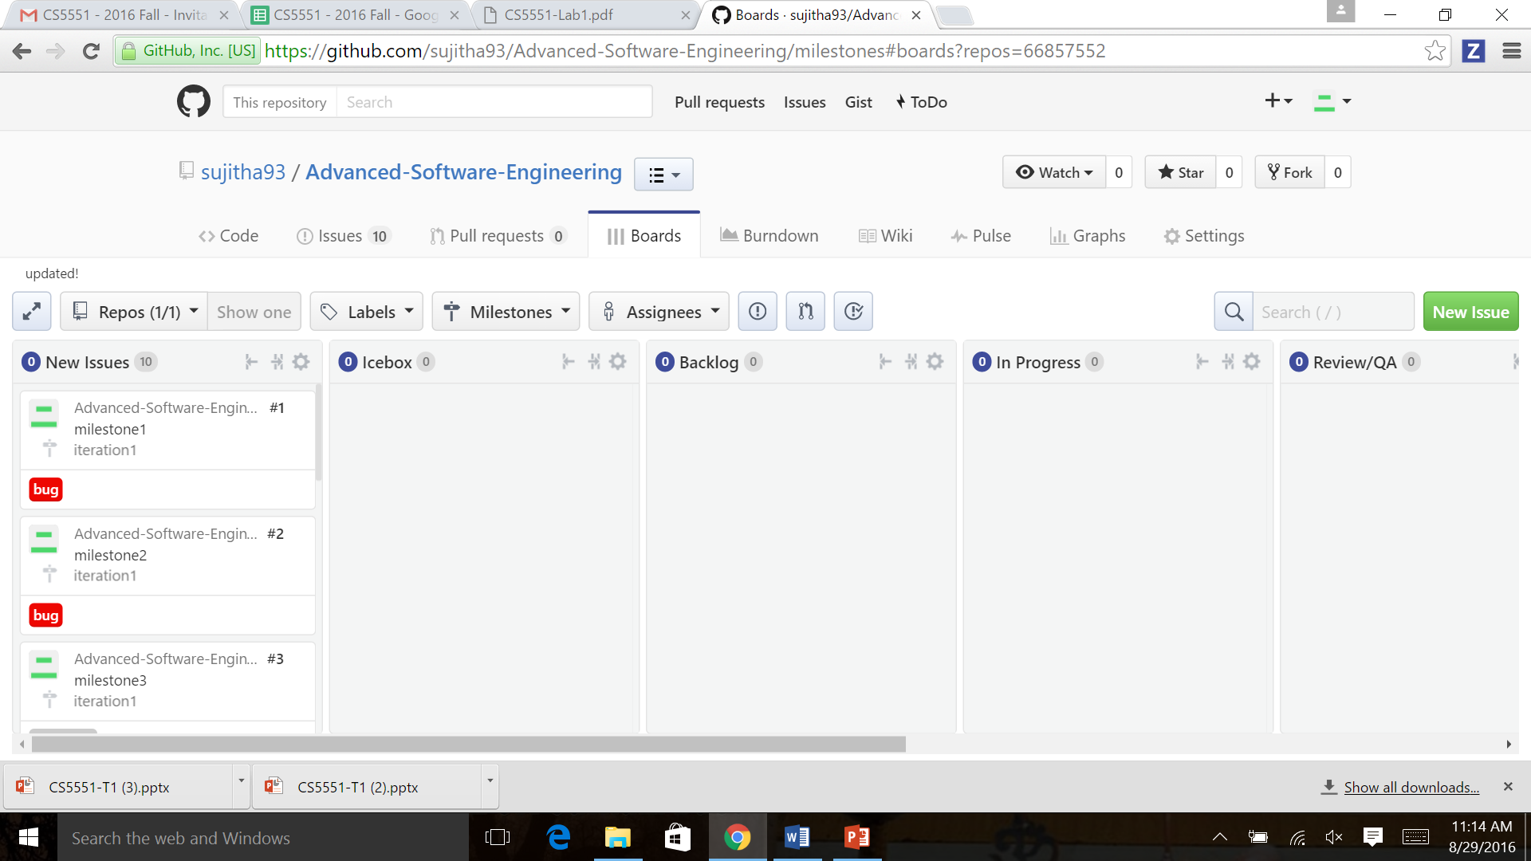

After modifying the Milestone 1 of Iteration 1 to in progress state

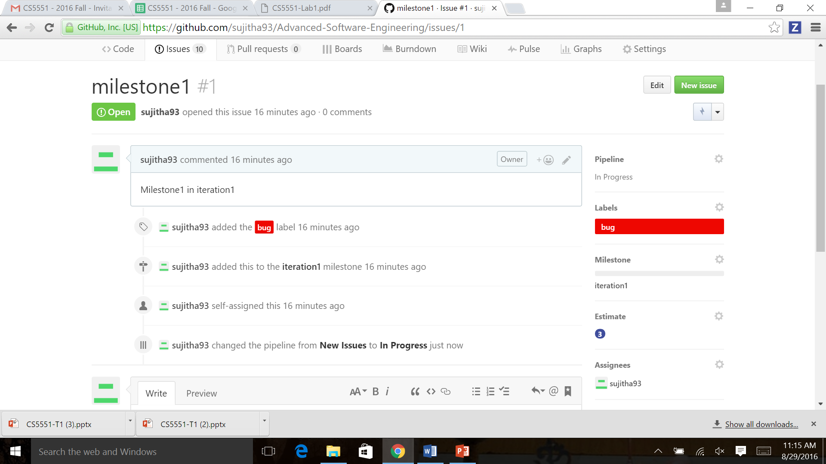

Closed milestone 1 of iteration 1

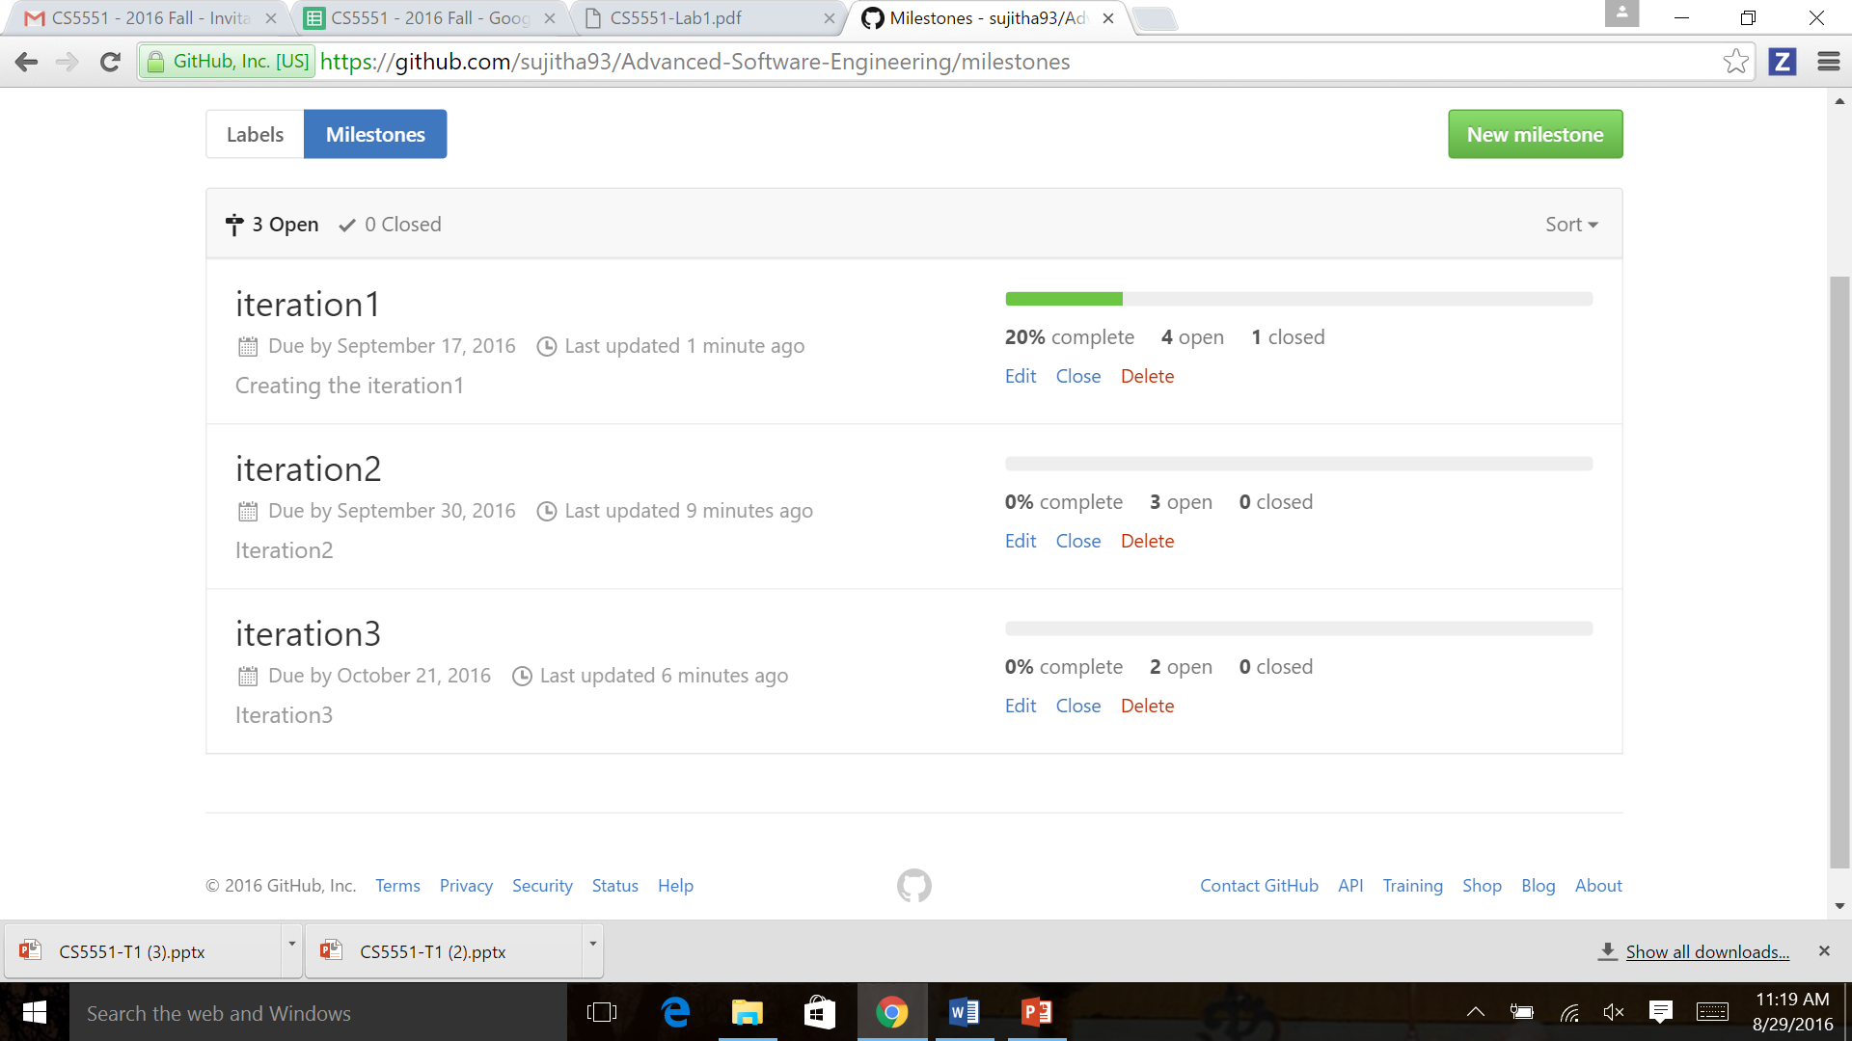

Closed all the issues of Iteration 2

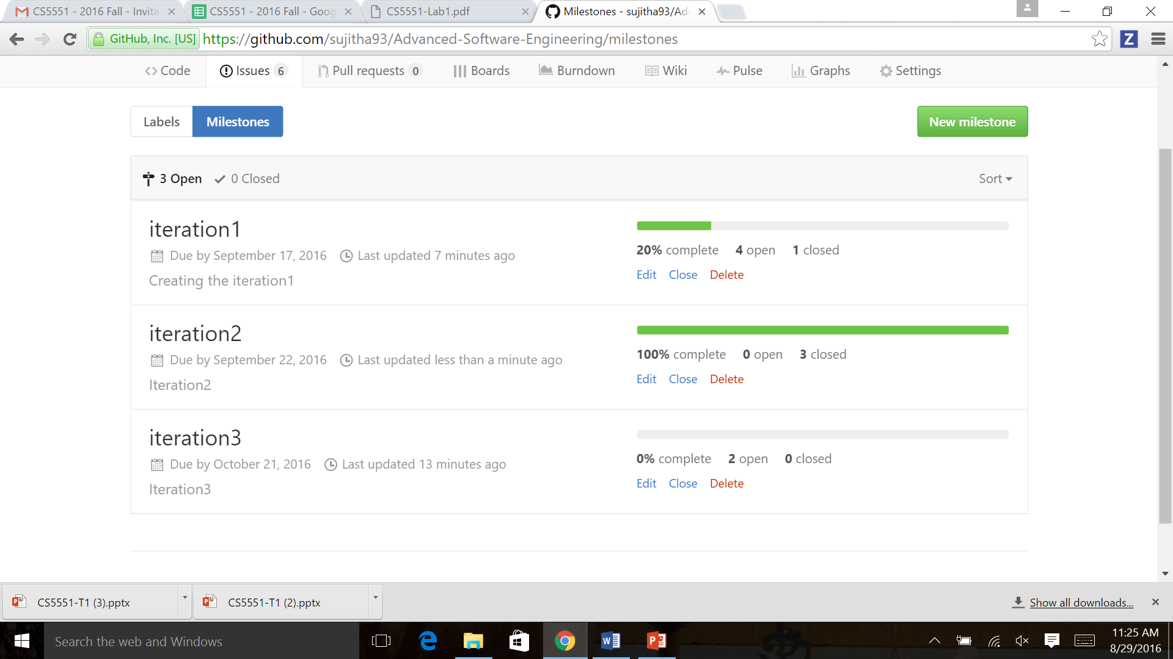

Closed Iteration 2

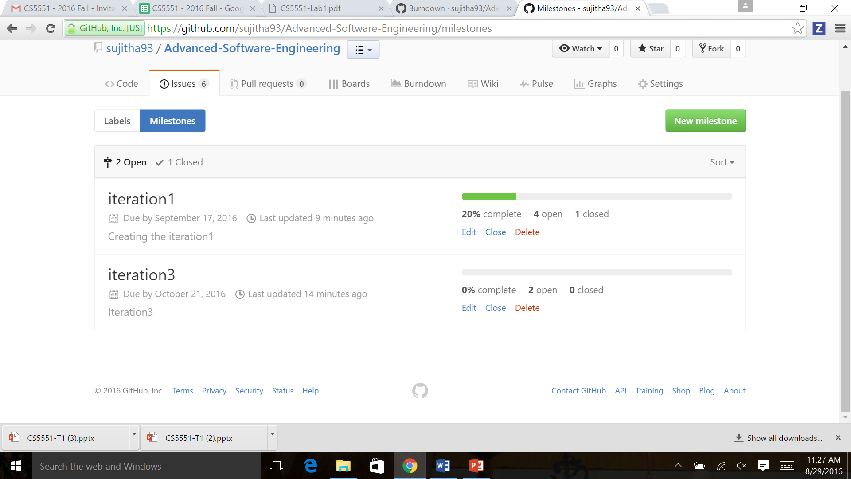

Step3: Create Analytic graph

Burndown graph for Iteration 1

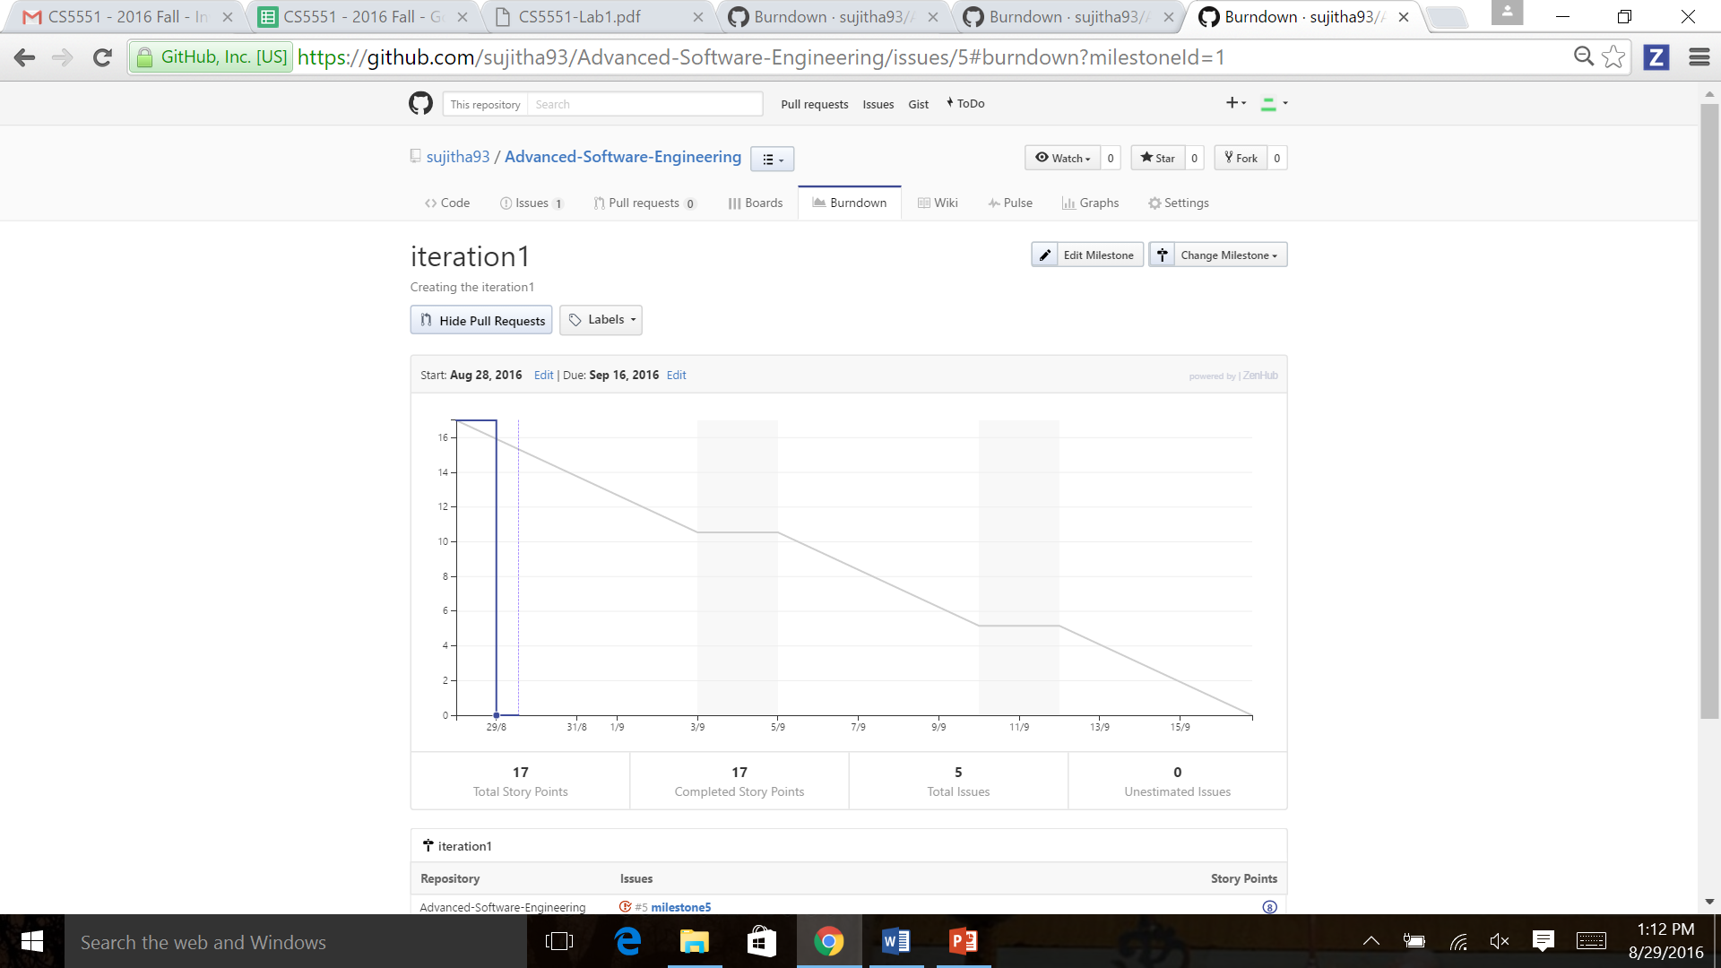

Burndown graph for Iteration 2

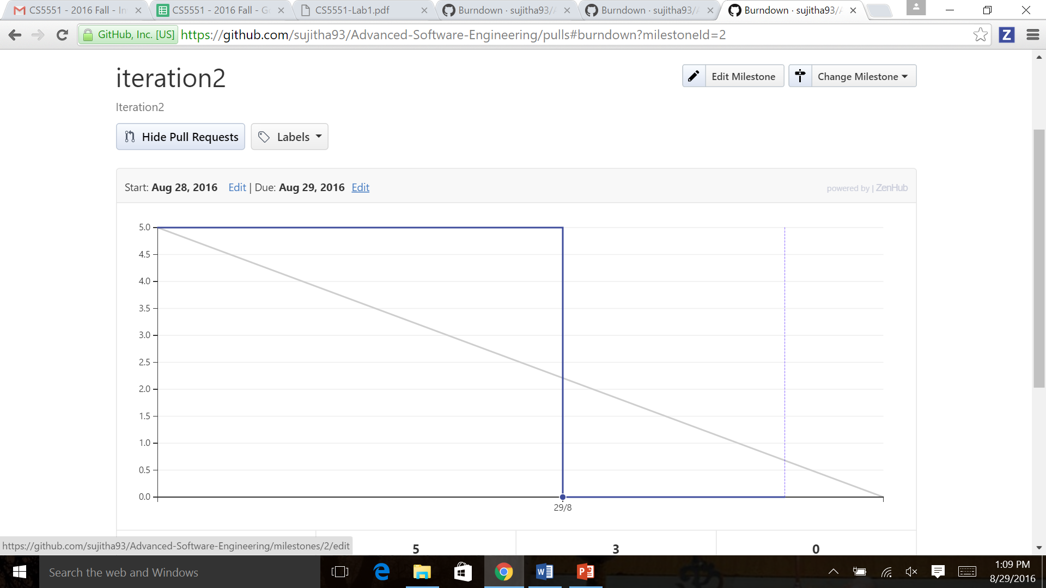

Burndown graph for Iteration 3

