**What is Vagrant?**

You can think of vagrant as a virtual machine manager for building and maintaining VMs. It is compatible with Windows, macOS, Linux. We will be using vagrant to build, boot and ssh into our VM. This VM will be preconfigured to include all the dependencies needed to compile and run xv6.

**Prerequisite**

* Download the version of vagrant that is for your system (<https://www.vagrantup.com/downloads.html>)
  + Note: I am on 2.0.3
  + To verify that vagrant was installed properly, run the command vagrant version. You should get an output similar to the one below.

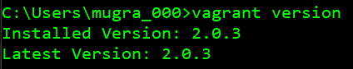

* Install an updated version of virtual box (<https://www.virtualbox.org/wiki/Downloads>)
  + Note: I am on 5.2.8 (Make sure that the version of vagrant you install supports the version of virtual box you install)

**Instructions**

**Setting up the VM with vagrant**

* Fork my repository (<https://github.com/LuvneeshM/os3224_vagrant>) and then *git clone* a local version of the freshly forked repository. You will be using this repository to submit homework assignments, via tagged released on github (<https://help.github.com/articles/creating-releases/>).
  + The release must be made before the deadline. Once you've made the release, submit the URL of the release so that we know that you got it in before your deadline. (Make a private repo and add give permissions to all the TAs)
* Using terminal/command prompt *cd* into the cloned repo
* To start up the VM run the command: *vagrant up*
  + Note: This might take a few minutes since it will be running for the first time and thus setting up a few things
  + If you open VirtualBox, you should notice a new VM named xv6_box has been made
* 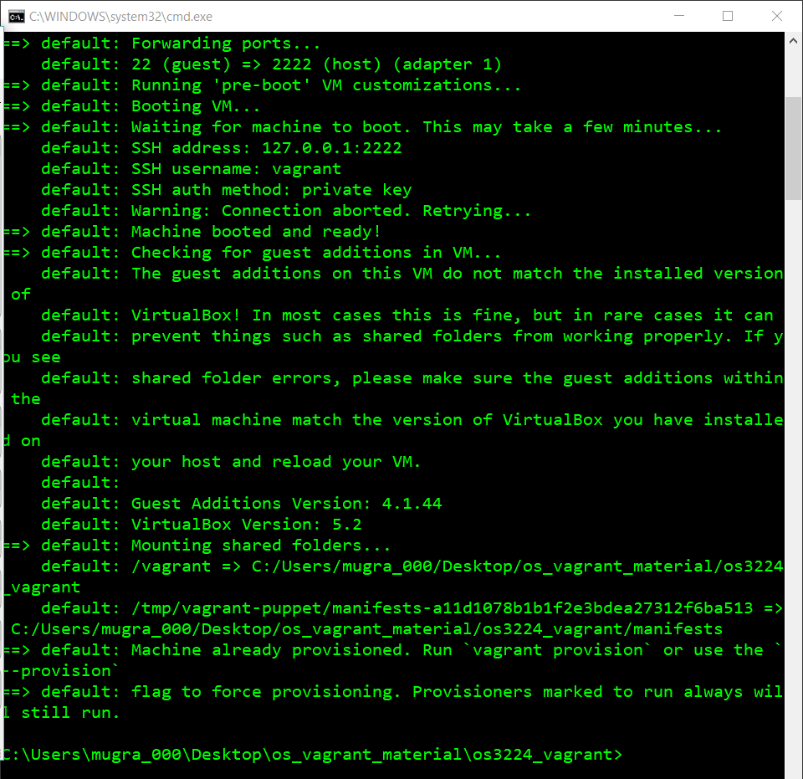Once it finishes, the VM will have booted and you should see something similar to below
* 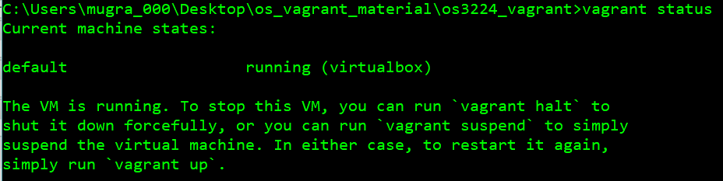Run the command *vagrant status*, to verify that the vm is up and running
  + 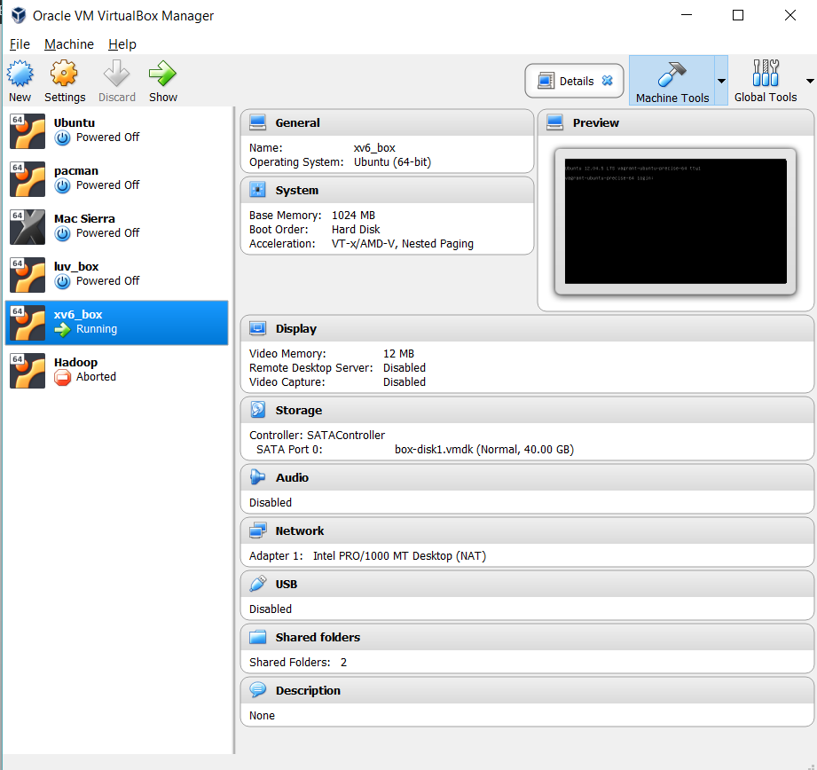Note that the VM in virtual box will also say running
* 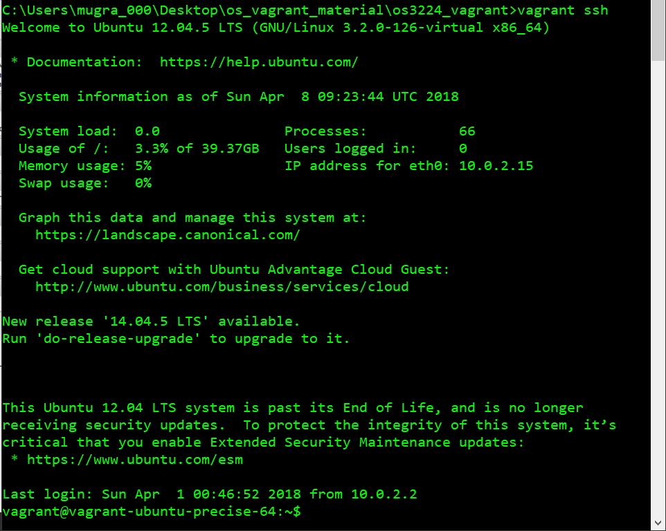We will now ssh into the machine by running the command: *vagrant ssh*
* If the vagrant ssh command does not work, we will connect to the machine manually:
  + Run the command: *vagrant* *ssh-config*
  + From what shows up in terminal, you can run the following command (make sure to fill in the variables with those from what shows up after running the vagrant ssh-config command)

ssh <USER>@<HOSTNAME> -p <PORT> -i <IDENTITYFILE>

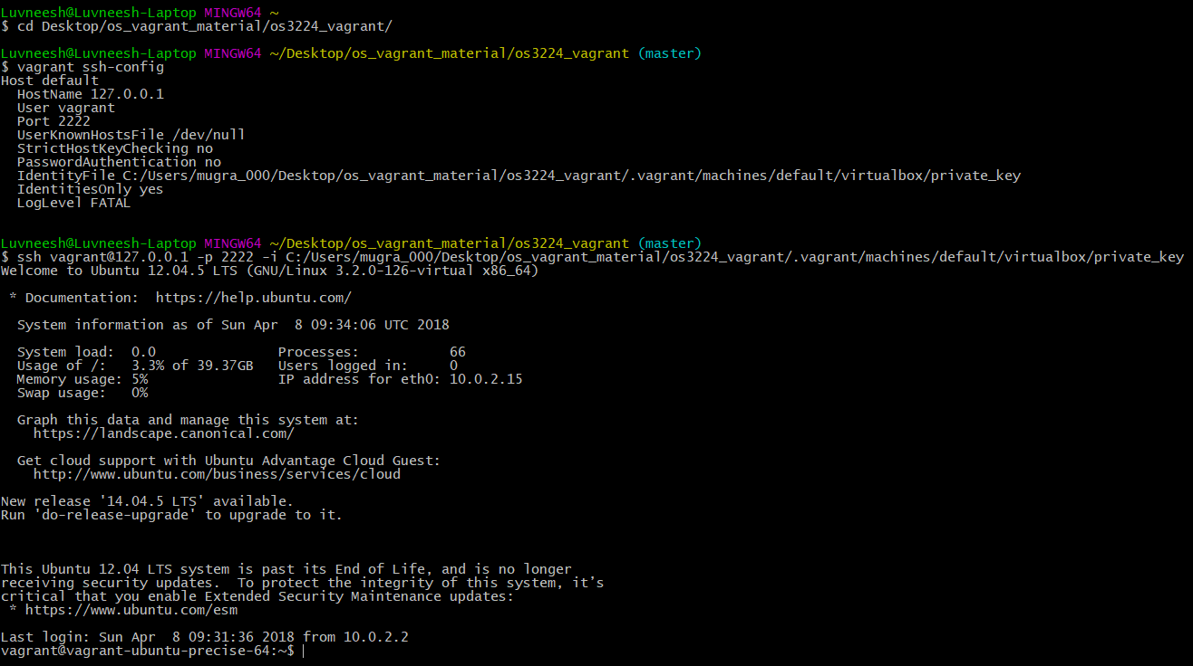(Note: I had to swap over to my Git Bash terminal since Windows does not allow for you to directly perform an ssh).

* To exit the VM, enter the command *exit*
* To shut down the VM, once you have exited the VM enter command *vagrant halt*. This will attempt to gracefully shut down the VM.

**Using vagrant with xv6**

* Now that you have successfully ssh’d into the VM, we now need to navigate to the directory with the vagrant file and the xv6 folder (I will refer to this directory as the root directory later on). Follow these commands:
  + cd /vagrant (Note: The / is necessary, as you can see from the screenshot, you will get an error without it.)
  + 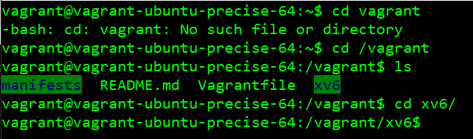cd xv6
* We are now inside the xv6 directory. To start up xv6 run the following commands:
  + 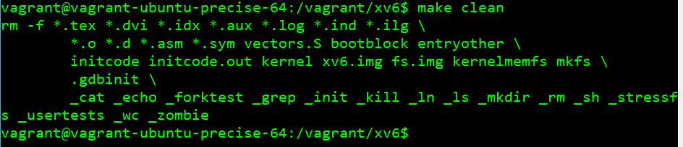make clean
  + 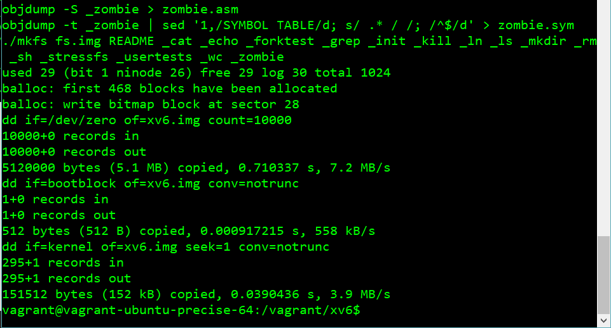make
  + 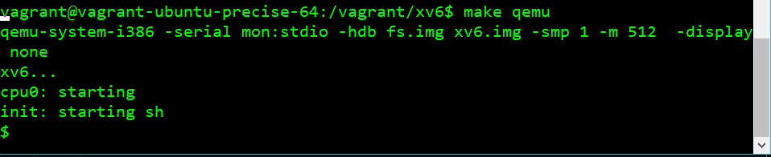make qemu
* 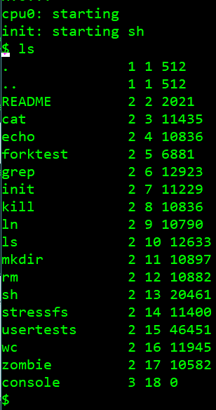Now that we are inside xv6, you can run the normal xv6 commands or any system calls that you may write yourself.

(Note: To exit xv6 you can use the shortcut Ctrl A, X)

**How To Do My Homework…**

Now that we have the environment and xv6 set up and running, you can proceed to do any homework that is involved with xv6. You will make any changes/add new files to the local repository you git cloned at the start. Then to run these changes you will need to start up the VM using vagrant, ssh into it, change to the right directory once inside the VM, then run the commands to compile and boot xv6. You may stay ssh’d in vagrant when doing homework as any changes you make inside the folder will be reflected inside the VM. For example, add a txt file, named name.txt, to the root of the local repository in your normal laptop with your Name and Email. Then inside the VM, if you cd into the root directory and type ls you will see the newly made txt file. If you still do not believe they are one and the same, open the file in the VM with vim: *vim name.txt*