**Recommendation Engine:**

**Product Recommendations**

**Business Use Case:**

Recommending the right products to customers based on their past behaviour can increase customer loyalty and boost cross-selling opportunities.

**Approach:**

● Algorithm:

Matrix Factorization

● Steps:

1. Data Preprocessing: Preparing the data and handling sparsity in the customer-product matrix.

2. Model Building: Implementing the recommendation algorithm and generating product recommendations.

3. Evaluation: Measuring the effectiveness of recommendations using metrics like Precision and Recall.

**Data Understanding:**

* Data Source: This dataset is a snapshot of a fictional retail landscape, capturing essential attributes that drive retail operations and customer interactions.

**Key Data Dictionary:**

1. **Transaction ID:** A unique identifier for each transaction, allowing tracking and reference.
2. **Date:** The date when the transaction occurred, providing insights into sales trends over time.
3. **Customer ID:** A unique identifier for each customer, enabling customer-centric analysis.
4. **Gender:** The gender of the customer (Male/Female), offering insights into gender-based purchasing patterns.
5. **Age:** The age of the customer, facilitating segmentation and exploration of age-related influences.
6. **Product Category:** The category of the purchased product (e.g., Electronics, Clothing, Beauty), helping understand product preferences.
7. **Quantity:** The number of units of the product purchased, contributing to insights on purchase volumes.
8. **Price per Unit:** The price of one unit of the product, aiding in calculations related to total spending.
9. **Total Amount:** The total monetary value of the transaction, showcasing the financial impact of each purchase.

**Data Preparation:**

Packages: NumPy, Pandas, Matplotlib, Seaborn, Sklearn.

**Data Cleansing:**

* There are no null values in the data.

**Exploratory Data Analysis:**

**Age Distribution**

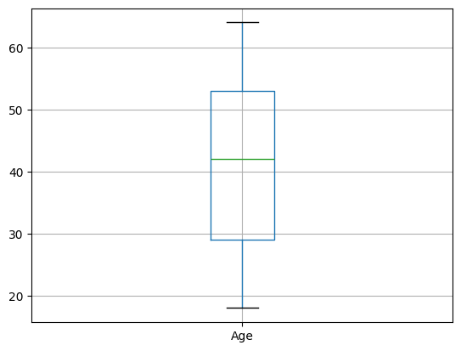

**Age VS Product**

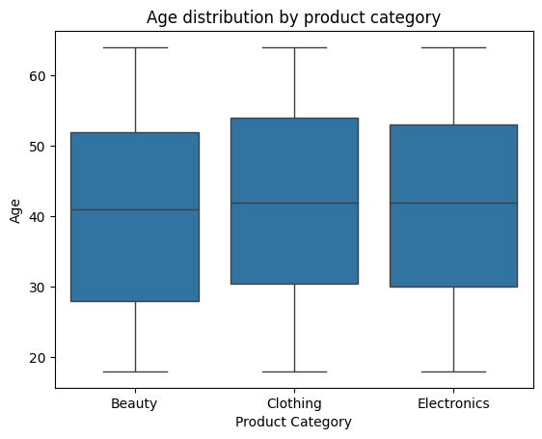

**Histogram**

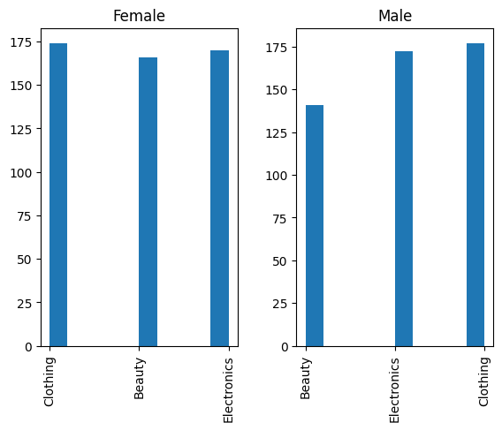

* Female histogram shows that there is no significant preference of purchase between different product categories.
* For male there is a significant lesser preference for beauty products.

**Model:**

**Matrix Factorization**

Matrix factorization is a mathematical technique used extensively in recommendation systems, particularly collaborative filtering methods. It works by breaking down a large matrix (e.g., user-item interaction matrix) into smaller matrices to reveal latent patterns, enabling better predictions of user preferences.

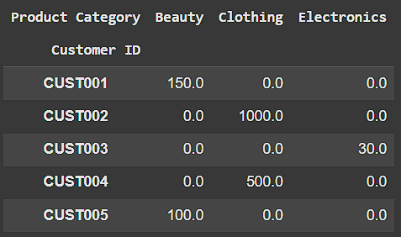

**Model Evaluation:**

**Precision and Recall**



**Mean Average Precision (MAP)**



**Normalized Discounted Cumulative Gain (NDCG)**

