Sonar Configuration:

Software required:

1) sonarqube-5.6.6

2) jdk1.8.0_112

3) apache-maven-3.3.9

4) sts-3.9.0.RELEASE

Configuration Path in environment variable:

JAVA_HOME : D:\Java\jdk1.8.0_112

M2_HOME:- D:\apache-maven-3.3.9

Path: D:\Users\suryaprakash.r\AppData\Local\Programs\Git\cmd;D:\Java\jdk1.8.0_112\bin;D:\apache-maven-3.3.9\bin;

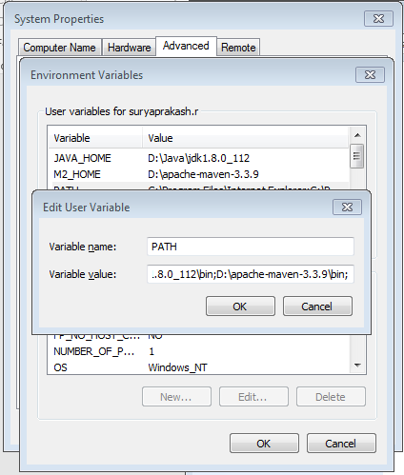

Added bellow the setting for pom.xml

<properties>

<project.build.sourceEncoding>UTF-8</project.build.sourceEncoding>

<java.version>1.8</java.version>

<sonar-maven-plugin.version>3.0.2</sonar-maven-plugin.version>

<sonar.exclusions>src/main/webapp/content/**/*.*,

src/main/webapp/bower_components/**/*.*,

target/www/**/*.*,

src/test/java/Unmentionable/AbstractControllerTest.java

</sonar.exclusions>

<!-- Sonar properties -->

<sonar.host.url>http://localhost:9000</sonar.host.url>

<!-- <sonar.login>e26c044c53632fdc33b83a76d8bff115bb26a653</sonar.login> -->

</properties>

And

<plugin>

<groupId>org.sonarsource.scanner.maven</groupId>

<artifactId>sonar-maven-plugin</artifactId>

<version>${sonar-maven-plugin.version}</version>

</plugin>



Step 2: Unzip the sonarqube and open bellow path

D:\sonarqube-5.6.6\bin\windows-x86-64 and execute the sonar

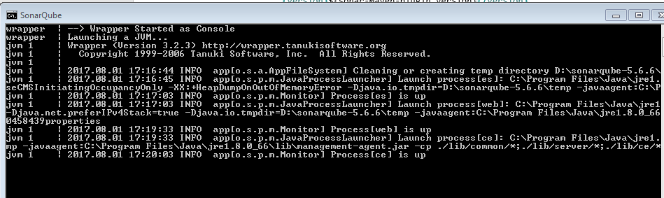

Execute bellow command:

mvn clean verify sonar:sonar

# In some situation you may want to run sonar:sonar goal as a dedicated step. Be sure to use install as first step for multi-module projects

mvn clean install

mvn sonar:sonar

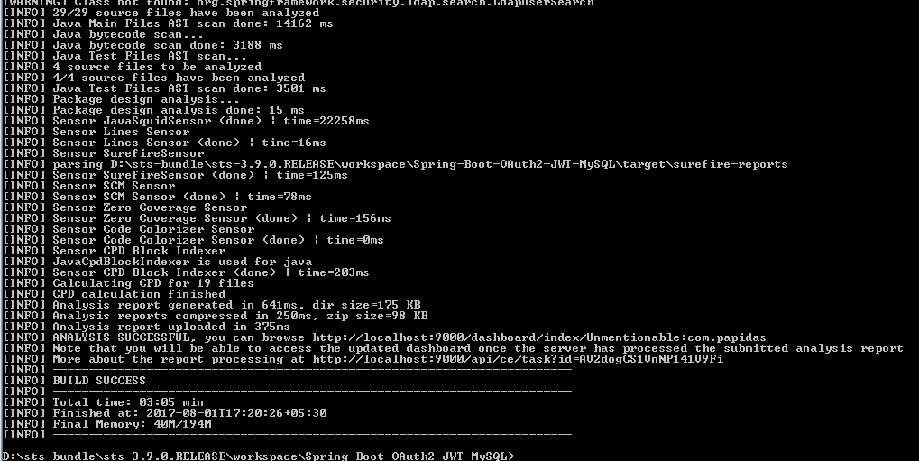

Then hit the browser URL check code coverage and report

<http://localhost:9000/>

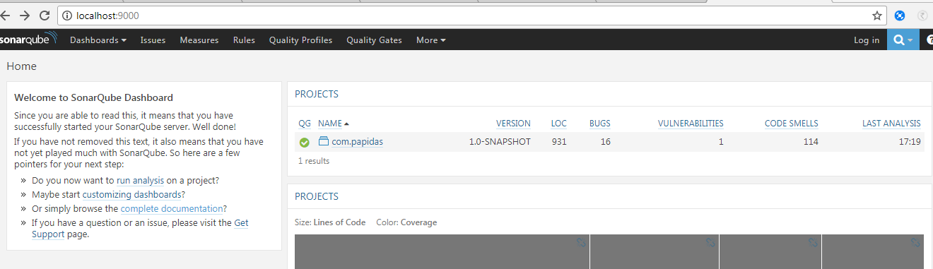

Referance :

https://dzone.com/articles/static-code-analysis-and