Separate before paying in
Receipt  Account / Payable to  CH44 3199 9123 0008 8901 2Thomas LeClaireRue examplaire 22a1000 Lausanne  Reference  12 34567 89012 34567 89012 34567  Payable by  Thomas LeClaireRue examplaire 22a1000 Lausanne  Currency CHF Amount 25.90  Acceptance point | Payment part 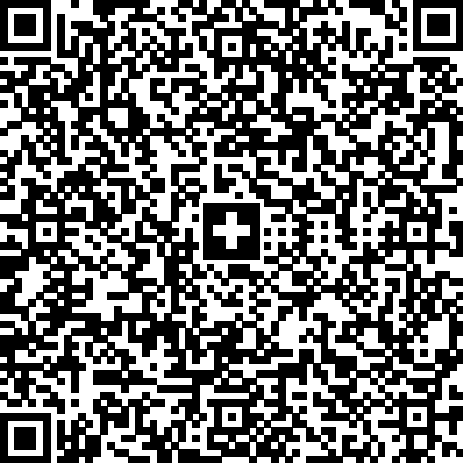 Currency CHF Amount 25.90 Account / Payable to CH44 3199 9123 0008 8901 2Thomas LeClaireRue examplaire 22a1000 Lausanne Reference 12 34567 89012 34567 89012 34567 Additional information Invoice 1234568Gardening workBill Information Payable by Thomas LeClaireRue examplaire 22a1000 Lausanne  foofoo

