Separate before paying in
Receipt  Account / Payable to  CH44 3199 9123 0008 8901 2Thomas LeClaireRue examplaire 22a1000 Lausanne  Reference  12 34567 89012 34567 89012 34567  Payable by  Thomas LeClaireRue examplaire 22a1000 Lausanne  Currency EUR Amount   Acceptance point | Payment part 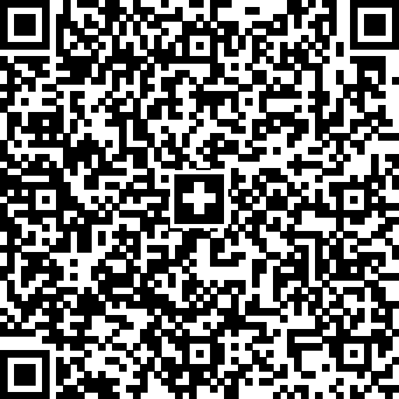 Currency EUR Amount  Account / Payable to CH44 3199 9123 0008 8901 2Thomas LeClaireRue examplaire 22a1000 Lausanne Reference 12 34567 89012 34567 89012 34567 Payable by Thomas LeClaireRue examplaire 22a1000 Lausanne

