Separate before paying in
Receipt  Account / Payable to  CH44 3199 9123 0008 8901 2Thomas LeClaireRue examplaire 22a1000 Lausanne  Reference  12 34567 89012 34567 89012 34567  Payable by (name/address)    Currency EUR Amount   Acceptance point | Payment part 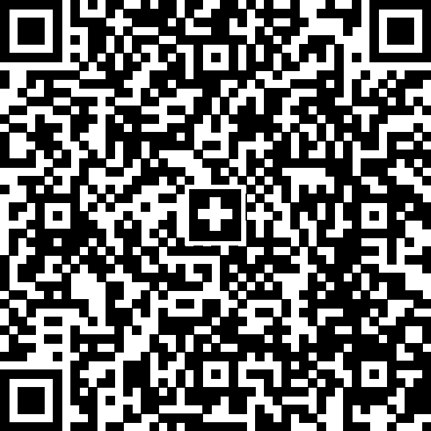 Currency EUR Amount  Account / Payable to CH44 3199 9123 0008 8901 2Thomas LeClaireRue examplaire 22a1000 Lausanne Reference 12 34567 89012 34567 89012 34567 Payable by (name/address) 

