Receipt  Account / Payable to  CH93 0076 2011 6238 5295 7Thomas LeClaireRue examplaire 22a1000 Lausanne  Reference  RF18 5390 0754 7034  Payable by (name/address)    Currency CHF Amount 25.90  Acceptance point | Payment part 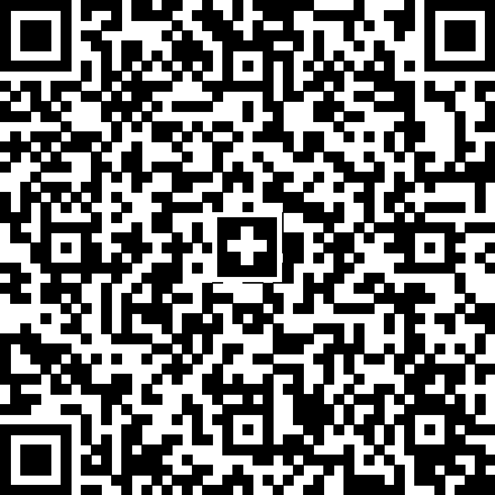 Currency CHF Amount 25.90 Account / Payable to CH93 0076 2011 6238 5295 7Thomas LeClaireRue examplaire 22a1000 Lausanne Reference RF18 5390 0754 7034 Payable by (name/address) 

