**LISTNER - AI-based Life Assistance Chabot Integration for public welfare**

**Challenge title:** IBM HACK CHALLENGE 2023

**Project ID:** SPS_PRO_3604

**Project Title**: LISTNER - AI-based Life Assistance Chatbot Integration for public welfare

**Team Name**: GRAYMOON

**Team Size**: 4

**Team lead**: Madasu Sriram

**College Name**: Narasaraopet Engineering College

**Introduction:**

Introducing LISTNER, a chatbot for life assistance powered by AI and created to promote public welfare. LISTNER is here to help people in all facets of their lives in real-time support, information, and assistance. LISTNER is a flexible tool designed to improve public well-being. It includes health advice, educational materials, emergency response, and community interaction. LISTNER's sophisticated natural language processing abilities enable it to comprehend and reply to a wide range of enquiries, making it a priceless tool for all communities.

Fully complete chatbot powered by AI that can offer help and support in a variety of situations. Flask-based backend infrastructure was created to facilitate easy chatbot integration and communication. Including the Telegram or WhatsApp API will make it easier for users to communicate through well-known messaging services for efficient comprehension and response creation based on user questions, integration of OpenAI GPT or a comparable NLP API is recommended. The use of a sentiment analysis API to extract emotional information from talks and provide individualized and empathic help. Sending SMS or phone notifications to support workers in urgent situations through integration of the Twilio API or a comparable service.

**Literature Survey:**

Researching existing studies, articles, and papers relating to AI chatbot, public welfare initiatives, and their integration is undoubtedly a necessary step in completing a literature study for the introduction of an AI-based life aid chatbot like LISTNER. Here is a quick summary of what the literature review might cover.

Explore research on advances in artificial intelligence (AI) and natural language processing (NLP) technologies that have made it possible to create intelligent chatbot. Learn how AI chatbots can imitate human-like interactions and offer tailored support.

Public Welfare Initiatives: Research numerous public welfare projects, programs, and initiatives that try to alleviate societal issues. Consider how these programs have been made more effective by the use of technology, especially AI.

Benefits of AI for Public Welfare Locate papers that discuss the possible advantages of using AI chatbots into initiatives for public welfare. Improved scalability, affordability, and the capacity to reach a bigger audience could be examples of this.

Research the value of user-centered design concepts for developing AI chatbots for the general good. Examine how user demands, preferences, and usability should be taken into account in the design to enable effective communication.

Ethical Considerations Look into the moral issues surrounding AI chatbots for the benefit of the public. Investigate the literature on bias reduction, data privacy, and making sure that the technology does not prejudice vulnerable people.

**Theoretical Analysis:**

**24/7 Availability:** "LISTNER" would be accessible round-the-clock, ensuring users can seek assistance whenever they need it.

**Multi-Lingual Support**: The chatbot could support multiple languages, ensuring that it caters to a diverse population.

**Personalized Recommendations:** Utilizing AI, "LISTNER" could analyze user preferences and behaviors to provide personalized recommendations for services, resources, and activities.

**Health and Well-being Assistance:** The chatbot could offer tips for maintaining physical and mental health, suggest healthy habits, and provide crisis intervention resources.

**Educational Guidance:** "LISTNER" could help users find educational resources, online courses, and study materials, promoting continuous learning.

**Career and Job Support**: The chatbot might assist with job search, career advice, and skill development, potentially bridging the unemployment gap.

**Emergency Response:** Integrating emergency response features could enable the chatbot to provide first aid instructions, safety tips, and direct users to the nearest medical facilities or authorities.

**Legal and Financial Advice**: Offering basic legal and financial guidance could empower users to make informed decisions.

**Community Engagement:** The chatbot could foster community connections by suggesting local events, clubs, and activities.

**Government Services:** "LISTNER" could help users navigate government services, eligibility criteria, and application procedures.

**Social Support:** The chatbot might provide a platform for users to share experiences, connect with others facing similar challenges, and receive emotional support.

**Experimental Investigations:**

**Determine the needs of the target audience**: What particular issues will the chatbot be trying to solve? Who will be using it, specifically? What do they anticipate?

**Assemble information and data:** This information includes specifics about the target market, the issues they are having, and the resources that can be used to assist them.

**Create the conversation flow for the chatbot**: In doing so, it will be necessary to specify the various conversational trajectories and user query responses that the chatbot can employ.

**Pick the appropriate technology**: The chatbot must be able to comprehend user inquiries, provide appropriate responses, and glean emotional information from chats.

**Create a chatbot:** In order for the chatbot to understand and respond to user inquiries, data and information must be fed to it.

**Run a chatbot test**: To ensure that the chatbot is functioning as planned, this entails testing it with actual users.

**Activate the chatbot**: The chatbot can be released to the public once it has undergone testing and is ready.

**Flowchart:**

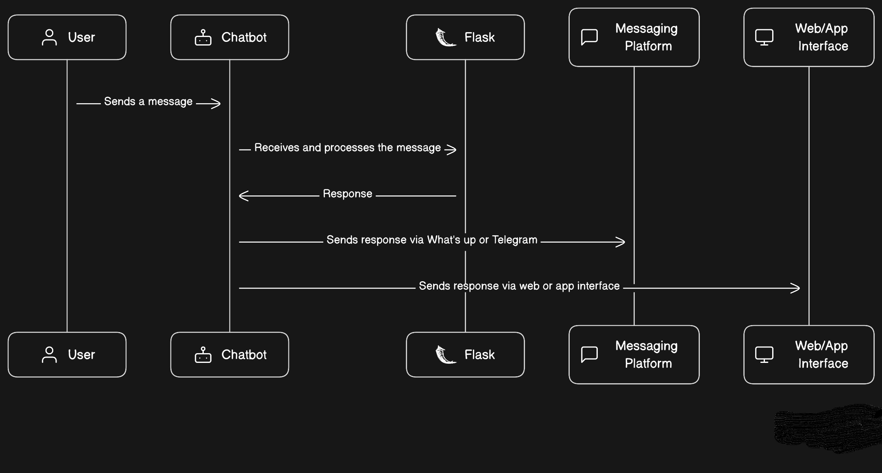

**Result:**

An extensive amount of research emphasizing the potential of AI-based life help chatbots like LISTNER in advancing public welfare programs was found in the literature review. The advantages of deploying AI chatbots to offer accessible and individualized support across a variety of disciplines, including mental health, education, public services, and health information, are often emphasized in studies.

The literature now in existence shows how using AI chatbots into public welfare can boost efficiency and reach. These chatbots can respond quickly, are available around-the-clock, and can handle many requests at once. They can also provide tools and information in a user-friendly and engaging way, meeting the demands of various demographics.

There are issues including technical constraints, user resistance to using AI, and the requirement for continuous progress. To produce efficient and long-lasting AI chatbot solutions, it is necessary to carefully plan, monitor, and iteratively evolve the solutions.

**Advantages:**

1. **24/7 Accessibility**: AI chatbots can assist consumers round-the-clock, making sure they have access to information and support even outside of regular business hours.

2. **Scalability:** Chatbots are extremely scalable and can reach a broad audience without taxing human resources because they can manage a lot of enquiries at once.

3. **customised Support**: AI chatbots are able to assess user inputs and preferences to offer customised suggestions and responses that are catered to the needs of each user.

4. **Cost-Effectiveness**: Once created and implemented, AI chatbots may be less expensive to use than a huge staff of human assistants who would need to be hired and trained.

5. **Consistency**: AI chatbots respond to user inquiries in a consistent manner, lowering the possibility of human error or informational variability.

6.**Instant Response**: Users receive immediate answers to their inquiries, reducing the need to wait for a human response, which can be very important in urgent circumstances.

7**. Multilingual Support**: AI chatbots may be trained to comprehend and answer in a variety of languages, enhancing accessibility for a range of users.

8. **Reduced Workload**: Routine enquiries can be easily handled by the chatbot, freeing up human personnel to focus on more difficult and specialized activities.

10. **Data Collection and Analysis**: Chatbots can collect insightful information on user interactions, preferences, and needs that can be used to enhance services and customize products.

**Disadvantages:**

**Limited comprehension**: Despite advances in natural language processing, AI chatbots may occasionally misunderstand user inputs or have trouble comprehending complex questions.

**Algorithmic Bias**: AI chatbots may inherit biases from training data if they are not properly developed and trained, which could result in unfair or discriminating responses.

**Reduced User** Satisfaction due to Loss of Human Touch: Some consumers may prefer human interactions and find chatbots impersonal.

**Dependence on Technology**: An excessive reliance on chatbots could result in a deterioration in social abilities and face-to-face encounters.

**Initial Development Costs**: Creating and executing a high-caliber AI chatbot can be expensive up front due to the need for integration, technological development, and training.

**Maintenance and Updates**: AI chatbots need constant upkeep in order to stay current with evolving user needs and technological advancements.

**Applications:**

**Awareness and Education**: Chatbots can convey knowledge about methods for preventing violence, constructive dispute resolution techniques, and readily available support resources.

**Risk Assessment**: AI chatbots can help identify potential violent risk factors and offer users the right advice and tools to help reduce those risks.

**Referral of Resources**: In situations of acute danger, chatbots can point people toward local law enforcement, crisis hotlines, shelters, and counseling facilities.

**Anonymous Reporting:** Chatbots can provide a safe environment for people to anonymously report violent crimes or other shady activity.

**24/7 Support**: AI chatbots can offer quick assistance to people going through mental health crises, including coping mechanisms and resources.

**Screening and assessment**: Chatbots can give users mental health assessments, assisting them in understanding their mental health and pointing them in the direction of the right resources.

**Sharing Resources**: AI chatbots can provide users with a plethora of educational materials by exchanging knowledge on mental health conditions, self-care techniques, and available therapies.

**Crisis intervention**: Chatbots are able to spot the telltale signals of sudden distress and offer calming strategies while also urging users to get help from a professional when necessary.

**OUTPUT’S SCREEN SHOTS:**

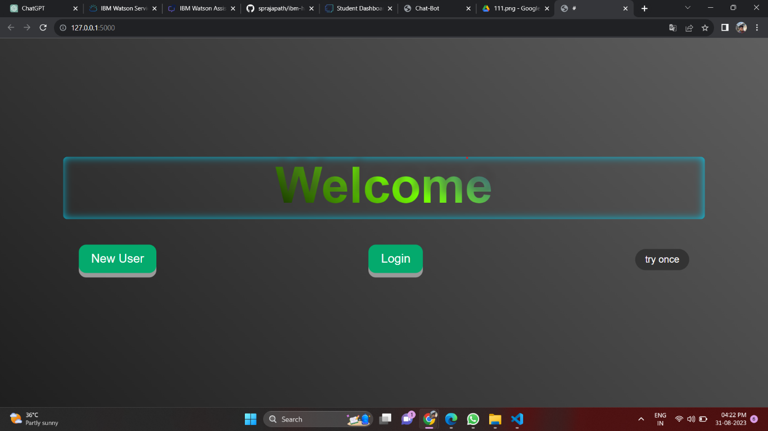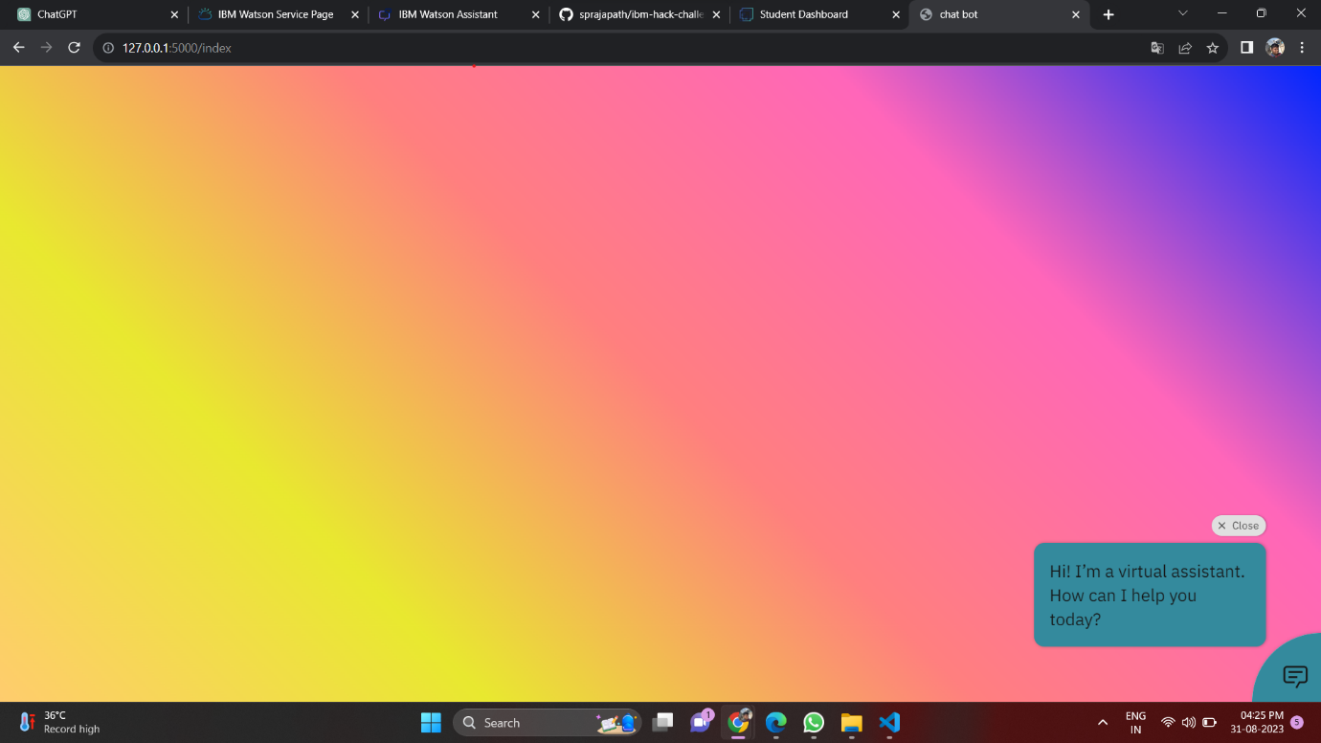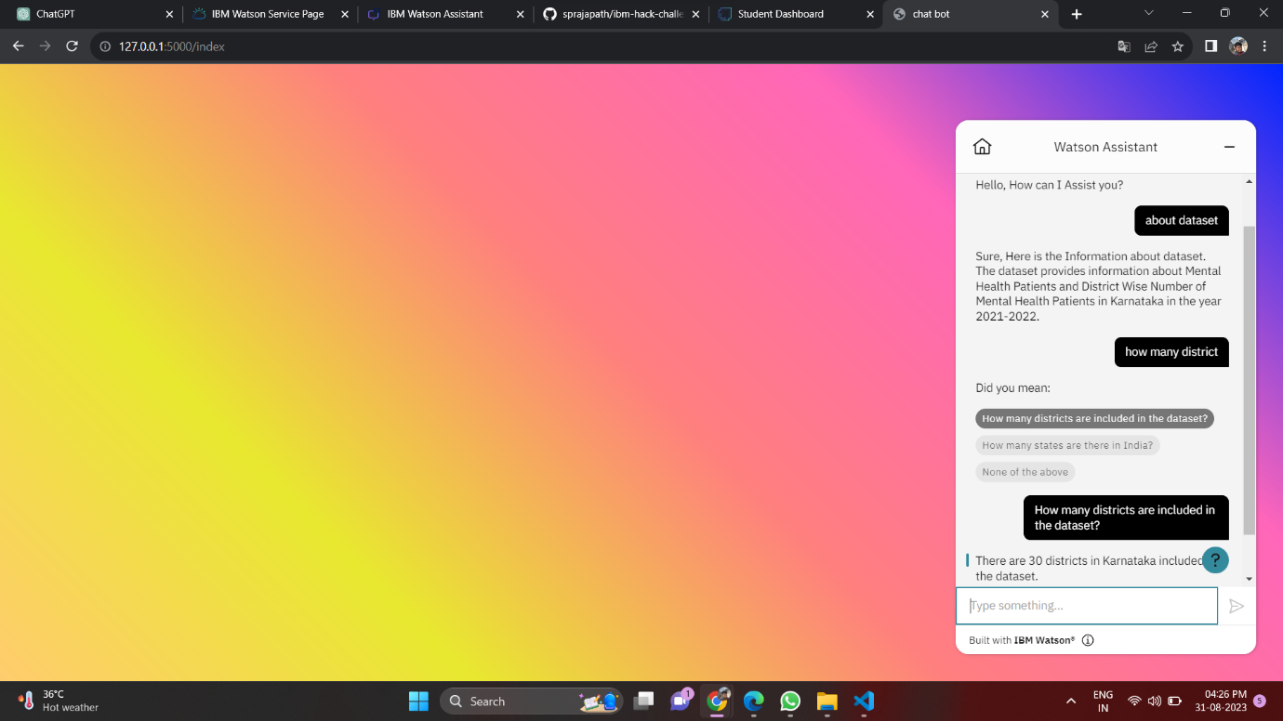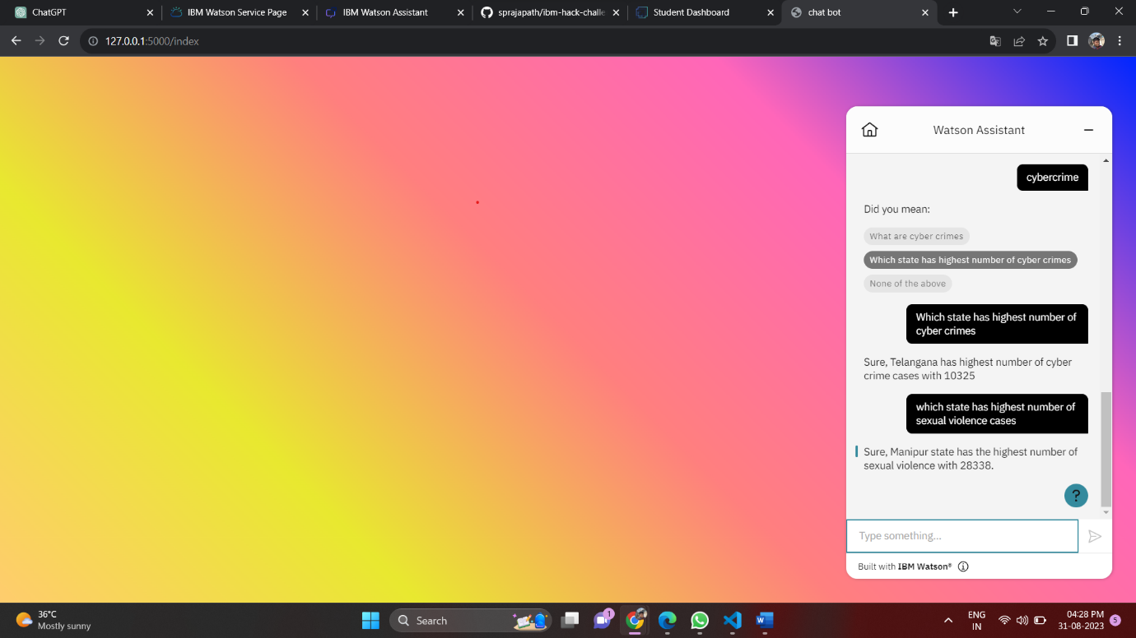

**Conclusion:**

Finally, the incorporation of AI-based life assistance chatbots like LISTNER has enormous potential to alter public welfare programs, notably in the areas of mental health support and state-level violence prevention. These intelligent chatbots have a number of advantages, including cost effectiveness, 24/7 accessibility, and scalability. They can significantly contribute to the effectiveness of public welfare initiatives by immediately offering people support, resources, and information.

Collaboration between AI developers, mental health practitioners, law enforcement organizations, and experts in violence prevention is necessary for successful implementation. States can develop a more approachable, effective, and user-centered method of tackling mental health issues and reducing violence by utilizing the capabilities of AI chatbots. A huge step forward in utilizing technology for social good, AI chatbots' potential to favorably impact public welfare projects are still hopeful as technology develops.

**Future Scope:**

**Expanded Services:** The chatbot's capabilities might be increased to offer a wider range of services, including career counseling, financial advice, and legal support, making it a complete resource for many facets of people's lives.

**Support in several Languages**: The chatbot's language capabilities might be improved to cater to a variety of demographics by offering support in several languages, which could help it reach a wider audience.

**Continuous Learning:** Putting machine learning techniques into practice would allow the chatbot to continuously learn from user interactions and modify its responses over time, improving accuracy and effectiveness.

**IoT integration**: By integrating the chatbot with Internet of Things (IoT) devices, it may be possible for it to offer real-time information and support for various smart home and healthcare systems.

**Personalized Recommendations**: By using AI algorithms to examine user preferences and behavior, the chatbot may be able to provide tailored suggestions for products, occasions, or resources that suit specific requirements.

**Health and Wellness:** Integrating health-related elements, such as delivering mental health support, organizing appointments, and providing information about healthcare providers, could promote overall wellness.

**Collaboration with Organizations**: The impact of the chatbot's services may be increased and users could receive more thorough support if there was collaboration with governmental organizations, nonprofit groups, and educational institutions.

**Data Analysis for Policy Decisions**: User interaction data that has been aggregated and anonymized can be examined to find patterns and insights that can be used to advise policymakers about the wants and requirements of the general population.

**Accessible Platforms:** The chatbot's accessibility can be improved by making it available on more channels, including websites, social media, mobile apps, and even voice assistants.

**Privacy and ethical improvements**: Maintaining user confidence and complying with rules will require integrating strong privacy safeguards, eliminating potential biases, and making sure that user data is protected.

**Source Code:**

**GitHub link: https://github.com/sprajapath/ibm-hack-challenge-2023**