Pemba chhering Sherpa
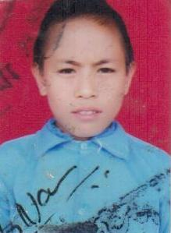
Pemba chhering Sherpa is a student of grade 7 a distinction holder student since last 5 years in Shree Himalaya Panchkanya school, listikot, Ghipche. Everymorning Pemba has to walk 2 km from her house to reach to school. She lost her father when she was small. Since then she has been living with her relatives.

As she started growing up, her relatives forced her to get married in her small age which was making her childhood spoil and it was also against the law. She wants to get education and has a dream to be a social worker, so that she can serve the nation.

