Ganga B.K
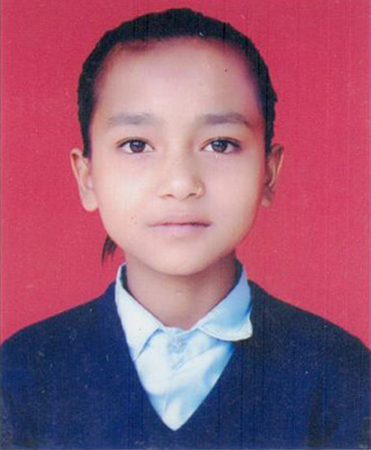
Ganga B.K. is 12 years old girl from Marming-5 sindupalchowk. She stays with her maternal uncle. Living in a poor farmer’s family, her uncle is unable to afford for her studies althought she want to gain knowledge. Ganga has to do all the house hold works like cleaning home, feeding cattles, Fetching water and all. With all these works and effors she has to walk around 1 km from her house to go to her school.
Her school, Shree Seti Devi, Devastated by the April’s earthquake. Every Morning, Ganga performs her house hold activites and togetherly with her friends bulid their school so that they can study. From Cleaning up the place to arranging desks and white boards.
Everyday performing all these tasks and also arranging for her school with a poor economic backgrond, Ganga has a dream to become a teacher so that she can give knowledge to others.

