**Chhiring Sherpa**

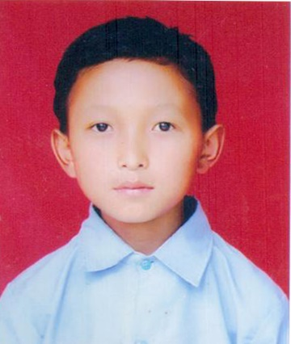Chhiring Sherpa is a student of grade 7 studying in Shree Seti Devi School, Listikot, Sindhupalchowk. Living in a poor family with three children’s, his parents are unable to afford for their studies. Chiring is a bonfire student with capability of scoring good results. Chiring along with his family lives in a temporary shelter. Every morning Chiring performs household activities like cleaning house, feeding cattle’s and also looking after his brother.

Chiring along with his friends walks about 1 km and reach their school every day. Although their school was divasted by the earthquake, they manage their class rooms from arranging the desk and benches to cleaning the room so that they can study.

With all these problems Chiring has not lost his hope and is continuing to study and also has a dream to become an engineer & build the strong homes which shall not be demised in earthquake.