1. Introduction

1.1 Background
This document outlines the software requirement specification for the ABC e-Recruitment company. It is the outcome of the Analysis Phase during which discussions were held with the users. The objective of this Analysis Phase was to:

- Define the scope for the e-Recruitment system.
- Serve as the baseline for the design of the e-Recruitment system.

Any changes to requirements after acceptance of this document will be through appropriate Change Management procedure, as detailed in the contract.

Both the user and designer should go through the document carefully in order to ensure that:
- All the user requirements which need to be supported by the system have been identified and detailed.
- The document is a clear and unambiguous statement of functionality required from the system for the design and development team.
- The document can be used as a basis for development of the System Test data.

It is essential to identify the problems, if any, with the basic structure of the proposed system at this stage. If these are not taken care of at this stage, it may be difficult to incorporate the desired modifications to overcome the shortcomings at a later stage.

Client Details:
ABC Company wants to develop an application for online recruitment in order to recruit efficient employees for the company. The company intends to create online system which reduces the burden of managing incoming resumes without losing candidates who are interested in applying to a company

Project Details:
On-boarding Process:-
It enables employee on-boarding through automatic generation of CTC documents, medical check-up instructions etc. The steps of this module are follows:-
Candidates who have cleared the medical tests meet HR with the documents. Recruitment team does the compliance checks, background checks. After completing the above process, the offer letter is sent to the candidate. On accepting the offer, the candidate is added as an employee.

1.2 Scope:

- Empowers HR to accurately process candidate’s profiles in depth in order to find the right candidates.
- Help company find new employees, employ them in positions that suit their capabilities.
- Promote the professional development of employees and retain them in long term.
- Offers effective means for tracking compliance with anti-discrimination policies and laws.
- Integrate work flows to automate information flow and multiple processes, such as the approval process.

1.3 Key Assumptions, Dependencies, Constraints
Assumptions

- Unless it is specified, data /entries will be made available through pre-approved list. No special screens need to be made to enter or delete such that E.g. under Initiation module, designing screens for capturing details such as Unit Head, Project details etc. is not requested. This data should be taken from Company ABC as existing data to be used in new screens.
- A Unit Head or an employee under a Unit Head may raise an unlimited number of Vacancy request.
- The task of placement consultants is to actually source candidates and this process is handled offline outside of the systems.
- Management of placement consultants is done outside the system.
- Placement consultant need to upload CV's as doc files.
- Other than sending notification details thereof, actual implementation and recording of penalties are done offline and outside the system.
- A Candidate profile cannot be repeated within a period of 6 months if it has already been selected by HR.
- Placement Consultants will access the application through their own login.
- Conduction of HR, Technical and Medical Tests are done outside the system.
- Conduction of Background Tests are done outside the system.

Dependencies
- System Software from the client for development must be available.
- Installed System Software for implementation must be available.

Constraints
- Look-up data where ever applicable is loaded from the database.
- CTC calculation is read only field.
- Before saving and deletion of any Information in System, confirmation is taken from user.
- Access to pages are restricted to specific users accordingly.

1.4 User Classes and Characteristics:

1.5 Hardware and Software Platform

1.5.1 Hardware
- Dual Core processor or latest versions.
- Minimum 2GB RAM.
- Minimum 7GB Hard Disk Space.

1.5.2 Software
- Windows XP or later versions.
- Visual Studio 2012.
- SQL Server 2012.

2. Functional Requirements:

E-Recruitment aims at developing a web application for tasks involved with finding, attracting, assessing, interviewing and hiring new personnel. The purpose of e-Recruitment is to make the processes involved more efficient and effective, as well as less expensive. Online recruitment can reach a larger pool of potential employees and facilitate the selection process.
The application allows users to perform edit/update, search and delete operations over the personnel details. Further, the candidate can accept the offer, only after he/she has completed giving all the required tests. After accepting the offer the BGC schedule will be initiated for the candidate.

2.1 On boarding Process:

USE CASE 1: Add BGC test administrator

- Primary user: HR Recruitment Officer
- Primary user action: HR Recruitment officer selects the administrator for conducting the BGC. Unit head has to approve the persons selected for conducting the BGC Check. If the status of BGC Administrator is approved then candidates BGC check is scheduled.
- Associated users: NA.
- Input Criteria- Employee is selected to become BGC administrator.
- Output or success guarantee: BGC administrator is added.

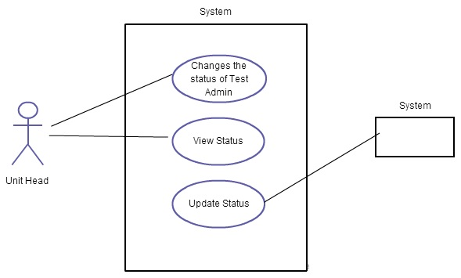

USE CASE 2: Approve BGC test administrator

- Primary user: Unit Head
- Primary user action: Unit Head changes the status of test administrator. The status will be pending approval initially and it can be changed to approved/rejected/On leave by the unit head.
- Associated users: NA.
- Input Criteria- Change in the status.
- Output or success guarantee: Status of the BGC administrator is changed for further process.

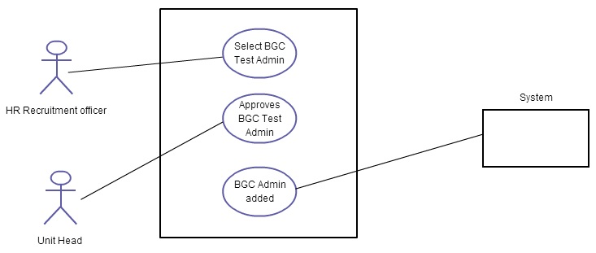

USE CASE 3: View BGC test administrator
- Primary user: HR Recruitment officer
- Primary user action: HR Recruitment officer views all the available BGC test administrator.
- Associated users: NA.
- Input Criteria- NA.
- Output or success guarantee: Views all the administrator's details.

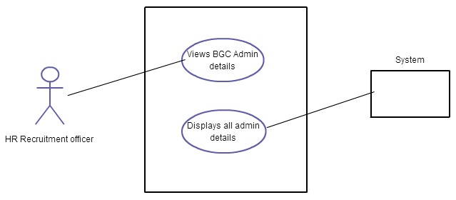

USE CASE 4: Log In/ Change Default Password – All users
- Primary user: All the users
- Primary user action: User can login. If it is their first login they will be prompted with the change password page to change the default password
- Associated users: NA.
- Input Criteria- User Name and password for login. Old password, New password and confirm password for Change password.
- Output or success guarantee: Login successful. Change password successful.

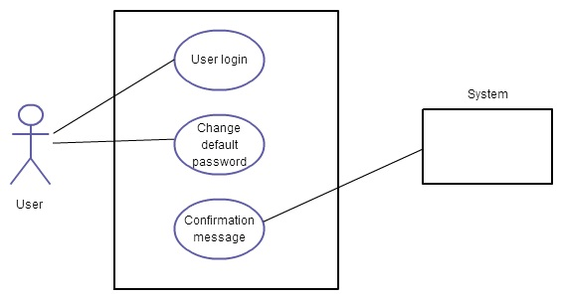

CRUD 2: BGC Updates

USE CASE 5: Create Background and Compliance Checks Ids

- Primary user: HR Recruitment Officer
- Primary user action: HR Recruitment officer selects the administrator for conducting the BGC. If the status of BGC Administrator is approved then candidates BGC check is scheduled. He decides the start date, end date and the administrator for the BGC check. Candidates profile table is updated with the BGCID generated now.
- Associated users: Unit Head.
- Input Criteria: From date, To date and administrator's ID.
- Output or success guarantee: Details of the candidate is updated initiating BGC.

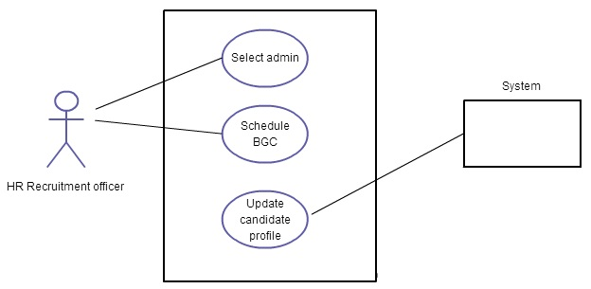

USE CASE 6: Edit Background and Compliance Checks Scheduled

- Primary user: BGC Administrator.
- Primary user action: BGC Administrator updates the BGC test status in Candidate profile table. If the candidate passes the BGC Check then the Administrator changes the BGC test status as 1. Once this status becomes 1 then automatically the candidates Test Status becomes confirmed.
- If a candidate fails the BGC check then remarks is mentioned in the Candidate Profile table.
- Associated users: NA.
- Input Criteria: Status of the Candidate is updated.
- Output or success guarantee: Candidates get confirmed or rejected based on this BGC check.

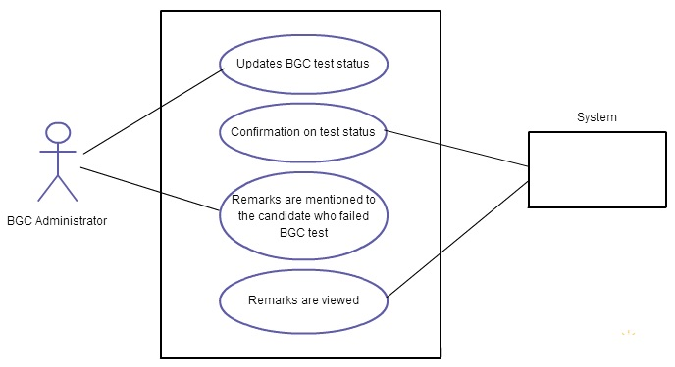

USE CASE 7: Display Background and Compliance Checks Scheduled

- Primary user: HR Recruitment officer, BGC Administrator
- Primary user action: Views the candidates based on the Test status / BGC Status / Vacancy ID.
- Associated users: NA.
- Input Criteria: Selects status for viewing the candidates status.
- Output or success guarantee: Views the candidates.
- Data Requirement: Candidate Profile table.

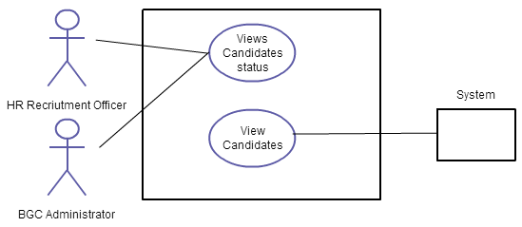

CRUD 3: Employee Details

USE CASE 8: Create Employee ID

- Primary user: HR Recruitment officer
- Primary user action: All the employees who have cleared the interview are selected. They are added to the employee table with the following details: EmployeeName, DOB, DOJ, Division, Gender, CTC, Designation, UnitHead ID, and Project ID.
- The CTC is the cost to company or gross salary of the employee. This must be
- 1.5 to 3 for first year of experience and 1.5 per annum for every subsequent year.
- Associated users: Candidates (They have to accept the offer to complete this process.
- Input Criteria- Employee details are added.

- Output or success guarantee: Employee gets added to the company after confirming the unit head and the candidate.

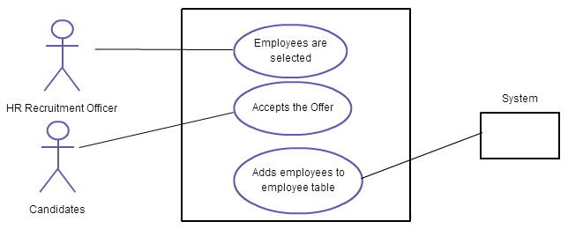

USE CASE 9: Display Employee

- Primary user: HR Recruitment officer.
- Primary user action: Views the new employees added to the company.
- Associated users: NA.
- Input Criteria- Employee details is viewed.
- Output or success guarantee: Views all the employees added to the company.

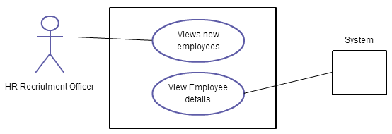

USE CASE 10: Edit Designation, CTC

- Primary user: HR Recruitment officer.
- Primary user action: Edit the designation and CTC.
- Associated users: NA.
- Input Criteria- Employee details is viewed.
- Output or success guarantee: Edit designation and CTC.
- Data requirement: Update employee table.

