Document Number: 1 | Copy Number: 1


ABC Company Pvt Ltd.
Hyderabad

ABC E-Recruitment System
User Manual Version 1.0
August 2014

PF3020
DOCUMENT RELEASE NOTICE
Notice No.
Client
Project | ABC E-Recruitment System
Document details

Name | Version No. | Description

Revision details:
Action taken  (add/del/chg) | Preceding  page No. | New  page No. | Revision  description

Change Register serial numbers covered:
The documents or revised pages are subject to document control.
Please keep them up-to-date using the release notices from the distributor of the document.
These are confidential documents. Unauthorised access or copying is prohibited.

Approved by : ________________________________ Date: _________

Authorised by: ________________________________ Date: _________

PF2060C
DOCUMENT REVISION LIST
Client
Project | ABC E-Recruitment System
Document Name
Release Notice Reference (for release)

Rev.  No. | Revision  date | Revision  description | Page  No. | Prev  page No. | Action  taken | Addenda/New page | Release  Notice reference

PREFACE

Purpose:

ABC E-Recruitment System enables employee on-boarding. BGC

Audience :

HR Recruitment Officer,Unit head,Employee,BGC Test Administrator.

Prerequisites :

The users must have a basic knowledge of using internet applications .

About this volume:

This volume (Volume I) is written to help the users understand and use the ABC E-Recruitment website. It contains the procedures that one must follow while using ABC E-Recruitment website to accomplish various tasks.

Organisation of the Manual:

The User Manual for the Joy Life Insurance website is contained in 2 volumes as follows:

Volume Number | Contents
I | Chapter 1 provides a brief introduction to the ABC E-Recruitment website. It also details the hardware and software requirements and the interfaces with other systems.  Chapter 2 takes you on a quick tour of ABC E-Recruitment website. It gives a brief introduction about the general working features of ABC E-Recruitment website that you should keep in mind while working.  Chapter 3 gives you a brief description regarding adding,approving,viewing the details of BGC Administrator and changing of default password by the users.  Chapter 4 gives you a brief description regarding creating,editing and displaying the background and compliance check scheduled.  Chapter 5 gives you a brief description regarding adding,viewing and editing the employee details.
II | Appendix A : This includes the various screen shots in order to exemplify website use.

Note: Since Chapters 1 and 2 contain general information about ABC E-Recruitment website, you should read these chapters before proceeding with specific task-related procedures explained in Chapters 3 to 5.

Table of Contents
Chapter 1 - INTRODUCTION 1
1.1Welcome to ABC E-Recruitment System 1
1.2ABC E-Recruitment Modules 1
1.2.1BGC Administrator Module 1
1.2.2BGC Updates Module 1
1.2.3Employee Details Module 1
1.3Software Environment 1
1.3.1Hardware Environment 1
1.3.2Network Environment 1
Logging on to ABC E-Recruitment website 1
1.4Before Opening ABC E-Recruitment website 1
1.4.1About the ABC E-Recruitment Set up Screen 1
1.5ABC E-Recruitment Components 1
Chapter 2 - a quick tour of ABC E-Recruitment 2
2.1Starting and Quitting ABC E-Recruitment 2
2.1.1Starting ABC E-Recruitment website 2
2.1.2Quitting ABC E-Recruitment website 2
2.2Menu Options 2
2.2.1Definition of Key Terms: 2
2.2.2Tools Bars and Tool Tips 3
Chapter 3 - BGC Administrator 1
3.1Home screen: 1
3.2Add BGC Test Administrator: 2
3.3Approve BGC Test Administrator 3
3.4View BGC Test Administrators 4
3.5Login / Change Default Password 5
3.5.1User Login 5
3.5.2Change default Password 5
Chapter 4 - BGC Updates 1
4.1Create Background and Compliance Check Ids 1
4.2Edit Background and Compliance Checks Scheduled 2
4.3 View Background and Compliance Checks Scheduled 3
Chapter 5 - Employee Details 1
5.1Add Employee Screen 1
5.2Employee ID generation screen 2
5.3View/Edit Employee screen 3

INTRODUCTION

Welcome to ABC E-Recruitment System
ABC E-Recruitment provides a comprehensive insurance solution for a wide variety of users, including professionals as well as common citizens.

ABC E-Recruitment Modules
Following are the modules of the ABC E-Recruitment website :

BGC Administrator Module
This module enables the HR recruitment officer to add,view the BGC test administrators and enables the Unit head to approve the BGC test administrators. It also enables the users to change their default password.

BGC Updates Module
In this module ,the HR recruitment officer schedules the BGC Check and BGC Administrator will edit and view the candidates BGC Test Status based on Vacancy ID,BGC Test Status,Test status.

Employee Details Module
In this module,the HR recruitment officer adds,edits and views the employee details of candidates who have cleared the Background check and Medical Tests.

Software Environment
- Internet Browser

Hardware Environment
- 256 MB RAM
- Windows XP or higher
- Intel Pentium 4 Processor

Network Environment
- Internet Access

Logging on to ABC E-Recruitment website

Before Opening ABC E-Recruitment website
A browser must be installed in the system. If the operating system is Windows, the default browser will be internet explorer. Other Operating systems should have any other browser example :Mozilla Firefox,Chrome,Safari,Opera

About the ABC E-Recruitment Set up Screen
The set up screen enables the user to login to the system. It allows users to proceed with user name and ID. It also allows new users to change their default passwords.

ABC E-Recruitment Components
- BGC Administrator
- BGC Updates
- Employee Details

a quick tour of ABC E-Recruitment

Starting and Quitting ABC E-Recruitment
In order to start ABC E-Recruitment website following steps should be followed:

Starting ABC E-Recruitment website
- Double click on the browser icon

- Type the the URL in the address bar of the browser
(www.abcrecuitment.com)

- Press Enter.

Quitting ABC E-Recruitment website
In order to quit the site just close the browser window

Menu Options
The Menu options are as follows:
- Home -to redirect to the home page
- About Us- to give a brief description regarding the organisation
- Contact Us - to provide contact information of the organisation

Definition of Key Terms:
Prerequisites of the customer:

CoverageAmount :
It is the basic amount reserved to meet the liabilities.

Term of Insurance :
It is the number of years for which the premium to be paid

PremiumAmount :
It is amount paid at the end of every negotiated period based on customer choice

Tools Bars and Tool Tips
Tool Tips are given to the user for ease of use .

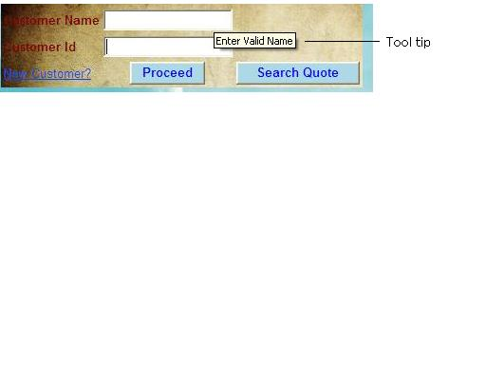

BGC Administrator

Home screen:
The home screen contains brief description about the E-Recruitment process. It has About Us, Contact Us and Login page. Users can login into the website using Login link.

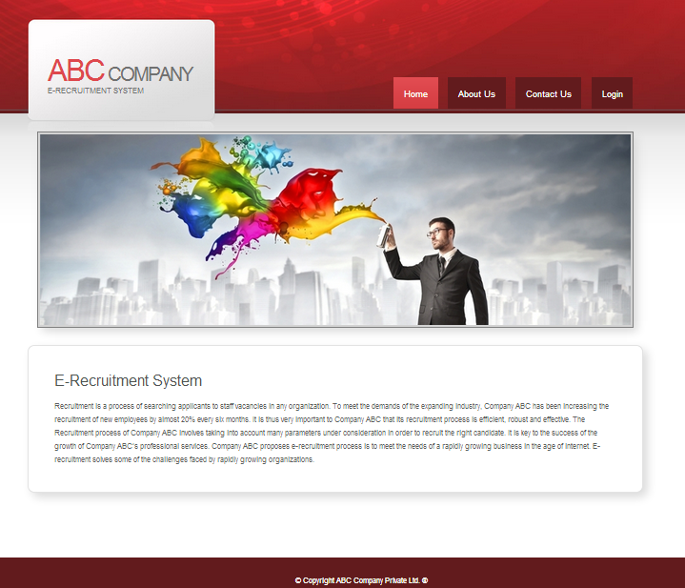

Add BGC Test Administrator:
HR Recruitment officer selects an employee from the drop down list and the employee is added as BGC Test Administrator with BGC status as pending.

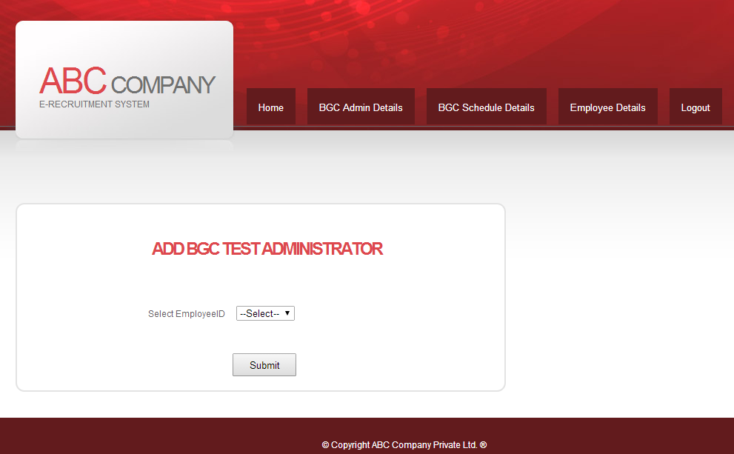

After the administrator is added, the BGCID of the Administrator is displayed in the alert window.

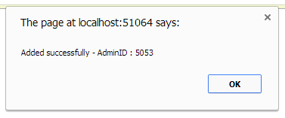

Approve BGC Test Administrator
Here the Unit Head can change the status of BGC Test Administrator. The status will be pending initially and it can be changed to approved/pending/On Leave by the unit head.

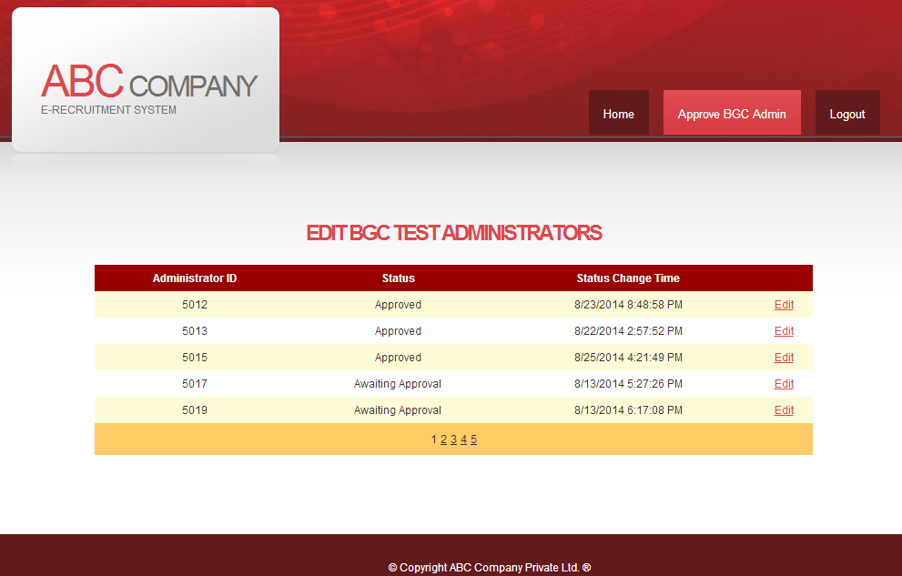

View BGC Test Administrators
Here HR Recruitment officer can view the BGC Test Administrators and their respective Status and last Status Change Time.

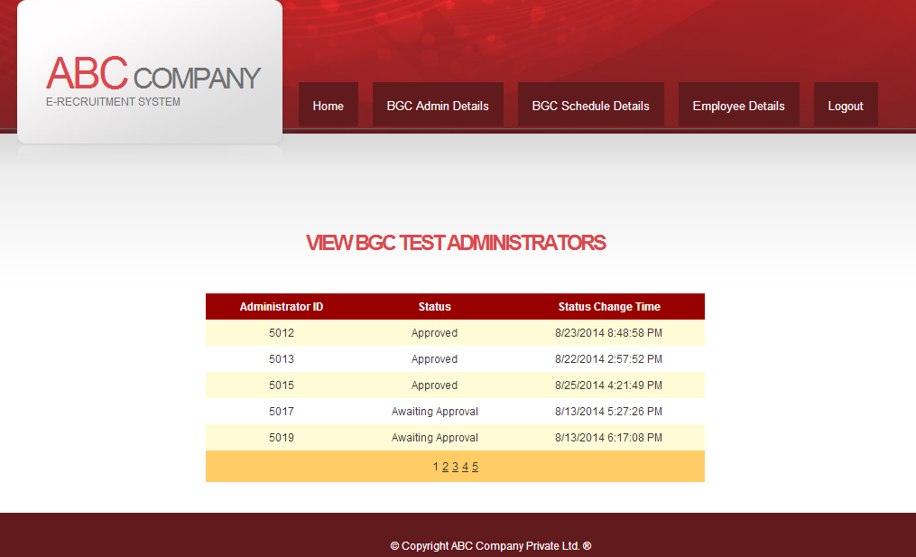

Login / Change Default Password

User Login
Existing user can login into the website using the Username and Password. The system will identify the user as either HR or BGC Administrator or Unit Head or Employee based on login credentials and will be redirected to corresponding home page.
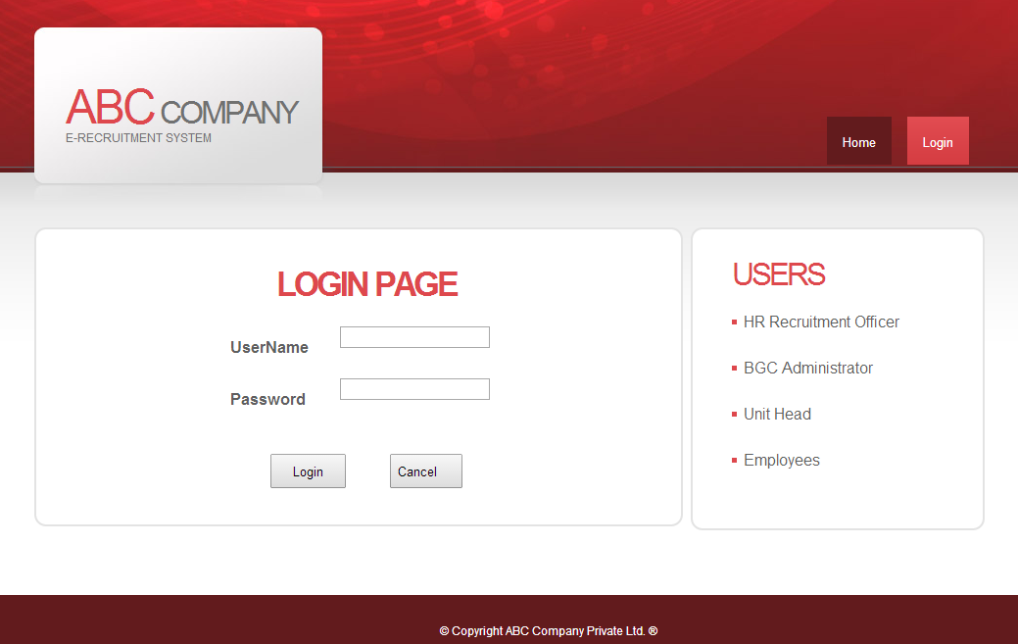

Change default Password

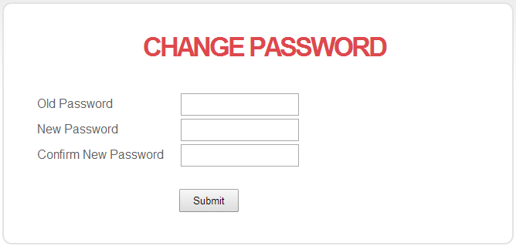
If the user is logging in for the first time with default password (tcshyd), then the user will be redirected to change password page to change the password.

BGC Updates

Create Background and Compliance Check Ids
HR Recruitment officer selects the administrator for conducting the BGC. If the status of BGC Administrator is approved then candidates BGC check is scheduled. He decides the start date,end date and the administrator for the BGC check.
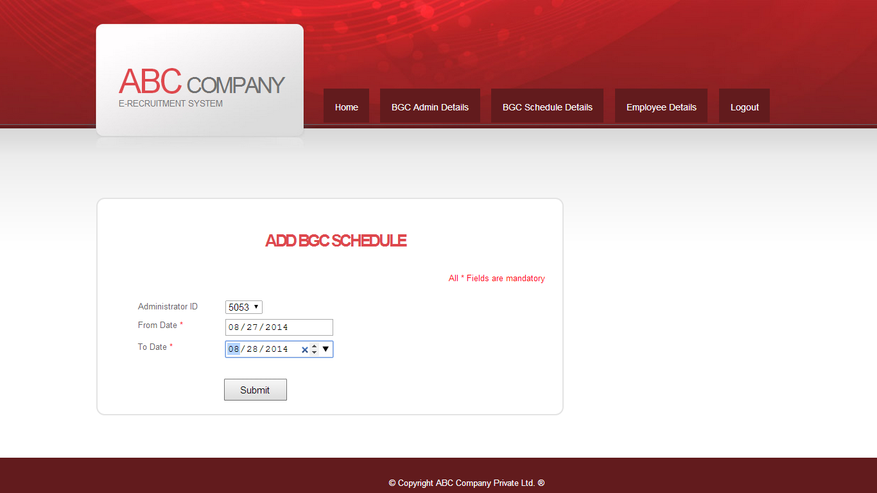

After clicking on submit the BGC Test Schedule is saved and BGC Id is generated.
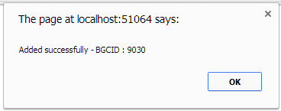

Edit Background and Compliance Checks Scheduled

BGC Administrator updates the BGC test status from pending to cleared, if the candidate had passed the BGC Check .

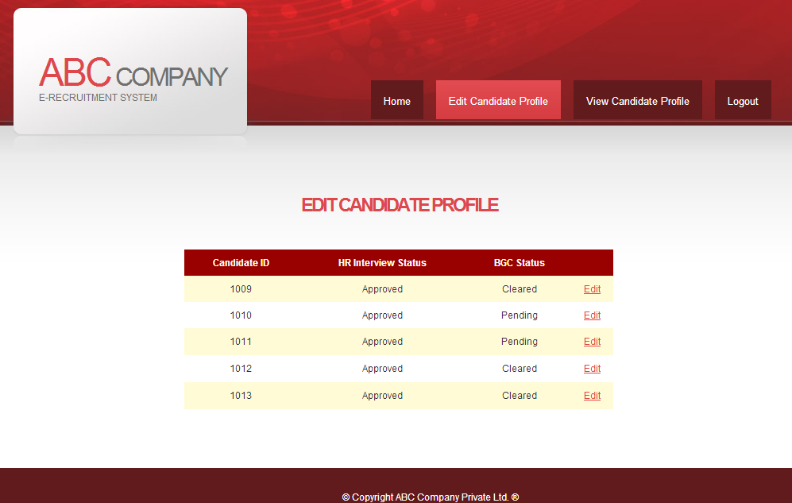

View Background and Compliance Checks Scheduled

HR Recruitment Officer views the Candidate details based on Vacancy ID,BGC Test Status and Test Status.
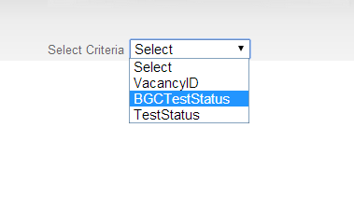

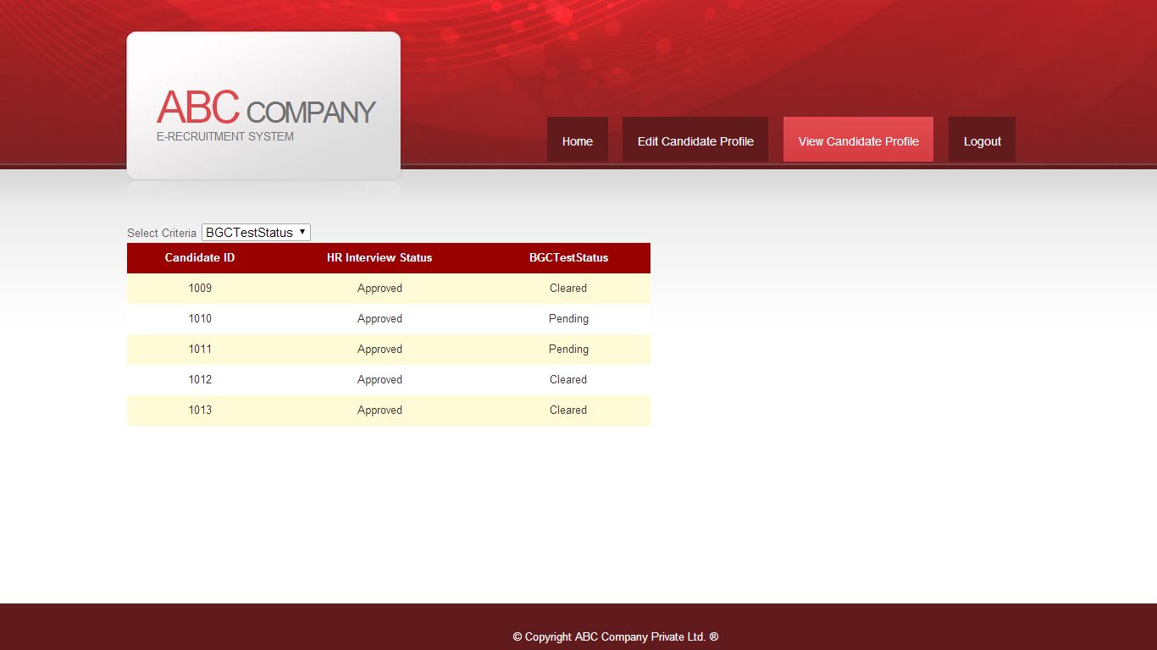

Employee Details

Add Employee Screen

All the employee who have cleared the interviews and BGC test are selected. They are added to the employee table by HR officer through Add Employee screen,where he/she is prompted to enter the details like Employee Name, DOB, DOJ, Division,Gender, CTC, Designation, Unit Head ID, Project ID.
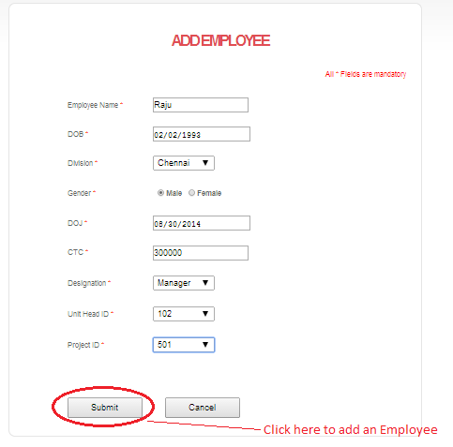
After providing all the necessary details, these are the possible actions a HR officer can do
- He/she can submit the details of an employee where an Employee ID is auto generated.
- He/she can cancel where the employee is not added and HR is redirected to the login screen.

Employee ID generation screen

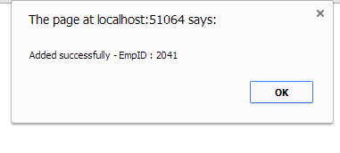
After the Employee ID is generated HR officer is redirected to Home screen.

There are many methods to cancel adding an employee ,these are the following methods

- HR officer can cancel just by closing the window by press of


- Just by press of Home in Menu option

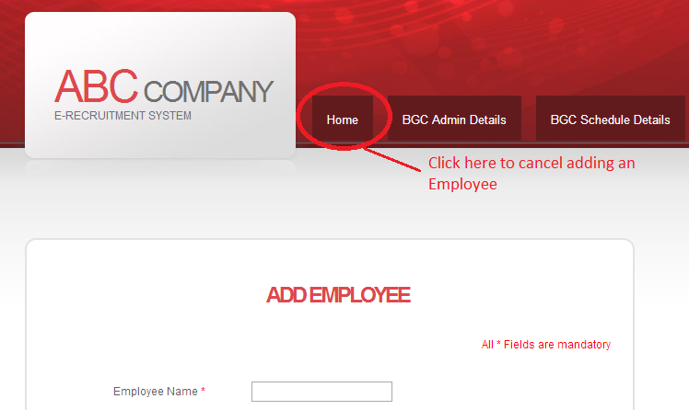

- On clicking the cancel button.

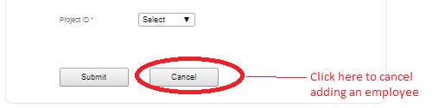

View/Edit Employee screen
These are the possible actions a HR officer can do
- He/she can view the details of all the employees.
- He/she can Update designation and CTC of a particular employee through the Edit option given on the screen.
- He/she can cancel editing the details through the Cancel option provided.

