5351 based VFO and BFO
SP Bhatnagar, VU2SPF (vu2spf.blogspot.com, vu2spf@gmail.com)
Bhavnagar, 364001 Gujarat, India

Introduction
Si 5351A came as a boon to amateurs as it provides upto 3 square wave outputs in a very tiny pack. Using the AD 9851 DDS some experiments were done with PIC and Arduino. It was decided to build a combined VFO and BFO generator using Si 5351A. A simple first hardwired prototype was made and is being used in a multibander Bitx. The first prototype used a 2 line LCD and had facility to change the frequency of BFO too. This feature was found to be very useful when using the same generator with different ransceivers, each having different needs. Results were encouraging and it was further improved with a 4 line LCD display showing few more information to help in operation. A 4X4 keypad was used to ease entry of numeric information.

Features
- Rotary dial and keypad for ease of operation
- 4 line display
- 4 VFOs for quick frequency hopping
- 30 Memory Channels
- Each VFO /Memory has its own settings for IF Offset, SSB Offset, BFO frequency, RIT setting and Side band.
- Quick selection of Ham Band using rotary dial.
- Direct frequency entry for VFO / BFO from Keypad.
- Last used settings stored and retreived on Power up.
- Each function active for 5 seconds, so no need to deselect.
- Displays VFO/MEM ch no, Ham Band, Side Band and RIT info on top line, Frequency of VFO and Step size on second line, Some messages on 3rd line and user inputs on 4th line.
- Toggle type PTT (press once to activate PTT, next press releases PTT), Tx displayed in 2nd line
- Outputs to control Band select relays and PTT relay.
- Short key press activate / deactivate some modes, long press to store information in memory.
- Change Side Bands from key pad.
- Can be used as signal generator or Broadcast band VFO (1 -30 MHz continuously variable)
- One spare oscillator available for future use.

Block & Circuit diagram

4X20 LCD Display

AVR
Si5351
4X4
Keypad
Encoder

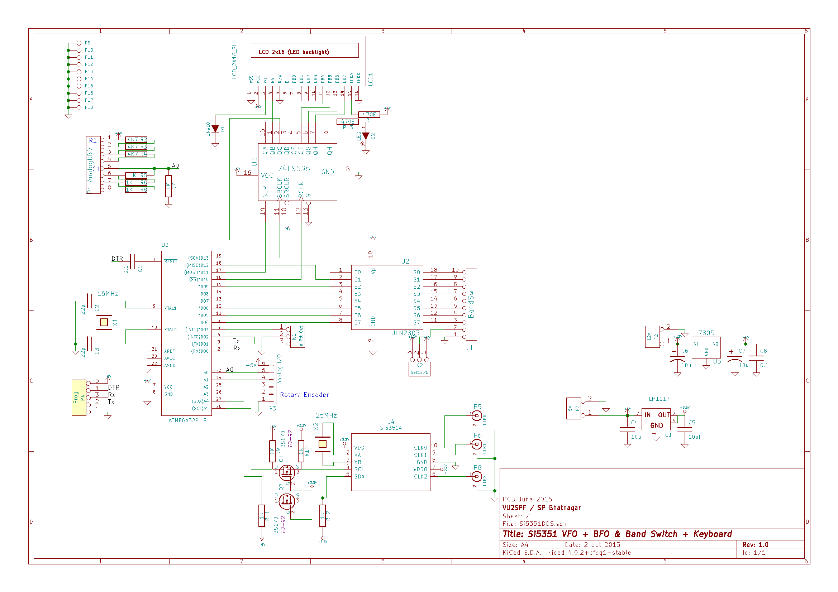
Circuit Description :
ATMEGA328-P is used for control. A LCD display is connected using shift register 74LS595 to save on the pins for I/O. ULN2803 driver is used to drive relays on the Band Pass and Low Pass filters of the transceiver. Si 5351 is interfaced using SCL/SDA lines where level conversion from 5V to 3.3V is achieved using BS170 Mosfets. The three clocks fom 5351 are available for VFO/BFO. Onboard regulators for 5V and 3.3 V are provided. The keypad is analog divider network type 16 key version and uses only one analog pin.

Program:
Program used to control all functions of this generator is available from vu2spf.github.com.
Note: This is not completely my original work. Freely available libraries are used for 595 shift register, encoder, 5351. Ideas from other hams and electronic enthusiasts are incorporated.

Operation

On Power up the last used station will be loaded. Using Keypad and Encoder various funcions can be selected. All information related to VFO, BFO, IF and SSB Offsets etc are stored on EEPROM for later retreival. Long pushes of related Keys are used to store these . Seleting a MEM channel or VFO will retreive the sored info.

Any function will be active for 5 seconds after selection from keypad. A ‘<<o>>’ indicates use of Rotary dial for adjustments. ‘#’ key works as Enter Key to terminate an Input from Keypad. ‘A’ is to Escape from some Keypad entry functions. * key is for setting -ve sign (where allowed).

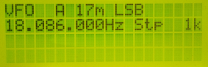
A typical startup screen. LSB on 17 m is intentional. VFO A is tuned to 17m LSB at 18.086MHz, frequency adjust step is 1k, for using rotary dial.

KEY 0: Enter Frequency directly using Keypad. Use a leading 0 if less than 10 Mhz. (eg 7.050 is entered as 07050#,( ‘#’ is the enter/terminator key, to cancel function press the “A” key )

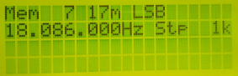
KEY 1: Toggle between VFO and MEM Modes. First line displays VFO selected or memory channel. Here memory channel 7 is selected.

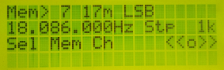
KEY 2: Select a MEM channel using encoder. Long Press (1.5 second ) will save the currently set parameters like VFO, BFO, RIT, Band, Sideband on MEMory channel selected. The ‘>’ and <<o>> are prompts for mem ch and rotary dial.

KEY 3: Select a Ham Band using rotary dial. A “Cont” band is for continuous tuning between 1 and 30 Mhz. Useful as a Signal Generator or for broadcast band reception.

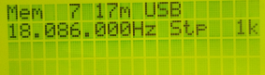

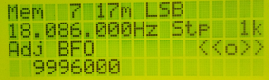

KEY 4: Select available sideband (USB/LSB for now). Long press KEY 4 to adjust BFO
frequency. First set step size (key 7) to adjust BFO freq.

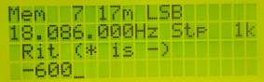
KEY 5: Enable / Disable RIT.

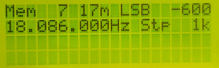
KEY 6: Set RIT Frequency using keypad. Use * key to enter – ve sign). (between +/- 1 Hz to +/- 1000 Hz)
Once the RIT is set, it can be activated with KEY 5. The RIT will be added to Tx freq.

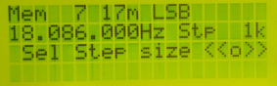
KEY 7: Choose Step Size for Tuning and adjustments (1Hz to 10MHz steps). Mainly used for VFO and BFO adjustments.

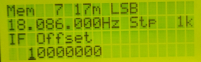
KEY 8: Enter IF from Keypad . Each MEM channel and VFO can be set to a different IF Offset (to use this VFO/BFO generator with different tranceivers). (A 10MHz crystal filter will have 10MHz IF). IF offset upto 25 MHZ can be entered.

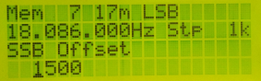
KEY 9: Set SSB Offset. Can be selected for each MEM and VFOs.( upto +/- 3 kHz).

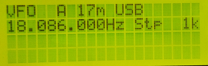
KEY A, B, C, D : Select VFO A or B or C or D (For quickly jumping between 4 saved stations) Long press will save all info for selected VFO.

PCB: A PCB is designed with Kicad, and is available from :
github.com/sprakashb/Si5351VFO-BFO-with-Keypad
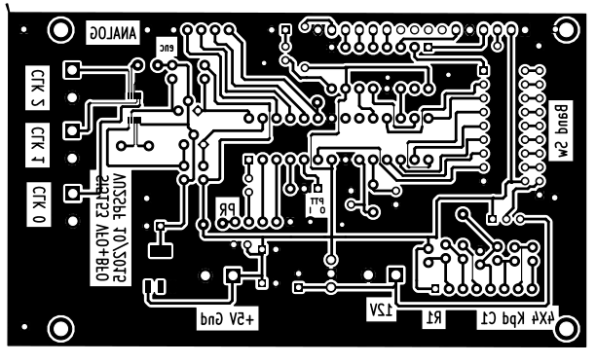
Efforts to improve the pcb are on. Please suggest improvements and corrections.

What more ?
Some more facilities like S-meter can be added if there is a in-built tap in transceiver using one of the free analog inputs. Suggestions are welcome to improve the functioning and operation.

CopyLeft: All Hams are encouraged to use this design and improve upon it and give the improved version back to the community. If you are using it for commercial purpose do it by all means, and if possible send me one piece as gift ;) .

https://github.com/sprakashb/Si5351VFO-BFO-with-Keypad
mail: vu2spf@gmail.com

