Chapter 4

Design and implementation

Section 4.1 – System description

Smart energy meter is basically based on the concept of INTERNET OF THINGS. In order to calculate the power consumed we need two parameters i.e. voltage and current.

To achive the same we did the following:

4.1.1 - Measuring the current

We used the current sensor (ACS712) to measure the current which is drawn by the load from the mains. The sensor calculates the current flowing through the circuit using the concept of Hall Effect i.e. when a current caring conductor is placed in the magnetic field, voltage is being generated across its edges. To which the ACS712 generates analog values so that the arduino can read them.

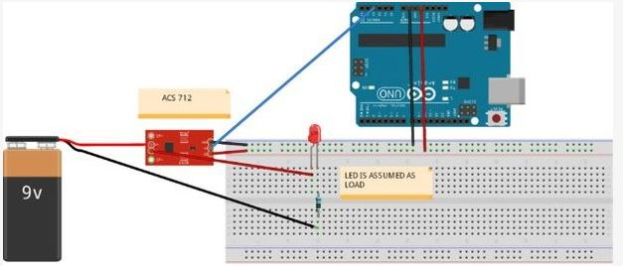

4.1.2 – Measuring the voltage

Voltage is measured by the help of a voltage divider circuit.As the ARDUINO analog pin input voltage is  
restricted to 5V I designed the voltage divider in such a way that the output voltage from it should be less than 5V.My battery used for storing the power from the solar panel is rated 6v, 5.5Ah.So I have to step down this 6.5v to a voltage lower than 5V.  
I used R1=10k and R2 =10K. The value of R1 and R2 can be lower one but the problem is that when resistance is low higher current flow through it as a result large amount of power (P = I^2R) dissipated in the form of heat. So different resistance value can be chosen but care should be taken to minimize the power loss across the resistance.

Vout=R2/(R1+R2)\*Vbat  
Vbat=6.5 when fully charged  
R1=10k and R2=10k  
Vout=10/(10+10)\*6.5=3.25v which is lower than 5v and suitable for ARDUINO analog pin

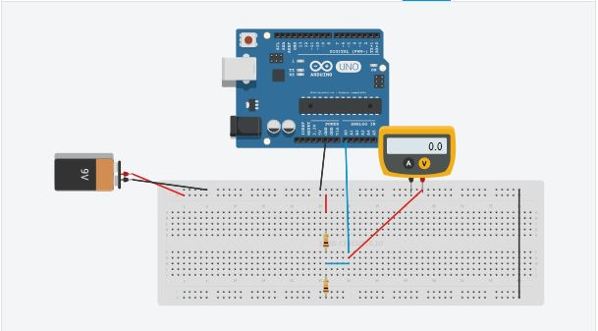

4.1.3 – The display unit

All the results can be visualized on the serial monitor and on the lcd display for easy viewing of the live data. We used a 16 X 2 character display.

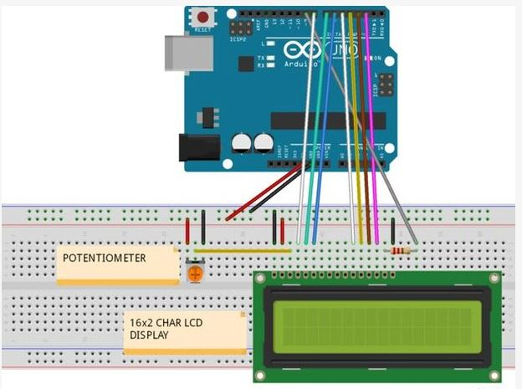

So after doing all the following steps we have calculated the power consumed by the load. Now we need to make this offline system online which can be done by connecting the following system to the internet. Hence we used raspberry pi to connect to the internet, so that the data can be made readily available to the user anywhere anytime. And also the fact that to implement the home automation features.

4.2 – Connecting to the internet

4.2.1 – Bridge connection between arduino and raspberry pi

For the data to me measured by arduino to be transferred to the internet firstly we need to transfer the data from the arduino to the raspberry pi which was made possible using the usb cable.

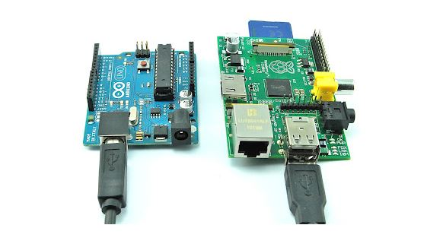

4.2.2 – Connecting pi to the internet

Now when we have got all the data on the pi from the arduino using serial port we need to transfer the data from the pi itself to the internet. So to do the same we have two methods i.e.

1. Via wifi module
2. Via lan cable

We used the raspberry pi 2, as it does not have a build in wifi module therefore we used the lan cable to establish a bridge connection on to the raspberry pi with pc which is connected to the internet via wifi.

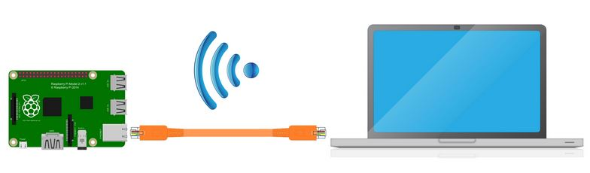

4.3 – logging of data on to the internet

Now we were supposed to log the data on to the internet for which we choose “THINK SPEAK”.

Which is an IOT analysis website, moreover it is open data IOT with data analysis powered by MATLAB. The website supports easy integration of the sensors so that data from the raspberry pi can be easily updated and plotted on the website with its easy to use functions.

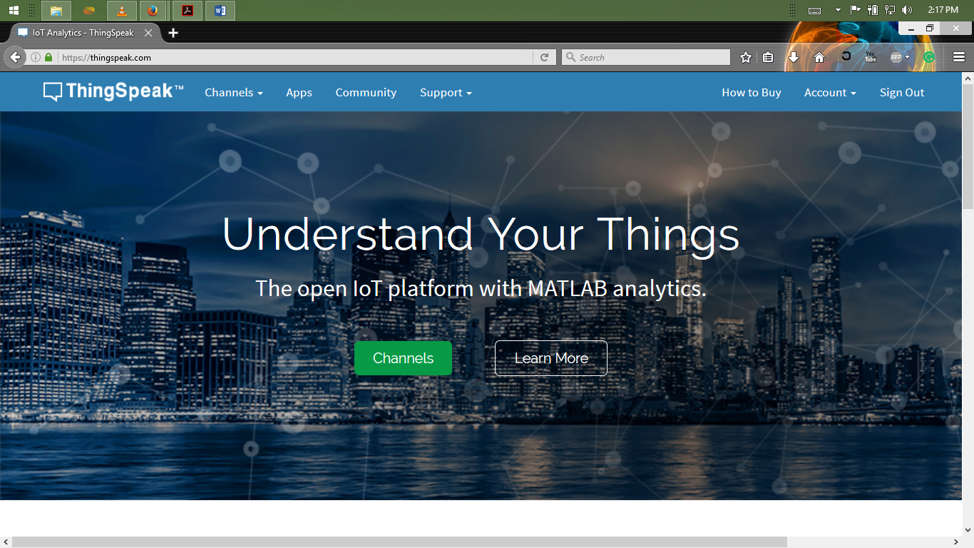

Now for the Home automation integration into the system we used the android app “CAYNNE DEVICES”

It is an extremely effective platform for IOT solution which packs a highly customizable dashboard and also an online dashboard.

