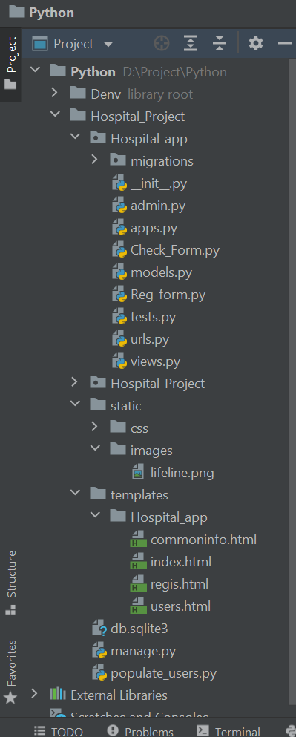

The Project

**Patient Management Application**

**(Screenshot’s)**

Prepared By:

**Prashant Singh | Technical Trainee, at TEKsystems Global Services Pvt. Ltd.**

**1.Home Page**

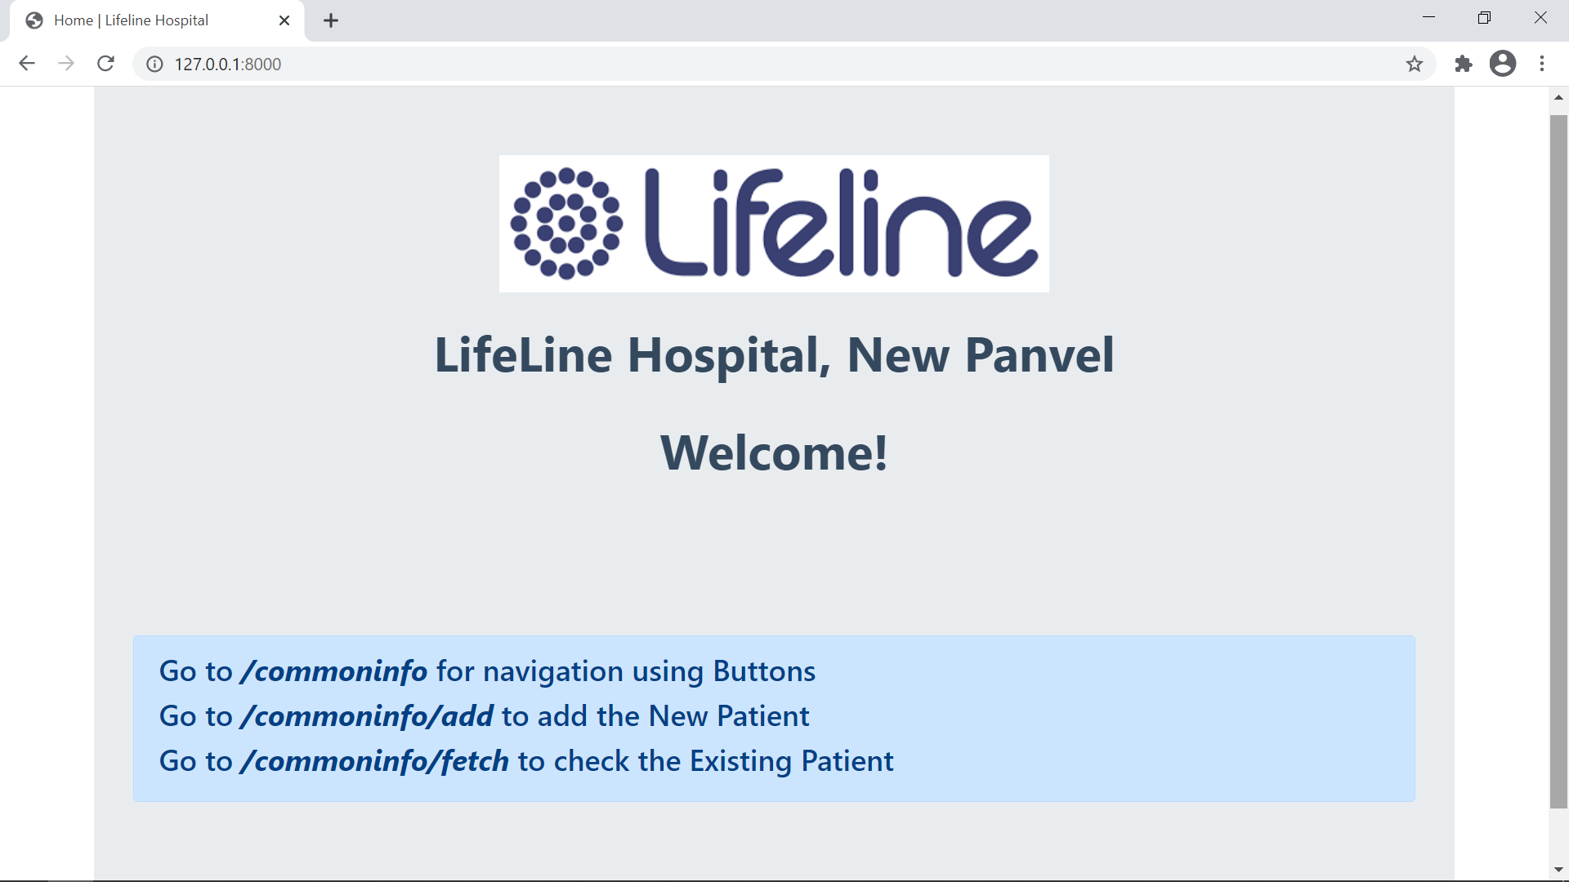

**2. 127.0.0.1:8000/commoninfo/**

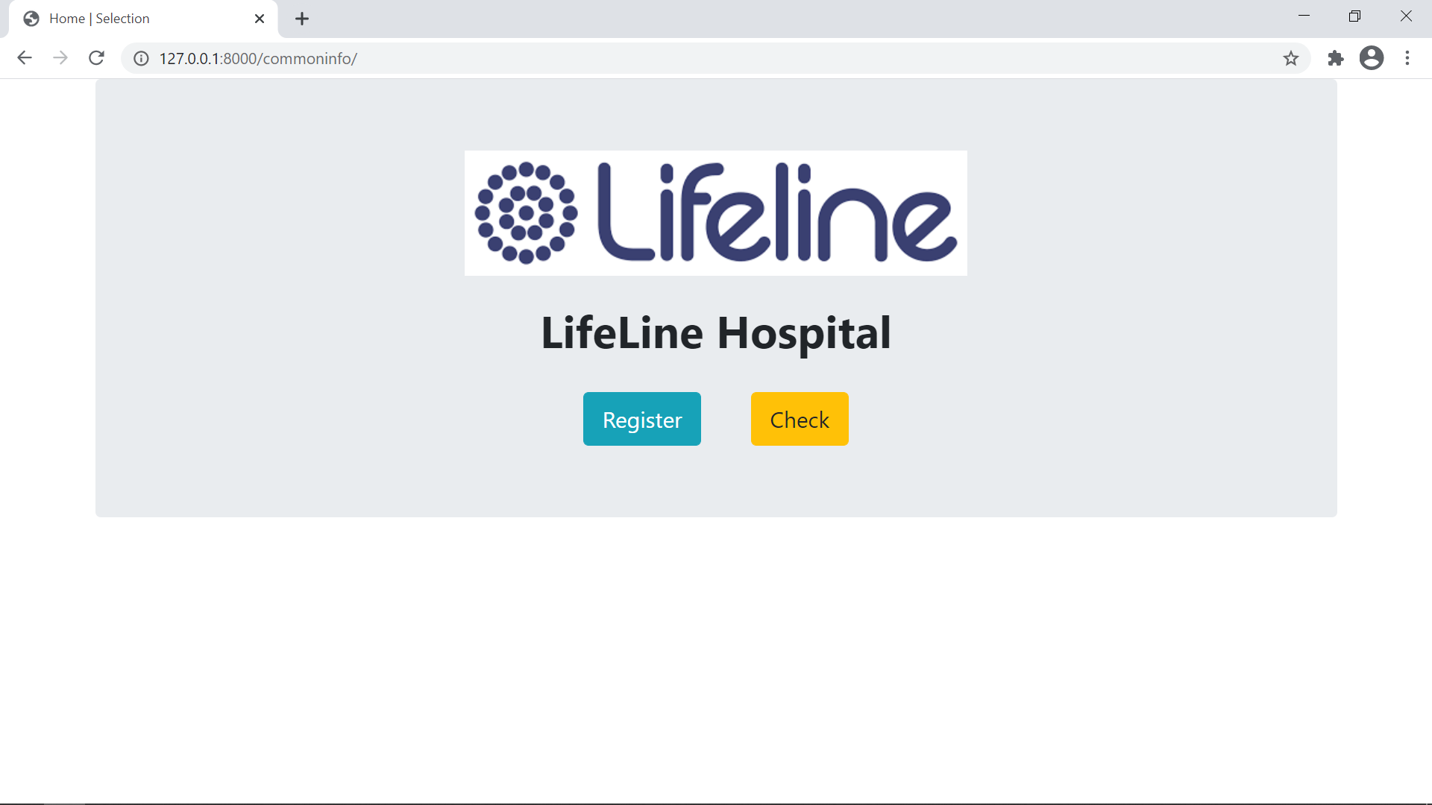

**3. 127.0.0.1:8000/commoninfo/add/**

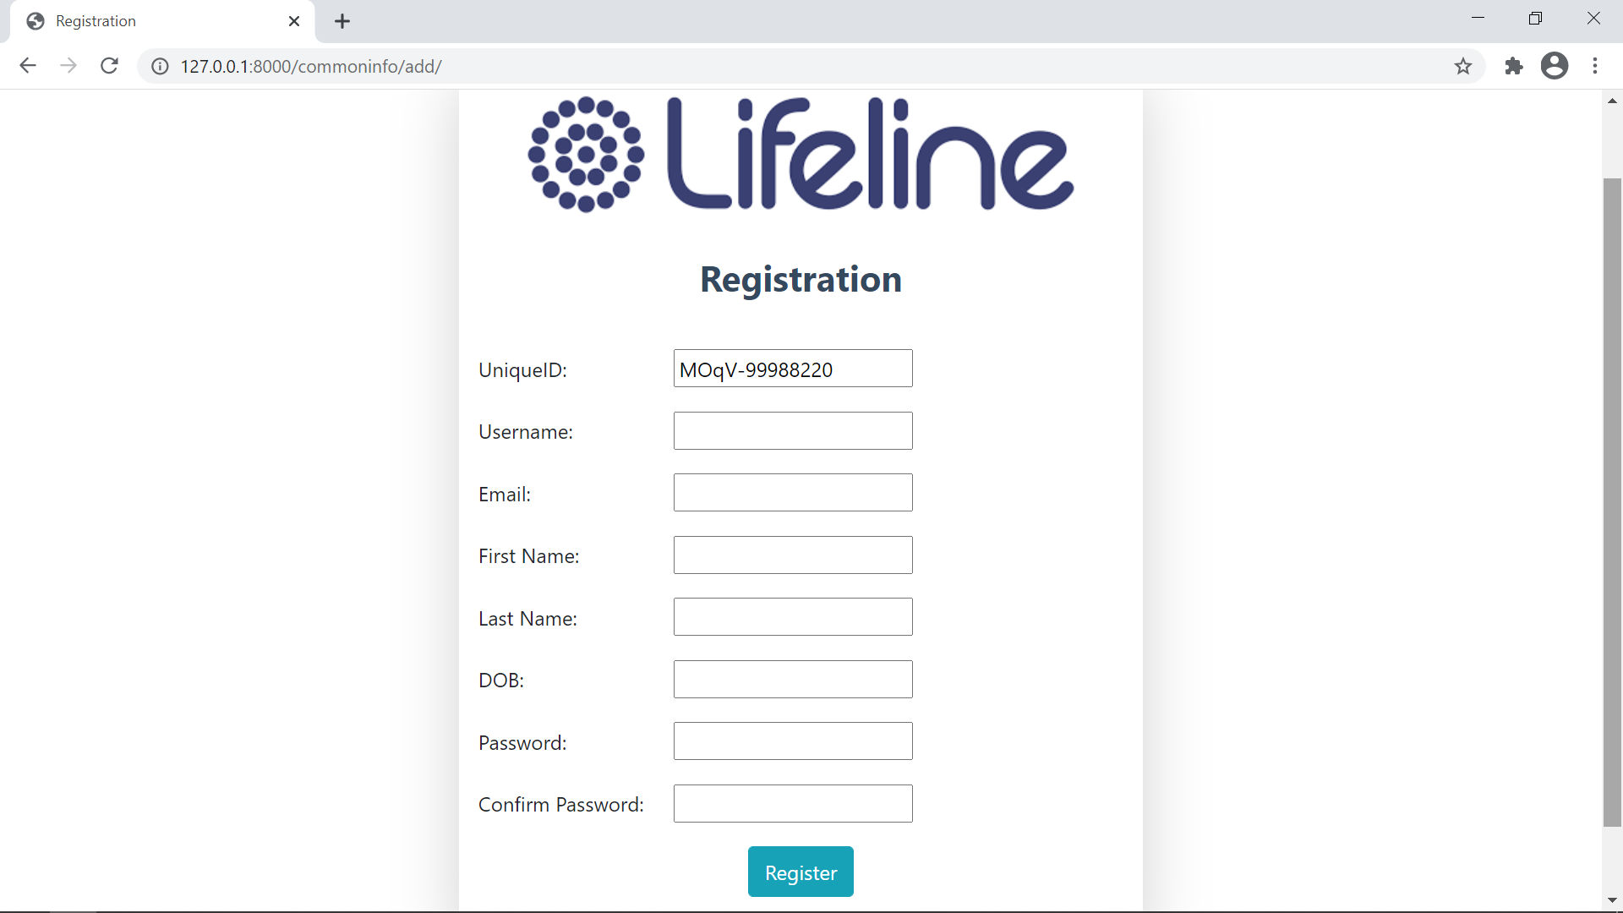

**4. 127.0.0.1:8000/commoninfo/add/ (Adding New Patient)**

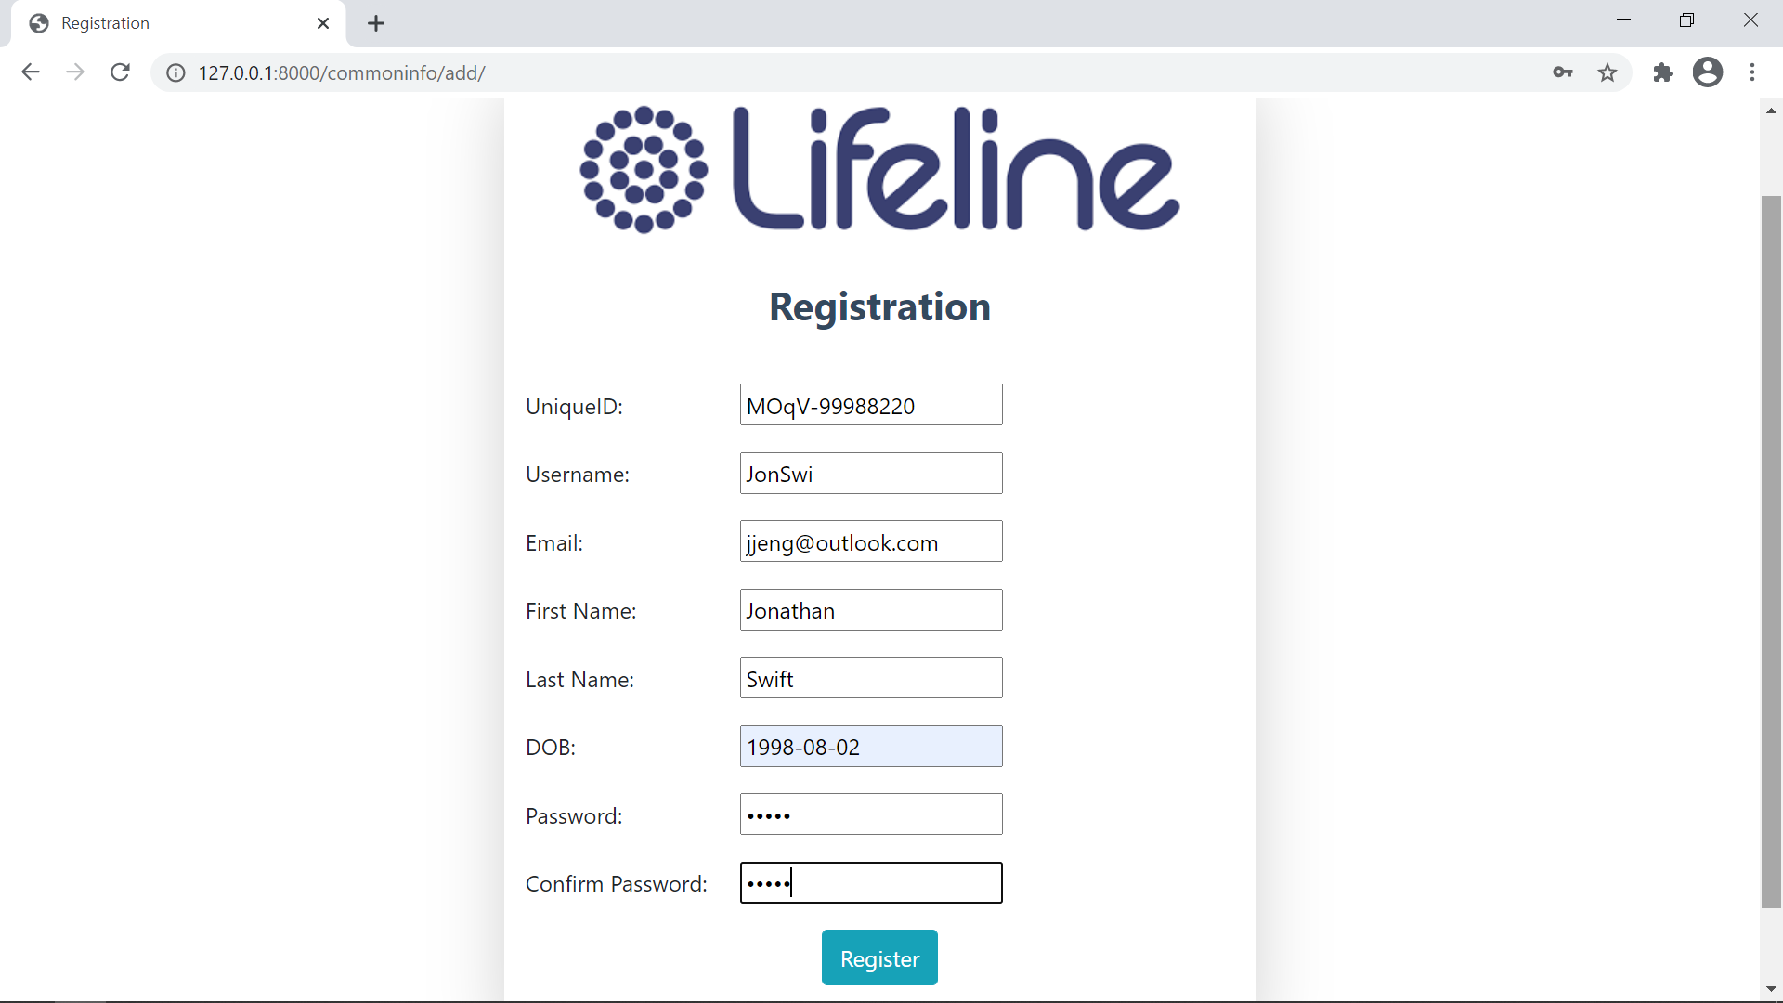

**5. 127.0.0.1:8000/commoninfo/add/ (Adding New Patient) - Validation**

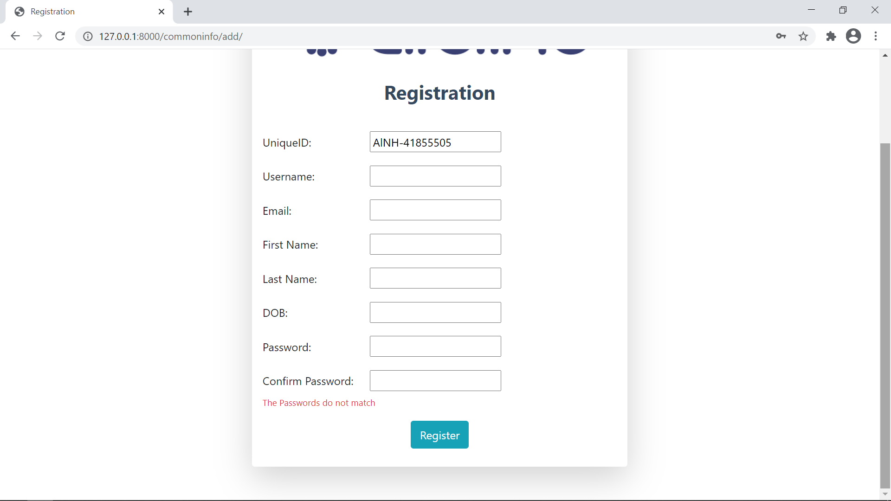

**6. On Successful Registration**

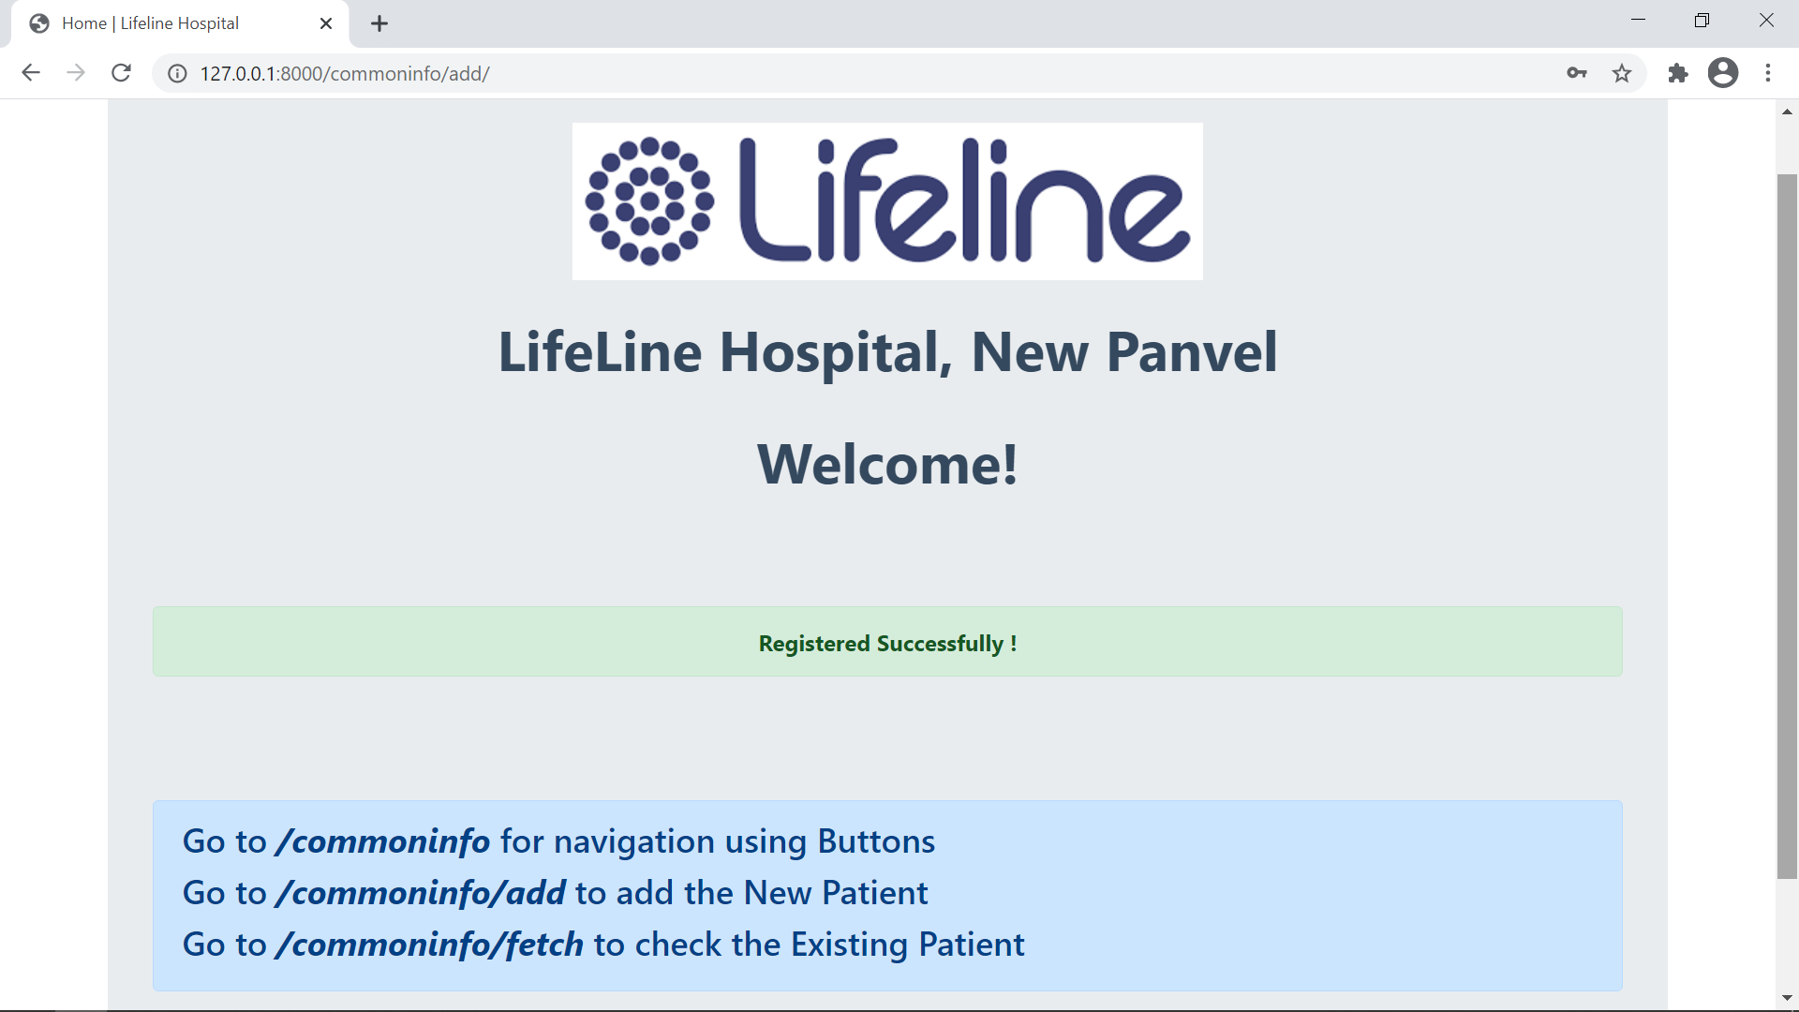

**7. 127.0.0.1:8000/commoninfo/fetch/ (Fetching the Details of Unregistered Patient )**

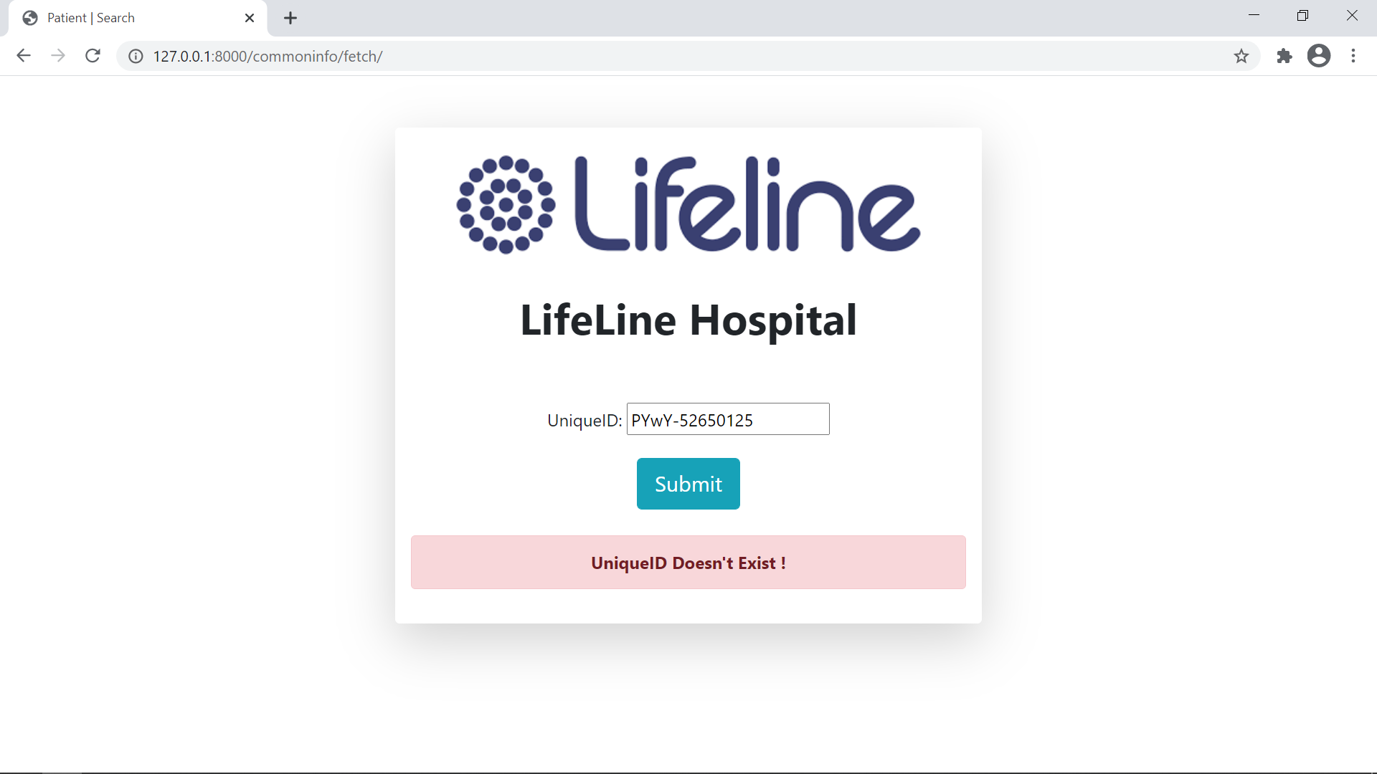

**8. 127.0.0.1:8000/commoninfo/fetch/ (Fetching the Details of Registered Patient )**

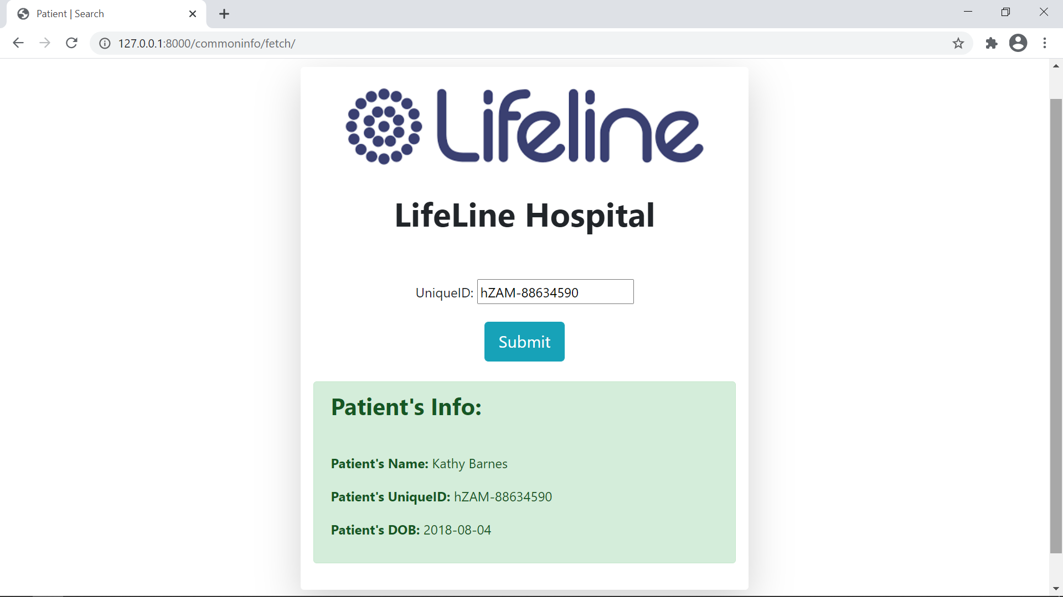

**9. 127.0.0.1:8000/admin/Hospital_app/userinfo**

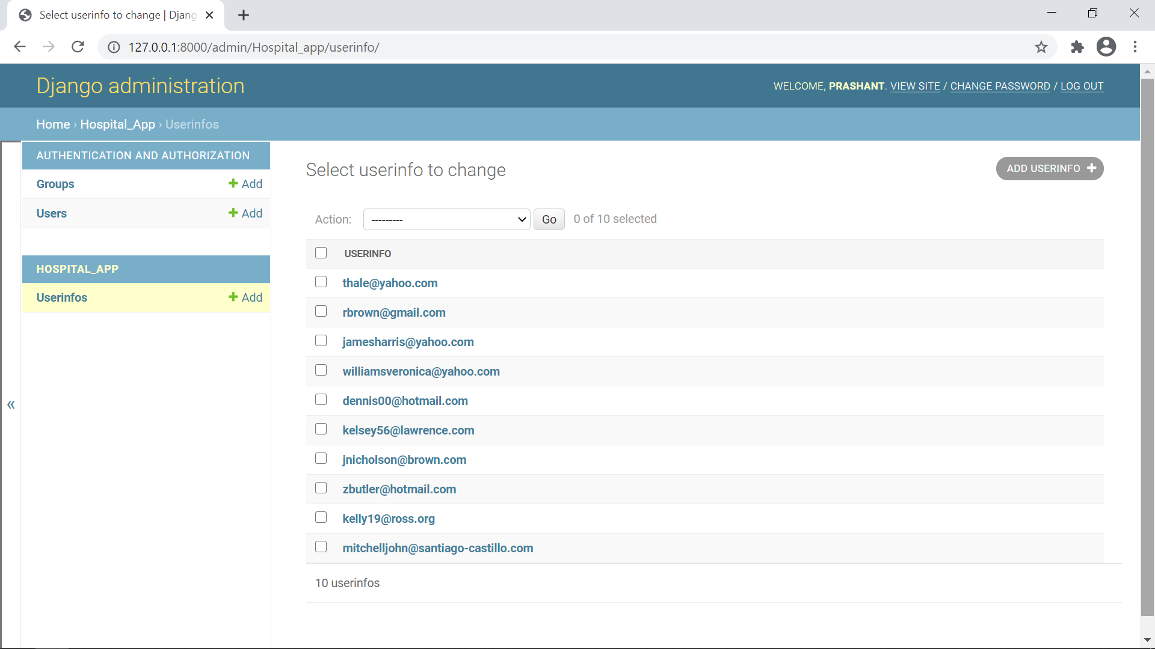

**10. 127.0.0.1:8000/admin/Hospital_app/userinfo/67/change/**

