



Xeria Innovations Inc.
Atlanta, GA 30303 | support@xeriainnovations.com

User Manual Work Instruction:
Smart Home Thermostat

2083
Version 1.2

Table of Contents

Introduction 3
Product Overview 4
1 - Safety Information 5
2 - Set-Up Instructions 5
3 - Operating Procedures 6
4 - Troubleshooting 6
5 - FAQs 7
Revision History 8

INTRODUCTION

Welcome to the Xeria Smart Home Thermostat User Manual!

This manual is designed to provide you with detailed instructions and guidance on the use and maintenance of the Xeria Smart Home Thermostat. Our goal is to ensure that you can fully utilize all the features and benefits of this innovative product, enhancing the comfort and efficiency of your home environment.

The Xeria Smart Home Thermostat is a state-of-the-art temperature control system that offers a range of smart features such as remote accessibility, automatic temperature adjustments, energy usage analytics, and compatibility with various smart home ecosystems. With its user-friendly interface and advanced functionalities, this thermostat is not just a tool for climate control but a gateway to a smarter, more efficient home.

Throughout this manual, you will find all the information you need to install, operate, and troubleshoot your Smart Home Thermostat. We have included step-by-step instructions, safety guidelines, maintenance tips, and much more to provide you with a comprehensive understanding of your new thermostat.

We at Xeria Innovations Inc. are committed to your satisfaction and are always available to support you with any questions or concerns regarding your product. Thank you for choosing Xeria Innovations, and we hope you enjoy the enhanced comfort and convenience offered by the Xeria Smart Home Thermostat.

PRODUCT OVERVIEW

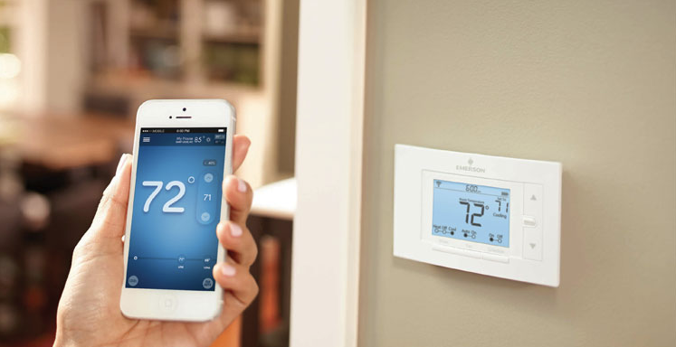

The Xeria Smart Home Thermostat is an advanced climate control solution that combines innovative technology with user-friendly design. This digital thermostat allows you to create a comfortable and energy-efficient environment in your home with ease and precision.

Key Features and Specifications

- Intelligent Temperature Control: Automatically adjusts the temperature based on your preferences, time of day, and weather conditions.
- Remote Accessibility: Control your home's temperature from anywhere using our mobile app, compatible with both iOS and Android devices.
- Energy Usage Analytics: Monitors and reports on your energy consumption, helping you understand your usage patterns and save on utility bills.
- Easy-to-Read Display: Features a clear, backlit LCD screen that shows temperature settings, current room temperature, and humidity levels.
- Wi-Fi Connectivity: Connects to your home network for regular firmware updates.
- Dimensions: 3.5 inches (H) x 5.0 inches (W) x 1.2 inches (D).

1 - SAFETY INFORMATION

1.1. Safety Warnings

- Installation should only be performed by a qualified electrician. Do not attempt to install the device if you are unfamiliar with household wiring.
- Use only the specified type of batteries for the backup power source. Improper use of batteries may lead to leaks or explosions.
- Do not open, disassemble, or modify the thermostat, as this could result in electric shock, fire, or damage to the device.
- Keep the thermostat away from water and extreme heat sources to prevent damage or malfunction.

1.2. Guidelines for Safe Usage

- Install the thermostat in a location free from direct sunlight, drafts, doorways, windows, and areas with significant temperature variation.
- Periodically clean the thermostat with a dry cloth. Do not use chemical cleaners or solvents.
- Regularly update the thermostat’s software via the mobile app to ensure optimal performance and security.
- In case of a malfunction, turn off the power to the thermostat at the circuit breaker and contact Xeria customer support.

2 - SET-UP INSTRUCTIONS

- Power Off: Turn off your home's electricity at the circuit breaker to ensure safety during installation.
- Remove Old Thermostat: Carefully remove your old thermostat, labeling wires as you detach them to track their functionality.
- Mount the New Thermostat: Position the Xeria Thermostat base plate against the wall, level it, and mark the screw holes. Drill holes (if necessary) and secure the base plate with screws provided.
- Connect the Wires: Attach the labeled wires to the corresponding terminals on the Xeria Thermostat.
- Attach the Thermostat: Click the thermostat display onto the mounted base plate.
- Initial Setup: Restore electricity at the circuit breaker. Follow the on-screen prompts to configure basic settings like language, Wi-Fi connection, and initial temperature preferences.

3 - OPERATING PROCEDURES

3.1. Basic Operations
- Adjusting Temperature: Use the up and down buttons on the thermostat or the mobile app to set your desired temperature.
- Setting Schedules: In the app, navigate to 'Schedules' to program temperature settings for different times and days.
- Using Voice Commands: Pair the thermostat with your smart home assistant and use voice commands for hands-free adjustments.

3.2. Optimal Usage Tips
- Location-Based Settings: Enable geo-fencing in the app for automatic adjustments when you're away from home.
- Energy Saving Mode: Utilize the energy-saving mode during periods when you're usually out to reduce costs.
- Regular Software Updates: Keep the thermostat’s firmware updated through the app for new features and improvements.

4 - TROUBLESHOOTING

Problem | Solution
Thermostat Not Turning On | Check if the circuit breaker is on and ensure the thermostat is properly mounted on the base. Verify the wiring connections.
Inaccurate Temperature Control | Ensure the thermostat is not in direct sunlight or near any heat sources. Calibrate the temperature sensors via the settings menu.
Wi-Fi Connectivity Problems | Reset your Wi-Fi router and reconnect the thermostat. If the issue persists, reset the thermostat to its factory settings and set it up again.

5 - FAQS

Question | Answer
Can I control the thermostat when I'm not at home? | Yes, you can control the thermostat remotely using the Xeria mobile app from anywhere with an internet connection.
Is the thermostat compatible with all types of heating and cooling systems? | The Xeria Thermostat is compatible with most HVAC systems. Please refer to the compatibility chart in the user manual for specific details.
How does the energy-saving mode work? | Energy-saving mode adjusts the temperature settings to reduce energy consumption when you're not at home or during non-peak hours.
Can I set different temperatures for different rooms? | The Xeria Thermostat controls the overall home temperature. For room-specific control, additional hardware like smart vents is required.
What should I do if I receive an error message on the thermostat? | Note the error code and consult the user manual for specific instructions. If the issue persists, contact Xeria customer support.
How often do I need to update the thermostat’s software? | Software updates are automatically pushed to your device when connected to Wi-Fi. Ensure your thermostat is always connected for the latest updates.

REVISION HISTORY

Version | Date | Changes Made
1.0 | 2082-01-15 | Initial creation of the manual
1.1 | 2082-03-10 | Updated safety protocols
1.2 | 2083-06-20 | Added FAQs section

