Article Title
Authors

Resumo - This text follows de DETUA Journal format. Its context is informative so you must remove it to use strictly the template styles. This part of the text must be in Portuguese while de rest of the article can be in Portuguese or English.

Abstract - Must be in English.

I. Introduction
......

II. Another heading (The 1ª letter is caps)
When you want to create a figure, you must align it to the center, insert a Frame in the selection figure+legend and select Format-Frame (top or bottom) in order to avoid figures in the middle of the page. Finally remove the Border.

A. This sub-title is of Style Heading 2
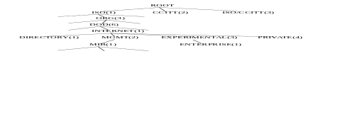
Fig. 1 - This is Style “legenda”.
To construct a item enumeration use the format “pontos”.
• bla-bla-bla;

To insert programs code or similar text just use the format “código” :

OBJECT-TYPE MACRO::=
BEGIN
TYPE NOTATION ::=
ReferPart
IndexPart
DefValPart
VALUE NOTATION ::= value (VALUE ObjectName)

References
Use the Style “referencia” to the references. Example:
[1] M. T. Rose and K. McCloghrie, "Structure and Identification of Management Information for TCP/IP-based Internets", RFC 1155, DDN Network Information Center, SRI International, May 1990.

This file is available by anonymous FTP in:
greco.inesca.pt: ~/pub/docs/dos/revdetua.doc
$ftp greco.inesca.pt
user: anonymous
passwd: <none>
cd pub/docs/dos
bin
get revdetua.doc
bye
$

Any comments to enhance this format can be send to jlo@inesca.pt.
This document was written in Word for Windows 2.0.

94.6.13 JLO

