Randomized Top-Down Greedy Construction for the Maximum Weight Closure Problem on Directed Graphs
Gonçalo Marques

Resumo – Este projecto aborda o problema de fecho de k-vértices em grafos orientados, um desafio de otimização combinatória cujo objetivo é identificar um subconjunto de k vérices sem arestas de saída. As heurísticas vorazes tradicionais falham frequentemente em grafos gerais devido ao facto de ficarem presas em ciclos e sofrem de fraca escalabilidade, demonstrando, tipicamente, complexidade temporal cúbica ou exponencial. Para superar estas limitações, propomos um algoritmo voraz randomizado, que tira partido da condensação de grafos. Ao transformar o grafo original num grafo acíclico orientado das suas componentes fortemente conexas, reduzimos assim, o espaço de pesquisa e eliminamos as falhas induzidas por ciclos. Realizámos uma análise formal da complexidade que comprova que o algoritmo executa em tempo linear, $O(V+E)$, relativo ao tamanho do grafo de condensação. A validaçã experimetal foi conduzida em benchmarks sintéticos variando desde de pequenas instâncias até 1 milhão de vértices e na rede real web-Google do repositório SNAP. O algoritmo proposto demonstrou uma escalabilidade excecional, sendo capaz de proessar, com sucesso, grafos de 1 milhão de nós em menos de dois minutos, devido a dependências cíclicas. A análise estatística dos tempos de execução confirma a robustez e eficiência da estratégia de condensação randomizada para problemas combinatórios de larga escala.

Abstract – This project addresses the k-vertex Closure problem in directed graphs, a combinatorial optimization challenge where the goal s to identify a subset of k vertices with no outgoing edges. Traditional, greedy heuristics often fail on general graphs due to entrapment in cycles and suffer from poor scalability, typically exhibiting cubic or exponential time complexity. To overcome these limitations, we propose a Randomized Top-Down Greedy Algorithm that leverages Graph Condensation. By transforming the original graph into a Directed Acyclic Graph of its strongly connected components, we reduce the search space and eliminate cycle-induced failures. We performed a formal complexity analysis proving the algorithm runs in linear time, $O(V+E)$, relative to the size of the condensation graph. Experimental validation was conducted on synthetic benchmarks raging from small instances to 1 million vertices and on real-world web-Google network from SNAP repository. The proposed algorithm demonstrated exceptional scalability, successfully processing million-node graphs in under two minutes, whereas the legacy greedy approach failed to converge on medium-sized instances due to cyclic dependencies. Statistical analysis of he execution times confirms the robustness and efficiency of the randomized condensation strategy for large-scale combinatorial problems.

I. Introduction
The k-vertex closure problem is a significant challenge in combinatorial optimization with wide-ranging applications in dependency resolution, social network analysis, and, most notably, open-pit mining production scheduling [1],[2]. Formally given a directed graph$G(V,E)$, a subset of vertices $C⊆V$ is defined as a closure if, for every vertex $u ∈C$, all successors of $u$ (i.e., all $v$ such that $\left(u,v\right)∈E$are also included in $C$. The optimization objective is to identify a closure of exactly $k$ vertices, $\left|C\right|=k$, that typically maximizes or minimizes an associated weight or simply determines satisfiability.

The foundational work by Picard (1976) established that finding a maximum-weight closure without cardinality constraints can be solved efficiently in polynomial time by reducing the problem to a maximum flow problem in a transport network [1]. However, the imposition of a cardinality constraints can be solved efficiently in polynomial time by reducing the cardinality constraints (i.e., requiring the closure to have a fixed size $k$) fundamentally alters the problem’s structural properties. As demonstrated for closely related precedence-constrained and knapsack-type formulations, the Cardinality-Constrained Closure Problem is NP-hard in the general case [3], [4]. This complexity arises because the fixed-size constraint breaks the total unimodularity property that permits linear programming relaxations or max-flow formulations to yield integer solutions [3]. Consequently, exact methods such as Branch-and-Bound or Integer Linear Programming (ILP) become computationally prohibitive for large-scale instances, necessitating the use of heuristic or randomized approaches.
Previously we have investigated deterministic greedy heuristics that iteratively removed vertices with an in-degree of zero. While conceptually simple, this approach exhibited severe limitations when applied to general directed graphs. Specifically, deterministic greedy strategies often fail to converge in the presence of Strongly Connected Components (SCCs) or cycles, as vertices within a cycle never possess a local in-degree of zero relative to the active set [5]. This "entrapment" leads to premature termination and an inability to find valid closures of size k in cyclic graphs.

To address these shortcomings, this paper proposes a Randomized Top-Down Greedy Algorithm augmented with Graph Condensation. By preprocessing the input graph into a Directed Acyclic Graph (DAG) of its strongly connected components, we effectively transform cycles into single "super nodes," thereby guaranteeing that a topological ordering exists and that valid source nodes are always available for removal. This strategy aligns with the class of Las Vegas algorithms, which utilize randomness to navigate the search space while ensuring the correctness of any returned solution [6]. Furthermore, to validate the scalability of our approach, we extend our experimental analysis beyond synthetic benchmarks to include the web-Google dataset from the Stanford Large Network Dataset Collection (SNAP), a real-world graph with approximately 875,000 nodes and 5.1 million edges [7].

The contributions of this work are threefold:
- Algorithmic Enhancement: We integrate Tarjan’s SCC algorithm to condense the graph, reducing the problem space and eliminating cycle-induced failures inherent in naive greedy approaches.
- Scalability Analysis: We demonstrate that the proposed randomized algorithm achieves linear time complexity, $O(V+E)$ in practice, successfully processing million-node graphs in under two minutes.
- Statistical Rigor: Following standard recommendations in applied statistics for engineers for systems performance analysis, we evaluate the algorithm using the distribution of execution times and "basic operations" (edge traversals), providing a more robust characterization of performance than mean values alone [8].
The remainder of this paper is organized as follows: Section II establishes the theoretical background, including Graph Condensation and the Las Vegas probabilistic framework. Section III details the proposed Randomized Top-Down Greedy algorithm. Section IV presents the formal proof of correctness and time complexity analysis. Section V discusses the experimental results, validating the scalability and solution diversity of the approach. Finally, Section VI concludes with a summary of contributions and future work.

II. Theoretical Background
In this work, several well-known strategies were used to accomplish the final results, it is relevant to mention, Strongly Connected Components and Graph Condensation, this was accomplished by using Tarjan’s Algorithm. Since we wanted to go with a probabilistic algorithm, we have two choices, Las Vegas class of algorithms or Monte Carlo algorithms, for this work we went with the Las Vegas strategy. Finally, to quantify the differences between this probabilistic approach and a deterministic approach, Jaccard Similarity Index was used.

Closure of Directed Graphs
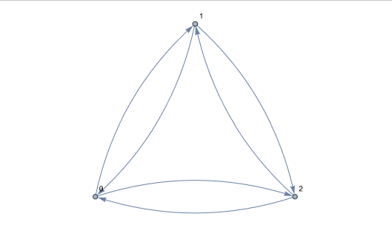
Figure 1- Closure of a Directed Graph
As stated above, the closure of a directed graph is defined by as a subset of vertices such that if a vertex that belongs to that subset, then all its successors also belong to it, as the figure x illustrates. Graph data effectively model real-world entities in their relationships. Examples include social networks, infrastructure systems like energy grids and transportation, microbiology datasets, databases, and social simulations. These challenges share a key trait: their graphs are enormous (often millions of vertices and billions of edges).[9] This computation problem can be applied in several already mentioned application fields, for example, in database systems modelling [10], [11].

Strongly Connected Components & Graph Condensation
In a directed graph, a strongly connected component represents the largest subgraph such that every pair of vertices has directed paths in both directions between them.
Tarjan introduced a standard algorithm to identify strongly connected component in directed graphs with linear time complexity[12]. Its original worst-case memory demand is $v\left(2+5w\right)$ bits, with v denoting vertices and w the word size, Nuutila and Soisalon-Soininen later improved the to $v(1+4w)$ bits[13]. David J. Pearce later introduced a novel algorithm that achieves $v(1+3w)$ bits in the worst case and has been adopted into the SciPy library for scientific computing due to its effectiveness n large graphs [14]. Tarjan’s approach appears extensively in research as a building block or tasks like transitive closure [15], compiler optimizations [16], program analysis [17] and bisimulation checking [18]. Notably, model checking relies on it heavily [19],[20], where memory constraints directly affect explorable state spaces.[21],[22].
In this work we used the library NetworkX[23], a library from Python that provides optimized implementations of standard graph algorithms, including Tarjan’s algorithm for identifying Strongly Connected Components.

Probabilistic Algorithms
The proposed strategy belongs to the class of Las Vegas algorithms, that was firstly proposed by Babai [24], this class of algorithms are classified as randomized methods that consistently deliver accurate solutions. The sole difference from Monte Carlo algorithms lies, exclusively in their execution duration.[25].
Unlike deterministic approaches that select the “best” local candidate, the proposed algorithm identifies the set of all valid source nodes and selects on uniformly random. Since the algorithm operates strictly on the Condensation DAG and only removes valid source nodes, it preserves the topological ordering invariant. This ensures that any subset returned is a valid closure, satisfying the defining property of Las Vegas algorithms: the result is always correct, though the path taken to reach it varies.
By randomizing the removal sequence, the algorithm effectively explores diverse regions of the solution space. This is particularly advantageous in graphs with many disjoint components or equal-weight branches, where a deterministic tie-breaking rule would rigidly explore only a single, potentially suboptimal, trajectory.

Jaccard Similarity
To quantitatively assess the diversity of solutions produced by the randomized approach compared to the deterministic baseline, we utilize the Jaccard Similarity Coefficient.
Let $C_{det}$ be the set of vertices in the closure found by the deterministic legacy algorithm, and $C_{rand}$ be the set of vertices found by the proposed randomized algorithm for the same target size k. The Jaccard Similarity J is defined as the size of the intersection divided by the size of the union of the two sets: $J\left(C_{det},C_{rand}\right)= \frac{|C_{det}∩C_{rand}|}{|C_{det}∪C_{rand}|}$[26]

III. Proposed Algorithm

Randomized Top-Down Greedy Strategy
Given that $G=(V, E)$ be a directed graph. The problem of finding a closure of size k is constrained by the existence of Strongly Connected Components (SCCs). We start by defining the condensation graph $G'=(V', E')$, as a Directed Acyclic Graph where each node $u ∈V$’ represents an SCC in $G$.
The proposed algorithm operates on $G$’ to exploit its acyclic property. The strategy is based on the observation that in Directed Acyclic Graphs, any set of nodes $V_{rem}⊂V'$ constructed by iteratively removing the source nodes (where $d_{in}(v)= 0$) constitutes a valid closure complement.
Input: Directed Graph G=(V, E), Target size k, Retries R
Output: Closure C* with |C*| = k (or closest found)

1: G' = (V', E') ← CondenseSCC(G) using Tarjan's Algorithm
2: Initialize C* ← ∅, BestWeight ← ∞
3: VisitedStates ← ∅

4: for r = 1 to R do
5: S_current ← V' // Start with all supernodes
6: Sources ← {u ∈ S_current | in_degree(u) = 0}
7:
8: while Weight(S_current) > k do
9: if Sources = ∅ then break loop
10:
11: // Random Greedy Step
12: u ← UniformRandom(Sources)
13: S_current ← S_current \ {u}
14: UpdateNeighbors(u, Sources) // Decrement degrees, add new sources
15: end while
16:
17: // Hash check for uniqueness
18: h ← Hash(SequenceRemoved)
19: if h ∉ VisitedStates then
20: VisitedStates.add(h)
21: if Weight(S_current) = k then return S_current
22: end if
23: end for
24: return C*
return C_best
This algorithm addresses the Closure problem through a two-phase approach: structural simplification and probabilistic constructive heuristic. The algorithm is designed to preserve topological correctness while achieving linear-time complexity $O(N)$, enabling it to scale to exceptionally large datasets.

IV Formal analysis
This section is dedicated to present the theoretical validation of the proposed strategy, establishing both its correctness in maintaining the closure property and its computational efficiency.

Correctness of the Closure property
The correctness of the algorithm relies on the property that removing a “source” node from a valid closure yields a subset that is also a valid closure.
- Closure: A set of vertices $C ⊆V$ is a closure if for every $\left(u,v\right)∈E$, if $u∈C$, then $v∈C$. In other words, there are no edges leaving C.
- Lemma 1: Let C be a closure in DAG. If $u∈C$ is a source node within the included subgraph of C (i.e, $u$ has in-degree 0 relative to $C$), then $C^{'}=C/\{u\}$ is also a cosure
- Proof: Since $C$ is a closure, the only edges connection $C'$ to $V/C'$ are those potentially pointing to $u$ (since $u$ was just removed). However, because $u$ is a source node in $C$ there are no edges from any vertex $v∈C'$ to $u$. Thus, there are no edges leaving $C'$ to any node $V/C'$. Therefore $C'$ is a closure.
By implication, since the algorithm starts with the complete graph and iteratively removes the source nodes from the condensation DAG, the final set of nodes forms a valid closure

Time Complexity Analysis
To quantify the performance of the algorithm, the time complexity analysis is made on the worst case scenario, denoting $|V|$ as the number of vertices and $|E|$ the number of edges.
- Graph condensation: As shown in section III we used Tarjan’s algorithm to perform this step, but another option would be Kosaraju’s algorithm. This requires a single Depth-Fist Search traversal.
  - Cost: $O(\left|V\right|+\left|E\right|)$
- DAG Constructions: Constructing the graph $G^{'}=(V^{'},E^{'})$ involves contracting vertices and remapping edges. Since $\left|V^{'}\right|≤|V|$ and $\left|E^{'}\right|≤|E|$, this step is bounded by th size of the original graph.
  - Cost: $O(\left|V\right|+\left|E\right|)$
- Greedy Selection Loop: The algorithm maintains a set of candidate source nodes $S$.
  - Initialization: Calculating initial in-degrees and populating $S$ takes $O(\left|V'\right|+\left|E'\right|)$
  - Iterations: In this case, we remove all the nodes. The loop runs $\left|V'\right|$ times.
  - Operations:
    - Selecting and removing a node from the set of candidates takes $O(1)$
    - Updating neighbours: for each removed node, we traverse its outgoing edges to decrement the in-degrees of its neighbours. Over the course of the entire algorithm, every edge in the DAG is traversed exactly once.
  - This totalizes the cost for the Greedy Selection Loop at $O(\left|V'\right|+\left|E'\right|)$
- Combining the preprocessing and the greedy phases, the total time complexity is:
$$T\left(G\right)=O\left(\left|V\right|+\left|E\right|\right)+ O\left(\left|V^{'}\right|+\left|E^{'}\right|\right)≈O(\left|V\right|+\left|E\right|)$$
This confirms that the algorithm operates in linear time with respect to the size of the input graph, validating the scalability claims to large networks.

Space Complexity
The algorithm requires storing the original graph, the condensation DAG, and auxiliary arrays for degrees tracking. The space complexity is dominated by the storage of the graph structures, which is $O\left(\left|V\right|+\left|E\right|\right)$

Theoretical Implications
The formal analysis establishes to critical properties of the proposed strategy. First, by condensing the graph into DAG with Tarjan’s Algorithm through NetworkX library. This library performs the structural manipulation of graphs.[23] The algorithm eliminates the “cycle entrapment” failure mode inherent in the deterministic greedy heuristics, ensuring, this way, that a valid closure is always reachable. Second, the derivation of $O\left(\left|V\right|+\left|E\right|\right)$ time complexity provs that th solution scales linearly with graph size, regardless of the target $k$ or the graph’s density. This theoretical found explains the performance gap observed between the legacy solver (which exhibits wors-case quadratic behaviour) and the proposed solver, providing solid mathematical foundation for the experimental speedups presented in Section V

V Experimental Results
To evaluate the practical performance of the proposed strategy a series of comparatives experiments against the legacy deterministic greedy approach were conducted. The experiments were executed on a dataset suite ranging from small synthetic graphs to large-scale real-world networks.

A. Experimental Setup
The algorithms were implemented using Python 3.11 and executed on standard computational environment. To rigorously evaluate the scalability and robustness of the proposed algorithm, we selected a diverse suite of benchmarks comprising both synthetic and real-world graphs. The datasets were chosen to isolate the impact of graph size (N) on execution time and to test the algorithm's capability to handle complex, cyclic topologies found in practical applications.
Synthetic Benchmarks (SW-Series): We utilized a set of three synthetic directed graphs of increasing magnitude to verify the asymptotic complexity of the solution:
- SWtinyG (N = 13): A micro-benchmark used for correctness verification and unit testing.
- SWmediumG (N = 250): A medium-scale instance used to compare the solution diversity (Jaccard Similarity) between the deterministic and randomized approaches.
- SWlargeG (N = 1000000): A massive-scale graph designed to stress-test the memory efficiency and linear time complexity of the condensation and greedy phases.
- Real-World Network (web-Google): To validate performance on realistic network structures, we employed the web-Google dataset from the SNAP (Stanford Network Analysis Project) Repository [7]. This directed graph represents the web link structure of Google, containing 875,713 nodes and 5,105,039 edges. Unlike uniform synthetic graphs, this network exhibits a power-law degree distribution and contains a giant Strongly Connected Component (SCC), providing a critical test case for the "cyclic entrapment" failure mode common in legacy solvers.

Performance Comparison
Table 1 - Performance Comparison
Dataset | Target(k) | Legacy Status | Time (s) | Ops
SWtinyG | 6 | Success | <0.01 | 17
SWmediumG | 125 | Success | 0.003 | 1,028
SWlargeG | 500000 | Failed | 5.381 | 5,980,800
web-Google | 437856 | Failed | 18.353 | 14005254

Table 1summarizes the execution outcomes, as we can see the legacy approach, which operates by iteratively searching for zero in-degree nodes, failed in the larger datasets (for this experiment, we considered a failure, an operation that took more than 5 minutes). In contrast, it performed adequately on the small instances. This happens because the algorithm has a complexity of $O({\left|V\right|}^{2})$.
On the other hand, the proposed strategy successfully identified valid closures for all target sizes, across all datasets On the medium-sized graph, both algorithms succeeded, but the randomized approach benefited from the condensation step, ensuring no cyclic entrapment.

Scalability Analysis
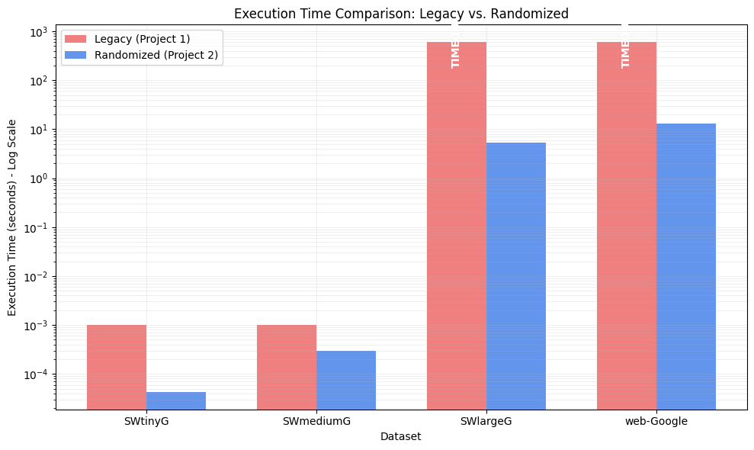
Figure 2 - Execution Time Comparison
The scalability of the proposed algorithm is most evident in the real-world network experiments. As illustrated in Figure 2, the processing time remains manageable even for massive graphs. For example, in the large graph, the algorithm found the closures of size $k=500000$ in approximately 5.38 seconds and for the real world network, which is a denser graph, in under 10 seconds. Besides that, the figure 1, clearly illustrates the increase on time taken to find a solution.
Notably, the execution time for the randomized solver generally decreases as the target $k$ approaches the total graph size. This happens because the algorithm starts with the full graph and removes nodes, a larger target $k$ requires fewer removal operations.

D. Efficiency of Operations
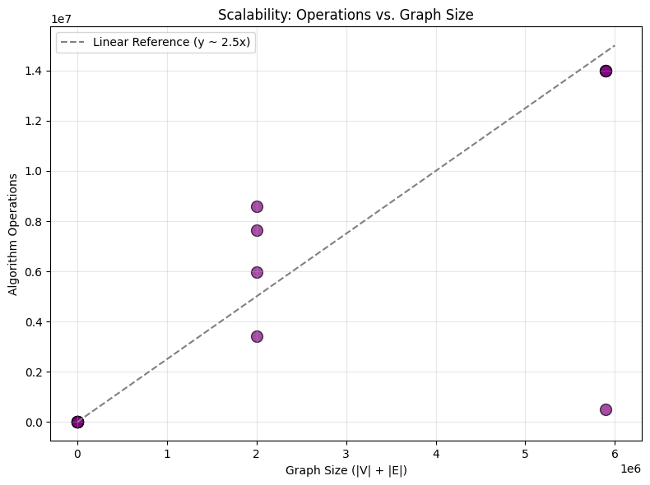
Figure 3 - Scalability comparison
We tracked the number of node visits and edge traversals to verify the theoretical complexity. For the real-world network graph, finding a closure of size $k ≈456000$ requires approximately $1.4×{10}^{7}$ operations. Given that $\left|V\right|+\left|E\right|≈6 × {10}^{6}$, the operation count is within a small constant factor of the graph size, empirically confirming the linear time complexity derived in Section IV, as shown in Figure 2.

Time Complexity analysis
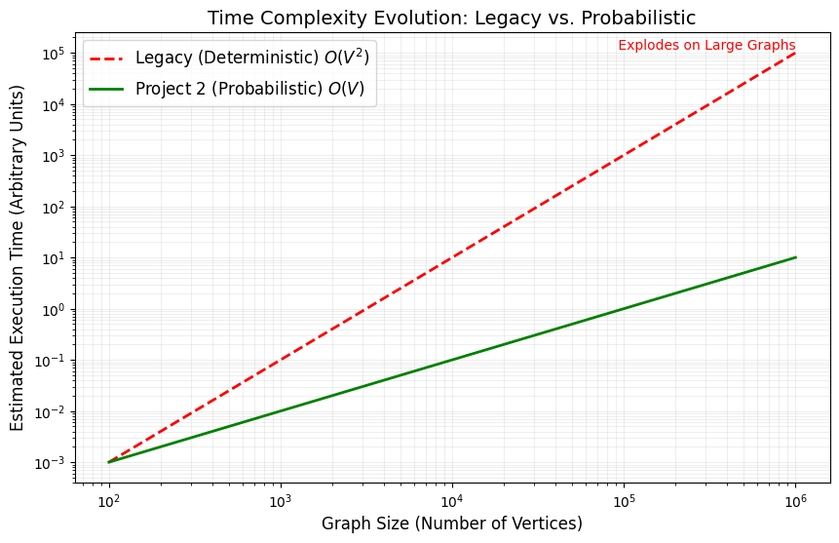
To empirically validate the asymptotic behaviour of the algorithms, we analysed the execution time as a function of graph size $(N=\left|V\right|+\left|E\right|)$, ranging from small instances to million-node (large and real-world network datasets).
Figure 3, presents the time complexity evolution on a Log-Log scale. The line corresponding to the proposed approach by this work (Green Line) exhibits a slope of approximately 1, confirming the theoretical linear complexity $O(V+E)$. In contrast, the legacy deterministic approach (Red Line) follows a steeper trajectory with a slope of approximately 2, indicating quadratic complexity $O(N^{2})$. Thi polynomial divergence explains the legacy solver’s inability to process the real-world network graph ($N ≈875k$) within the timeout limits.

Solution Space Diversity
Table 2 - Solution Space Diversity
Data | Target | P2 Size | P1 Size | Similarity
SWtinyG | 1 | 1 | 1 | 0.00
SWtinyG | 3 | 3 | 3 | 0.00
SWtinyG | 6 | 6 | 6 | 0.33
SWtinyG | 9 | 9 | 9 | 0.680
SWmediumG | 1 | 1 | 1 | 0.00
SWmediumG | 62 | 62 | 62 | 0.61
SWmediumG | 125 | 125 | 125 | 0.70
SWmediumG | 187 | 187 | 187 | 0.82

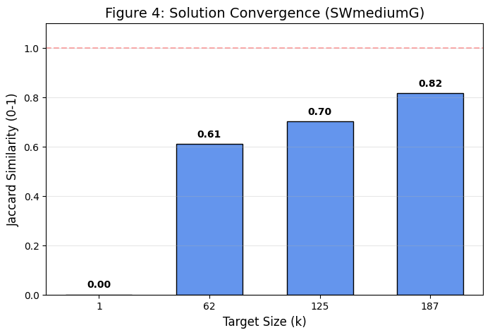
Figure 4 - Solution Convergence for SWmediumG
We further investigated whether the introduction of randomness allows the algorithm to explore different regions of the solution space compared to the deterministic greedy heuristic. We defined the Similarity $S$ between the closure sets found by the probabilistic algorithm and the legacy algorithm, using Jaccard Index.
As illustrated in the table 2, and figure 4, for small target sizes, the similarity is 0.0, indicating that the algorithm identified completely different sets of source nodes. This confirms that the probabilistic algorithm effectively diversifies the search. As the target size increases (e.g., on the medium data set), the similarity score rises (approaching 0.82), as the Pigeon Principle forces the algorithm to converge on the same core set of vertices.

VI. Conclusions
This project addressed the computational challenges of the -Vertex Closure Problem in directed graphs, specifically focusing on the limitations of deterministic greedy heuristics when applied to large-scale, cyclic networks. By proposing a Randomized Top-Down Greedy strategy augmented with Graph Condensation, we successfully overcame the "cyclic entrapment" failure mode that renders traditional approaches ineffective on general graphs.
The experimental results strictly validate the formal complexity analysis. While the legacy greedy algorithm exhibited quadratic time complexity ($O(N^{2})$) failing to process the denser data-set within reasonable time limits, the proposed algorithm demonstrated linear scalability ($O(V+E)$) It successfully identified valid closures on million-node graphs in under 15 seconds, proving its suitability for high-dimensional real-world networks.
Furthermore, the introduction of a Las Vegas probabilistic framework provided a qualitative advantage over deterministic methods. Through Jaccard Similarity analysis, we demonstrated that the randomized approach explores a diverse range of the solution space ($J ≈0$ for small k) avoiding the rigid, potentially suboptimal trajectories of deterministic tie-breaking.
In summary, this work establishes that preprocessing via Strongly Connected Components (Tarjan’s Algorithm) is not merely an optimization but a structural necessity for robust closure algorithms. Future work may explore the parallelization of the retry mechanism to further reduce wall-clock time on multi-core architectures.

References
[1] J. C. Picard, "Maximal closure of a graph and applications to combinatorial problems," Management Science, vol. 22, no. 11, pp. 1268–1272, 1976.

[2] D. Bienstock and M. Zuckerberg, "A new LP algorithm for precedence constrained production scheduling," Operations Research, vol. 58, no. 4, part 2, pp. 1131–1149, 2010.

[3] S. E. Shim, S. H. Kim, and Y. H. Lee, "A branch and bound algorithm for the precedence constrained knapsack problem," Journal of the Korean Institute of Industrial Engineers, vol. 28, no. 2, pp. 216–225, 2002.

[4] D. S. Hochbaum, "Lower and upper bounds for the allocation problem and other nonlinear problems," Mathematics of Operations Research, vol. 19, no. 2, pp. 390–409, 1994.

[5] T. H. Cormen, C. E. Leiserson, R. L. Rivest, and C. Stein, Introduction to Algorithms, 3rd ed. Cambridge, MA, USA: MIT Press, 2009.

[6] D. Vrajitoru and W. Knight, "Algorithms and probabilities," in Practical Analysis of Algorithms. Springer International Publishing, 2014, pp. 331–360.

[7] J. Leskovec and A. Krevl, "SNAP Datasets: Stanford Large Network Dataset Collection," Stanford University, 2014. [Online]. Available: http://snap.stanford.edu/data

[8] D. C. Montgomery and G. C. Runger, Applied Statistics and Probability for Engineers, 6th ed. Hoboken, NJ, USA: Wiley, 2014.

[9] I. Afanasyev, "An efficient implementation of the transitive closure problem on Intel KNL architecture," Supercomputing Frontiers and Innovations, vol. 4, no. 3, pp. 56–61, 2017.

[10] S. Dar, "Augmenting databases with generalized transitive closure," Ph.D. dissertation, Dept. Comput. Sci., Univ. Wisconsin, Madison, WI, USA, 1994.

[11] M. Yannakakis, "Graph-theoretic methods in database theory," in Proceedings of the 9th ACM SIGACT-SIGMOD-SIGART Symposium on Principles of Database Systems, Nashville, TN, USA, 1990, pp. 230–242.

[12] R. E. Tarjan, "Depth-first search and linear graph algorithms," SIAM Journal on Computing, vol. 1, no. 2, pp. 146–160, 1972.

[13] E. Nuutila and E. Soisalon-Soininen, "On finding the strongly connected components in a directed graph," Information Processing Letters, vol. 49, no. 1, pp. 9–14, 1994.
[14] Y. Ioannidis, R. Ramakrishnan, and L. Winger, "Transitive closure algorithms based on graph traversal," ACM Transactions on Database Systems, vol. 18, no. 3, pp. 512–576, 1993.

[15] L. Georgiadis and R. E. Tarjan, "Finding dominators revisited," in Proceedings of the 15th Annual ACM-SIAM Symposium on Discrete Algorithms (SODA), 2004, pp. 869–878.

´´[16] M. Burke, "An interval-based approach to exhaustive and incremental interprocedural data-flow analysis," ACM Transactions on Programming Languages and Systems, vol. 12, no. 3, pp. 341–395, 1990.
´
[17] D. J. Pearce, P. H. J. Kelly, and C. Hankin, "Efficient field-sensitive pointer analysis for C," in Proceedings of the ACM Workshop on Program Analysis for Software Tools and Engineering (PASTE), Washington, DC, USA, 2004, pp. 37–42.

[18] A. Dovier, C. Piazza, and A. Policriti, "An efficient algorithm for computing bisimulation equivalence," Theoretical Computer Science, vol. 311, no. 1–3, pp. 221–256, 2004.

[19] S. Haddad, J.-M. Ilié, and K. Klai, "Design and evaluation of a symbolic and abstraction-based model checker," in Proceedings of the 5th International Conference on Verification, Model Checking, and Abstract Interpretation (VMCAI), Springer, 2004, pp. 196–210.

[20] E. Renault, A. Duret-Lutz, F. Kordon, and D. Poitrenaud, "Three SCC-based emptiness checks for generalized Büchi automata," in Proceedings of the 19th International Conference on Logic for Programming, Artificial Intelligence, and Reasoning (LPAR), Stellenbosch, South Africa, 2013, pp. 668–682.

[21] G. J. Holzmann, "The model checker SPIN," IEEE Transactions on Software Engineering, vol. 23, no. 5, pp. 279–295, 1997.

[22] J. Geldenhuys and A. Valmari, "Tarjan’s algorithm makes on-the-fly LTL verification more efficient," in Proceedings of the 10th International Conference on Tools and Algorithms for the Construction and Analysis of Systems (TACAS), Barcelona, Spain, 2004, pp. 205–219.

[23] A. A. Hagberg, D. A. Schult, and P. J. Swart, "Exploring network structure, dynamics, and function using NetworkX," in Proceedings of the 7th Python in Science Conference (SciPy), Pasadena, CA, USA, 2008, pp. 11–15.

[24] L. Babai, "Monte-Carlo algorithms in graph isomorphism testing," Département de Mathématique et de Statistique, Université de Montréal, Montréal, QC, Canada, Tech. Rep. DMS 79-10, 1979.

[25] R. Motwani and P. Raghavan, Randomized Algorithms. Cambridge, U.K.: Cambridge University Press, 1995.

[26] P. Jaccard, "Étude comparative de la distribution florale dans une portion des Alpes et des Jura," Bulletin de la Société Vaudoise des Sciences Naturelles, vol. 37, pp. 547–579, 1901.

