Indian Media Bias & Sentiment Dashboard
BYOP Capstone Project Report

Fundamentals in AI and ML | CSA2001
VIT Bhopal University | Batch 2029
Registration No: 25BCE10530
March 2026

1. Introduction
India has one of the largest and most diverse media ecosystems in the world, with hundreds of national and regional news outlets publishing content in over twenty languages. But diversity does not always mean balance. Over the past decade, the line between editorial reporting and ideological advocacy has blurred significantly across Indian media. Outlets on both the right and left of the political spectrum have been documented running narratively consistent coverage that aligns with their editorial positions, often framing the same event in completely different ways.
This project was born out of a straightforward question: if I search for a topic in the news, how differently is it being covered depending on which side of the political spectrum I am reading from? And can that difference be measured and visualized in a way that is accessible to anyone?
The Indian Media Bias and Sentiment Dashboard is my attempt to answer that question. It is a real-time web application that pulls live headlines from ten major Indian news outlets, runs automated sentiment analysis on each article, and presents the results through an interactive dashboard. Users can search any keyword and see side-by-side how left-leaning and right-leaning outlets covered it, how many articles each side published, and what emotional tone their coverage carried.
The project directly applies concepts from the CSA2001 curriculum, specifically natural language processing and sentiment analysis from the CO5 case studies, data representation and feature learning from CO3, and practical machine learning application from CO4 and CO5. It is not a research paper claiming definitive conclusions about Indian media. It is a tool that makes patterns in coverage visible and lets the reader draw their own conclusions.

2. Objectives
The project had five core objectives:
- Build a working data pipeline that fetches live news articles from multiple Indian outlets spanning the full political spectrum, using a hybrid approach combining NewsAPI and RSS feed parsing.
- Apply sentiment analysis at scale using the VADER model to score each article's headline and description, producing a compound sentiment score and a categorical label (positive, negative, or neutral).
- Classify news outlets by political lean using a documented, reference-based methodology that is transparent about its limitations and assumptions.
- Visualize the resulting dataset through an interactive three-view dashboard that allows users to explore overall patterns, search specific topics, and profile individual outlets.
- Reflect critically on what the data shows, including counterintuitive findings, the limitations of automated sentiment analysis, and what a more sophisticated version of this tool might look like.

3. Background & Methodology

3.1 Why Sentiment Analysis for Bias Detection
Detecting media bias is a genuinely hard problem. True bias detection would require understanding the framing, word choice, story selection, and editorial omissions of an outlet over time. Sentiment analysis is a much simpler tool — it measures the emotional tone of text rather than its ideological content. But it serves a useful proxy function: if one side of the political spectrum consistently uses more negative language when covering the same topic, that pattern is worth noting even if it does not prove bias in any deep sense.
I chose VADER (Valence Aware Dictionary and sEntiment Reasoner) rather than training a custom model for several reasons. VADER is a rule-based model specifically designed for short-form social media and news text. It does not require training data, runs instantly, and produces a compound score on a scale from -1 to +1 that is easy to visualize and compare across groups. For a project with this scope and timeline, it was the right tool. A trained transformer-based model like BERT would produce more nuanced results but would require far more time and compute than was available.
One important limitation to acknowledge is that VADER was trained primarily on English social media text from a Western context. Indian news headlines often carry culturally specific phrases, transliterations, and mixed Hindi-English constructions that VADER may misread. This is documented as a limitation in Section 9.

3.2 Bias Classification Methodology
Classifying news outlets by political lean is inherently subjective and contested. My approach was to use existing reference databases as a baseline and supplement them with my own documented rationale where those references did not provide adequate coverage of Indian outlets.
The primary references I used were MediaBias/FactCheck (MBFC), AllSides, the Reuters Institute Digital News Report India chapter, and The Hoot, which is an Indian media watchdog. For outlets where these references provided ratings, I used them as the foundation. For outlets with limited international coverage, such as OpIndia, Swarajya, AltNews, and Scroll.in, I based my classification on observable editorial patterns: ownership structure, funding sources, consistent thematic focus, language and framing in headlines, and which political positions the outlet has historically amplified or criticized.
The resulting classification is not a claim to objectivity. It is a transparent, documented framework that any reader can inspect and disagree with. The report notes specific placements that are genuinely contested.

Outlet | Political Lean | Classification Basis
OpIndia | Far Right | MBFC + author rationale
Swarajya | Far Right | Author rationale (MBFC limited coverage)
Times of India | Moderate Right | MBFC + Reuters Institute
Hindustan Times | Moderate Right | MBFC + Reuters Institute
The Hindu | Centre | MBFC + Reuters Institute
The Print | Centre | Author rationale — editorially centrist
NDTV | Moderate Left | MBFC + author rationale
Indian Express | Moderate Left | MBFC + Reuters Institute
Scroll.in | Far Left | Author rationale — consistently liberal
AltNews | Far Left | Author rationale — fact-checking, anti-right-wing focus

One practical challenge worth noting: several outlets that were initially planned for inclusion had to be replaced due to RSS feed availability issues. The Wire had its website blocked by Indian ISPs in May 2025, making its feed inaccessible. Republic TV and DD News both had broken or blocked feeds. These were replaced with Swarajya, The Hindu, and AltNews respectively, which had working feeds and provided comparable coverage of the political spectrum.

4. System Architecture
The dashboard is built as a Python application with five distinct layers that work together in a linear pipeline. The architecture was kept intentionally simple to ensure reliability and maintainability within the project timeline.

4.1 Architecture Overview
The five layers of the system are the data collection layer, the processing and analysis layer, the caching layer, the application layer, and the presentation layer. Data flows in one direction from collection through to the browser, with the cache acting as a buffer between live fetching and the dashboard interface.

DATA FLOW PIPELINE
NewsAPI + RSS Feeds (feedparser)
↓
Clean → Deduplicate → Attach Bias Labels
↓
VADER Sentiment Analysis (headline + description)
↓
Cache to CSV (refreshed every 6 hours)
↓
Streamlit Dashboard → Browser

4.2 Technology Stack

Component | Tool / Library | Purpose
Data Fetching | NewsAPI + feedparser | Live article retrieval from RSS and REST API
Sentiment | VADER (vaderSentiment) | Compound sentiment scoring on headline + description
Data Processing | pandas | Cleaning, deduplication, aggregation
Visualisation | Plotly | Interactive charts and histograms
Dashboard | Streamlit | Web interface — three-view layout
Environment | python-dotenv | Secure API key management via .env
Caching | CSV (pandas) | 6-hour local cache to manage API limits

4.3 Caching Strategy
The NewsAPI free tier allows a maximum of 100 requests per day. To avoid exhausting this limit on every page load, the application implements a simple CSV-based caching strategy. On startup, the app checks whether a cached CSV exists and whether it was created within the past six hours. If the cache is fresh, it is loaded directly. If it is stale or missing, the app fetches fresh data from all sources, runs sentiment analysis, and saves a new CSV. A manual Refresh Data button in the sidebar allows the user to force a fresh fetch at any time.

5. Sentiment Scoring Pipeline

5.1 Input Construction
Each article arrives from its source with at minimum a title and usually a short description snippet of two to three sentences. Rather than scoring only the headline, I concatenate the title and description with a period separator to give VADER more context. This produces a richer input of typically fifty to eighty words, which meaningfully improves sentiment accuracy compared to scoring a five-word headline alone.

5.2 VADER Scoring
VADER produces four scores for any input text: positive, negative, neutral, and compound. The positive, negative, and neutral scores represent the proportion of the text that carries each tone and sum to 1.0. The compound score is a normalized weighted sum of all individual word valence scores, ranging from -1 (maximally negative) to +1 (maximally positive).
I use the compound score as the primary metric throughout the dashboard for three reasons: it is a single continuous value that is easy to visualize, it accounts for intensifiers and negations rather than just counting positive and negative words, and it maps cleanly to a three-class label system.

5.3 Labelling Thresholds
Articles are labelled using the standard VADER thresholds: a compound score of 0.05 or above is classified as Positive, a score of -0.05 or below is classified as Negative, and anything between the two thresholds is classified as Neutral. These thresholds are VADER's recommended defaults and were retained without modification.

Label | Condition | Example Score
Positive | compound >= 0.05 | +0.62
Neutral | -0.05 < compound < 0.05 | 0.00
Negative | compound <= -0.05 | -0.83

6. Dashboard Walkthrough
The dashboard is divided into three views accessible through the sidebar navigation. Each view is designed to answer a different type of question about the data.

6.1 Overview — The Big Picture
The Overview is the landing page. It shows four summary metric cards at the top giving the total article count, number of outlets tracked, the most negative lean, and the most positive lean. Below the cards, two bar charts sit side by side: one showing article volume by political lean and the other showing average compound sentiment score by lean. A third chart at the bottom shows the distribution of positive, negative, and neutral articles across all five lean categories grouped together.

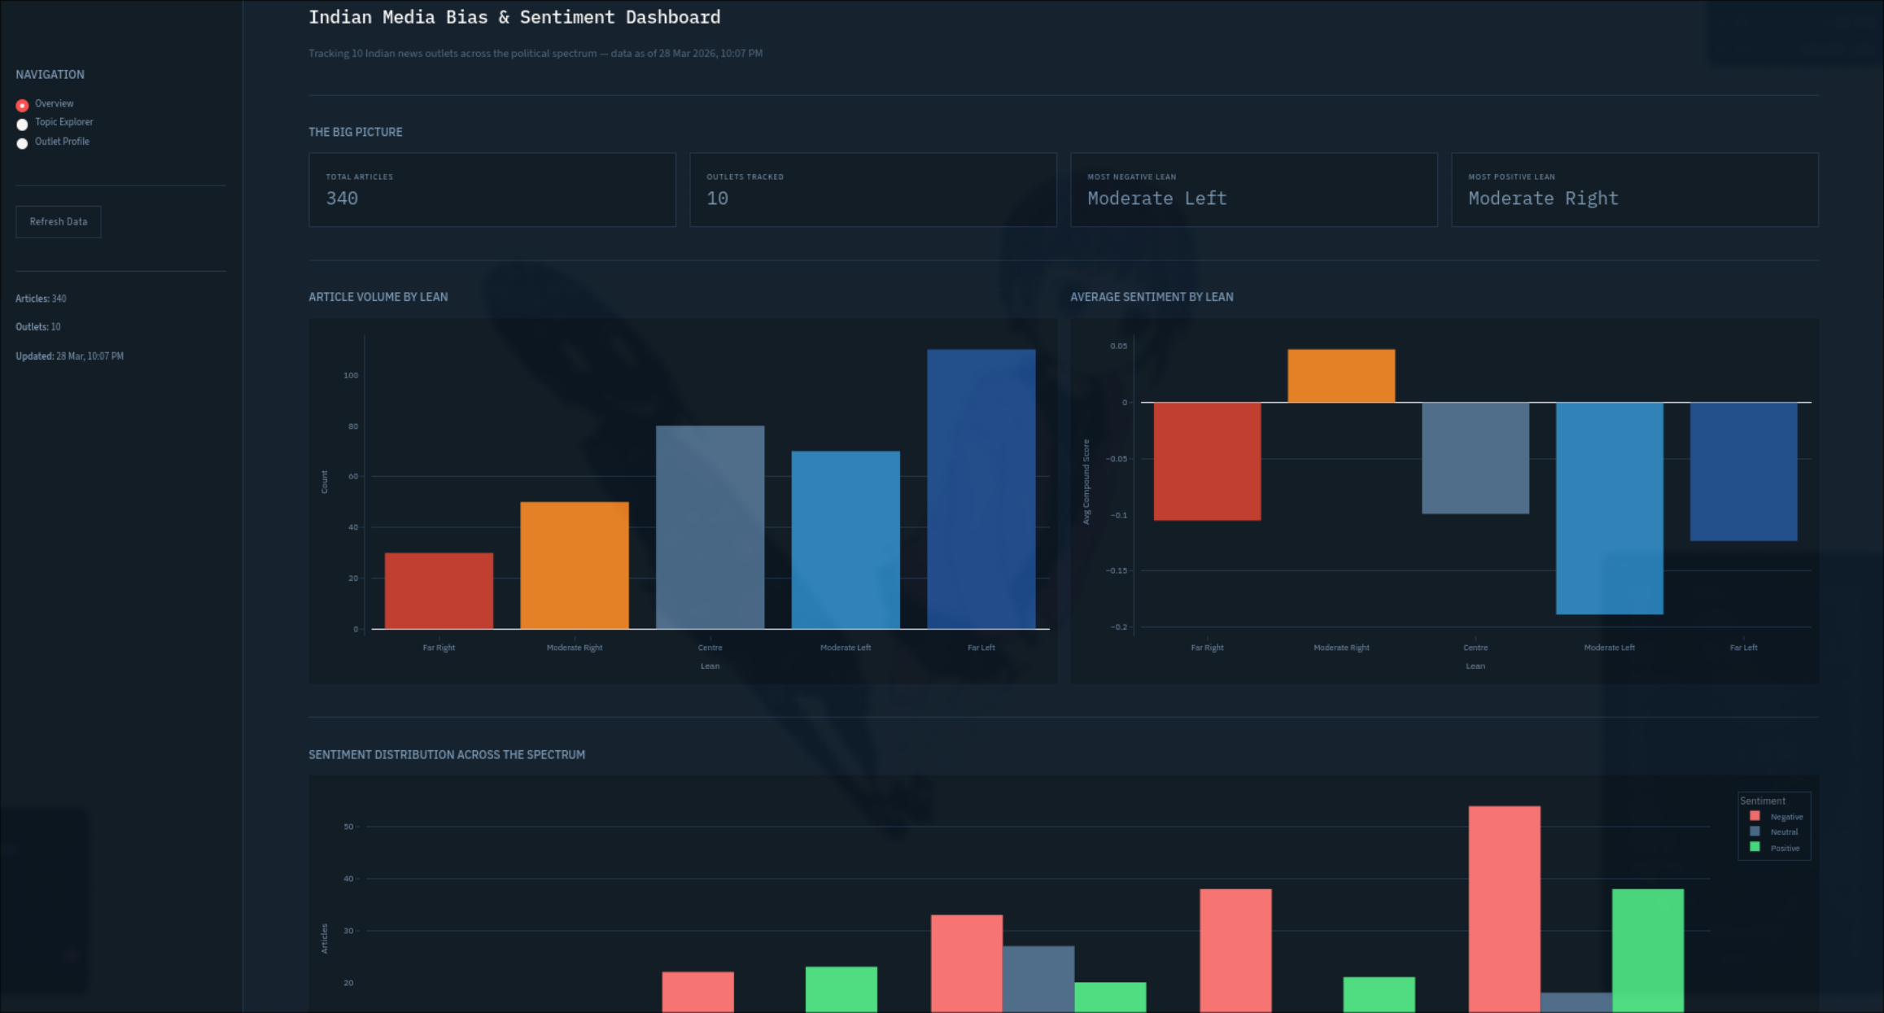
Figure 1 — Overview dashboard showing metric cards, volume chart, and average sentiment by lean

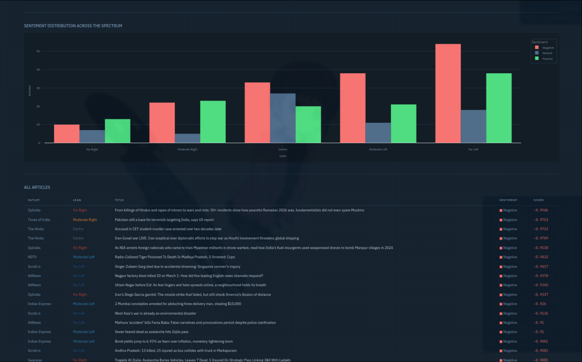
Figure 2 — Sentiment distribution chart and article table showing the most negatively scored headlines

The most immediate finding from the overview is that all five lean categories show a net negative average compound score. This is consistent with well-documented negativity bias in news media — conflict, crisis, and controversy drive readership, so negative framing is structurally incentivised across the spectrum regardless of political position.

6.2 Topic Explorer
The Topic Explorer is the most powerful feature of the dashboard. A user enters any keyword and the application filters all cached articles whose title or description contains that keyword, then presents the results as a set of charts and a side-by-side headline comparison. The left column shows headlines from far-left and moderate-left outlets, the right column shows headlines from far-right and moderate-right outlets, and centre outlets appear in a separate section below. Each headline is colour-coded with a small square indicator — red for negative, green for positive, grey for neutral — and is a live hyperlink to the original article.

This view directly answers the question the project was built around: given a topic, how differently is it being covered and with what emotional tone?

7. Case Studies
Three topics were selected for detailed analysis. These were chosen because they were all active in the news cycle at the time of data collection and because they represent politically sensitive subject matter where bias in framing is most likely to be visible.

7.1 Case Study One — The Iran War
The US-Israel conflict with Iran was the dominant story in the dataset, appearing across all ten outlets. Searching 'iran' returned 28 articles, making it the highest-volume topic in the entire dataset.

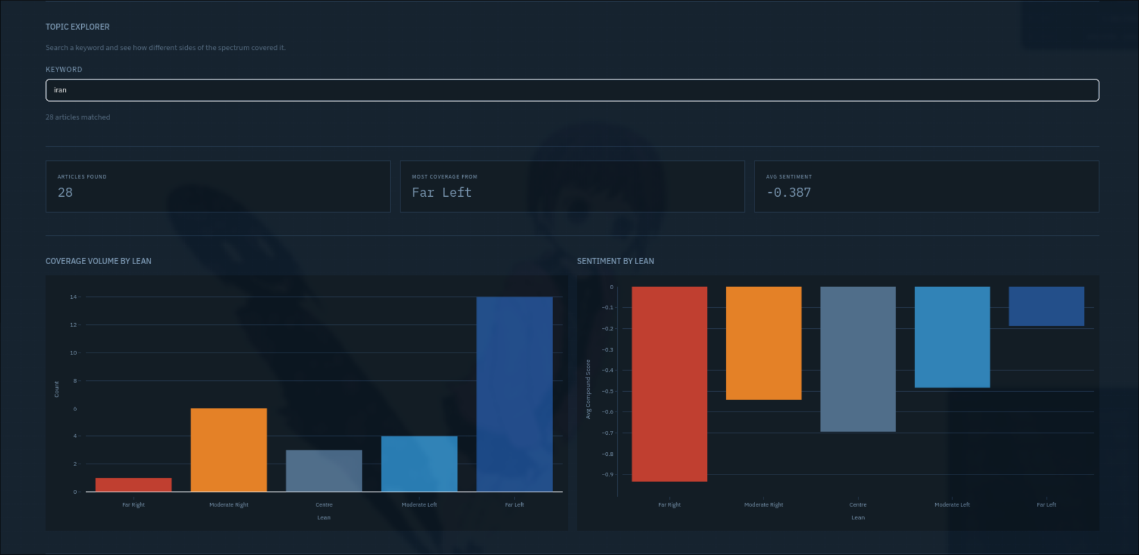
Figure 3 — Iran: coverage volume and sentiment by lean

The volume distribution was heavily skewed toward the far-left — Scroll.in alone accounted for the majority of Iran-related coverage, publishing over fourteen articles on the topic. This is consistent with Scroll.in's editorial focus on geopolitical analysis and international affairs. Far-right outlets published only one article on Iran, with OpIndia's single entry being a geopolitical opinion piece rather than straight news reporting.
The sentiment breakdown showed that Far Right outlets had the most negative average compound score on Iran at around -0.90, while Far Left outlets clustered around -0.15 to -0.20. This is an interesting inversion of what one might expect — right-leaning coverage of the conflict used significantly more negative language than left-leaning coverage. Looking at the actual headlines helps explain why: OpIndia's Iran article framed the conflict in terms of civilisational threat, using language like 'gambit' and 'shook America's illusion of distance', which VADER reads as strongly negative. Left-leaning outlets tended toward more analytical framing — 'how Iran managed to take on a superpower', 'five books on Iran' — which carries lower emotional intensity.

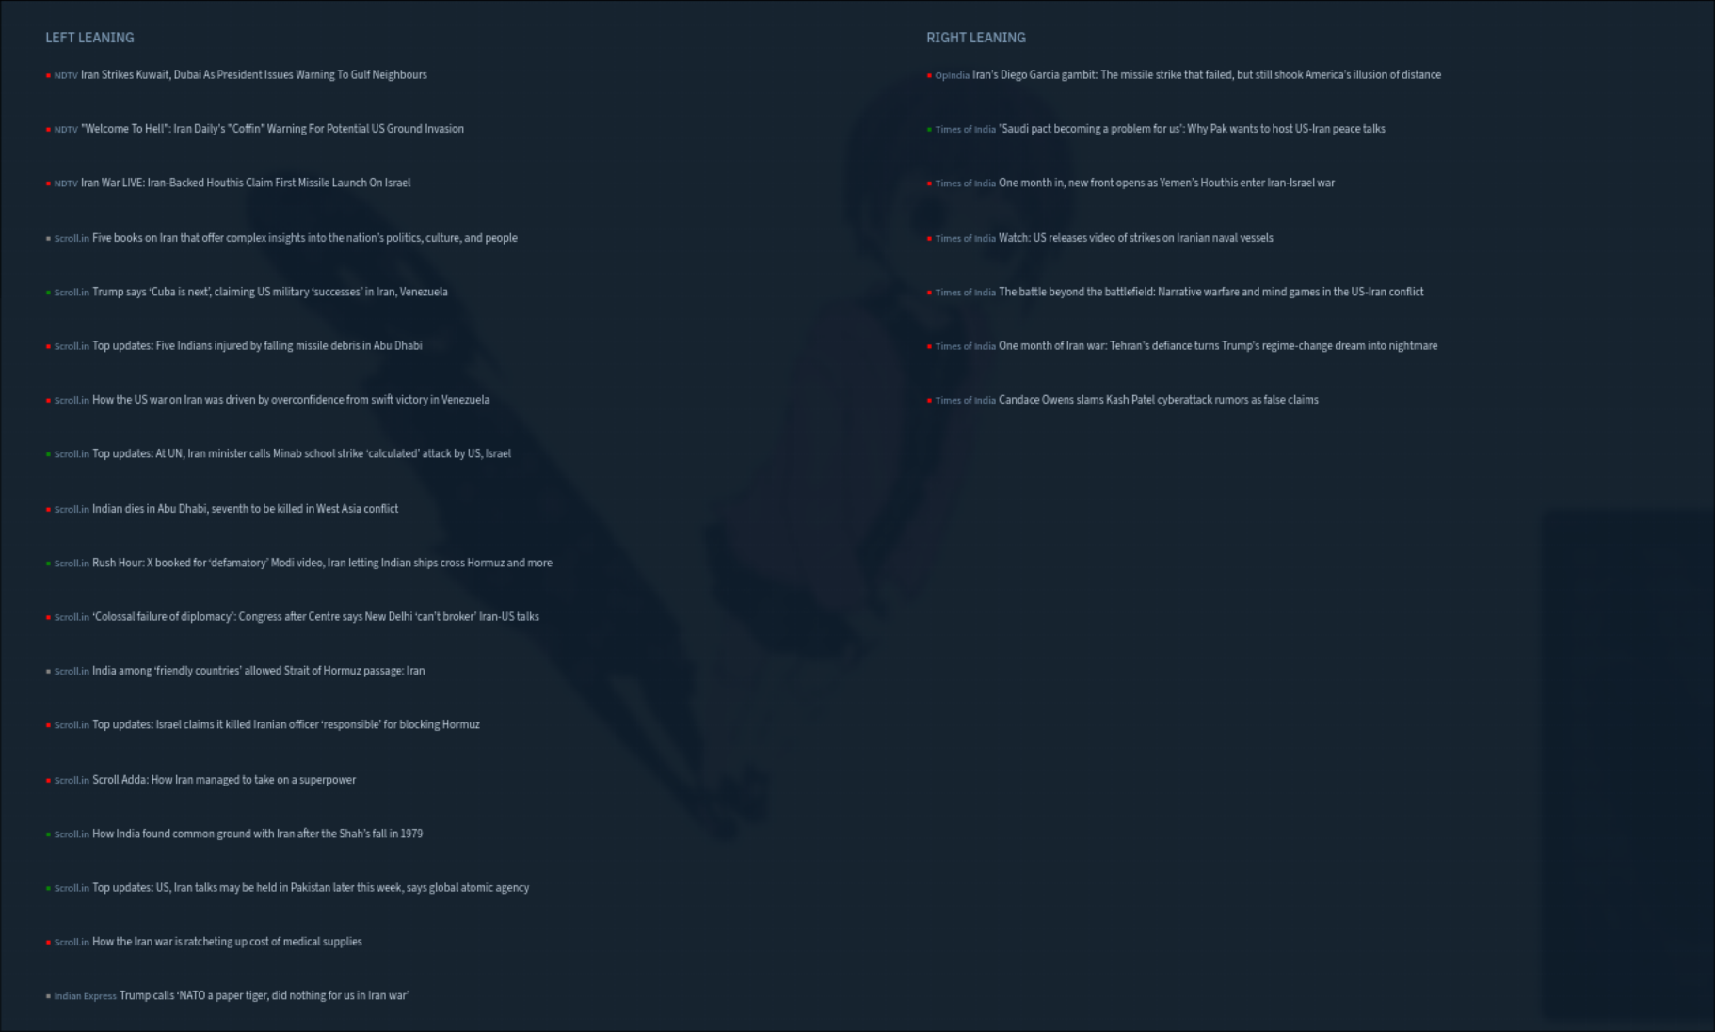
Figure 4 — Side-by-side headline comparison for 'iran': left vs right framing

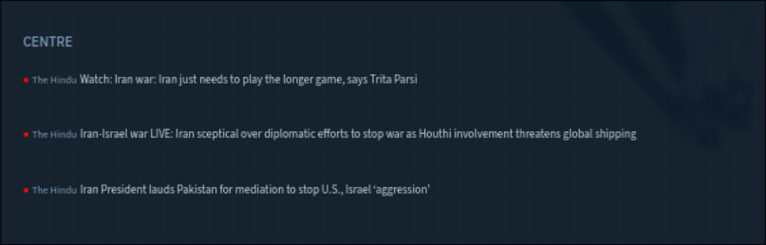
Figure 5 — Centre outlets' Iran coverage (The Hindu): measured, diplomatic framing

The Hindu's three Iran articles all used measured language — 'Iran just needs to play the longer game', 'Iran sceptical over diplomatic efforts' — which positioned the conflict as a diplomatic problem to be solved rather than an ideological confrontation. This framing distinction between the right (civilisational threat), left (geopolitical analysis), and centre (diplomatic process) is one of the clearest examples of how different editorial positions produce different narrative frames on the same set of events.

7.2 Case Study Two — BJP Coverage
Searching 'bjp' returned 21 articles and produced one of the most interesting findings in the entire dataset. The volume distribution was heavily weighted toward Centre outlets (11 articles, mostly from The Hindu and The Print) and Far Left outlets (8 articles, from Scroll.in and AltNews). Far Right outlets produced only 1 article mentioning BJP despite being ideologically aligned with the party.

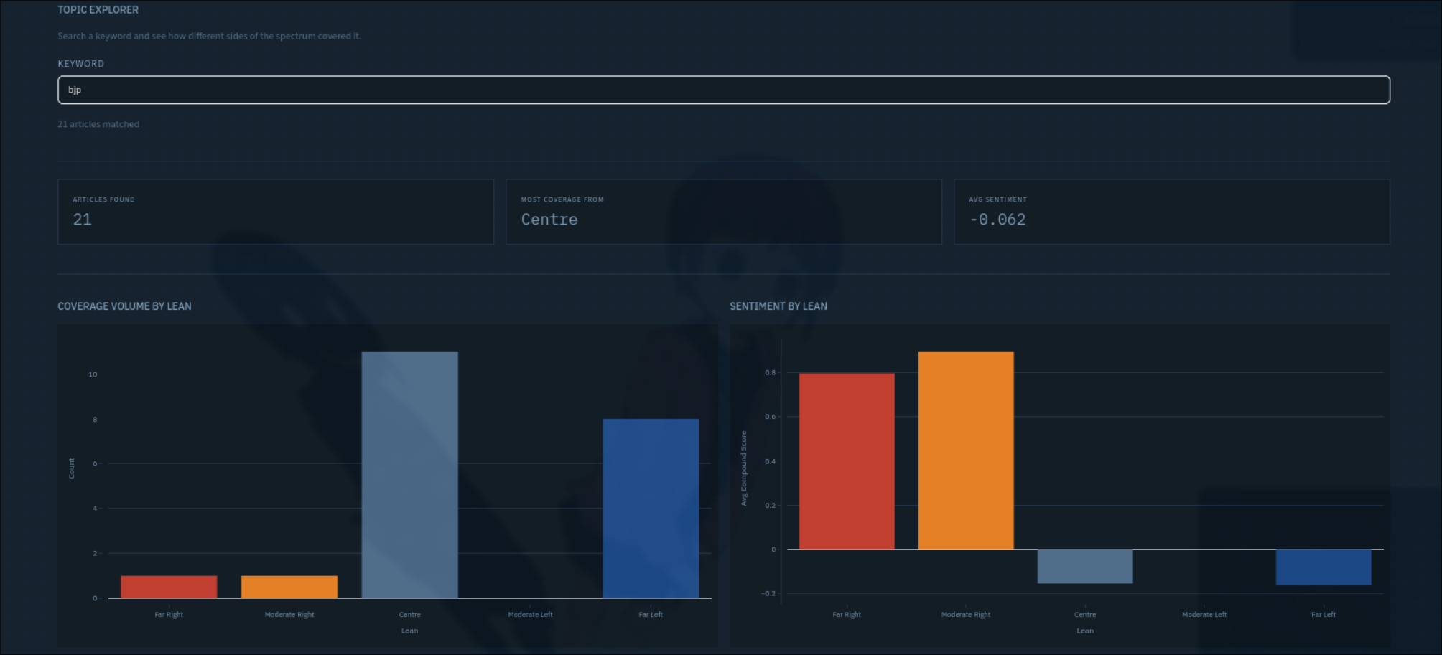
Figure 6 — BJP: coverage volume and sentiment by lean

The sentiment scores for BJP coverage were counterintuitive. Far Right and Moderate Right outlets showed strongly positive average compound scores (around +0.80) for their BJP-related articles. This makes sense on reflection: OpIndia's BJP article was an Assam elections analysis describing BJP as 'set for a comfortable hat-trick', which VADER correctly reads as positive. Hindustan Times produced a health article that incidentally mentioned BJP. Neither article was critical.
Far Left and Centre outlets, despite producing more BJP articles, scored significantly lower — AltNews articles criticising BJP policies and The Hindu's analytical pieces about BJP internal dynamics registered as neutral to slightly negative. This asymmetry is informative: right-leaning outlets mention BJP rarely but positively, while left and centre outlets cover BJP more extensively and in a more critical or analytical frame.

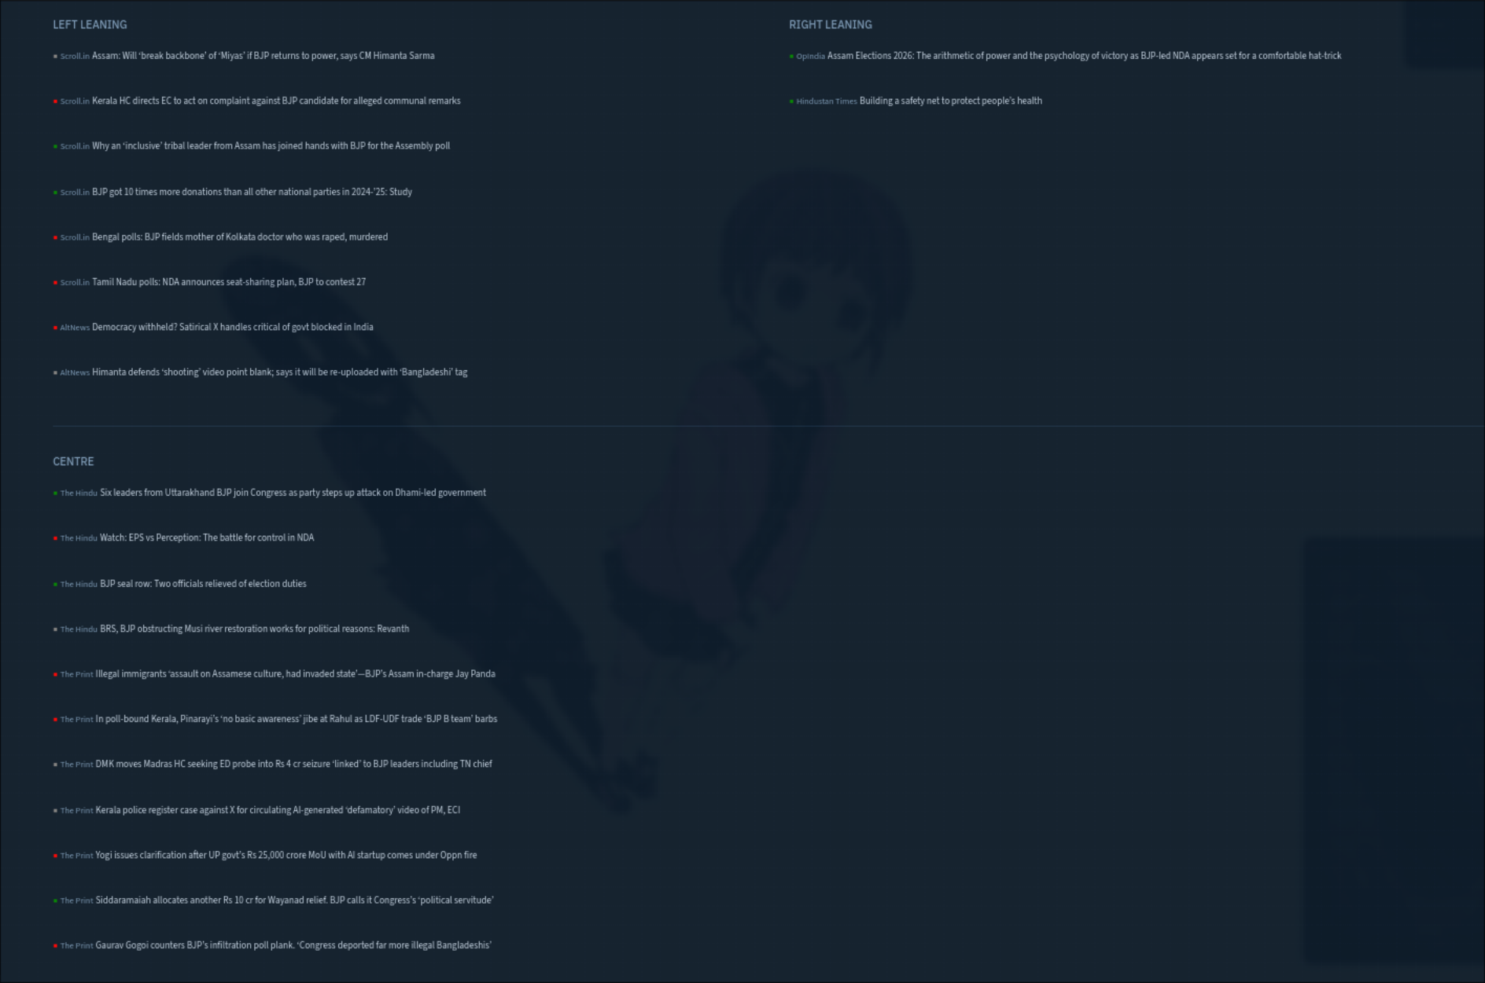
Figure 7 — BJP headlines: left outlets show critical analysis, right outlet shows electoral optimism

7.3 Case Study Three — Transgender Rights Bill
The Transgender Persons Amendment Bill 2026 was being debated in Parliament at the time of data collection. Searching 'transgender' returned only 3 articles, all from left-leaning outlets — 2 from Scroll.in and 1 from Indian Express. Not a single article on this topic appeared from any right-leaning outlet in the dataset.

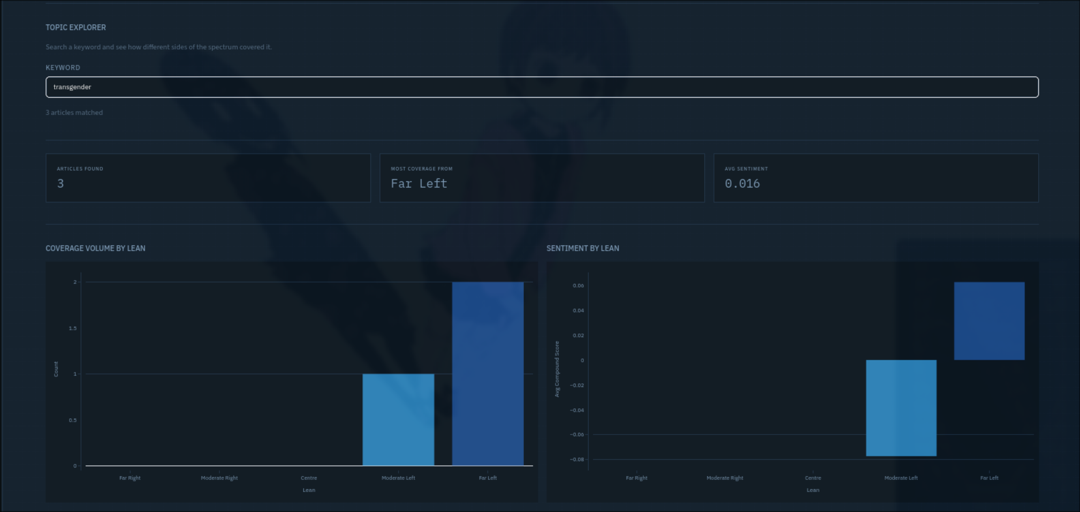
Figure 8 — Transgender bill: only left-leaning outlets covered the topic

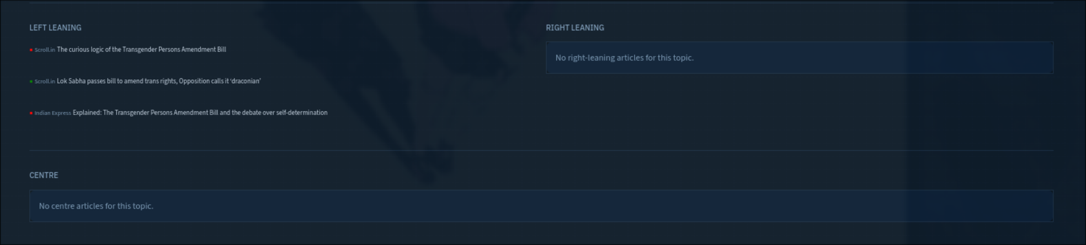
Figure 9 — All three transgender bill articles were from left-leaning outlets

This is arguably the most striking finding in the dataset. The absence of coverage is itself a data point. The right-leaning outlets in this dataset — OpIndia, Swarajya, Hindustan Times, Times of India — published nothing about a bill that directly affects a marginalised community and was generating significant parliamentary debate.
The three left-leaning articles that did appear framed the bill critically: Scroll.in called it 'draconian' in one headline and interrogated its 'curious logic' in another. Indian Express provided an explainer on the bill and the debate over self-determination. The overall average sentiment was nearly neutral at +0.016, which reflects the fact that explanatory and critical-analytical writing tends to register as less emotionally charged than outright advocacy.
The finding here is less about tone and more about selective coverage: the absence of the topic from right-leaning outlets effectively means their readership encounters a different version of current events — one in which this legislative development did not happen.

8. Outlet Profiles
The Outlet Profile view allows deep inspection of any individual outlet. Three profiles are documented here to illustrate the range of sentiment patterns across the political spectrum.

8.1 OpIndia — Far Right
OpIndia published 10 articles in the dataset with a mean compound score of -0.335, making it the most negative outlet relative to its lean peers. 60% of its articles were classified as negative and 40% as positive, with no neutral articles. This bimodal distribution — strongly negative on some topics, strongly positive on others — is consistent with advocacy journalism that takes clear ideological positions rather than neutral reporting.

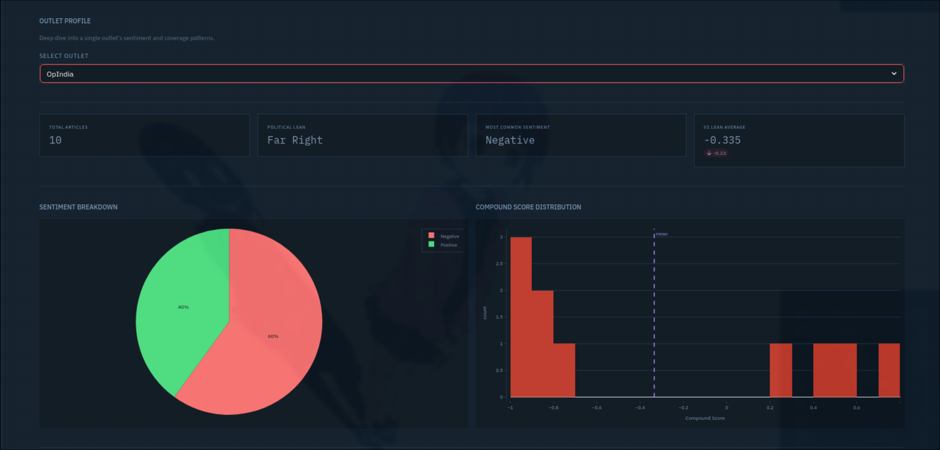
Figure 10 — OpIndia outlet profile: 60% negative, high compound score magnitude

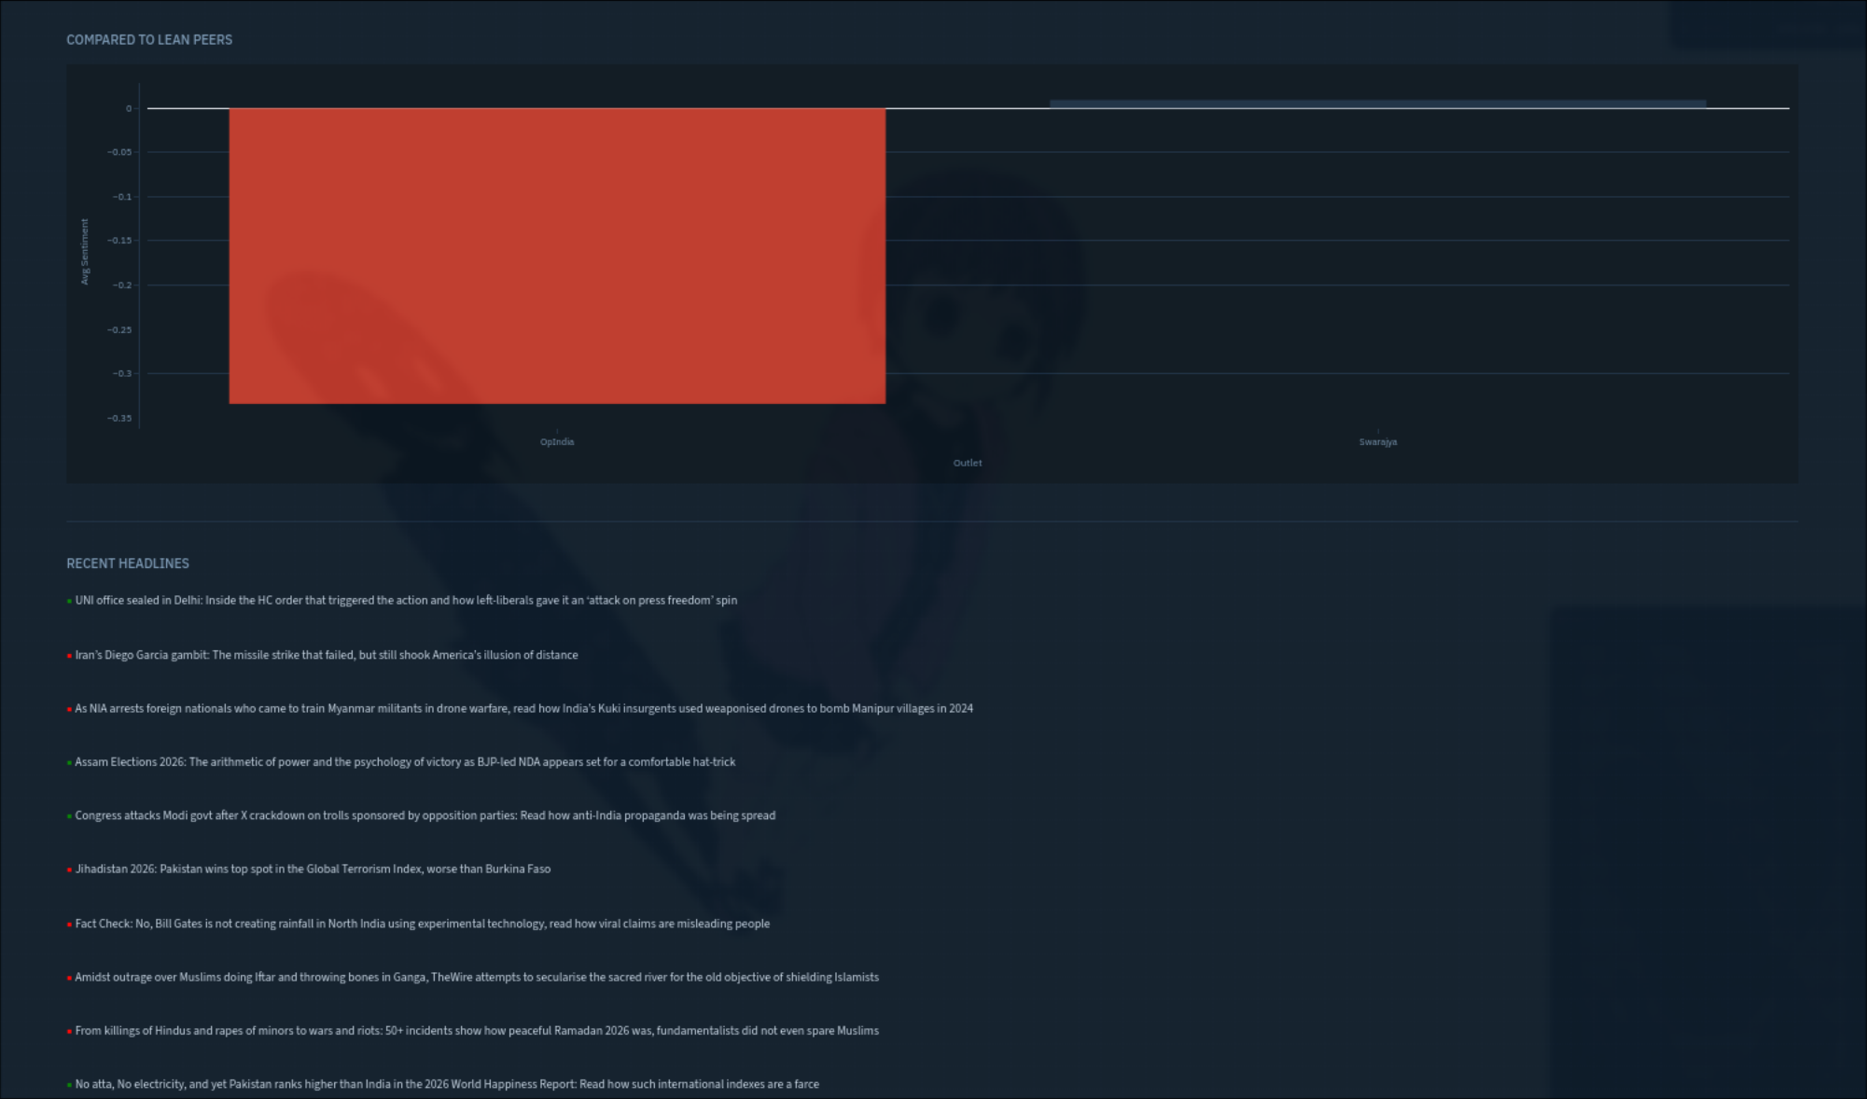
Figure 11 — OpIndia vs Swarajya: OpIndia significantly more negative than its Far Right peer

Compared to its lean peer Swarajya, OpIndia is significantly more negative. Swarajya's coverage in this dataset consisted heavily of infrastructure and economic development stories — highway projects, airport inaugurations, defence procurement — which carry inherently positive framing. OpIndia's coverage focused on religious and communal conflict, geopolitics, and ideological critique, which carries more negative emotional weight regardless of the author's intent.

8.2 Scroll.in — Far Left
Scroll.in published 100 articles in the dataset, by far the highest volume of any single outlet. Its mean compound score of -0.081 places it as the least negative of the Far Left outlets. The sentiment breakdown showed 46% negative, 37% positive, and 17% neutral — a more balanced distribution than OpIndia despite similar ideological positioning.

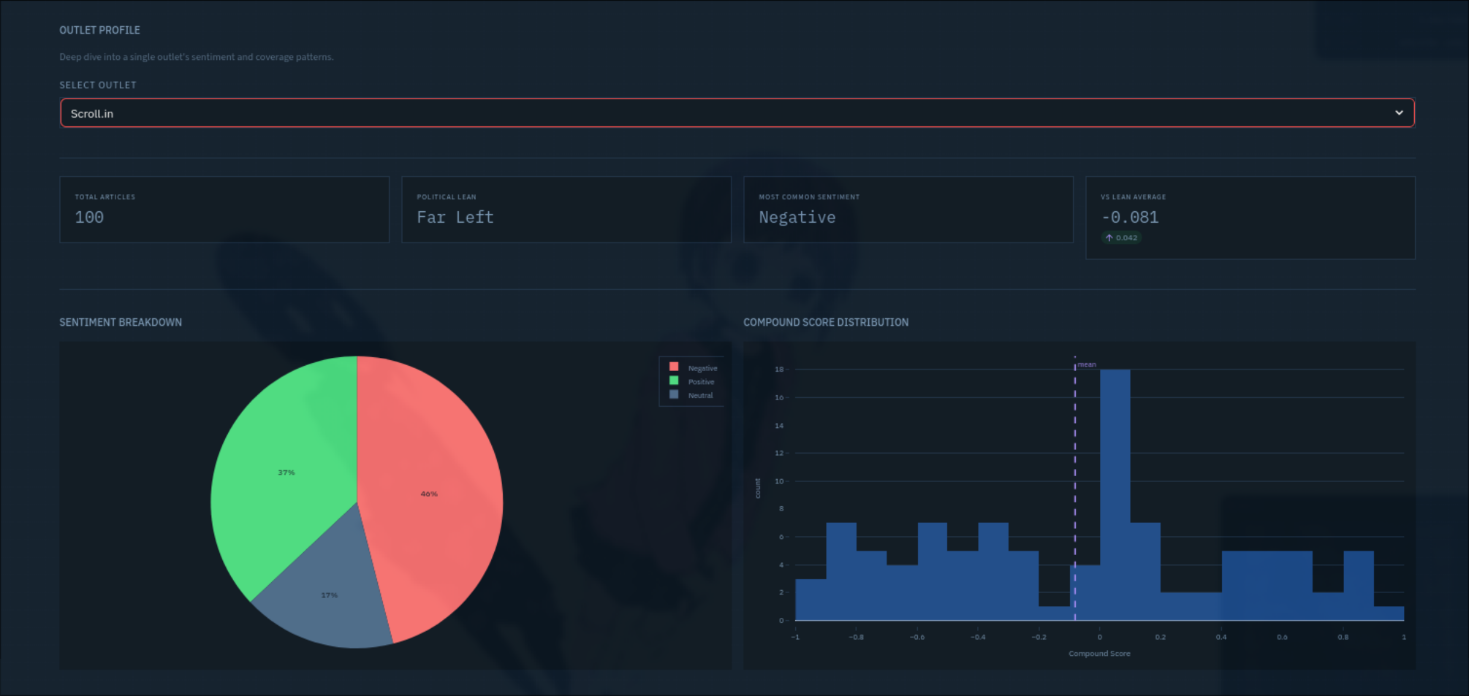
Figure 12 — Scroll.in outlet profile: high volume, relatively balanced sentiment distribution

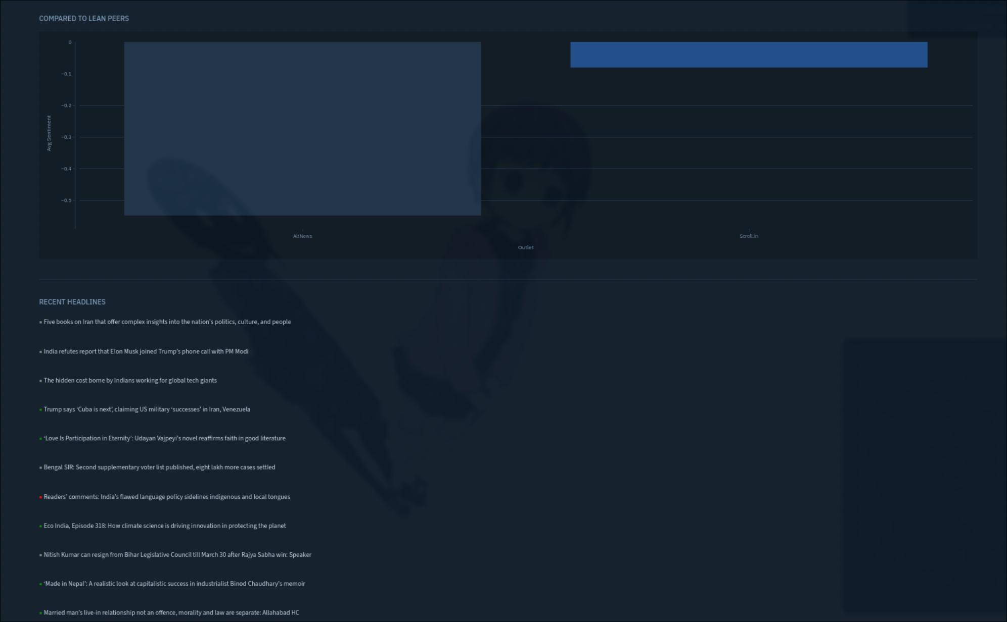
Figure 13 — Scroll.in vs AltNews: Scroll.in markedly less negative than AltNews

The high volume and relatively moderate negativity of Scroll.in reflects its broad editorial scope. Unlike AltNews which focuses primarily on fact-checking and debunking right-wing misinformation, Scroll.in covers a wide range of topics including culture, literature, sports, and science alongside political and social commentary. The histogram shows a peak near zero with a long tail into positive territory, driven by its substantial arts and culture content.

8.3 The Hindu — Centre
The Hindu published 60 articles with a mean compound score of -0.066, the least negative of all ten outlets. Uniquely, its most common sentiment classification was Neutral rather than Negative — 41.7% neutral, 33.3% negative, and 25% positive. This is the only outlet in the dataset where Neutral was the dominant category.

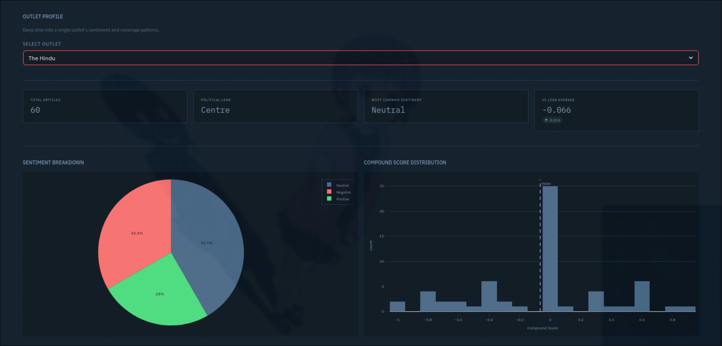
Figure 14 — The Hindu outlet profile: only outlet with Neutral as dominant sentiment

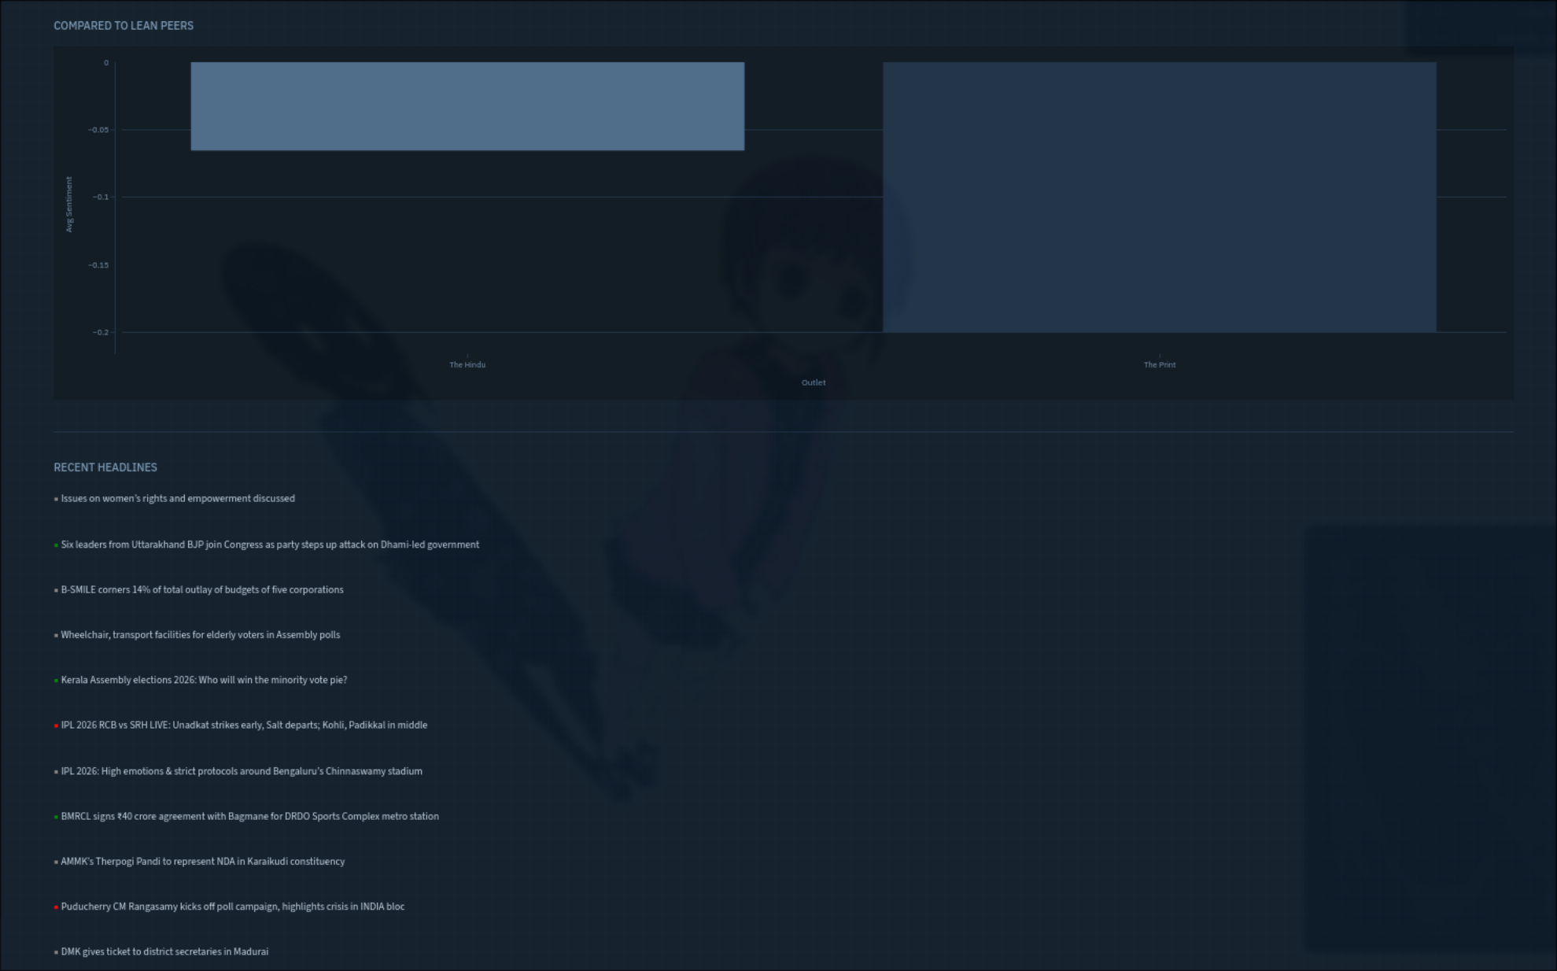
Figure 15 — The Hindu vs The Print: The Hindu slightly less negative than its Centre peer

The Hindu's compound score distribution is the most tightly clustered around zero of any outlet in the dataset, with the largest peak near 0.0 visible in the histogram. This is consistent with its editorial reputation for measured, process-oriented journalism. The Hindu regularly publishes election constituency watches, policy explainers, arts criticism, and data analysis — all genres that tend toward factual, lower-affect language that VADER reads as neutral.

9. Overall Findings
Political Lean | Avg Compound Score | Dominant Sentiment | Articles Collected
Far Right | -0.158 | Negative | 30
Moderate Right | -0.184 | Negative | 50
Centre | -0.072 | Neutral | 80
Moderate Left | -0.167 | Negative | 70
Far Left | -0.132 | Negative | 110

Across 340 articles from 10 outlets collected on 28 March 2026, four findings stood out:
- All lean categories showed net negative average sentiment. News as a genre is structurally negative across the political spectrum. This is not a bias finding — it reflects the nature of news itself.
- The most counterintuitive finding was that Moderate Right was the most negative lean overall (-0.184), driven primarily by Times of India's high volume of crime, conflict, and international crisis stories. This challenges the intuition that left-leaning media would be more alarmist in tone.
- Centre outlets showed the least negativity (-0.072) and The Hindu was the only outlet with Neutral as its dominant sentiment class. This is consistent with the hypothesis that centrist outlets tend toward more measured, analytical framing.
- Coverage gaps were as informative as coverage itself. The absence of transgender rights coverage from right-leaning outlets and the near-absence of BJP-positive coverage from left outlets reflect editorial priorities that shape what each audience knows about current events.

10. Limitations & Future Work

10.1 Limitations
- VADER was trained on English social media text, not Indian journalism. It may misread culturally specific phrases, sarcasm in Indian English, and mixed Hindi-English constructions common in Indian news writing.
- The dataset is a snapshot — 340 articles from a single day. Sentiment patterns shift with the news cycle and cannot be generalised from a single collection window.
- Bias labels are static and contested. Outlets evolve their editorial positions over time. NDTV's acquisition by the Adani Group in 2022, for example, has shifted its editorial positioning in ways that a static label does not capture.
- The Wire was blocked by Indian ISPs at the time of development and could not be included. This removed one of the most prominent left-leaning investigative outlets from the dataset.
- RSS feed reliability was inconsistent. Republic TV, DD News, and The Print's main feed all had broken or blocked feeds that required substitution or workarounds.
- Article volume is heavily uneven — Scroll.in published 100 articles while OpIndia published 10. Averages across unequal sample sizes should be interpreted with caution.

10.2 Future Work
- Replace VADER with a fine-tuned Indian English NLP model. Models like IndicBERT or a fine-tuned RoBERTa on Indian news corpora would handle cultural context and code-switching significantly better.
- Add historical trend tracking. Storing daily fetches over weeks and months would allow the dashboard to show how coverage and sentiment shift around specific events.
- Expand to Hindi and regional language outlets. The current dashboard covers only English-language outlets, missing a huge portion of the Indian media landscape.
- Implement topic modelling. Rather than requiring users to search keywords, the dashboard could automatically cluster articles into topics and show cross-lean coverage of each cluster.
- Add a confidence score for bias labels based on the number of reference sources that agree on a classification, making the methodology's uncertainty more visible to users.

11. Conclusion
The Indian Media Bias and Sentiment Dashboard is a working, live tool that does what it set out to do. It fetches real articles, measures real sentiment, and makes real patterns in coverage visible. Whether the findings are the ones I expected is a different question.
The most honest thing I can say about what I learned is that bias is less about tone than about selection. The sentiment scores across the political spectrum are all negative and closer to each other than I expected. What differs is what each outlet chooses to cover at all, how much space it gives to different topics, and what narrative frame it applies. The Iran war appeared across all outlets but was framed as a civilisational threat on the right and a geopolitical puzzle on the left. Transgender rights appeared only in left-leaning outlets. BJP coverage was positive on the right and analytical or critical on the left. VADER can measure the emotional temperature of a headline but it cannot measure what was left unsaid.
This project gave me a practical understanding of the full NLP pipeline — from raw data collection through cleaning, feature extraction, model application, and visualisation — that goes significantly beyond what any course exercise can teach. Every technical decision involved a real tradeoff: VADER vs. a trained model, live fetch vs. static dataset, ten outlets vs. twenty. These are the kinds of decisions practitioners make constantly and they cannot be resolved by a textbook.
The dashboard is publicly available on GitHub and is designed to be extended. If someone wanted to add more outlets, swap VADER for a better model, or store historical data, the architecture makes that straightforward. That extensibility was a deliberate design choice and I think it is the right one for a project that is genuinely trying to be useful rather than just academically complete.

12. References
- Russell, S. and Norvig, P. (2009). Artificial Intelligence: A Modern Approach, 3rd ed. Prentice Hall.
- Alpaydin, E. (2016). Machine Learning: The New AI. MIT Press.
- Hutto, C.J. and Gilbert, E. (2014). VADER: A Parsimonious Rule-based Model for Sentiment Analysis of Social Media Text. ICWSM.
- Reuters Institute Digital News Report — India Chapter (2023). University of Oxford.
- MediaBias/FactCheck (2024). Indian Media Source Ratings. https://mediabiasfactcheck.com
- The Hoot (2024). Indian Media Monitoring and Analysis. http://thehoot.org
- NewsAPI Documentation. https://newsapi.org/docs
- feedparser Documentation. https://feedparser.readthedocs.io
- Streamlit Documentation. https://docs.streamlit.io

