
Power BI Project Report
Student Name | Tufan Bera
AF Code | AF05308340
Project Title | Shop Sales and Profit Insights
Project Duration | 3 Days
Trainer Name | Sayan Sau
Submission Date | 4-10-2026
GitHub Username | Tufanbera
GitHub Repository Link | https://github.com/Tufanbera/Shop_Sales_Project_PowerBI

Shop Sales and Profit Insights

Executive summary
This project brings order and order-line data from a multi-category retail shop into one Power BI report. Its business purpose is to help management see where sales turn into profit and where they do not. The data covers 500 orders and 1,500 order lines placed between 1 January and 31 December 2018 across 19 Indian states.
The dashboard shows sales of ₹437,771, profit of ₹36,963 and 5,615 units sold, a profit margin of 8.44%. The main finding is that sales volume is a weak guide to profitability: 529 of the 1,500 order lines (35%) lost money, with combined losses of ₹38,079, and profit fell from ₹25,942 in the first quarter to a loss of ₹1,469 in the third. The recommended approach is to review loss-making products before increasing sales effort, and to test any change on a small scale first.

Project objective
The objective is to convert two separate files, order headers and order details, into an interactive report that explains sales, profit and quantity by product, payment mode, customer and time. It helps managers identify which products earn their sales, how results change by quarter, and which customers and payment modes contribute most profit.

Business problem
The details file holds amounts and profit, while the orders file holds dates, customers and places. Without joining them, a manager cannot see whether strong sales in a month, state or product line actually produce profit. This can lead to promoting products that lose money and overlooking the products and customers that drive profit.

Target audience
Dashboard user | Decision supported
Business owner and managers | Review overall sales and profit and choose priorities.
Sales and merchandising teams | Decide which products to promote, reprice or review.
Finance team | Track profit and margin by quarter, product and payment mode.
Regional and operations teams | Compare states and cities and plan service coverage.

Data and project methodology
The project uses two CSV files, Orders.csv and Details.csv, covering 2018. Order Date is stored as day-month-year (for example 24-01-2018), so the Power Query locale must be set to English (India) or English (UK) when converting the column to Date; a US locale would misread dates with a day above 12. The files do not state a currency. Amounts are shown in rupees (₹) because all customers are in India. Profit is used as supplied; the files contain no cost or discount fields.
Table | Business information
Orders (500 rows) | Order ID, Order Date, CustomerName, State and City; one row per order.
Details (1,500 rows) | Order ID, Amount, Profit, Quantity, Category, Sub-Category and PaymentMode; one row per product line within an order.

Tools and technologies
Power BI Desktop provides data modelling and interactive visuals. Power Query handles import, data types and the date locale. DAX provides calculated measures such as profit margin. SQL is not used.

Data preparation
Set Order ID, CustomerName, State, City, Category, Sub-Category and PaymentMode to Text, Order Date to Date using the day-month-year locale, and Amount, Profit and Quantity to Whole Number. Keep negative profit values; they are genuine losses, not errors. Use the date hierarchy to provide Year, Quarter and Month.

Relationships and record counts
Connect Orders to Details by Order ID as a one-to-many relationship, with filters flowing from Orders to Details. The source files show 500 unique Order IDs in Orders and 1,500 rows in Details covering the same 500 IDs, with no unmatched IDs in either direction and no blank values.

Quality checks before interpretation
Confirm that Order ID is unique in Orders, check for unmatched records, and compare totals with the source files: Amount ₹437,771, Profit ₹36,963 and Quantity 5,615. Test the quarter slicer on every visual. Treat CustomerName as a label, not a customer ID: the file has 336 distinct names across 500 orders, and two different people with the same name would be counted as one.

Metrics and dashboard features
Metric | Definition and business meaning
Total Sales | Sum of Amount; value of items sold across order lines (dashboard card).
Total Profit | Sum of Profit as supplied; negative when a line loses money (dashboard card).
Total Quantity | Sum of Quantity; units sold (dashboard card).
Profit Margin | Total Profit divided by Total Sales; profit earned per rupee of sales. A recommended DAX measure.
Total Orders | Distinct Order ID; counts each order once. A recommended DAX measure.
Average Order Value | Total Sales divided by Total Orders; average sales per order. A recommended DAX measure.

Profit is taken from the data as supplied and cannot be reconciled with cost, because the files contain no cost or discount fields. The data does not show whether Amount includes tax or is net of returns, so Total Sales should not be described as revenue after adjustments. The dashboard cards use implicit sums; profit margin, order count and average order value are calculated in this report from the same data.

Visuals and filters
The report page, taken from the Power BI file, has a title, three KPI cards (sum of Amount, Profit and Quantity), a line chart of quantity by month, a bar chart of sales by sub-category, a bar chart of profit by sub-category, a donut chart of quantity and profit by category, a donut chart of quantity and amount by payment mode, a combination chart of profit by customer name, and a slicer for quarter.

Interpretation rules
Compare profit with sales through margin, not by bar size alone. Each donut chart holds two measures; check which one sizes the slices before quoting a share. Profit by customer name ranks names, not unique people. All figures cover a single year, 2018, so differences between quarters are not evidence of seasonality.

Filter limitations
Selecting an Orders field, such as quarter, state or customer, filters Details through the relationship. Selecting a Details field, such as category, filters only Details, so any count taken from the Orders table will not respond to a category selection under the default relationship direction. Check each card before reading it as category-specific.

Refresh and automation
Power Query transformations are reapplied when the data is refreshed, reducing repeated cleaning work. Scheduled refresh and other automation should only be claimed if they have been configured and tested.

Business insights and decisions
The following insights are calculated from the 2018 source files. They describe what the data shows and propose follow-up actions; they do not prove why the results occurred.

Products and profit
Electronics has the highest sales at ₹166,267 (38%), but Clothing earned slightly more profit, ₹13,325 against ₹13,162, because its margin is 9.2% compared with 7.9%. Printers (₹8,606), Bookcases (₹6,516) and Saree (₹4,057) are the three largest profit sources. Five sub-categories lost money overall: Furnishings (−₹806), Electronic Games (−₹644), Kurti (−₹401), Skirt (−₹315) and Leggings (−₹130). Electronic Games is the priority review because it produced ₹39,168 in sales, 8.9% of the total, at a loss. Check price, supplier cost and discounting before promoting it further.

Sales trends and planning
Sales were highest in January (₹61,632) and March (₹60,694) and lowest in July (₹12,966). Profit was negative in May, July, September and December. By quarter, profit was ₹25,942 on ₹161,288 sales in Q1 (16.1% margin), ₹882 on ₹87,081 in Q2 (1.0%), −₹1,469 on ₹71,741 in Q3 (−2.0%) and ₹11,608 on ₹117,661 in Q4 (9.9%). November earned the highest monthly profit, ₹10,253, from only ₹48,469 in sales. With one year of data these patterns are signals to investigate, not proof of seasonality.

Regional sales and expansion
Maharashtra (₹102,498, 23.4%) and Madhya Pradesh (₹87,463, 20.0%) together provide about 43% of sales. Madhya Pradesh earned more profit (₹7,382) than Maharashtra (₹6,963) from lower sales. Rajasthan (₹22,334 in sales) and Andhra Pradesh (₹13,256) both lost money, by ₹323 and ₹280. Review the product mix and discounting in those states before changing marketing spend there.

Payments and checkout
Cash on delivery (COD) accounts for ₹155,181 (35.4%) of sales and 684 of the 1,500 lines. Credit card has the highest margin at 14.5% on ₹86,932, while UPI has the lowest at 4.8% on ₹68,641. The margin difference may reflect product mix rather than payment method, so test it before offering incentives to change how customers pay.

Customer value and repeat business
Average order value is ₹875.54 and average profit per order is ₹73.93. Of the 500 orders, 169 (34%) made a loss, totalling −₹26,127. The ten most profitable customer names provide about 40% of total profit, and 119 of the 336 names show a net loss. Because names are not unique IDs, confirm these customers in the source system before acting.

Action plan and success measurement
The timings below are a proposed implementation plan for a business using the report, not activities already completed. Approve targets after establishing the 2018 baseline.
Priority and timing | Owner and action | Success measure
1 | Week 1 | Analyst validates totals, dates, customer names and slicer behaviour. | Totals reconcile to ₹437,771 sales, ₹36,963 profit and 5,615 units.
2 | Weeks 2 to 3 | Merchandising reviews the five loss-making sub-categories, starting with Electronic Games. | Higher margin on repriced lines; fewer loss-making order lines.
3 | Weeks 2 to 4 | Sales tests a limited campaign in a profitable state with a comparison group. | Incremental profit, not only sales, against the comparison group.
4 | Monthly | Finance tracks margin by month and quarter. | Margin above the 2018 average of 8.44% in each quarter.

Additional measures for stronger decisions
Add profit margin as a DAX measure, the share of loss-making orders (169 of 500, or 34%, in 2018), and average order value. Repeat-customer rate needs a unique customer ID, which the current files do not provide.

How to document a verified insight
Record the selected period and filters, the measured result, a comparable baseline, the business interpretation and the proposed action. For example: During 2018, Electronic Games contributed 8.9% of sales but a loss of ₹644. We propose reviewing its price and supplier cost and measuring margin on the repriced lines against the 2018 baseline over one quarter.

Decision gate
Expand a pilot only when its agreed success measure improves and sales volume remains acceptable. If results are mixed, investigate rather than assuming success. Profit changes without a comparison group cannot establish that an action caused them.

Learning outcomes and project conclusion

Learning outcomes
The project develops practical skills in importing related CSV files, setting data types and date locales, building a one-to-many relationship, and creating DAX measures. It also develops the ability to turn sales and profit data into findings and proposed actions.

Business value
The report provides one place to review sales, profit, products, payment modes and customers. It can shorten the path from noticing a weak result to assigning an investigation. Its value depends on accurate measures, consistent filters and follow-up on the findings.

Limitations
The data covers one year, so trends and seasonality cannot be confirmed. Profit is supplied without cost or discount detail. Customers are identified only by name, the currency is assumed, and the data does not show whether Amount includes tax. The results describe 2018 and cannot predict future sales by themselves.

Conclusion
Shop Sales and Profit Insights shows how Power BI can join order and detail records into a practical decision-support report without SQL. In 2018 the shop earned ₹36,963 profit on ₹437,771 sales, but over a third of order lines lost money. The report supports decisions on product review, regional priorities and payment mix, provided actions are tested before they are expanded.

Dashboard results and verified findings

Reporting scope
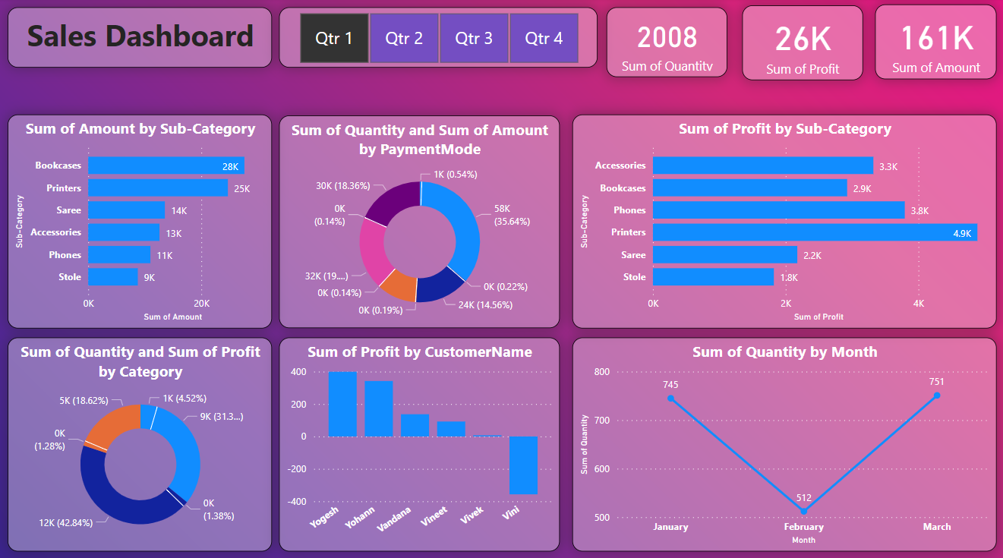
Figure 1: Completed Power BI Sales Dashboard (Qtr 1 selected).
Reporting period: 1 January to 31 December 2018, covering all 19 states. Figure 1 shows the completed dashboard with the Qtr 1 button selected: 2,008 units, ₹26K profit and ₹161K sales. These match the Q1 totals calculated from the source files (2,008 units, ₹25,942 profit, ₹161,288 sales). The KPI table and charts that follow cover the full year with no quarter selected. Values are in rupees (₹).

Verified KPI values
KPI | Value (2018, all states) | Note
Total Sales | ₹437,771 | Sum of Amount across 1,500 order lines.
Total Profit | ₹36,963 | Sum of Profit; includes ₹38,079 of line-level losses.
Total Quantity | 5,615 | Units sold; about 11.2 per order.
Profit Margin | 8.44% | Total Profit divided by Total Sales.
Total Orders | 500 | Distinct Order ID.
Average Order Value | ₹875.54 | Total Sales divided by 500 orders.

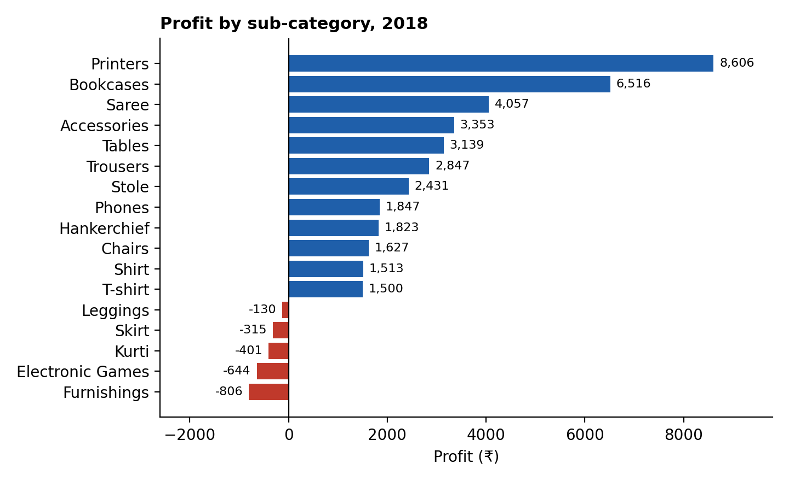
Figure 2: Profit by sub-category, 2018 (drawn from the source files).
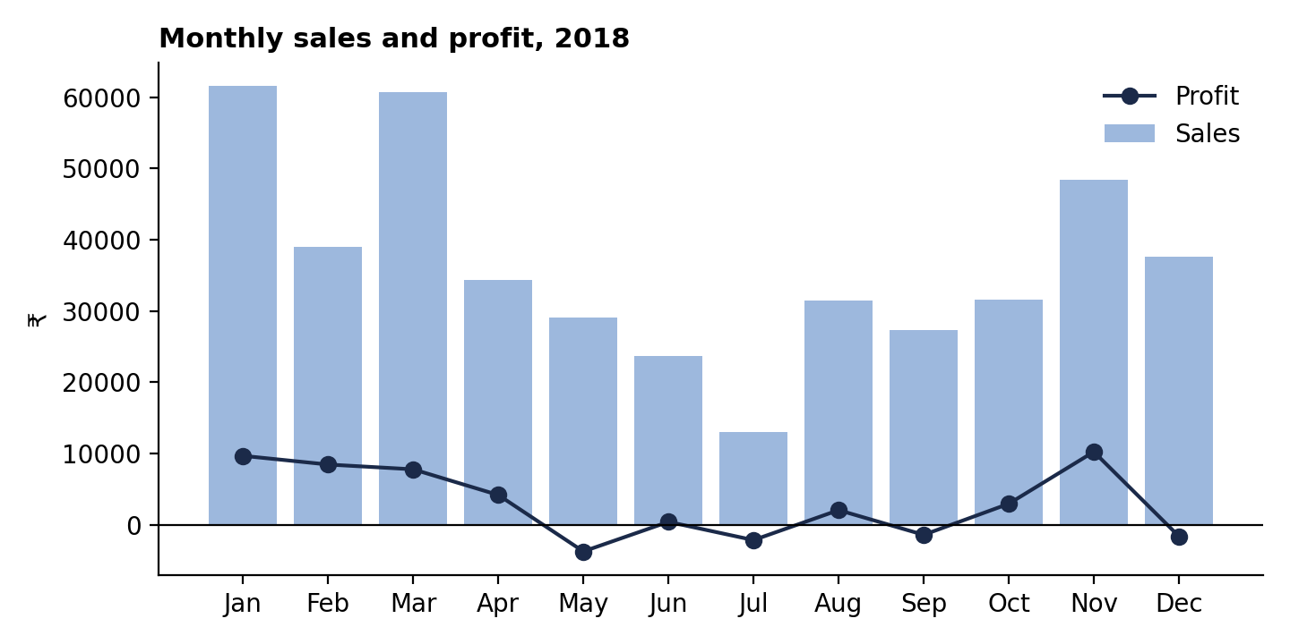
Figure 3: Monthly sales and profit, 2018 (drawn from the source files).

Quantified findings

Finding 1: Loss-making products
During 2018, five of the 17 sub-categories lost money: Furnishings (−₹806), Electronic Games (−₹644), Kurti (−₹401), Skirt (−₹315) and Leggings (−₹130), a combined −₹2,296. Electronic Games alone brought in ₹39,168, 8.9% of total sales. We propose that merchandising review price, supplier cost and discounting on these lines and measure their margin against the 2018 baseline over one quarter. Overall, 529 of 1,500 order lines (35%) lost money, so the review should extend to the weakest products within profitable sub-categories.

Finding 2: Profit varies sharply by quarter
Profit was ₹25,942 in Q1 (16.1% margin), ₹882 in Q2, −₹1,469 in Q3 and ₹11,608 in Q4 (9.9%). Q1 held 37% of annual sales and 70% of annual profit. We propose that Finance compare monthly margin with product mix and discounting in Q2 and Q3 before setting targets. A single year cannot show whether this pattern repeats.

Finding 3: Concentration by state and payment mode
Maharashtra and Madhya Pradesh provide about 43% of sales (₹102,498 and ₹87,463). COD is the largest payment mode at ₹155,181 (35.4% of sales), while credit card has the highest margin at 14.5% against 4.8% for UPI. We propose protecting service in the two leading states and testing whether the payment margin gap comes from product mix before offering any payment incentive. These shares describe sales values, not the number of customers.
Project basis: the supplied Power BI file (Sales-Dashboard-shop.pbix) and the Orders and Details CSV files. All findings are traceable to those files and the filters stated above.

