4:

Problem : Bishop Moves
Background
A Chess board position is accurately captured by Forsyth-Edwards notation and is abbreviated as FEN. A FEN "record" defines a particular game position, all in one text line and using only the ASCII character set. A FEN record contains six fields. A complete description of the FEN format to represent Chess positions can be found at here
For the purpose of this problem only consider first of the six fields of FEN. Before we describe the problem, let us look at how FEN maps to a board position. The following 5 images show board positions and its corresponding FEN representation.
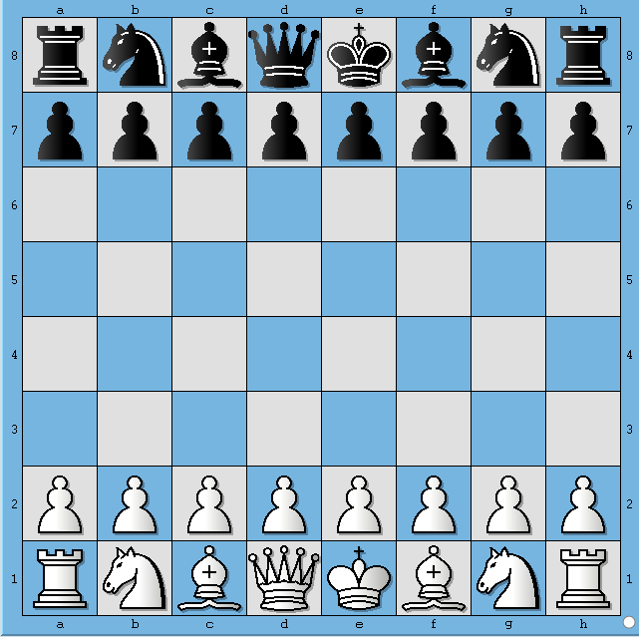
Figure 1.

This board position depicts initial position before any side has made a move. In FEN format this board position is represented as
rnbqkbnr/pppppppp/8/8/8/8/PPPPPPPP/RNBQKBNR w

Let's say, White plays e4. Then the board position looks like shown below
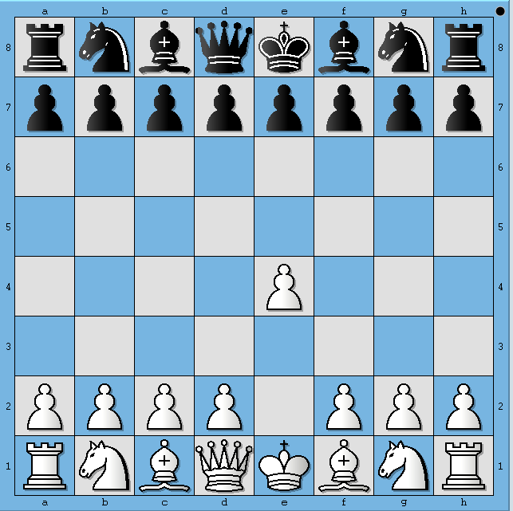
Figure 2.

This board position depicts the Chess board after White has played e4. In FEN format this board position is represented as
rnbqkbnr/pppppppp/8/8/4P3/8/PPPP1PPP/RNBQKBNR b

Similarly, 3 more half-moves are depicted in following diagrams
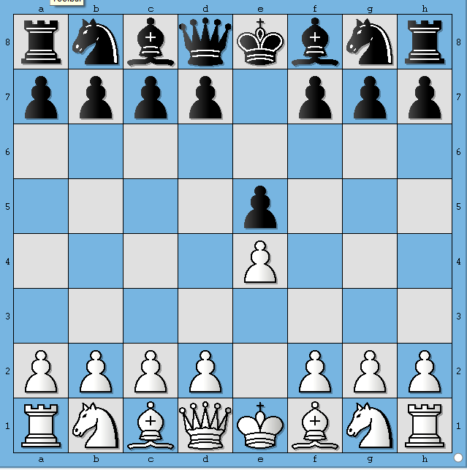 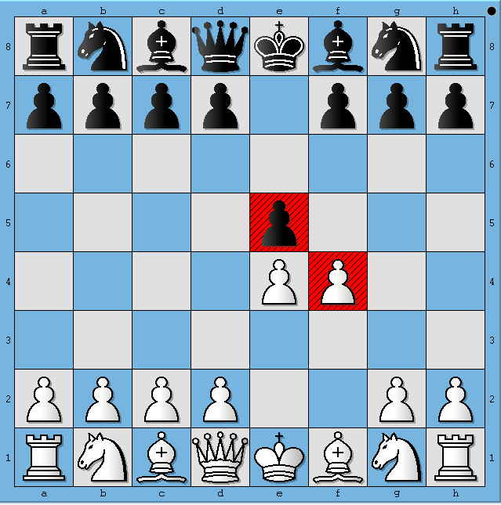 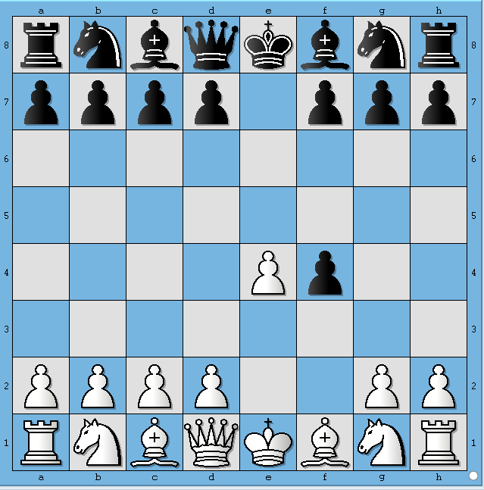 Figure 3. Figure 4. Figure 5.
The FENs corresponding to Figure 3, 4 and 5 are represented as
3. rnbqkbnr/pppp1ppp/8/4P3/4P3/8/PPPP1PPP/RNBQKBNR w
4. rnbqkbnr/pppp1ppp/8/4p3/4PP2/8/PPPP2PP/RNBQKBNR b
5. rnbqkbnr/pppp1ppp/8/8/4Pp2/8/PPPP2PP/RNBQKBNR w
Wikipedia describes first field of FEN format as follows
Each rank is described, starting with rank 8 and ending with rank 1; within each rank, the contents of each square are described from file "a" through file "h". Following the Standard Algebraic Notation (SAN), each piece is identified by a single letter taken from the standard English names (pawn = "P", knight = "N", bishop = "B", rook = "R", queen = "Q" and king = "K").[1] White pieces are designated using upper-case letters ("PNBRQK") while black pieces use lowercase ("pnbrqk"). Empty squares are noted using digits 1 through 8 (the number of empty squares), and "/" separates ranks.
The second field denotes whose move it is now. "w" depicts that it is White's turn to play and "b" indicates that it is Black's turn to play
CodeVita Problem Statement
Given a board position in FEN format, your task is to find out all the move(s) that Bishop(s) of the playing side can make.
Input Format:
- First line contains single FEN record, which corresponds to a particular board position and also indicates whose turn it is.

Output Format:
- The output must be printed as follows
  - All legal moves that Bishop can make must be in the format "[<Move Format>]"
  - Where <Move Format> is move represented in format "[fromSquare][toSquare]"
- See Example section for better understanding of output format
- Follow Output printing specification to print the output in required format

Constraints:
- Since we focus on only first two parts of the FEN, we are essentially ignoring possibility of Castling. Hence our test cases don't contain FENs which give rise to such positions.

Sample Input and Output
SNo. | Input | Board Depiction | Output
1 | 3k4/8/8/2P1P3/3B4/2R1R3/8/4K3 w | 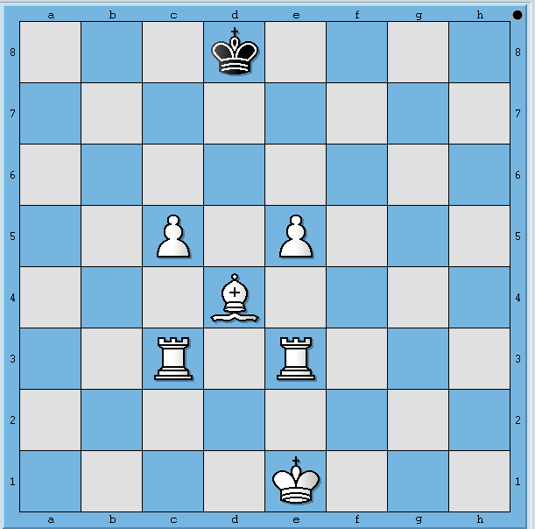 | []
2 | 3k4/8/8/4P3/3B4/2R1R3/8/4K3 w | 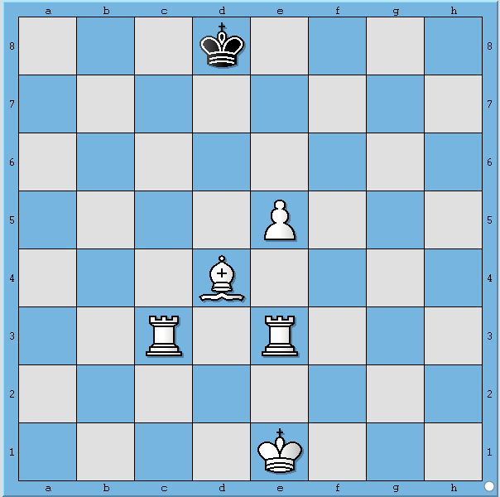 | [d4a7, d4b6, d4c5]
3 | 3k4/8/8/8/3B4/8/8/1B2K3 w | 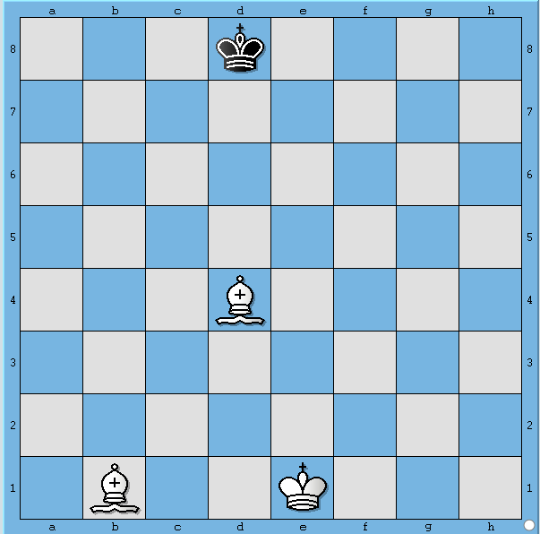 | [d4h8, d4a7, d4g7, d4b6, d4f6, d4c5, d4e5, d4c3, d4e3, d4b2, d4f2, d4a1, d4g1, b1h7, b1g6, b1f5, b1e4, b1d3, b1a2, b1c2]

Print Specification:
- Should start with "[" and end with "]"
- If more than one move is possible, moves should be separated by a comma followed by whitespace
- Moves of a single bishop should be printed in Move Format. Scan the board from 8th rank to 1st rank from a-file to h-file. Whichever square gets hit first, that move should be printed first.
- If more than one bishop exists for side to move, then start scanning for bishop from 8th rank to 1strank, left to right i.e. from a-file to h-file. Whichever bishop appears first, print all moves for that bishop first.
- Verify your understanding of how printing should happen against examples shown above
5:
Problem : Football League Table
Statement :
All major football leagues have big league tables. Whenever a new match is played, the league table is updated to show the current rankings (based on Scores, Goals For (GF), Goals Against (GA)). Given the results of a few matches among teams, write a program to print all the names of the teams in ascending order (Leader at the top and Laggard at the bottom) based on their rankings.
Rules: :
- A win results in 2 points, a draw results in 1 point and a loss is worth 0 points.
- The team with most goals in a match wins the match.
- Goal Difference (GD) is calculated as Goals For (GF) - Goals Against (GA)
- Ranking is decided as follows
  - Team with maximum points is ranked 1 and minimum points is placed last
  - Ties are broken as follows
    - Teams with same points are ranked according to Goal Difference(GD).
    - If Goal Difference(GD) is same, then team with higher Goals For is ranked ahead
    - If GF are same, the teams should be at the same rank but they should be printed in case-insensitive alphabetic according of the team names.
- Teams can play maximum of two matches against each other - Home and Away matches respectively
- More than 2 matches of same teams, should be considered as Invalid Input
- A team can't play matches against itself, hence if team names are same for a given match, it should be considered Invalid Input

Input Format:
First line of input will contain number of teams (N)
Second line contains names of the teams (Na) delimited by a whitespace character
Third line contains number of matches (M) for which results are available
Next M lines contain a match information tuple {T1 T2 S1 S2}, where tuple is comprised of the following information
- T1 - Name of the first team
- T2 - Name of the second team
- S1 - Goals scored by the first team
- S2 - Goals scored by the second team

Output Format:
Team names in order of their rankings, one team per line
OR
Print "Invalid Input" where appropriate.
Constraints:
- 0<N<=10,000
- 0<=S1,S2

Example:
Consider 5 teams Spain, England, France, Italy and Germany with the following fixtures:
Match 1: Spain vs. England (3-0)
(Spain gets 2 points, England gets 0)
Match 2: England vs. France (1-1)
(England gets 1 point, France gets 1)
Match 3: Spain vs. France (0-2)
(Spain gets 0 points, France gets 2)
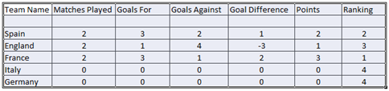
Table 1. Points Table after 3 matches
Since, Italy and Germany are tied for points, goals difference is checked. Both have same, so, Goals For is checked. Since both are same. Germany and Italy share the 4th rank. Since Germany appears alphabetically before Italy, Germany should be printed before Italy.
Then the final result is:
France
Spain
England
Germany
Italy
Sample Input and Output
SNo. | Input | Output
1 | 5  Spain England France Italy Germany  3  Spain England 3 0  England France 1 1  Spain France 0 2 | France  Spain  England  Germany  Italy
2 | 5  Spain England France Italy Germany  3  Spain England 3 0  England France 1 1  Spain Spain 0 2 | Invalid Input

6:
Problem : Mate In One
Background
A Chess board position is accurately captured by Forsyth-Edwards notation and is abbreviated as FEN. A FEN "record" defines a particular game position, all in one line of text and using only the ASCII character set. A FEN record consists of six fields. A complete description of the FEN format to represent Chess positions can be found here
For the purpose of this problem, only consider first of the six fields of FEN. Before we describe the problem, let us look at how FEN maps to a board position. The following 5 images show board positions and its corresponding FEN representation.
Figure 1.

This board position depicts initial position before any side has made a move. In FEN format this board position is represented as
rnbqkbnr/pppppppp/8/8/8/8/PPPPPPPP/RNBQKBNR

Let's say, White plays e4. Then the board position looks like shown below
Figure 2.

This board position depicts the Chess board after White has played e4. In FEN format this board position is represented as
rnbqkbnr/pppppppp/8/8/4P3/8/PPPP1PPP/RNBQKBNR

Similarly, 3 more half-moves are depicted in following diagrams
Figure 3. | Figure 4. | Figure 5.
The FENs corresponding to Figure 3, 4 and 5 are represented as
3. rnbqkbnr/pppp1ppp/8/4p3/4P3/8/PPPP1PPP/RNBQKBNR
4. rnbqkbnr/pppp1ppp/8/4p3/4PP2/8/PPPP2PP/RNBQKBNR
5. rnbqkbnr/pppp1ppp/8/8/4Pp2/8/PPPP2PP/RNBQKBNR
Wikipedia describes first field of FEN format as follows
Piece placement (from white's perspective). Each rank is described, starting with rank 8 and ending with rank 1; within each rank, the contents of each square are described from file "a" through file "h". Following the Standard Algebraic Notation (SAN), each piece is identified by a single letter taken from the standard English names (pawn = "P", knight = "N", bishop = "B", rook = "R", queen = "Q" and king = "K").[1] White pieces are designated using upper-case letters ("PNBRQK") while black pieces use lowercase ("pnbrqk"). Empty squares are noted using digits 1 through 8 (the number of empty squares), and "/" separates ranks
Statement
Given a board position in FEN format, your task is to find out all move(s) that lead to a forced mate. White to play and win in 1 move.
Input Format:
- First line contains single FEN record, which corresponds to a particular board position
- Second line contains -1 which indicates the end of input

Output Format:
- The output must be printed as follows
  - A string "Mating moves " followed by "[<move format>]"
  - Where <move format> is move represented in format "[Piece][fromSquare]-[Piece][toSquare]"
  - If a mating move involves a capture then represent it as "[Piece][fromSquare]-[Piece]x[toSquare]"
  - If the Piece inflicting a mate is a pawn represent it only as [fromSquare]-[toSquare]
  - If there is more than one mating move, then follow the rules given below
    - Moves must be sorted alphabetically according to their ascii values
    - Two moves must be separated by a comma followed by a white space characters
    - Between the last move and terminating "]" character there should be no space or comma
- See Example section for better understanding of output format

Constraints:
- The board position will always be White to move and mate in 1
- Since we focus on only first part of the FEN, we are essentially ignoring possibility of Castling being a mating move. Hence our test cases don't contain FENs which give rise to such positions.
- There is no need to handle En Passant positions. There are no test cases involving En Passant moves.
- No need to implement pawn promotion rules. Our test cases do not contain positions which will lead to a pawn getting promoted and inflicting a mate.
- There are no test cases in which capture by a white pawn leads to a mate.

Sample Input and Output
SNo. | Input | Output
1 | 3k4/8/3p4/7B/3Q4/2R1R3/8/5K2  -1 | Mating moves [Qd4-Qxd6]
2 | 8/R7/3k4/8/2Q1P1B1/8/8/2K1R3  -1 | Mating moves [Qc4-Qc7, Qc4-Qd5, e4-e5]

Explanation:
Board position for sample input 1:  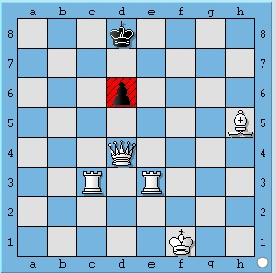  Figure 6. | Board position for sample input 2:  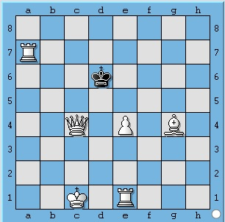  Figure 7.

