Package_TCA6416A_RTW24
封装已经有了。
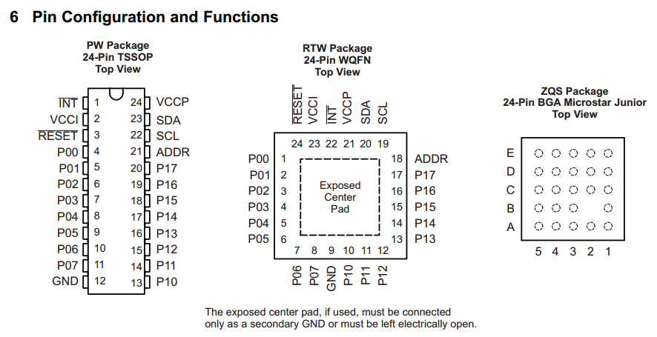

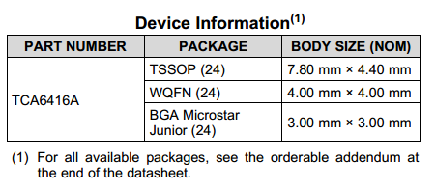

Package_Nrf51822_QFN48
封装已经有了。
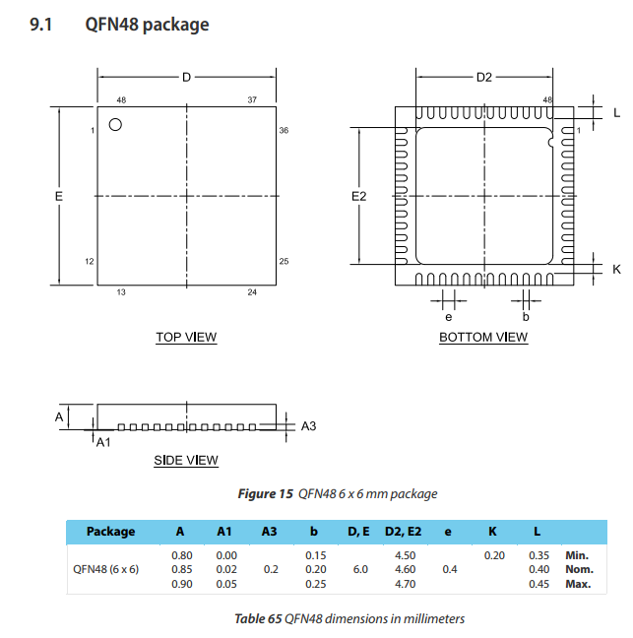

Package_NRF01D3_
封装已经有了。

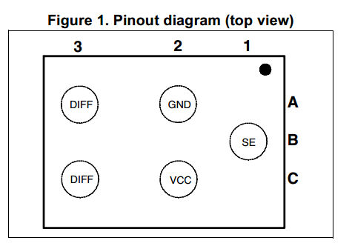
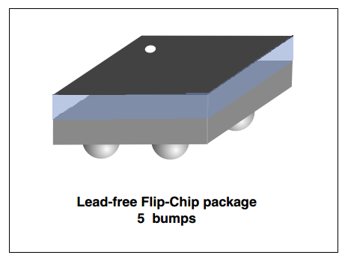

Package_bq24040_DFN10
封装已经有了。
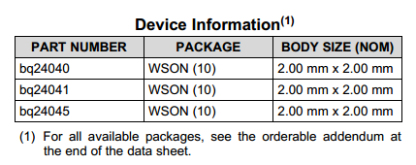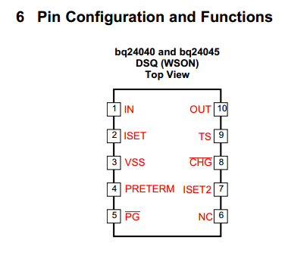
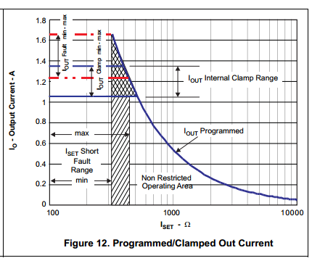
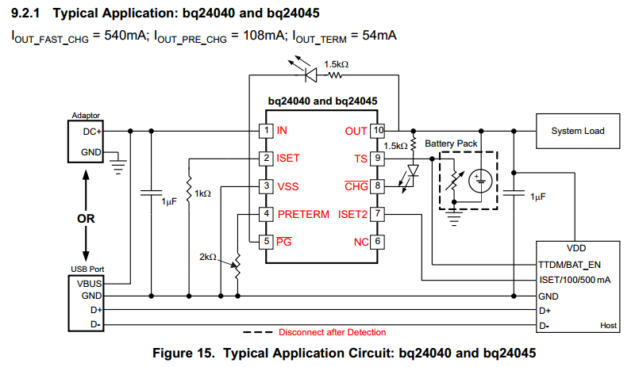

Package_TPS62260_QFN6
封装已经有了。

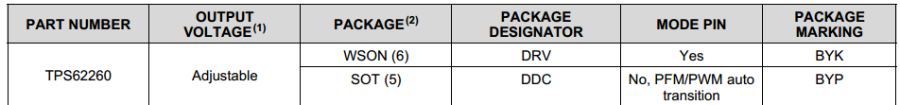

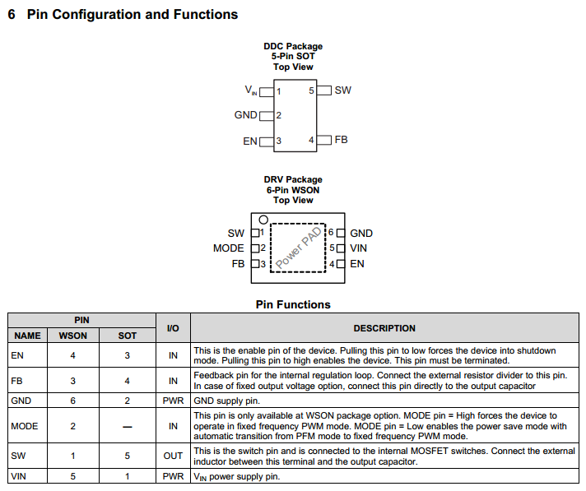

Package_LIS36H_LGA16
没有封装，但可以试着把这个.lia转过去。
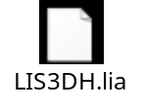
Follow these steps to import into Altium:
- Select File > Import Wizard.
- Select PCAD library from the list and click Next.
- Click Next again to skip importing a design.
- The next dialog will be to import a PCAD library. Add the file downloaded from SnapEDA and follow the rest of the prompts.

