WasteZero
Smart Waste Pickup & Volunteer Management Platform
Project Documentation
Infosys Springboard 7.0 — Virtual Internship
Full-Stack Web Application — MEAN-style Stack (Angular · Node.js · Express · MongoDB)
Document Version 1.0

Documentation Index
Section | Page
1. Introduction | 3
2. Project Overview | 4
3. Objectives & Scope | 5
4. Requirements & Technologies Used | 6
5. System Architecture | 8
6. Database Design | 10
7. Module Implementation | 13
8. Milestone-wise Implementation | 16
9. User Interface & Screenshots | 17
10. API Documentation | 24
11. Testing & Validation | 28
12. Deployment | 29
13. Challenges & Solutions | 30
14. Team Members & Contributions | 31
15. Future Enhancements | 32
16. Conclusion | 34
17. References | 34

1. Introduction
Improper waste segregation and disposal, combined with a shortage of organized, local volunteer effort, remains a persistent civic problem in urban and semi-urban India. Non-governmental organizations (NGOs) running cleanup and recycling drives frequently struggle to find and coordinate volunteers, while residents who want a household waste pickup have no simple digital channel to request one from a nearby NGO.
WasteZero is a full-stack web application designed to close that gap. It gives NGOs a platform to publish volunteer opportunities and manage on-demand waste pickup requests, and gives volunteers/residents a single place to discover opportunities, apply to them, request pickups, and communicate directly and securely with the NGOs they work with.
This document describes the complete design and implementation of WasteZero — its objectives, architecture, database design, module-by-module functionality, the four development milestones it was built across, its REST and real-time API surface, testing approach, deployment process, and the challenges encountered while building it.

2. Project Overview
WasteZero connects three kinds of platform users — volunteers, NGOs, and administrators — around two core workflows:
- Opportunity matching: NGOs post volunteer opportunities (cleanup drives, recycling camps, awareness events); volunteers browse, filter, and apply to the ones that match their skills and location.
- On-demand pickups: Any user can schedule a household waste pickup for a chosen date, time slot, and waste type; nearby NGOs see the request sorted by distance and can accept, decline, or complete it.
Underneath both workflows sits a shared identity, messaging, and notification layer: every opportunity application and pickup update triggers an in-app notification, and volunteers and NGOs can message each other directly through an end-to-end encrypted, real-time chat built on Socket.IO. An administrator role oversees the platform as a whole — moderating users and opportunities, reviewing audit logs, and exporting CSV reports.

2.1 Problem Statement
WasteZero is a digital platform to help users schedule waste pickups, categorize recyclables, and promote responsible waste management. Pickup agents are assigned intelligently based on location.

2.2 Proposed Solution
A three-role (volunteer / NGO / admin) web application with a Node.js/Express/MongoDB backend and an Angular single-page frontend, offering: opportunity posting and application management; distance-aware pickup scheduling and acceptance; real-time, end-to-end encrypted direct messaging; a notification system; and an administration console with platform analytics, moderation tools, and CSV reporting.

3. Objectives & Scope

3.1 Objectives
- Provide secure registration and authentication for three distinct user roles, with email verification and optional two-factor authentication.
- Allow NGOs to create, update, and manage volunteer opportunities, and allow volunteers to discover and apply to them.
- Allow any authenticated user to schedule a waste pickup and allow NGOs to discover pending pickups near them and manage their lifecycle.
- Provide real-time, end-to-end encrypted direct messaging between volunteers and NGOs, with delivery confirmation, read receipts, and typing indicators.
- Keep users informed through an in-app notification system covering application and pickup lifecycle events.
- Give administrators visibility into platform health through a dashboard, a searchable user/opportunity moderation console, an audit log, and downloadable CSV reports.
- Apply defense-in-depth security practices throughout — password hashing, JWT-based auth with refresh-token rotation, rate limiting, input validation, and ownership checks on every mutating endpoint.

3.2 Scope
The current release covers the full opportunity-application lifecycle, the full pickup lifecycle, encrypted direct messaging with multi-device key backup, notifications, a role-aware dashboard, and an administration module. It is a web application (desktop and mobile-responsive browser); a native mobile app, payment/donation handling, and route-optimized multi-stop pickup logistics are explicitly out of scope for this release and are listed under Future Enhancements.

4. Requirements & Technologies Used

4.1 Functional Requirements
- User registration, login, email OTP verification, password reset, and optional 2FA.
- Role-based access control for volunteer, NGO, and admin accounts.
- CRUD operations on volunteer opportunities, restricted to the owning NGO (or an admin).
- Volunteers can apply to, and withdraw from, open opportunities; NGOs can accept or reject applicants.
- Users can schedule a pickup with address, city, date, time slot, waste type(s), and notes.
- NGOs can view available pickups sorted by distance from their registered city, and accept, decline, or complete them.
- Authenticated users can exchange end-to-end encrypted direct messages in real time.
- Users receive notifications for application status changes, new messages, and pickup updates.
- Admins can view platform statistics, search/filter/suspend users, remove opportunities, and export CSV reports.

4.2 Non-Functional Requirements
- Security: passwords hashed with bcrypt, JWT-based stateless authentication, rate limiting on sensitive endpoints, and server-side validation on every request.
- Privacy: message content must never be readable by the server or database — only by the sender and receiver.
- Performance: paginated, indexed queries for all list endpoints (opportunities, pickups, messages, admin logs).
- Usability: a responsive interface that works across desktop, tablet, and mobile breakpoints, with a dedicated bottom-navigation bar on mobile.
- Maintainability: a layered backend (routes → controllers → services → models) and a modular, standalone-component Angular frontend.

4.3 Technology Stack
Layer | Technology | Purpose
Frontend framework | Angular 22 (standalone components, zoneless change detection) | Single-page application UI
Frontend state/data | RxJS, Angular HttpClient, Socket.IO client | Reactive state and real-time communication
Client-side crypto | Web Crypto API (RSA-OAEP, AES-256-GCM), hash-wasm (Argon2id) | End-to-end message encryption & key backup
Styling | SCSS with CSS custom properties, Material Symbols icons | Theming (incl. dark mode) and iconography
Backend runtime | Node.js v24 | Server runtime
Backend framework | Express.js 5 | REST API routing & middleware
Database | MongoDB + Mongoose ODM | Persistent storage and schema modelling
Real-time layer | Socket.IO 4 | Messaging, typing indicators, presence
Auth | jsonwebtoken, bcrypt | JWT issuing/verification, password hashing
Validation | Joi | Request payload validation
Security middleware | Helmet, CORS, express-rate-limit | HTTP headers, cross-origin policy, abuse prevention
Logging | Winston | Structured application logging
Media storage | Cloudinary | Opportunity image uploads
Email | Nodemailer + SMTP | OTP / verification / password-reset emails
Reporting | PDFKit, dependency-free CSV encoder | Admin PDF/CSV report generation
Tooling | Angular CLI, Vitest, Prettier | Build, unit testing, formatting

4.4 Development Environment
- Node.js v24, npm 10+
- MongoDB (local instance or MongoDB Atlas)
- Angular CLI 22
- A Cloudinary account (image uploads) and an SMTP provider (OTP emails) for full functionality

5. System Architecture
WasteZero follows a classic three-tier architecture: an Angular single-page application (presentation tier), an Express.js REST + Socket.IO API (application tier), and MongoDB (data tier). The frontend never talks to the database directly — every read or write goes through the validated, authenticated API layer.

5.1 High-Level Architecture
Client (Angular SPA) ↔ HTTPS/WebSocket ↔ Express REST API + Socket.IO server ↔ Mongoose ODM ↔ MongoDB. Cloudinary is used out-of-band for image storage, and an SMTP provider is used out-of-band for transactional email.

5.2 Backend Request Pipeline
Every REST request that reaches a protected route passes through the same layered pipeline before it touches the database:
- Global middleware — Helmet (security headers), CORS, JSON body parsing (10 MB limit), and a global rate limiter.
- Auth middleware — verifies the JWT access token and attaches the authenticated user to the request.
- Role middleware — restricts the route to one or more of volunteer / ngo / admin.
- Ownership middleware — for update/delete routes on a specific resource, confirms the authenticated user owns that resource (or is an admin).
- Joi validator — validates and sanitizes the request body/query before it reaches business logic.
- Controller — a thin function that reads the request and calls the corresponding service; contains no business logic itself.
- Service layer — owns all business logic and Mongoose queries.
- Response — every successful response is wrapped in a standard envelope: { success, message, data, timestamp }; errors are normalized by a central error-handling middleware.

5.3 Real-Time Layer
Socket.IO runs alongside the HTTP server and reuses the same JWT for authentication (sent as socket.handshake.auth.token). On connection, each socket joins a private room named after the user’s ID, so every open tab/device for that user receives events emitted to that room. This backs live message delivery (message:send / message:new), read receipts (message:read), typing indicators (typing:start / typing:stop), and online-presence broadcasts (presence:update, presence:list).

5.4 Frontend Architecture
The Angular application uses standalone components (no NgModules) organized by feature under src/app/features (auth, dashboard, opportunities, pickups, messages, profile, settings, admin, help), with cross-cutting singletons under src/app/core (an HTTP auth interceptor, the end-to-end crypto service, a theme service) and reusable presentational components under src/app/shared (sidebar, mobile bottom navigation, city autocomplete, notification bell). The app runs with zoneless change detection, and all styling is done with SCSS and CSS custom properties to support light/dark theming.

6. Database Design
WasteZero uses MongoDB with Mongoose schemas. All eight collections share a common convention: Mongoose timestamps (createdAt/updatedAt), a toJSON transform that strips the internal __v version key, and compound indexes chosen to match the platform’s most frequent query patterns (e.g. "opportunities open in city X", "messages between two users", "pickups pending near coordinate Y").

6.1 Entity-Relationship Summary
- A User (role = ngo) creates many Opportunities.
- A User (role = volunteer) submits many Applications, each referencing one Opportunity.
- A User creates many Pickups; an NGO User is optionally assigned to a Pickup once accepted.
- Two Users exchange many Messages, optionally linked to an Application.
- A User receives many Notifications, optionally triggered by another User (sender).
- An admin User performs many logged AdminLog actions against a target User/Opportunity/Pickup/Application.
- A User has many RefreshTokens, one per logged-in device/session.

6.2 Collections

6.2.1 User
Stores identity, role, profile, security state (login attempts/lockout, OTP and 2FA state, refresh-session metadata), and the end-to-end encryption key material for messaging.
Field | Type | Notes
name, email, password | String | password is bcrypt-hashed and excluded from query results by default (select: false)
role | String enum | volunteer | ngo | admin
skills, city, bio | Array / Object / String | city stores { name, lat, lng } for distance calculations
isSuspended, suspendedAt, suspendedReason | Boolean / Date / String | Admin moderation flags; historical data is preserved on suspension
publicKey | String | RSA-OAEP public key (JWK) used by others to encrypt messages to this user
keyBackup | Object | ciphertext, iv, salt, kdf params — password-wrapped backup of the private key for multi-device recovery
isEmailVerified, emailVerificationOtp*, passwordResetOtp*, twoFactor* | Boolean / String / Date / Number | OTP codes are hashed; attempt counters and lockout timestamps throttle abuse
loginAttempts, loginLockedUntil | Number / Date | Account lockout after repeated failed logins

6.2.2 Opportunity
Field | Type | Notes
title, description, requiredSkills | String / [String] | requiredSkills is de-duplicated and lower-cased on write
image, imagePublicId | String | Cloudinary URL and public ID for the opportunity banner image
location.city / .state, lat, lng | String / Number | Used for city-based filtering and distance sorting
duration.value / .unit | Number / String enum | hours | days | weeks | months
status | String enum | open | closed | completed (see opportunityStatus constants)
maxVolunteers, applicationDeadline | Number / Date | Optional caps on applications
ngo, createdBy, updatedBy | ObjectId → User | Ownership and audit trail
isDeleted, deletedAt | Boolean / Date | Soft delete — records are hidden, not destroyed

6.2.3 Application
Links a volunteer to an opportunity. A compound unique index on (opportunity, volunteer) prevents duplicate applications. status moves through pending → accepted / rejected, or volunteer-initiated withdrawn; reviewedBy and reviewedAt record which NGO/admin actioned it and when.

6.2.4 Pickup
Represents a scheduled waste-collection request from any user. Stores the pickup address plus lat/lng (resolved from the selected city), preferred date and time slot, one or more waste types, and free-text notes. status moves through PENDING → IN_PROGRESS → COMPLETED, or CANCELLED at various points; ngo records which NGO accepted it, with acceptedAt / completedAt / cancelledAt timestamps.

6.2.5 Message
Stores only ciphertext — never plaintext. Each row holds an AES-GCM ciphertext + iv, and two RSA-OAEP-wrapped copies of the AES key (encryptedKeyForSender, encryptedKeyForReceiver) so either party can decrypt their own copy client-side. Optionally linked to the Application that started the conversation. isRead / readAt back the read-receipt feature.

6.2.6 Notification
Intentionally denormalized — title, message, and link are snapshotted at creation time so a notification still reads correctly even if the underlying opportunity, pickup, or message is later edited or deleted. type is one of MESSAGE | OPPORTUNITY | PICKUP | APPLICATION.

6.2.7 AdminLog
An immutable (createdAt-only) audit trail of every administrative action — action (CREATE/UPDATE/DELETE/APPROVE/REJECT/…), targetType, targetId, a free-form details object, and the acting admin’s IP/user agent.

6.2.8 RefreshToken
One row per active login session/device. Stores a hash of the refresh token (never the raw token), an expiry, a rememberMe flag that determines the token lifetime (7 vs. 30 days), and revocation state, enabling both single-session logout and "logout everywhere."

6.3 Indexing Strategy
Every collection carries indexes matched to its dominant read pattern: a text index on Opportunity.title for search, compound indexes on (status, location.city) and (ngo) for opportunity listings, a unique compound index on (opportunity, volunteer) for applications, (sender, receiver, createdAt) and (receiver, isRead) for message threads and unread counts, (status) and (ngo, status) for pickup queues, and a TTL index on RefreshToken.expiresAt so expired sessions are automatically purged by MongoDB.

7. Module Implementation

7.1 User Management
Covers registration, authentication, session management, and profile/security settings.
- Registration collects name, email, password, and role, and sends a 6-digit email OTP that must be verified before login (verify-email / resend-otp).
- Login validates credentials, enforces a lockout after 5 failed attempts (30-minute auto-unlock), and, if the account has 2FA enabled, issues a short-lived 2FA session that must be completed with a second OTP (verify-2fa).
- Successful login returns a short-lived JWT access token (15 minutes) and a longer-lived, rotating refresh token (7 days, or 30 with "remember me"), stored server-side as a hashed RefreshToken document per device.
- Users can view active sessions and revoke a single device (revoke) or every device at once (logout-all); forgot-password / reset-password follow the same OTP pattern as email verification.
- Profile management (GET/PUT /users/profile) lets a user update name, bio, skills, and city; change-password-init / -confirm re-verifies the current password via OTP before a password change is committed.
- Admins can suspend or reinstate any non-admin account; a suspended user is rejected at login with a clear 403 while their historical data (opportunities, pickups, messages) remains intact.

7.2 Opportunity Management
NGOs (and admins) create opportunities with a title, description, required skills, location, duration, optional banner image (via Cloudinary), and an optional application deadline / volunteer cap. Volunteers browse a paginated, searchable, filterable list (by keyword, city, status) and view full opportunity detail. Only the owning NGO can edit or soft-delete an opportunity (enforced by the ownership middleware); status can be transitioned to closed or completed by the owning NGO or an admin.

7.3 Matching & Communication
This module covers three closely related features: applications, real-time encrypted messaging, and notifications.

7.3.1 Applications
- A volunteer applies to an open opportunity (POST /applications); a unique index prevents duplicate applications to the same opportunity.
- The volunteer can withdraw a pending application; the owning NGO (or an admin) can accept or reject it, which stamps reviewedBy / reviewedAt.
- Every status change triggers a notification to the affected volunteer.

7.3.2 Pickups
- A user schedules a pickup with an address, a city selected from a bundled dataset of ≈ 90 Indian cities (with lat/lng), a date, a time slot, one or more waste types, and optional notes.
- NGOs see pending pickups sorted by great-circle (haversine) distance from their own registered city, computed by the shared utils/geo.js helper.
- An NGO accepts a pickup (assigning themselves and stamping acceptedAt), declines it, or marks it completed (completedAt); the requesting user can cancel a pending pickup.

7.3.3 Real-time encrypted messaging
Messaging is described in full in the Milestone 3 and Security sections. In summary: messages are end-to-end encrypted in the browser (RSA-OAEP key pairs + per-message AES-256-GCM), delivered over an authenticated Socket.IO connection, with a REST fallback (POST /messages) for clients not connected to the socket. Conversation history, typing indicators, read receipts, and online presence are all supported.

7.3.4 Notifications
A lightweight, denormalized notification is created server-side whenever a tracked event occurs (new application, application accepted/rejected, new message, pickup accepted/declined/completed). The frontend polls an unread-count endpoint for the notification bell badge and a paginated list endpoint for the full feed, with mark-as-read (single or bulk) support.

7.4 Administration & Reporting
Restricted entirely to the admin role via router-level middleware. Provides:
- Platform statistics (GET /admin/stats) — user counts, pickup and opportunity counts, etc.
- User search/filter with pagination (GET /admin/users) and suspend/reinstate (PATCH /admin/users/:id/suspend) — an admin cannot suspend themselves or another admin.
- Opportunity moderation — force soft-delete any opportunity (DELETE /admin/opportunities/:id).
- An audit log viewer (GET /admin/logs) reading from the AdminLog collection.
- CSV report downloads for users, pickups, opportunities, or a combined report (GET /admin/reports/:type), generated by a dependency-free CSV encoder with UTF-8 BOM for clean Excel/Sheets compatibility.
- A role-aware Dashboard (GET /dashboard, shared with non-admin roles) showing month-over-month trend percentages, a recycling breakdown, and upcoming pickups; estimated CO₂ saved and total kg collected are derived from a constant average weight per completed pickup, since per-pickup weight capture is not yet part of the schema.

8. Milestone-wise Implementation
Development proceeded through four sequential milestones, each frozen and verified before the next began.

8.1 Milestone 1 – User Management
Established the backend foundation: Express app setup, MongoDB connection, the core middleware stack (Helmet, CORS, rate limiting, centralized error handling), the layered route → controller → service → model architecture, and the full authentication system — registration, email OTP verification, login, JWT issuing, refresh-token rotation, password reset, account lockout, and optional two-factor authentication. Delivered as a REST-only backend, verified with a Postman collection.

8.2 Milestone 2 – Opportunity Management
Built the Angular frontend shell (routing, auth interceptor, shared layout components) and the Opportunity Management module end-to-end: opportunity CRUD APIs with Joi validation and ownership checks, Cloudinary image upload, and the corresponding Angular pages (opportunity list with search/filter, opportunity detail, and a create/edit form) with role-based UI (only NGOs see create/edit actions).

8.3 Milestone 3 – Matching & Communication
Added the Application APIs (apply/withdraw/review), and built real-time messaging from the ground up: a Socket.IO server authenticated with the existing JWT, conversation history and pagination endpoints, typing indicators, read receipts, and online presence. The end-to-end encryption layer (RSA-OAEP key pairs, per-message AES-256-GCM, and the Argon2id-based multi-device key backup) was implemented on the frontend crypto service during this milestone, alongside the notification system that ties application and message events together.

8.4 Milestone 4 – Administration & Reporting
Delivered the admin dashboard and platform reporting, admin moderation controls, and the previously placeholder user Dashboard. On the backend this added user suspension fields and enforcement at login, a dependency-free CSV encoder, and the dashboard/admin controllers and routes. On the frontend this added the fully implemented Dashboard page (stat cards, upcoming pickups, recycling breakdown, recent messages) and the Admin Panel (stat cards, report downloads, user management with search/filter/suspend, and an admin logs tab), plus sidebar/mobile-nav links and a post-login redirect to /dashboard.

9. User Interface & Screenshots
The interface is a responsive Angular single-page application with a persistent sidebar on desktop and a bottom navigation bar on mobile, light and dark themes driven by CSS custom properties, and Material Symbols iconography throughout. The main screens are:
- Auth screen — combined login / registration
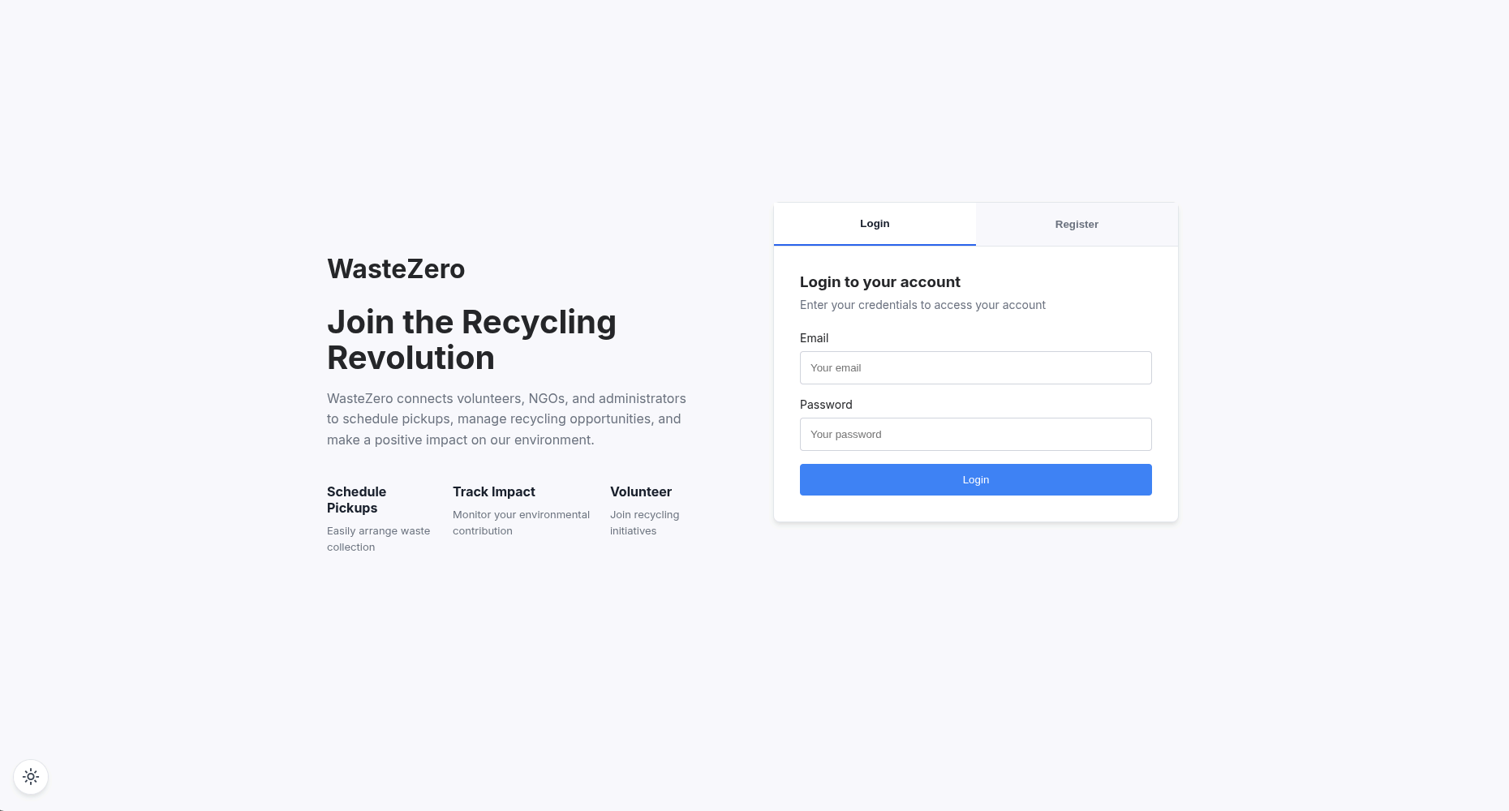
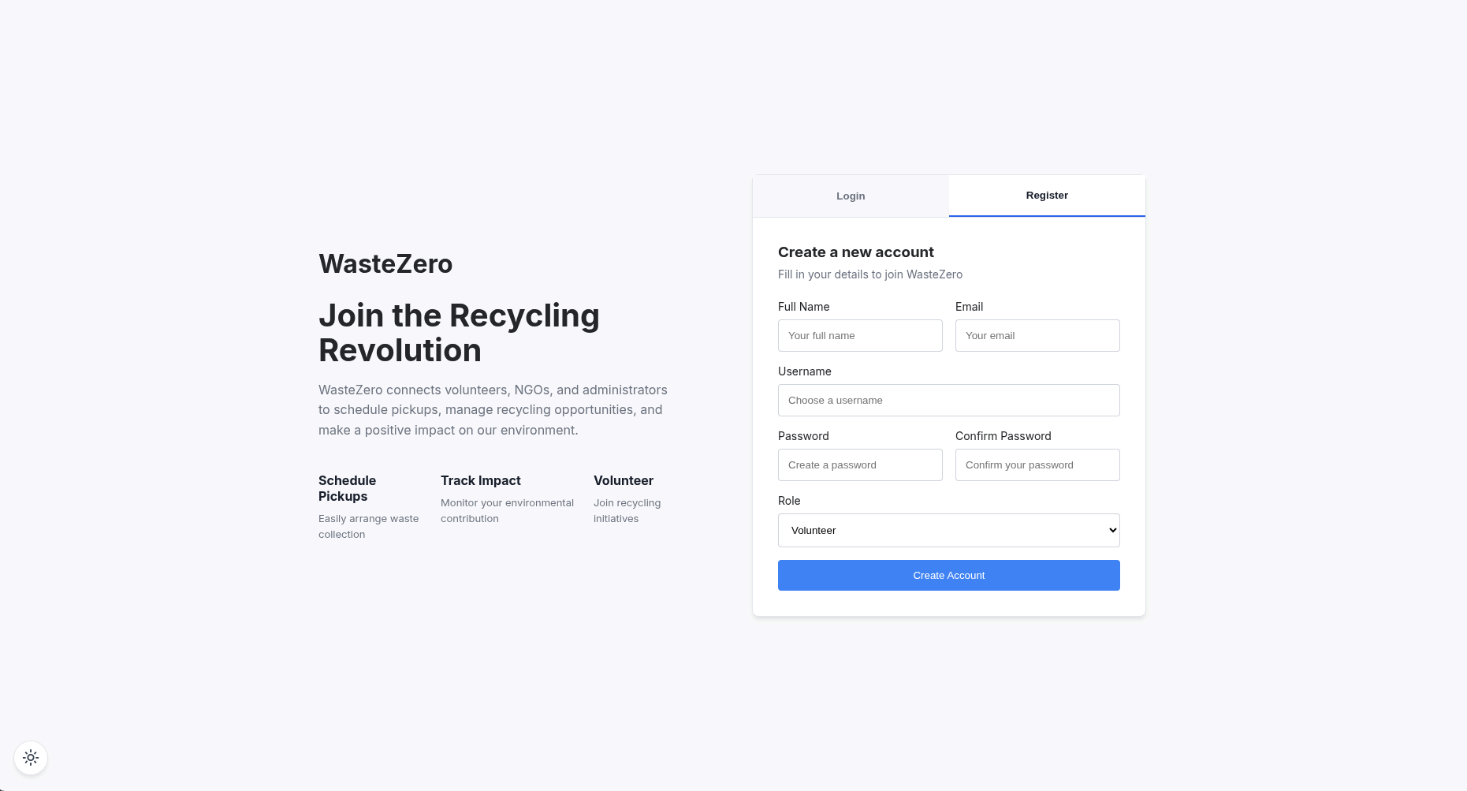
- Dashboard — role-aware stat cards, upcoming pickups, recycling breakdown, recent messages.
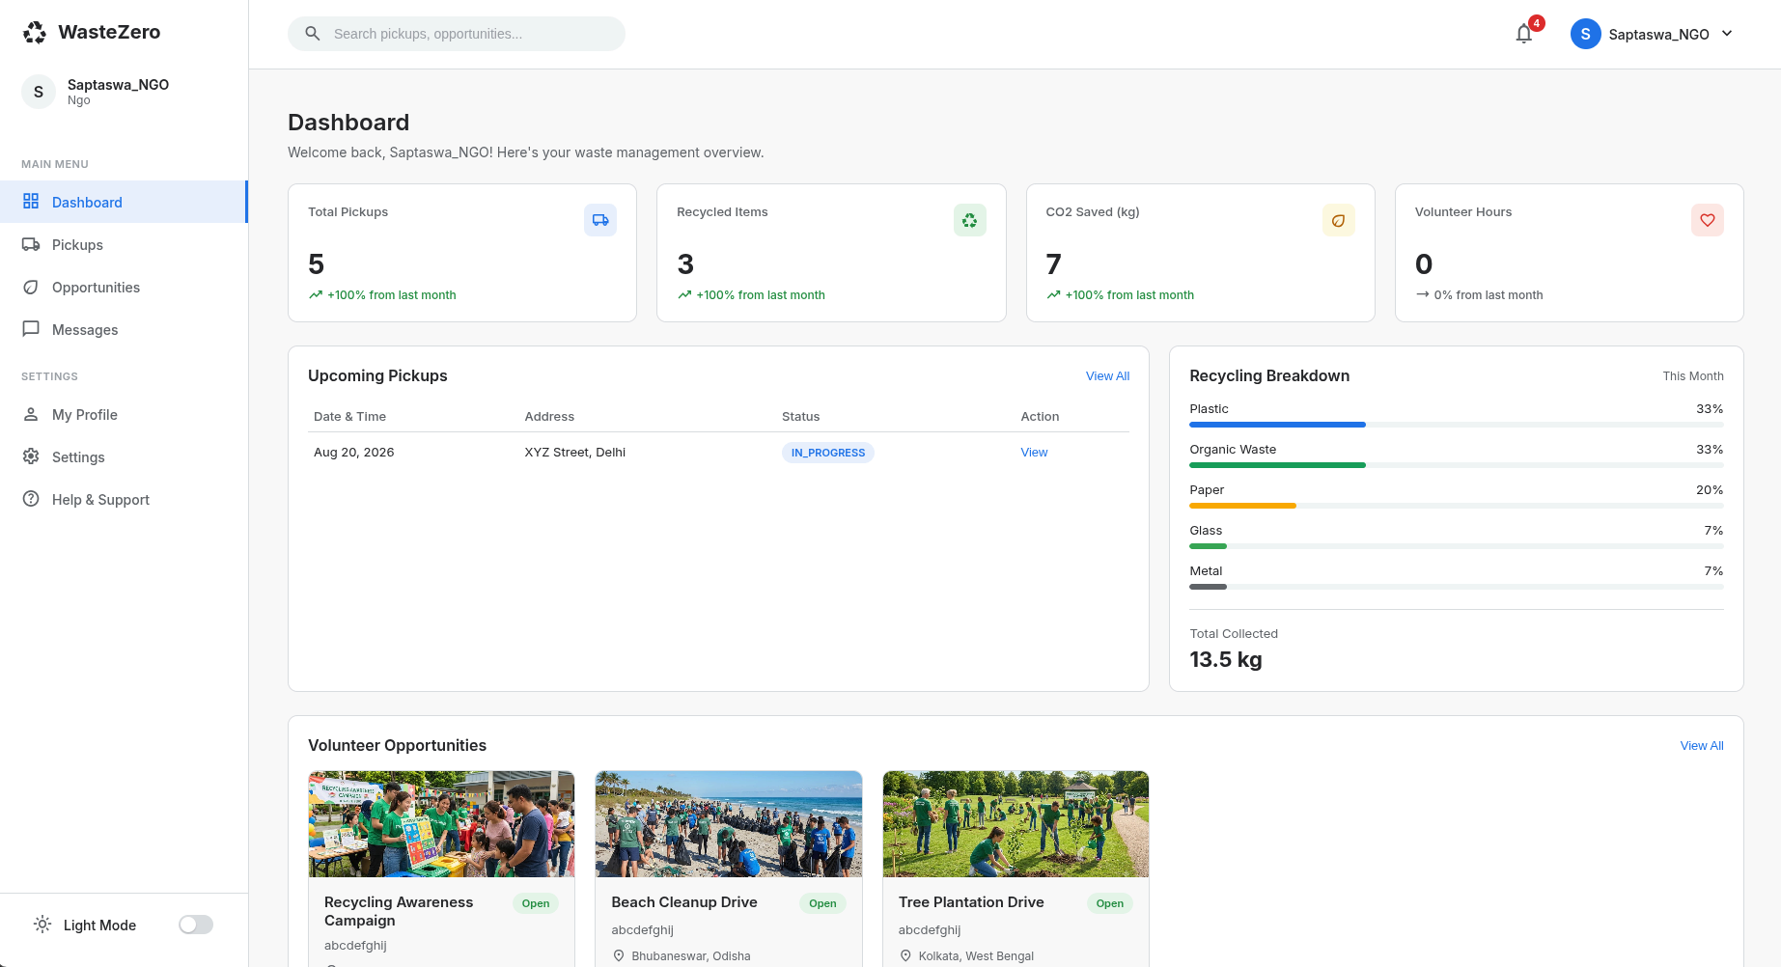
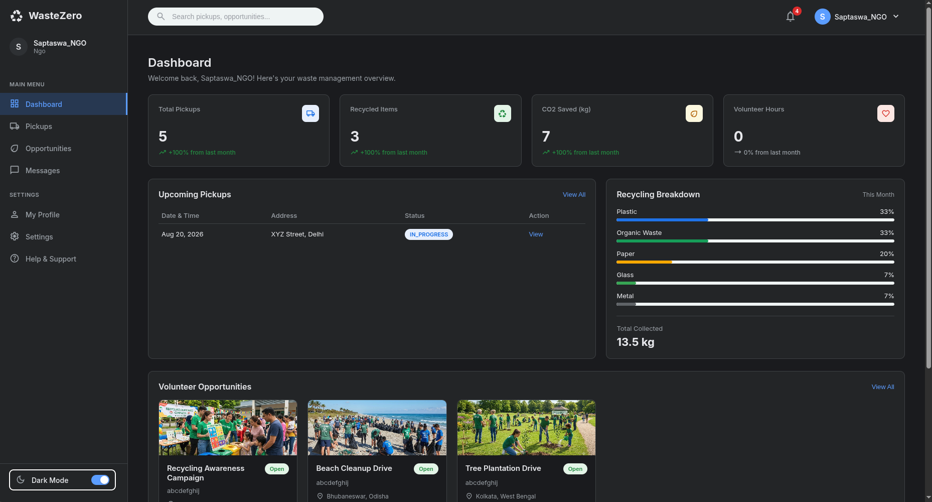

- Opportunities — searchable/filterable list, detail view, and create/edit form (NGO only).
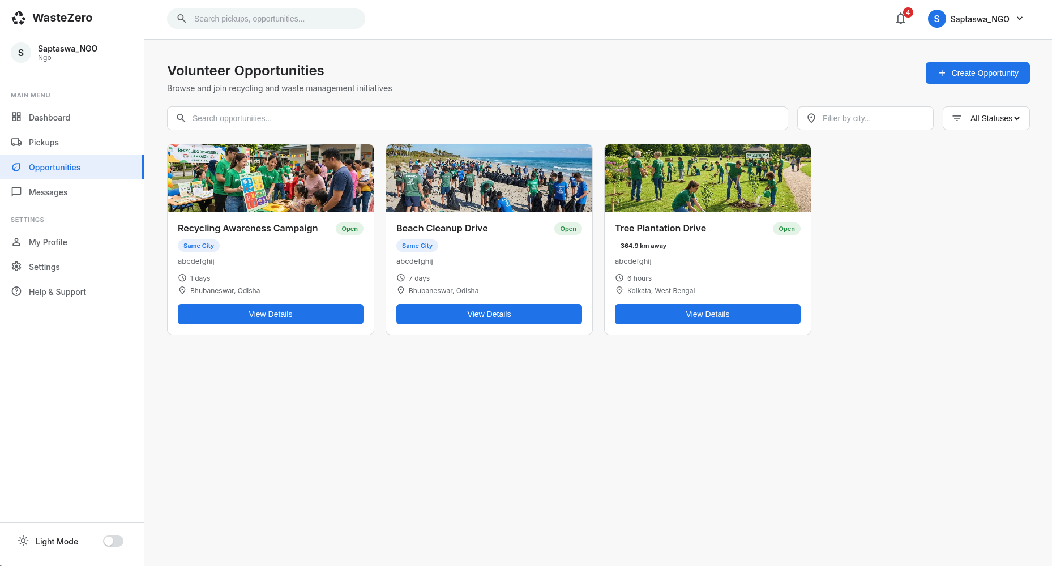

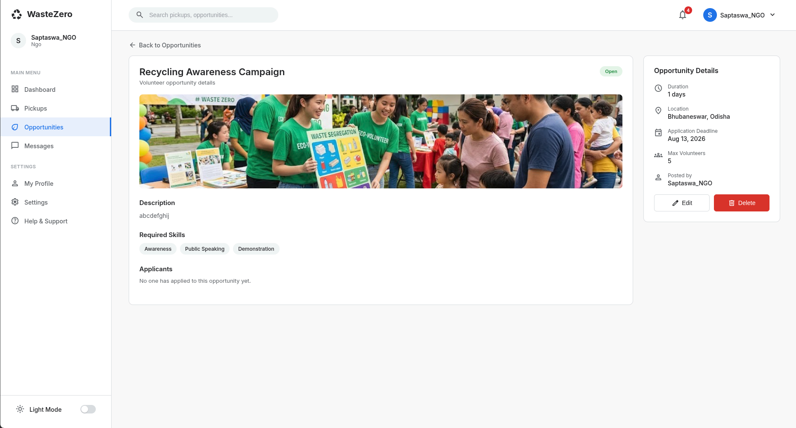

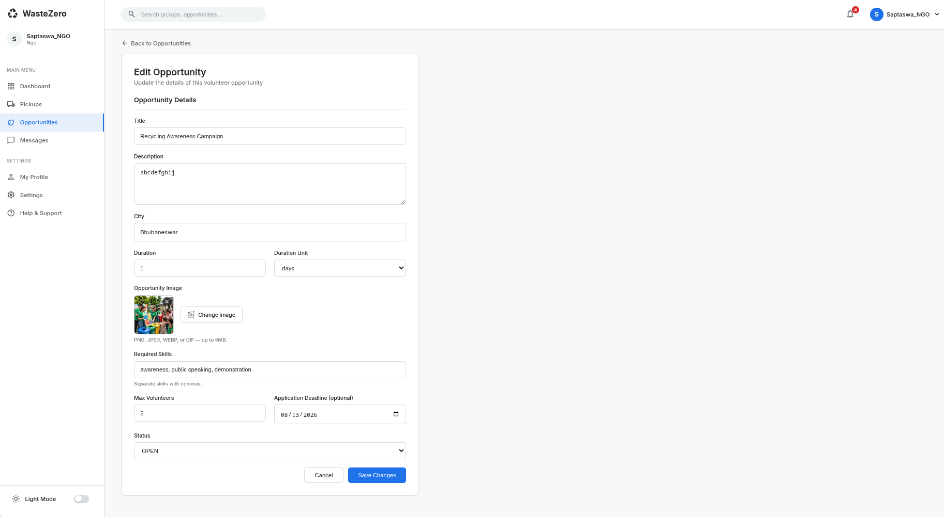
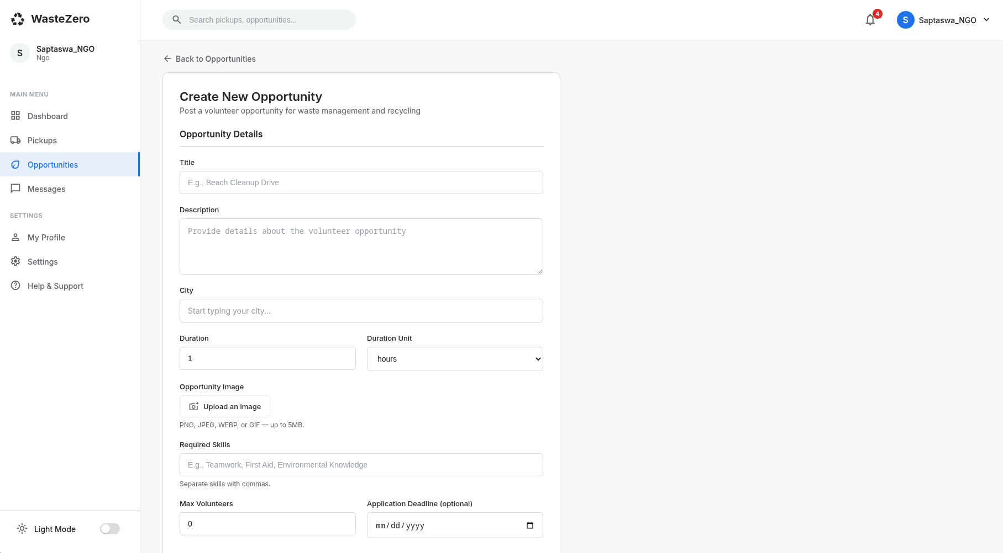

- Pickups — schedule-pickup form for any user; a distance-sorted manage-pickups queue for NGOs.
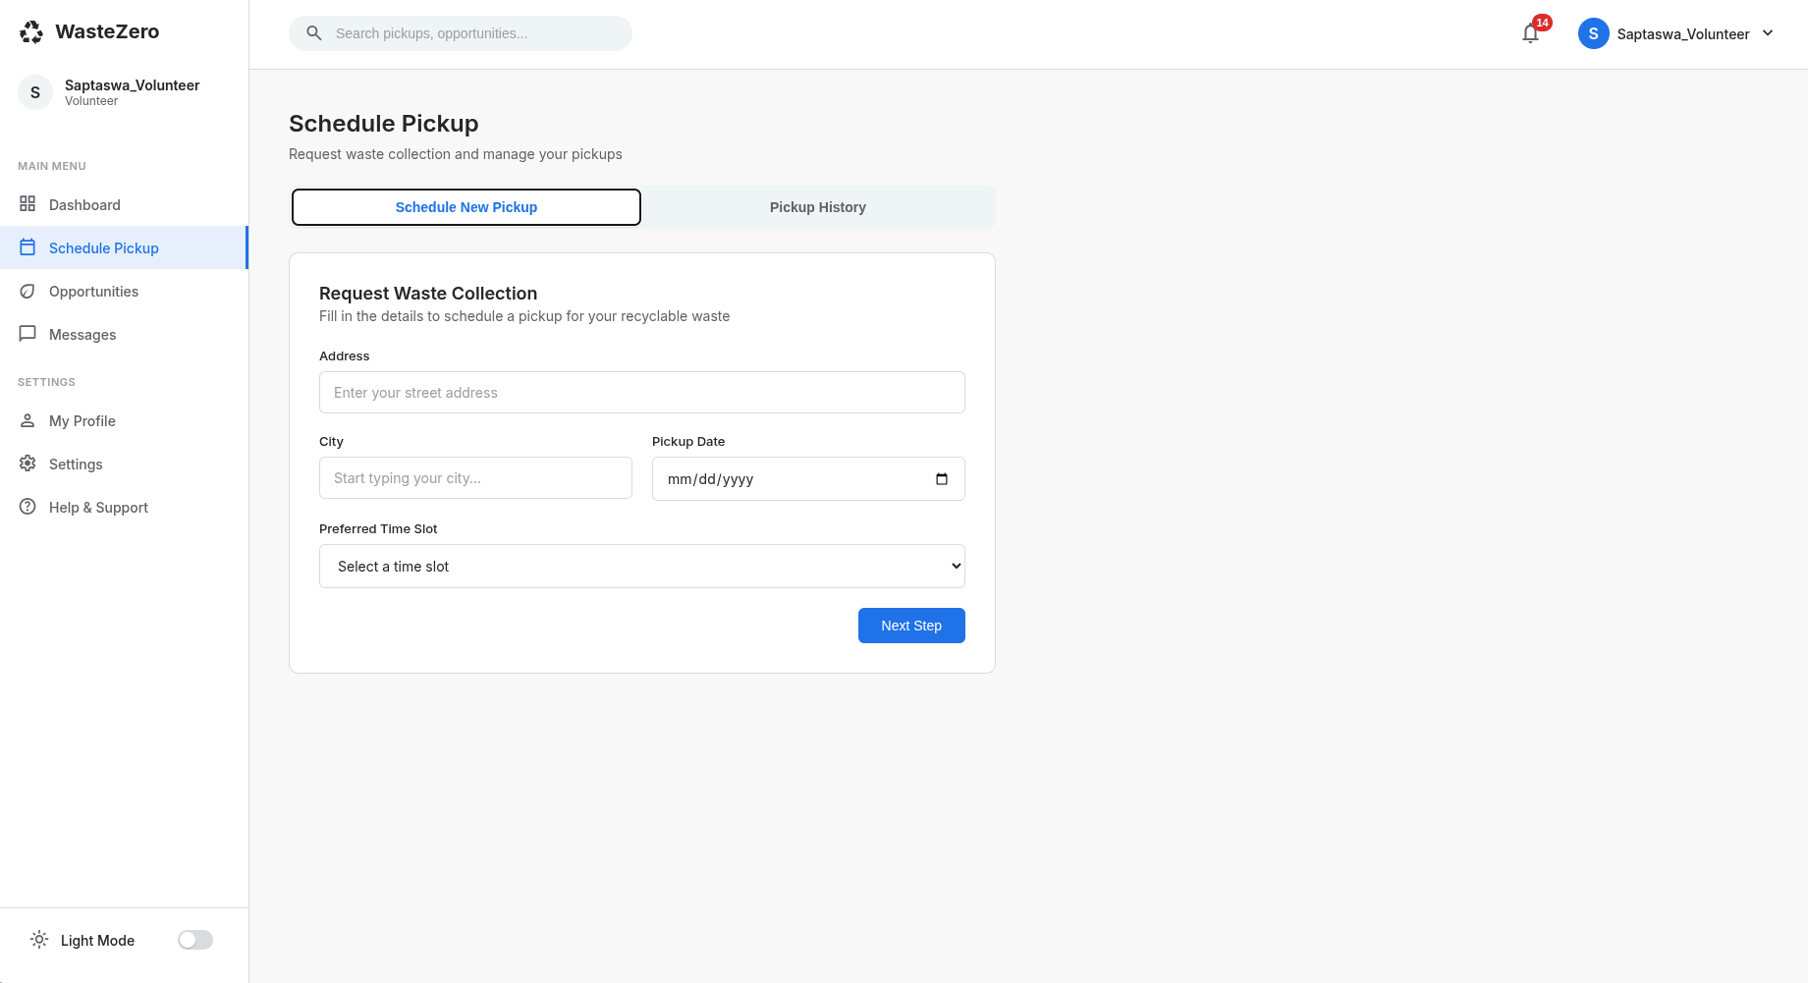

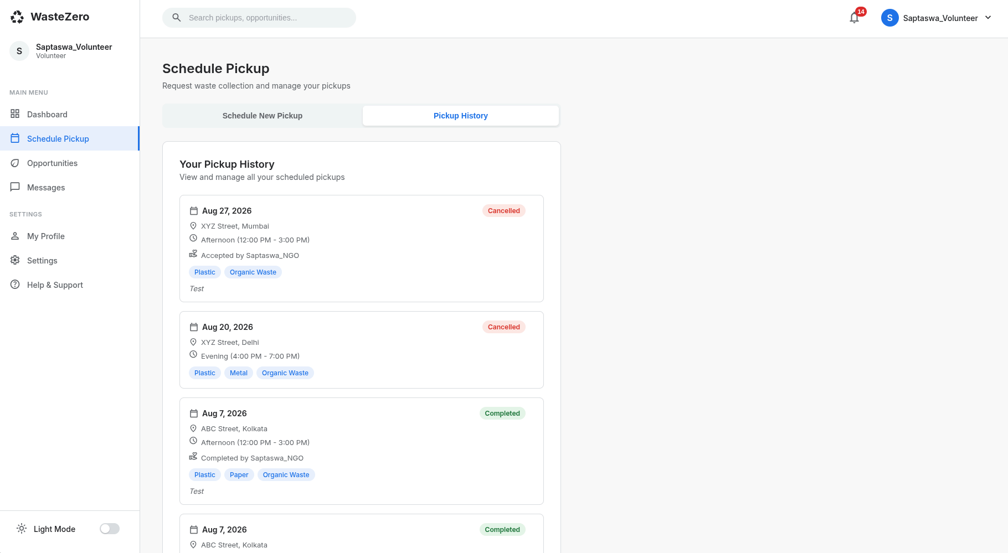
- Messages — conversation list and an end-to-end encrypted chat thread with typing indicators and read receipts.
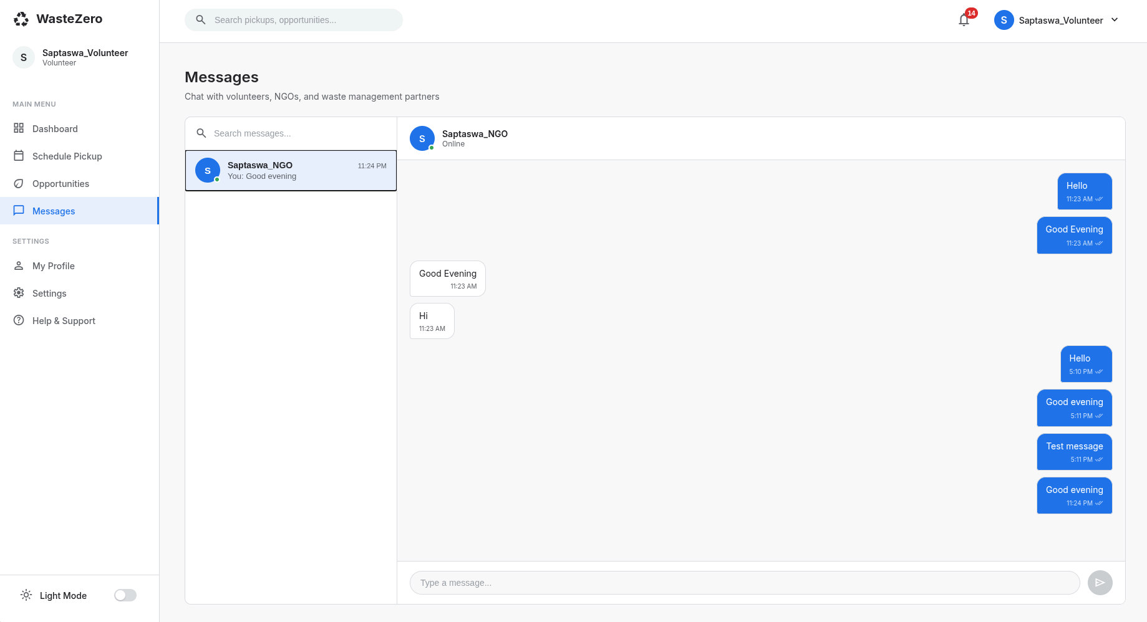
- Profile & Settings — personal info, password change, theme preference.
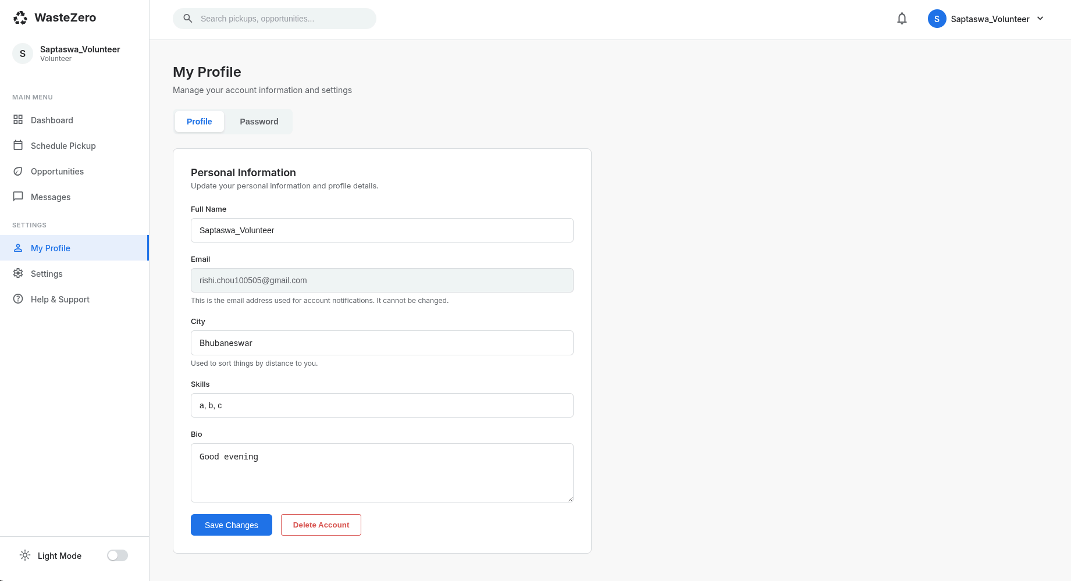

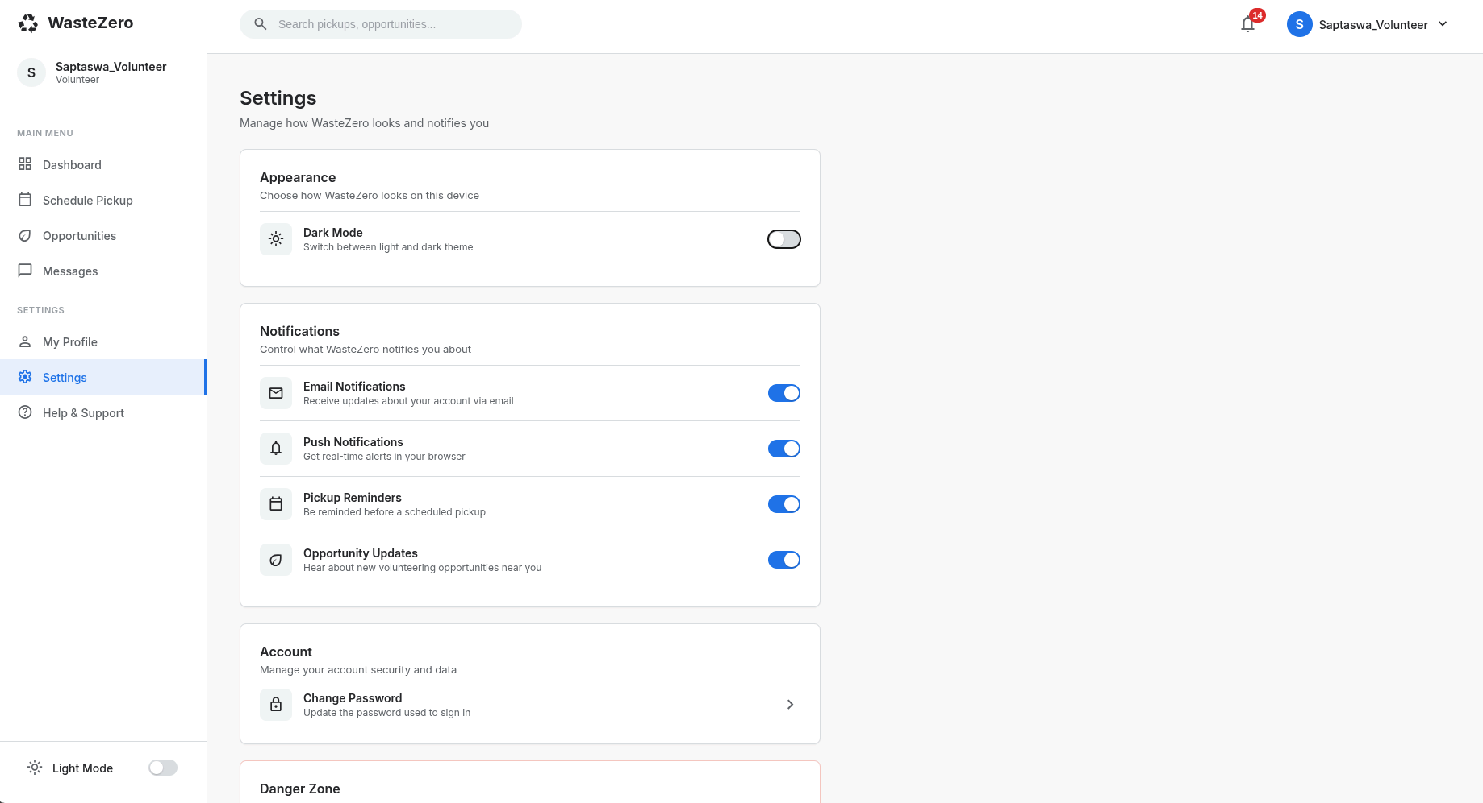
- Admin Panel — platform stats, user management, report downloads, admin logs (admin only).
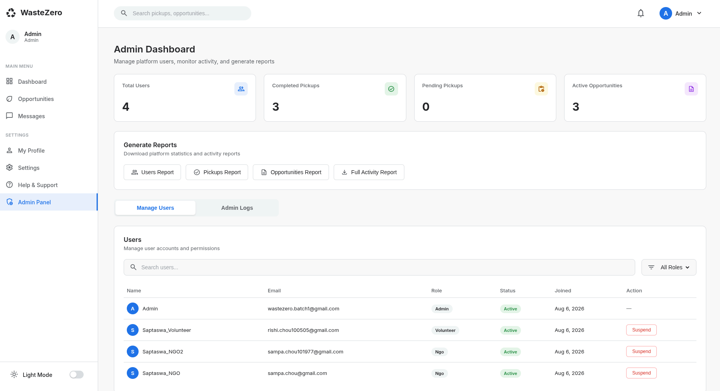

10. API Documentation
All REST endpoints are mounted under the base path /api/v1. Except where marked "Public", every route requires an Authorization: Bearer <accessToken> header. Every response follows the envelope { success, message, data, timestamp }.

10.1 Auth — /api/v1/auth
Method & Route | Auth | Description
POST /register | Public | Register a new user (volunteer / ngo / admin) and send an email OTP
POST /login | Public | Validate credentials; returns JWT + refresh token, or a 2FA challenge
POST /verify-email | Public | Verify the registration OTP
POST /resend-otp | Public | Resend the email verification OTP (rate-limited)
POST /forgot-password | Public | Request a password-reset OTP
POST /reset-password | Public | Reset the password using the OTP
POST /refresh-token | Public | Rotate a refresh token for a new access token
POST /verify-2fa / /resend-2fa | Public | Complete or resend the post-login 2FA challenge
POST /logout | JWT | Revoke the current refresh token
GET /session | JWT | Validate the current session
POST /revoke | JWT | Revoke one specific refresh token/device
POST /logout-all | JWT | Revoke every refresh token for the account

10.2 Users — /api/v1/users
Method & Route | Description
GET /search | Search users (used to start a new conversation)
GET /profile · PUT /profile | Get / update the current user’s profile
DELETE /profile | Delete the current user’s account
PUT /public-key | Upload the user’s E2EE public key
GET /:userId/public-key | Fetch another user’s public key (for encrypting a message to them)
PUT /key-backup · GET /key-backup | Upload / fetch the password-wrapped E2EE key backup (self only)
POST /change-password-init / -confirm | OTP-verified password change

10.3 Opportunities — /api/v1/opportunities
Method & Route | Role | Description
GET / | Any | List opportunities (search, filter, paginate, sort)
POST / | ngo, admin | Create an opportunity
GET /:id | Any | Get one opportunity
PUT /:id | ngo (owner) | Update an opportunity
PATCH /:id/status | ngo (owner), admin | Change opportunity status
DELETE /:id | ngo (owner) | Soft-delete an opportunity

10.4 Applications — /api/v1/applications
Method & Route | Role | Description
POST / | volunteer | Apply to an opportunity
GET /mine | volunteer | List the current volunteer’s applications
DELETE /opportunity/:opportunityId | volunteer | Withdraw an application
GET /opportunity/:opportunityId | ngo, admin | List applicants for an opportunity
PATCH /:id/status | ngo, admin | Accept or reject an application

10.5 Pickups — /api/v1/pickups
Method & Route | Role | Description
POST / | volunteer | Schedule a pickup
GET /mine | volunteer | List the current user’s pickups
GET /available | ngo | List pending pickups, sorted by distance
GET /accepted | ngo | List pickups accepted by the current NGO
GET /:id | Any | Get one pickup
PATCH /:id/cancel | volunteer, admin | Cancel a pickup
PATCH /:id/accept | ngo | Accept a pending pickup
PATCH /:id/decline | ngo | Decline a pending pickup
PATCH /:id/complete | ngo | Mark a pickup completed

10.6 Messages — /api/v1/messages
Method & Route | Description
GET /conversations | List every conversation the user is part of
GET /:userId | Full encrypted message history with one user
PATCH /:userId/read | Mark all messages from :userId as read
POST / | Send a message (REST fallback — primary path is the socket)

10.7 Notifications — /api/v1/notifications
Method & Route | Description
GET / | Paginated notification list + unread count
GET /unread-count | Badge count only
PATCH /read-all | Mark every notification read
PATCH /:id/read | Mark one notification read

10.8 Dashboard & Admin
Method & Route | Role | Description
GET /dashboard | Any | Role-aware platform stats for the current user
GET /admin/stats | admin | Platform-wide statistics
GET /admin/users | admin | Search/filter/paginate users
PATCH /admin/users/:id/suspend | admin | Suspend or reinstate a user
DELETE /admin/opportunities/:id | admin | Force-remove an opportunity
GET /admin/logs | admin | Audit log listing
GET /admin/reports/:type | admin | Download a CSV report (users / pickups / opportunities / full)

10.9 Real-Time Events (Socket.IO)
Clients authenticate the socket handshake with the same JWT access token (auth.token). All events are namespaced by direction:
Event | Direction | Purpose
message:send | Client → Server | Send an encrypted message payload; acknowledged via callback
message:new | Server → Client | Broadcast a new message to sender and receiver rooms
message:read | Client ↔ Server | Mark a conversation read; notifies the other party
typing:start / typing:stop | Client ↔ Server | Typing indicator relay
presence:check / presence:list / presence:update | Client ↔ Server | Online/offline presence

11. Testing & Validation

11.1 Approach
Backend changes are verified in three layers before being considered complete: static syntax verification of every changed file, a require-time wiring check (booting the server and confirming every router/controller/model/middleware resolves and mounts cleanly), and — where a live MongoDB instance is reachable — functional verification against real requests (via Postman or equivalent). Frontend changes are verified with a full Angular production build (ng build), which must complete with zero errors and zero unused-import/template warnings, confirming type-safety against existing services and valid routing/DI wiring; component-level behavior is additionally covered by Vitest unit tests (ng test) for components that ship a .spec.ts file.

11.2 Areas Covered
- Authentication: registration, OTP verification, login lockout, 2FA challenge/verify, refresh-token rotation, logout / logout-all.
- Authorization: role middleware and ownership middleware correctly reject cross-role and cross-owner requests.
- Opportunities & Applications: CRUD validation, duplicate-application prevention, status-transition rules.
- Pickups: distance-sort correctness against the bundled city coordinate dataset, and status-transition rules (accept/decline/complete/cancel).
- Messaging: end-to-end encryption/decryption round-trips, conversation pagination, read-receipt and typing-indicator events.
- Admin: suspended-user login rejection, self/other-admin suspension guards, CSV report structure and encoding, audit-log correctness.

12. Deployment

12.1 Local Development
Backend: cd Backend && npm install && npm run dev (starts on http://localhost:3000, health check at GET /health). Frontend: cd Frontend && npm install && npm start (starts on http://localhost:4200 via ng serve, pointed at the backend URL configured in src/environments/environment.ts).

12.2 Environment Configuration
The backend is configured entirely through environment variables (Backend/.env): server port and Node environment, the MongoDB connection string, JWT secret and expiry, SMTP credentials for transactional email, and Cloudinary credentials for image uploads. None of these values are committed to source control in a real deployment — a .env.example template should be provided and the actual .env populated per environment.

12.3 Production Build
Frontend: npm run build produces an optimized static bundle in Frontend/dist/, which can be served from any static host or CDN, or from the Express server itself. Backend: npm start runs the server directly under Node.js; in production this is typically wrapped with a process manager (e.g. PM2) or containerized, sitting behind a reverse proxy (e.g. Nginx) that terminates TLS and forwards both HTTP and WebSocket traffic to the Node process.

12.4 Suggested Production Topology
- MongoDB Atlas (or a managed MongoDB instance) as the database tier.
- The Node/Express API (with Socket.IO) deployed to a Node-capable host (e.g. a VM, container platform, or PaaS) with the reverse proxy configured for WebSocket upgrade support.
- The Angular production build served as static assets from a CDN or the same reverse proxy.
- Cloudinary for image storage and an SMTP provider (e.g. a transactional-email service) wired via the existing environment variables — no code changes required to swap providers.

13. Challenges & Solutions
Challenge | Solution
Keeping message content unreadable to the server/database while still supporting multi-device access and read receipts. | Implemented client-side end-to-end encryption (RSA-OAEP key pairs + per-message AES-256-GCM), and a password-derived (Argon2id) key backup so a second device can recover the original key pair instead of generating a new, history-incompatible identity, without the password or KEK ever leaving the browser.
Distance-aware pickup sorting without a paid geocoding API. | Bundled a static dataset of ≈ 90 Indian city coordinates and implemented a lightweight haversine-distance utility (utils/geo.js) shared by both the pickup and opportunity flows.
Preventing duplicate or inconsistent state (e.g. a volunteer applying twice, an NGO suspending another admin). | Enforced at the data layer with a unique compound index (opportunity, volunteer) on Application, and explicit guard checks in the admin service for suspension of self/other admins.
Verifying backend and frontend correctness without a reachable database or browser in the build environment. | Adopted a three-layer verification approach — static syntax checks, require-time wiring checks, and full production builds — with any check that genuinely needs a live database explicitly documented as a follow-up rather than silently skipped.
Angular routing regressions (placeholder hrefs, wildcard-redirect loops) and zoneless change-detection quirks introduced by newer Angular versions. | Systematic codebase audits before each change, replacing href="#" placeholders with real routerLink bindings, and adjusting components to zoneless-compatible change-detection patterns.
Keeping a growing REST surface consistent (response shape, error format, validation) across nine feature modules. | A shared ApiResponse / ApiError utility, a single asyncHandler wrapper, and one central error-handling middleware, combined with a strict route → controller → service layering convention applied to every module.

14. Team Members & Contributions
WasteZero was built by a six-person team, with responsibilities divided across the four development milestones as follows.

14.1 Milestone 1 – User Management
- Vaishnavi: Login and registration.
- Saptaswa: Profile and password change.
- Vinay: Backend database, authentication.
- Lakshana: Integration and client-side logic.
- Kethavath: Profile logic.

14.2 Milestone 2 – Opportunity Management
- Lakshana: Frontend — Create Opportunity component form interface.
- Vaishnavi: Frontend — Create Opportunity listing interface (dashboard).
- Kethavath: Backend — role-based access control and routing.
- Saptaswa: Implementation — opportunity deletion process and its associated UI warnings.
- Sravani: Implementation — the "Edit Opportunity" interface and logic.
- Vinay: Opportunity backend database.

14.3 Milestone 3 – Matching & Communication
- Vaishnavi: Frontend chat UI.
- Sravani: Integration — matching algorithm backend to opportunity frontend page.
- Lakshana: Notification system — frontend and integration.
- Vinay: Notification system and chat backend, database management.
- Kethavath: Matching algorithm backend.
- Saptaswa: Chat integration, real-time state updates, Schedule Pickup page.

14.4 Milestone 4 – Administration & Reporting
- Kethavath: Frontend — Admin Dashboard UI & KPI metrics.
- Vinay: Backend — report generation engine.
- Vaishnavi: Frontend — report download interfaces.
- Sravani: Frontend — Admin Dashboard user management controls.
- Saptaswa: Full stack — Admin Dashboard content moderation system.
- Lakshana: Integration — Admin Dashboard admin activity logging system.

15. Future Enhancements
- Native mobile apps (or a PWA) for volunteers and NGOs, with push notifications.
- Actual per-pickup weight capture (e.g. NGO-entered weight at completion) to replace the current constant-average CO₂/kg estimation on the Dashboard.
- Route optimization for NGOs handling multiple accepted pickups in a single trip.
- A ratings/feedback system between volunteers and NGOs after a completed opportunity or pickup.
- Group/broadcast messaging for an NGO to reach all volunteers on an opportunity at once, in addition to the current 1:1 encrypted chat.
- An automated end-to-end test suite (e.g. Playwright/Cypress) covering the full opportunity-application and pickup lifecycles in a real browser against a seeded database.
- Fine-grained analytics for NGOs (per-opportunity funnel: views → applications → acceptances) alongside the existing platform-wide admin dashboard.
- Internationalization/localization of the UI beyond the current English-only, India-focused city dataset.

16. Conclusion
WasteZero delivers a complete, security-conscious platform for coordinating volunteer opportunities and on-demand waste pickups between NGOs and residents. Built incrementally across four milestones — user management, opportunity management, matching & communication, and administration & reporting — the platform combines a layered, validated REST API with a responsive Angular frontend, real-time end-to-end encrypted messaging, and an administration console for platform oversight. The architecture and module boundaries established here are intended to support the future enhancements listed above without requiring a structural rewrite.

17. References
- Express.js documentation — https://expressjs.com/
- Mongoose documentation — https://mongoosejs.com/
- MongoDB documentation — https://www.mongodb.com/docs/
- Angular documentation — https://angular.dev/
- Socket.IO documentation — https://socket.io/docs/
- Web Crypto API (MDN) — https://developer.mozilla.org/en-US/docs/Web/API/Web_Crypto_API
- Argon2 password-hashing competition reference — RFC 9106
- JSON Web Tokens (JWT) — RFC 7519
- Joi validation library — https://joi.dev/
- Cloudinary documentation — https://cloudinary.com/documentation
- Project internal reports: Backend/README.md, Frontend/README.md

