Adding the client SSH key to Heroku server
- Login to the Heroku server with the command “heroku login” in the command prompt.
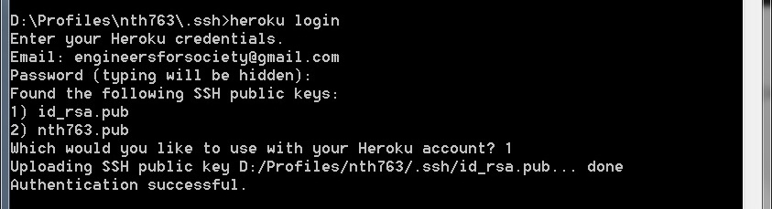
- Use the login details used while creating the heroku account i.e. Engineers For Society email ID and the password.
- The selection option of the key appears only if there are multiple keys. Select the appropriate key as required, if the selection option appears.
- Make sure that the selected key is not changed throughout its usage.
- Subsequent calls to “heroku login” should succeed as below:
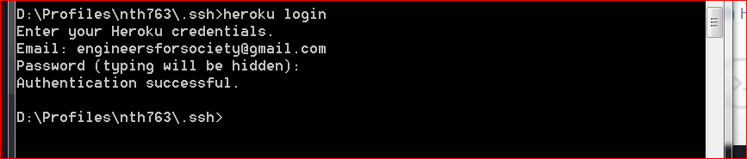
- In-case the key gets changed then the login authentication has to be done again

Note: In the below section, skip the all the 6 steps and move directly to the section “If reusing available repository”. The section immediately below is for creating a new repository for the first time which has already been done and need not be repeated again.

Working with the code

If creating for the repository first time
- Create a folder anywhere with any name (The below example uses: MobileEdu)
- From command prompt cd to the folder
- Type “git init” to initialize a repository under the current folder
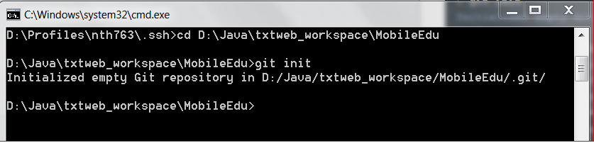
- Use “git add .” to add all the files under the current directory to the repository
- Use “git commit –m “<comment>” to commit the files into the repository. Make sure <comment> is replaced with a custom comment explaining the current action.
- Now to add the git module to the heroku created project use the below command

If reusing available repository
To use the existing repository use the below command:
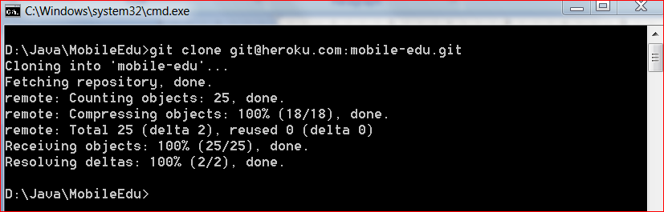
This can be done from any convenient path. The selected folder need not be necessarily empty. After the execution of this command completes, a new folder named mobile-edu will be created and all the resources will be available under this folder.

Compiling and deploying the code
- After successful execution of the above command, use the below command (git push heroku master) to finally compile, deploy and put the application on heroku server.
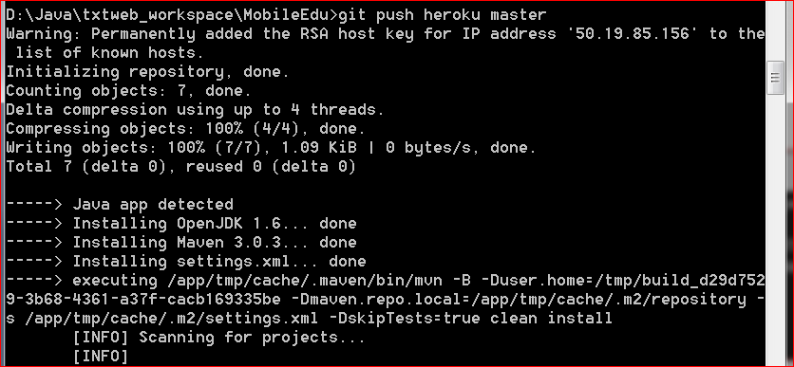
- The final result of the compilation should say “BUILD SUCCESS”
