GIT INSTALLATION
- Download GIT from
https://msysgit.googlecode.com/files/Git-1.8.4-preview20130916.exe

- Double click Git-1.8.4-preview20130916.exe

- Click on “Run”
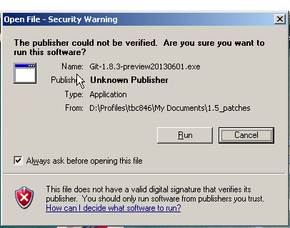

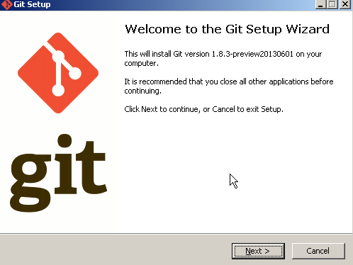
- Install Git to a folder. It is recommended to put it under a folder other than the default “Program Files”, with no space in the folder name. For E.g.: D:\Programs\Git
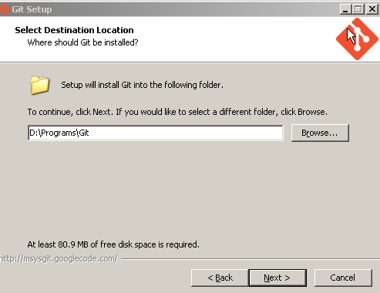
- Leave Default Options and click Next
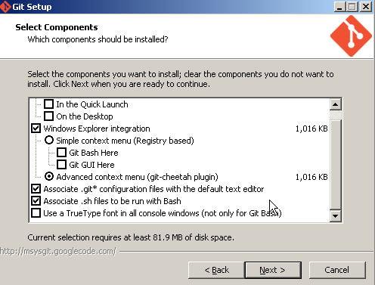
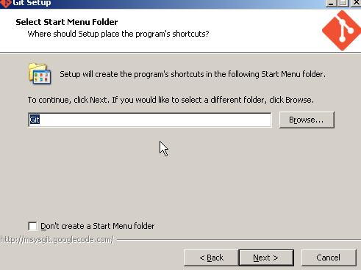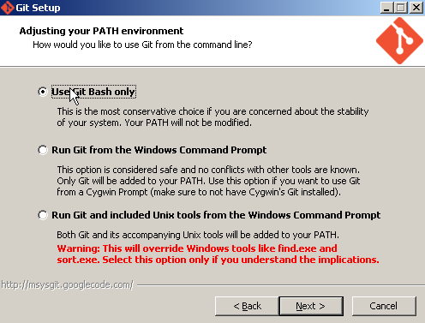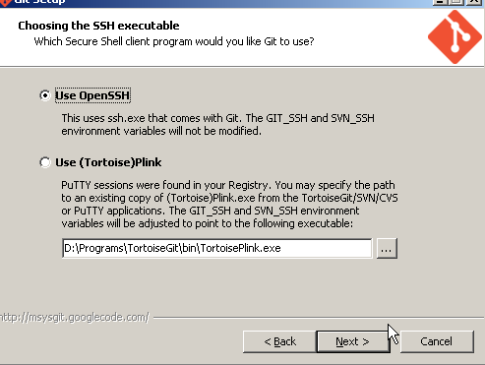
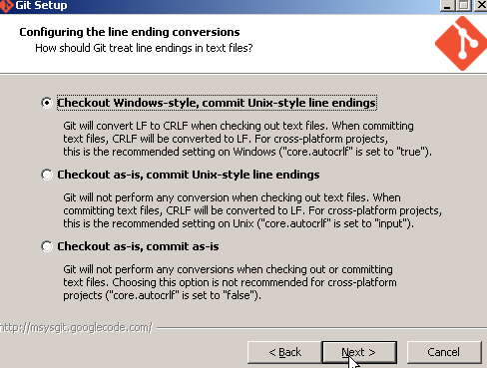
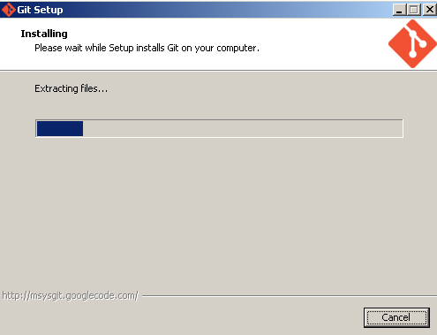
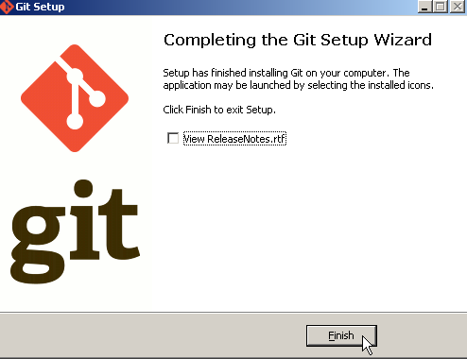

Adding to the environment variable

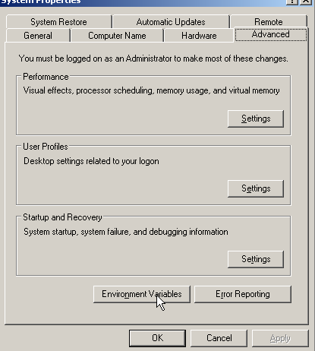
Click on New and create a new environment variable GIT_HOME , Click OK to save the changes
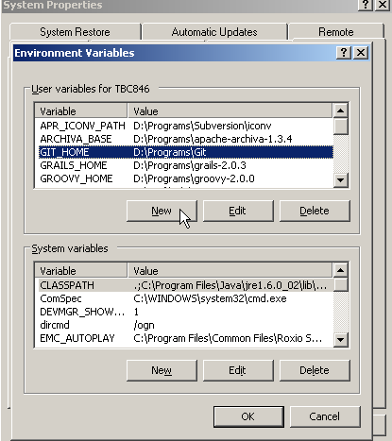
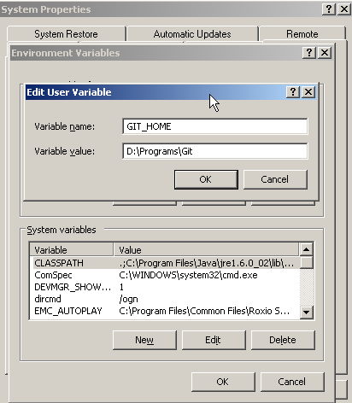

Add the following entries to the PATH Variable as shown below(under User Variables of Environment variables) %GIT_HOME%/bin;%GIT_HOME%/libexec/git-core;
Click OK to save the changes
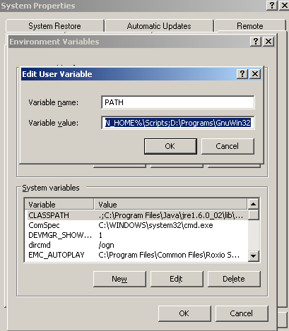
Create a variable called HOME , and Variable value = %USERPROFILE%
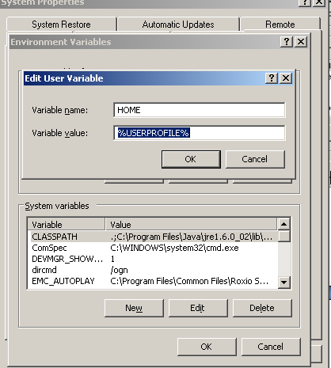
- Click Ok , and again OK button to come out of the System Properties
- Click on Start => Run and open command prompt
- Check GIT version , by typing git --version
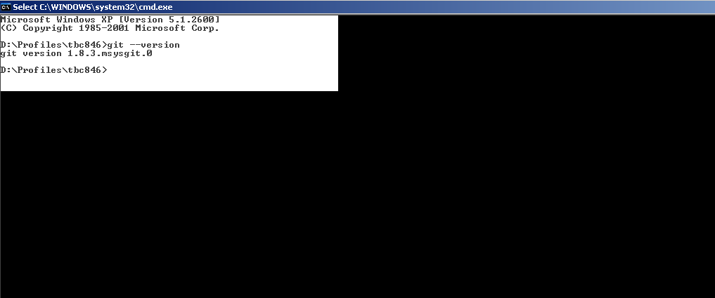
- Check the User Profile Directory, by type the following in command prompt
D:\Profiles\tbc846>echo %USERPROFILE%
D:\Profiles\tbc846

- Generate rsa key (Type the following command from prompt )
ssh-keygen -t rsa
- Keep pressing enter to generate the public / private key in %USERPROFILE% directory

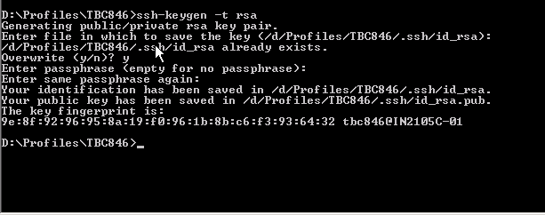

- Make sure that the public key (ends with .pub) is created under the %USERPROFILE%/.ssh folder

Installation of Heroku tool belt
- Download Heroku tool-belt from: https://toolbelt.heroku.com/windows
- Click on  for the windows installer
- Double-click the installer and then click “Run” as for the above example
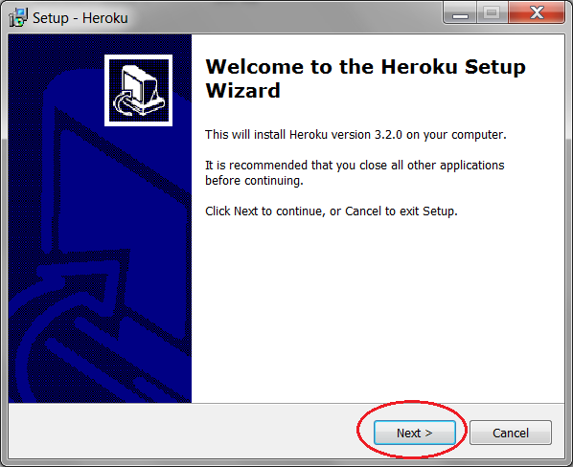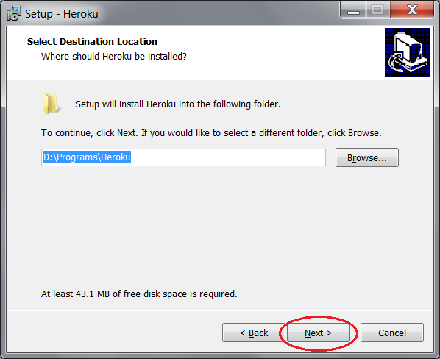
- Please note that it is recommended to put it under a folder other than the default “Program Files”, with no space in the folder name. For E.g.: D:\Programs\Heroku
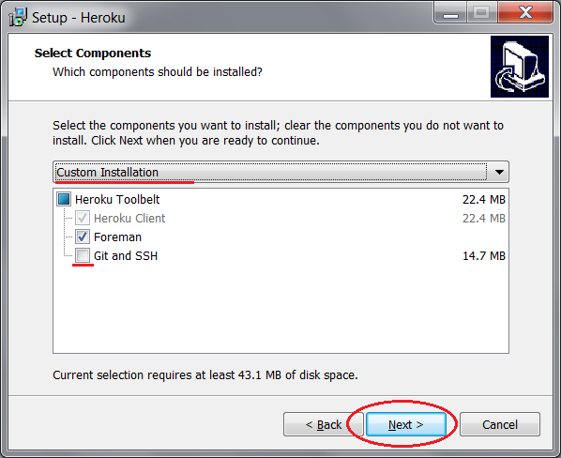
- Make sure that “Custom Installation” is selected and Git and SSH are not selected before clicking next (as we have completed this installation as part of our previous installation steps)
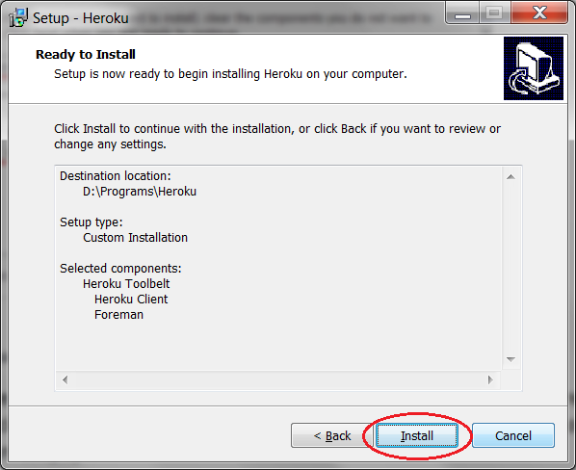
- Click “Install” to competed the installation

Adding the client SSH key to Heroku server
- Login to the Heroku server with the command “heroku login” in the command prompt
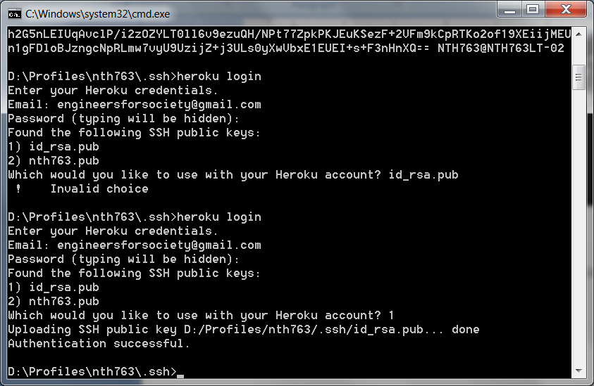
- Use the login details used while creating the heroku account
- The selection option of the key appears only if there are multiple keys. Select the appropriate key as required
- Make sure that the selected key is not changed throughout its usage
- Subsequent calls to “heroku login” should succeed as below:
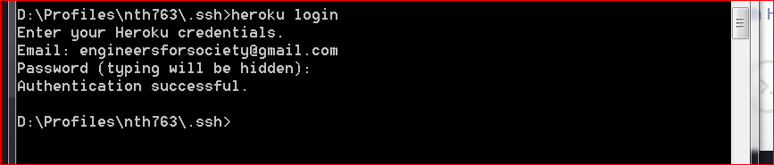
- In-case the key gets changed then the login authentication has to be done again

