ENVIROSCAN

Submitted by:
Amaldev K G
Master of Computer Applications (MCA)
Vidya Academy of Science and Technology
APJ Abdul Kalam Technological University (KTU)

Submitted to:
Springboard Mentor

Date: March 2026

Abstract
EnviroScan is an intelligent system developed to analyze environmental pollution data and predict the primary source of pollution. The system collects real-time air quality and weather data using APIs and processes it using machine learning techniques. A Decision Tree model is used to classify pollution sources such as vehicular, industrial, agricultural, and natural. The system also provides interactive visualizations including bar charts, scatter plots, pie charts, and maps to help users understand pollution trends effectively. This project demonstrates how data-driven approaches can assist in environmental monitoring and decision-making.

Introduction
Air pollution is one of the most serious environmental challenges affecting human health and ecosystems. Identifying the exact source of pollution is difficult due to the presence of multiple contributing factors such as vehicles, industries, and agricultural activities.
This project, EnviroScan, aims to solve this problem by using machine learning and data visualization techniques. It collects pollution data, processes it, and predicts the most likely source of pollution in a given area. The system also presents the results in a user-friendly interface for better understanding.

Objectives
- To collect air pollution and weather data using APIs
- To preprocess and clean the collected data
- To build a machine learning model for source prediction
- To visualize pollution data using graphs and charts
- To develop an interactive dashboard using Streamlit

Data Sources and APIs
The project uses the following data sources:
- OpenWeatherMap API
  - Provides air pollution data such as PM2.5, PM10, NO₂, SO₂, CO, and O₃
  - Provides weather data such as temperature, humidity, and wind speed
The collected data is stored in CSV files and used for further processing and analysis.

Data Preprocessing
The collected data undergoes several preprocessing steps:
- Removal of missing values using dropna()
- Selection of relevant features such as pollution parameters and weather data
- Formatting and structuring the dataset for model training
This ensures that the dataset is clean and suitable for machine learning.

Feature Engineering
A new column called “Source” is created using rule-based logic. The classification is based on environmental conditions:
- Industrial → High SO₂ and near industrial areas
- Agricultural → High PM2.5 and near farmland
- Vehicular → High NO₂ and near roads
- Natural → Default category
This step converts raw data into meaningful categories for prediction.

Model Architecture
The system uses a Decision Tree Classifier for predicting pollution sources.
Steps involved:
- Selecting input features (PM2.5, NO2, SO2, distances, etc.)
- Encoding target labels using LabelEncoder
- Training the model using the dataset
- Predicting pollution source for new inputs
The Decision Tree model is chosen because it is simple, interpretable, and effective for classification tasks.

Model Evaluation
The model achieved an accuracy of 100% on the training dataset.
However, this high accuracy is due to rule-based labeling, and real-world performance may vary when tested with unseen data.

System Architecture
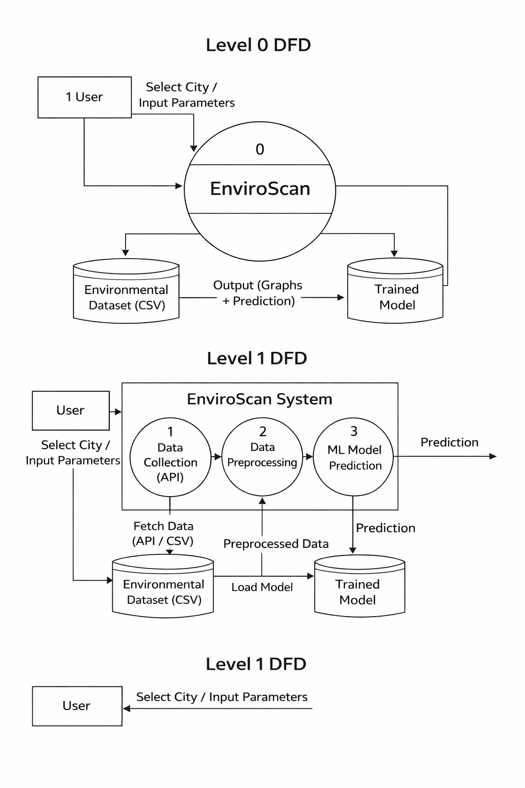
Explanation:
The system consists of the following components:
- Data Collection Module
- Data Preprocessing Module
- Machine Learning Model
- Visualization Module
- User Interface

Data Flow Diagram (DFD)

Level 0:
User → EnviroScan System → Output (Prediction + Graphs)

Level 1:
- Data Collection (API)
- Data Preprocessing
- Feature Engineering
- Machine Learning Model
- Visualization and Output

Visualization
The system includes the following visualizations:
- Bar Chart → Shows average PM2.5 values for each city
- Scatter Plot → Displays relationship between PM2.5 and NO2
- Pie Chart → Shows distribution of pollution sources
- Map → Displays pollution levels and source markers
These visualizations help in better understanding pollution patterns.

User Interface
The system provides an interactive interface using Streamlit:
- Sidebar for city selection
- Sliders for pollution and weather parameters
- Prediction button
- Graphs displayed in separate sections
The interface is designed to be simple and user-friendly.

Results
- Successfully collected and processed pollution data
- Built a machine learning model for source prediction
- Achieved accurate predictions
- Created visualizations for better analysis

Conclusion
EnviroScan is a useful system for analyzing air pollution and predicting its source. By combining machine learning with visualization techniques, the project provides meaningful insights into environmental data.

Future Scope
- Add more cities and datasets
- Improve model accuracy with advanced algorithms
- Deploy the application online
- Add real-time monitoring features

References
- OpenWeatherMap API
- Python Libraries: Pandas, NumPy, Scikit-learn, Matplotlib, Streamlit

