PROJECT DOCUMENTATION
TrafficVision AI
Smart Traffic Prediction & Congestion Management System
An AI-Powered Smart Traffic Monitoring, Prediction, Alerting, and Management Platform
GitHub: springboardmentor01092s-tech / Team_2_Smart_Traffic_AI

Table of Contents
1. Project Information
2. Abstract
3. Introduction
4. Scope
5. Existing System & Proposed Solution
6. Technology Stack
7. System Architecture
8. AI/ML Implementation
9. Database & API
10. User Interface
11. GitHub & Version Control
12. Error Handling & Security
13. Testing
14. Results
15. Deployment
16. Challenges & Limitations
17. Future Scope
18. Conclusion
19. References

1. Project Information
Project Title: TrafficVision AI: Smart Traffic Prediction & Congestion Management System
Team Members: Team 2 - Smart Traffic AI (GitHub: springboardmentor01092s-tech)
- Hemamrutha M P — hemamruthamp2005@gmail.com
- Barigala Shainy — shainysureshb@gmail.com
- Maharshini — maharshini01@gmail.com
- Pavan S — spavannalini29225@gmail.com
- Shreya Samal — shreysamal101@gmail.com
- Dibita Biswas — dibitabiswas4@gmail.com

Project Guide: Shravya U
Repository: https://github.com/springboardmentor01092s-tech/Team_2_Smart_Traffic_AI.git

2. Abstract
Traffic congestion — the overcrowding of vehicles on a road leading to slow movement, delays, and traffic jams — is a growing challenge for cities. TrafficVision AI is an AI-powered web platform that helps city authorities and traffic operators monitor traffic in real time, predict future congestion, analyze routes, generate alerts, and visualize traffic analytics through a centralized dashboard.
The platform combines Machine Learning, Flask, database management, and modern web technologies into a single traffic intelligence workflow. A Random Forest Classification model was trained on the Metro Interstate Traffic Volume dataset (~48,204 records) to predict congestion levels (Low, Moderate, Heavy) from weather and time-based features, achieving an accuracy of approximately 85.29%. Live traffic and routing information is retrieved from the TomTom Traffic Flow and Routing APIs and displayed on an interactive Leaflet.js/OpenStreetMap dashboard, complete with a geographical congestion heatmap for major Indian locations.
The system also includes role-based authentication (Admin, Traffic Operator, Public User), a real-time alert and notification engine (Socket.IO) for heavy congestion and accidents, historical traffic-trend and peak-congestion analysis, AI-based travel-time adjustment for alternate routes, AI-generated traffic recommendations, and downloadable PDF traffic reports (ReportLab). The completed platform was tested end-to-end, made responsive across devices, and deployed to the cloud using Docker and Render — delivering a complete traffic intelligence pipeline from raw data to actionable, AI-assisted decisions.

3. Introduction

3.1 Background
Urban traffic congestion is the overcrowding of vehicles on roads, leading to slow movement, delays, and traffic jams. As vehicle numbers grow, cities need intelligent systems that can monitor traffic conditions continuously, forecast congestion before it happens, and help both authorities and commuters make better decisions. Smart-city initiatives increasingly rely on AI/ML, real-time data feeds, and web dashboards to manage traffic more efficiently than traditional manual monitoring.

3.2 Problem Statement
City authorities and commuters currently lack a unified, intelligent system that can monitor live traffic, predict congestion in advance, recommend alternate routes, and issue timely alerts for accidents or heavy congestion. There is a need for a centralized platform that combines real-time monitoring, AI-based prediction, and route optimization to support smart-city traffic management.

3.3 Objectives
- Monitor live traffic conditions — continuously observe and display the current traffic status on roads.
- Predict traffic congestion using AI/ML — forecast where and when traffic jams may occur.
- Analyze vehicle density and road utilization — measure the number of vehicles on roads and how efficiently roads are being used.
- Recommend alternate routes — suggest less congested roads to help drivers reach destinations faster.
- Send congestion and accident alerts — notify users or authorities about traffic jams and accidents in real time.
- Display analytics through dashboards — show traffic information, charts, and reports in an easy-to-understand dashboard.
- Support smart city traffic management — help city authorities manage traffic efficiently using intelligent technology.

3.4 Smart Traffic Dashboard — UI Inspiration
The dashboard design draws on modern smart-city traffic monitoring interfaces, combining statistic cards, live tables, interactive maps, trend charts, and a notification panel into a single unified view — allowing an operator to understand the state of the entire road network at a glance.

4. Scope

4.1 In Scope
- Role-based authentication and access control (Admin, Traffic Operator, Public User).
- Live traffic monitoring dashboard with vehicle count, average speed, and congestion level.
- AI-based congestion forecasting using a trained Random Forest model.
- Traffic history tracking and hourly/daily trend & peak-traffic analysis.
- Alerts and notification system for heavy congestion and accidents (real-time via Socket.IO).
- Interactive live traffic map and congestion heatmap using Leaflet.js, OpenStreetMap, and the TomTom Traffic Flow API.
- Alternate route recommendation and AI-based travel-time prediction using the TomTom Routing API.
- Analytics dashboard with congestion heatmap for major Indian locations.
- AI-generated traffic recommendations and insights.
- Downloadable PDF traffic prediction reports generated with ReportLab.
- Cloud deployment using Docker and Render.

4.2 Out of Scope
- Direct integration with physical traffic cameras or IoT sensors for live video-based vehicle counting.
- Automatic accident detection from video/sensor feeds (accidents are currently reported manually by an operator).
- Native mobile application (the platform is currently web-based only).
- Traffic signal control or direct integration with physical traffic signal hardware.

5. Existing System & Proposed Solution

5.1 Existing System
Traditional traffic management largely relies on manual monitoring, fixed-timing traffic signals, and static reporting. Authorities often depend on periodic surveys or driver-reported information rather than continuous, data-driven monitoring. Such approaches offer limited real-time visibility, no predictive capability, and slow response to sudden events such as accidents or sudden congestion build-up.

5.2 Proposed Solution
TrafficVision AI proposes a centralized, AI-powered platform that continuously ingests live traffic data, applies a trained Machine Learning model to forecast congestion, and presents the results through an interactive dashboard. The system also recommends alternate routes based on real-time and predicted conditions, automatically raises alerts for heavy congestion and accidents, analyzes historical trends to detect peak periods, and produces AI-based recommendations and downloadable reports — enabling faster, data-driven decisions for both authorities and commuters.

5.3 Key Features
- Real-time traffic dashboard with statistics (Total Roads, Heavy/Moderate/Low Traffic, Active Alerts).
- AI-based congestion prediction (Random Forest Classifier, ~85.29% accuracy).
- Live traffic map with congestion heatmap for major Indian locations.
- Alternate route recommendation with AI-adjusted travel time.
- Real-time alerts and notifications for heavy congestion and accidents (Socket.IO).
- Historical traffic-trend analysis with automatic peak-traffic detection.
- AI-based traffic recommendations and insights.
- Downloadable PDF traffic prediction reports.

6. Technology Stack
Languages: Python, JavaScript
Frontend: React.js, Tailwind CSS
Backend: Flask (Python), Flask-Login, Flask-Bcrypt, Flask-SocketIO
Database: PostgreSQL / SQLite, SQLAlchemy (ORM)
AI/ML: Scikit-learn — Random Forest Classifier
Libraries / APIs: TomTom Traffic Flow API, TomTom Routing API, Leaflet.js, React Leaflet, OpenStreetMap, Chart.js, Recharts, ReportLab, Socket.IO
Deployment: Docker, Render (cloud hosting for frontend and backend)
Version Control: Git & GitHub

7. System Architecture
User
|
React Frontend
|
Flask Backend / REST API
|
AI/ML (Random Forest)
|
PostgreSQL Database
The user interacts with the React.js frontend, which communicates with the Flask backend through REST APIs and Socket.IO for real-time updates. The backend applies business logic, handles authentication, and calls the trained Random Forest model for congestion prediction. Live traffic and routing information is retrieved from the TomTom Traffic Flow and Routing APIs. All persistent data — users, roads, traffic records, predictions, routes, alerts, and analytics — is stored in a PostgreSQL/SQLite database accessed via SQLAlchemy.

7.1 System Modules
- Authentication & Role-Based Access — user registration, login, session management, and RBAC for Admin, Traffic Operator, and Public User roles.
- Live Traffic Monitoring — dashboard showing per-road vehicle count, speed, and congestion level, with automatic congestion classification.
- AI Congestion Forecasting — predicts congestion level from temperature, rainfall, cloud cover, and hour.
- Traffic History — stores and displays historical traffic updates for trend analysis.
- Alerts & Notifications — real-time congestion and accident alerts via Socket.IO.
- Live Map & Route Recommendation — interactive map, route analysis, and alternate-route suggestions with AI travel-time adjustment.
- Analytics & Heatmap — traffic statistics, congestion heatmap, and trend charts for major Indian locations.
- Traffic Trend Analysis — hourly/daily analysis, trend detection (Increasing/Decreasing/Stable), and peak-traffic detection.
- AI Recommendations & Reports — generates traffic insights, recommendations, and downloadable PDF reports.

7.2 Congestion Detection Logic
The Live Traffic Monitoring dashboard classifies congestion directly from vehicle count and speed:
Condition | Congestion Level
Vehicle Count > 250 (high vehicles + low speed) | Heavy
Vehicle Count > 100 (medium traffic) | Moderate
Otherwise (normal traffic) | Low

When Admin/Traffic Operator users update vehicle count or average speed, the congestion level is recalculated automatically and displayed using colour-coded badges; a heavy-congestion update also triggers an alert.

8. AI/ML Implementation

8.1 Dataset
The Metro Interstate Traffic Volume Dataset was used to train the congestion prediction model. It contains approximately 48,204 records with 9 attributes.
Attribute | Description
holiday | Indicates holiday information
temp | Temperature
rain_1h | Rainfall during the previous hour
snow_1h | Snowfall during the previous hour
clouds_all | Cloud coverage percentage
weather_main | Main weather condition
weather_description | Detailed weather condition
date_time | Date and time of observation
traffic_volume | Number of vehicles / traffic volume

8.2 Data Processing
Key features (temperature, rainfall, snowfall, cloud coverage, hour, day, and month) were selected for model training. The date_time attribute was processed to extract hour, day, and month. Traffic volume was converted into three congestion categories for training labels:
Traffic Volume | Congestion Level
Less than 2500 | Low
2500 to 4999 | Moderate
5000 or above | Heavy

8.3 Model / Algorithm
A Random Forest Classifier was chosen because it combines multiple decision trees to make a robust final classification, which suits this problem since congestion depends on multiple interacting factors such as weather and time.
Model Inputs: Temperature, Rainfall, Cloud coverage, Hour
Target Variable: Congestion level — Low / Moderate / Heavy

8.4 Training & Evaluation
The prepared dataset was provided to the Random Forest classifier, which learned the relationship between environmental/time-based factors and traffic congestion levels.
Metric | Value
Accuracy | ≈ 85.29% (0.8529198215952702)
Algorithm | Random Forest Classifier
Classes Predicted | Low, Moderate, Heavy

Trained model files were saved for use by the Flask application:
- models/traffic_model.pkl and traffic_model.joblib — the trained Random Forest model.
- models/label_encoder.pkl and label_encoder.joblib — converts the model's encoded output into readable congestion labels (Low / Moderate / Heavy).

8.5 AI Congestion Forecasting Workflow
The dashboard's AI Congestion Forecasting panel accepts Temperature, Rainfall, Cloud percentage, and Hour from the user; the system automatically fills in Snowfall, current day, and current month. The Flask backend then:
- Receives the input values and converts them into numerical form.
- Loads the trained Random Forest model and the label encoder.
- Creates the required feature set and sends it to the ML model.
- Generates the congestion prediction and converts the encoded result into a readable label.
- Displays the prediction on the dashboard and stores it in the prediction history.
This is implemented via the /predict-congestion route in routes/dashboard.py.

8.6 AI/ML Data Flow
Input (Temperature, Rainfall, Cloud %, Hour)
|
Processing (Feature Engineering)
|
Model (Random Forest)
|
Output (Congestion Level)

This AI/ML data flow diagram illustrates a supervised machine learning pipeline designed to predict traffic conditions based on environmental and temporal factors. The pipeline begins with the Input stage, which collects raw environmental data—specifically Temperature, Rainfall, Cloud %, and Hour—to capture how weather conditions and the time of day interact to influence driver behavior. This raw data immediately passes into the Processing (Feature Engineering) phase, where the inputs are cleaned, scaled, or transformed into optimized formats. For instance, the "Hour" might be converted into cyclical features or categorized into rush-hour windows, ensuring the downstream model can easily interpret the underlying patterns and relationships within the dataset.

Once processed, the refined features are fed directly into the Model stage, which utilizes a Random Forest algorithm. This ensemble learning method constructs multiple decision trees during training and merges their predictions together to deliver a highly accurate and stable final output. By evaluating combinations of weather severity and specific times of day across these trees, the Random Forest model maps the complex, non-linear relationships of the input data to generate the final Output: Congestion Level. This output provides actionable intelligence, classifying or scoring traffic density to help urban planners and navigation systems anticipate and mitigate gridlock.

9. Database & API

9.1 Database Schema
The database schema stores user information, road details, live traffic data, AI predictions, route recommendations, alerts, and analytics in an organized way, and defines how these modules are connected for efficient data management and retrieval. It is organized around seven core tables:
- Users — user_id, name, email, password (hashed), role; stores everyone who can access the system (Admins, Traffic Operators) and is used for authentication and role-based access.
- Roads — road_id, road name, location, road type, speed limit; stored once and referenced by other tables via road_id instead of repeating road information.
- Traffic_Data — the main table, storing live vehicle count, congestion level, average speed, and timestamp per road; every record links to a road via road_id.
- Predictions — stores AI-predicted vehicle density, congestion probability, and prediction time; linked to Traffic_Data since predictions are made from live traffic data.
- Routes — stores route recommendations: source, destination, suggested alternate route, estimated time, and distance, helping users avoid congested roads.
- Alerts — stores notifications such as congestion, accident, or roadblock alerts, each linked to a traffic record so users receive updates based on current conditions.
- Analytics — stores summarized reports: total vehicles, average speed, congestion percentage, and report date; used to display dashboards and analyze trends over time.

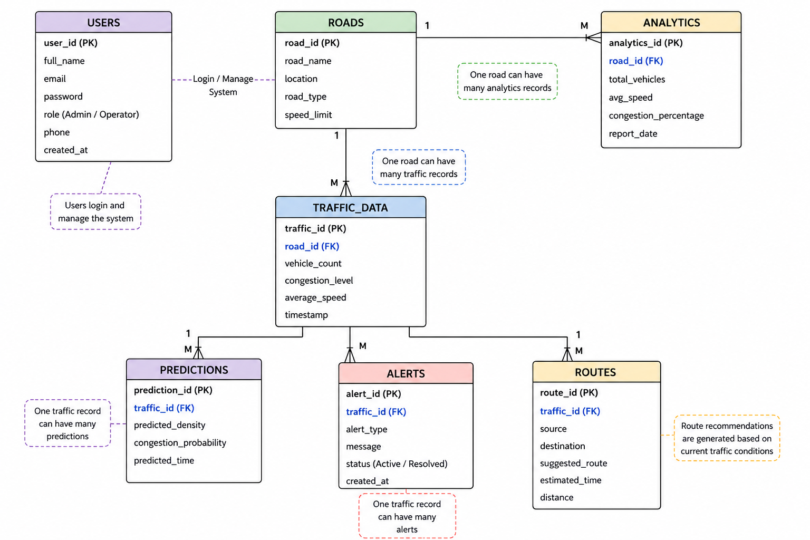
Figure: Entity-Relationship (ER) Diagram

9.2 API Endpoints
Endpoint | Purpose
/predict-congestion | Receives environmental/time inputs and returns the AI-predicted congestion level.
/download-report | Generates and returns a downloadable PDF traffic prediction report.
/api/traffic/flow | Returns live traffic flow information (speed, free-flow speed, travel time, confidence) from the TomTom Traffic Flow API.
/api/traffic/route | Returns route and alternate-route information from the TomTom Routing API.

9.3 Congestion Classification (Analytics & Heatmap)
In addition to the volume-based classification used for ML training labels, the Analytics & Heatmap dashboard classifies live congestion percentage (derived from the TomTom Traffic Flow API) as follows:
Congestion Percentage | Traffic Level
0 – 29.9% | Low
30 – 59.9% | Moderate
60 – 100% | Heavy

Heatmap intensity is derived from this congestion percentage using: Intensity = Congestion Percentage ÷ 100, restricted to a range of 0.10 to 1.00 — so low congestion produces low heat intensity and heavy congestion produces maximum heat intensity, allowing the map to visually highlight the most congested locations.

10. User Interface
The application provides the following major interfaces, shown below with actual output screenshots from the deployed platform.

Login / Authentication
A role-based login screen where the user selects Admin or Traffic Operator before signing in. The left panel highlights the platform's core capabilities — Real-time Monitoring, AI Prediction, Smart Routing, and Instant Alerts.
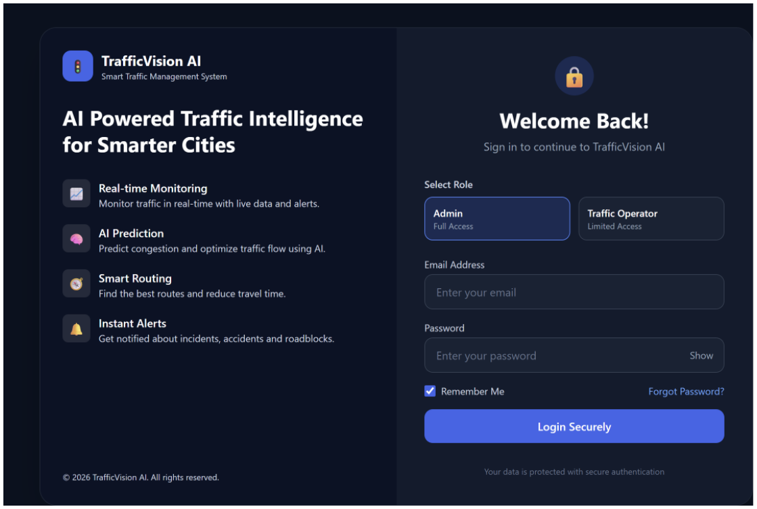
Figure: Login / Authentication screen

Dashboard
The main real-time overview, showing key statistics (Total Active Roads, High Congestion Areas, Average Speed, Today's Incidents, Active Alerts), a live traffic snapshot table, a Congestion Summary donut chart, and the Traffic Trend Analysis filter panel.
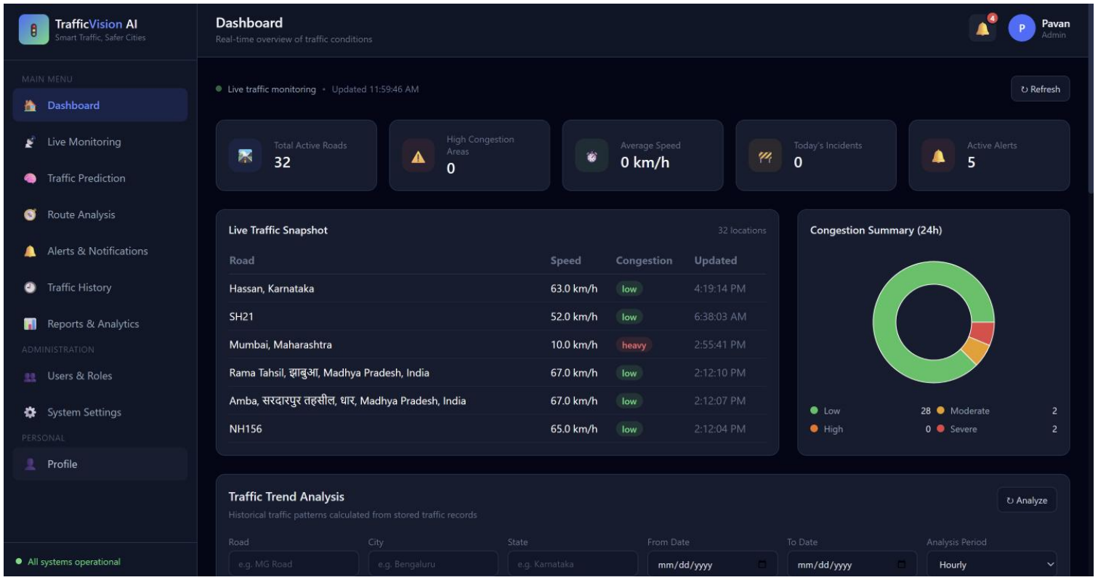
Figure: Dashboard screen

Live Monitoring
Lets the user search any location and view real-time traffic on an interactive Leaflet/OpenStreetMap map, along with live coordinates and current speed, free-flow speed, congestion percentage, and travel time for the selected place.
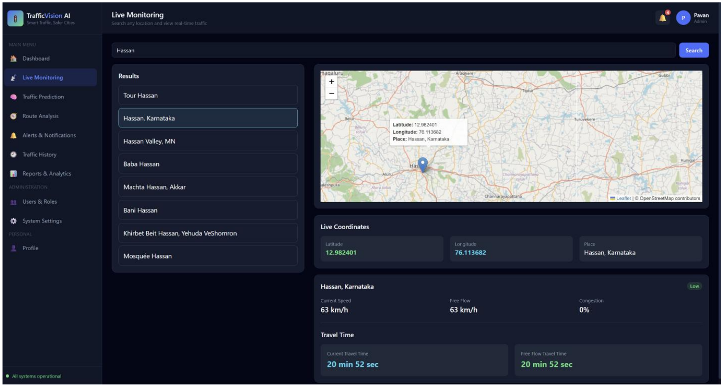
Figure: Live Monitoring screen

Traffic Prediction
The AI-powered forecasting panel. The operator enters Hour, Day of Week, Month, Temperature, Rain, Snow, Cloud Cover, Vehicle Count, and Vehicle Speed; the trained Random Forest model returns the predicted congestion level, a model confidence score, estimated delay, and a 24-hour confidence forecast chart.
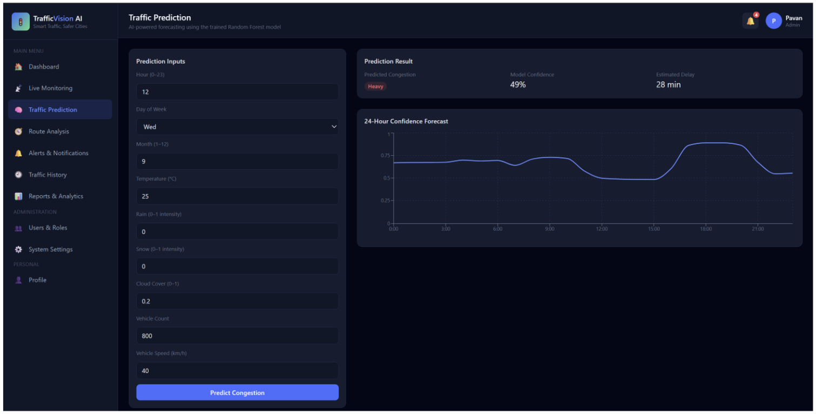
Figure: Traffic Prediction screen

Route Analysis
A route-comparison tool where the user enters an origin and destination. The map displays the recommended and alternate routes, and each route card shows distance, travel time, traffic delay, congestion level, and the AI-predicted travel time.
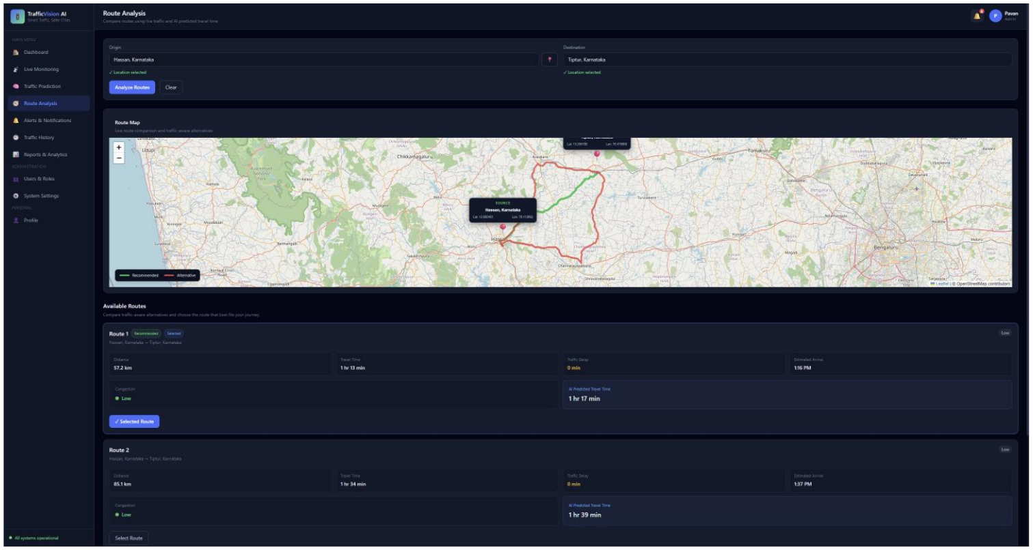
Figure: Route Analysis screen

Alerts & Notifications
Real-time alert feed showing Total Active, High Severity, Medium Severity, Resolved, and Unread counts, with filters by type/severity/status. Each alert can be expanded to show its type, severity, status, location, and message, with options to mark as read, resolve, or delete.
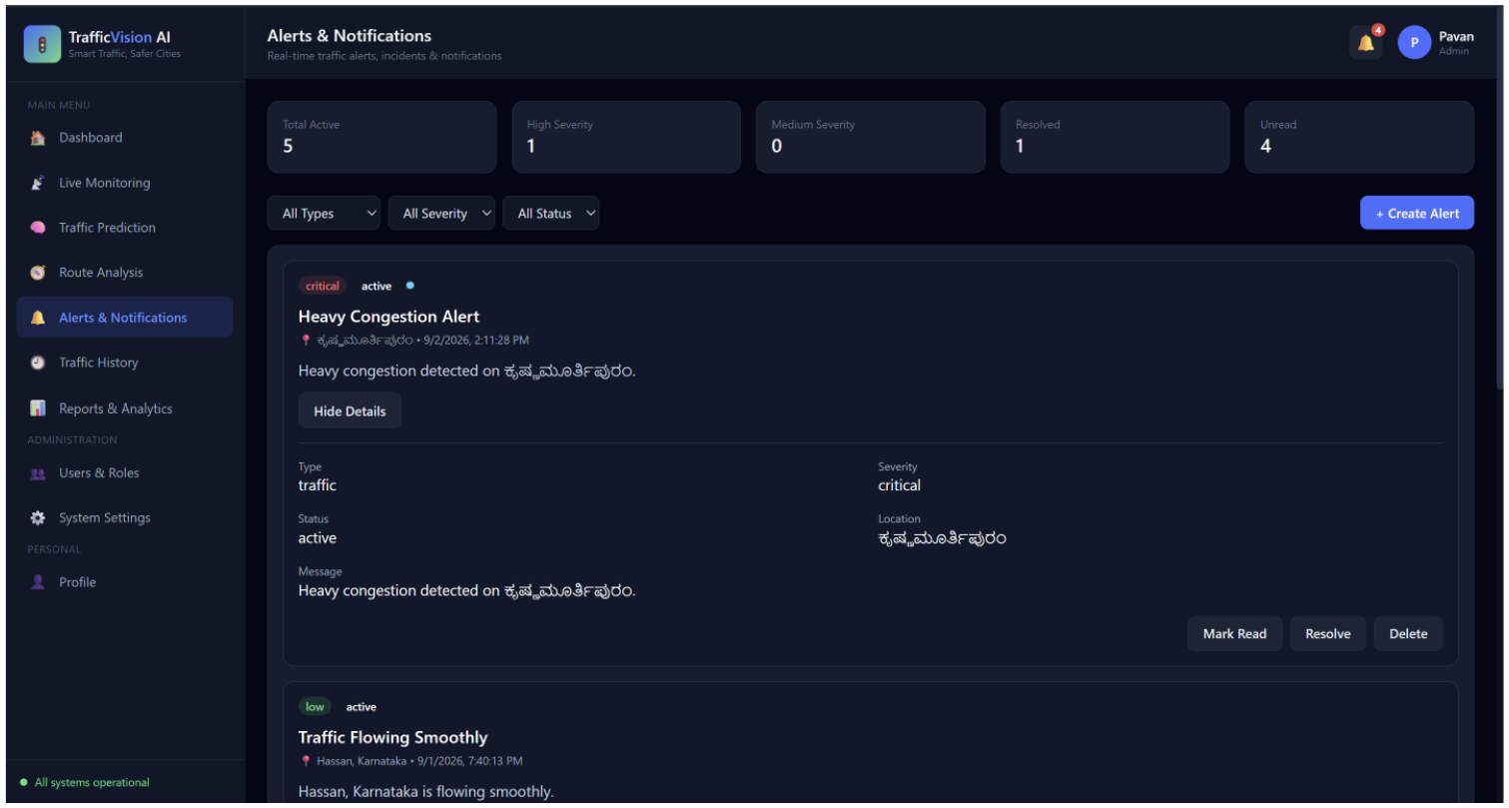
Figure: Alerts & Notifications screen

Traffic History
Historical traffic records with filters for Road/Area, City, and date range, listing date & time, location, average speed, congestion level, vehicle volume, and incidents for each record, with pagination through past data.
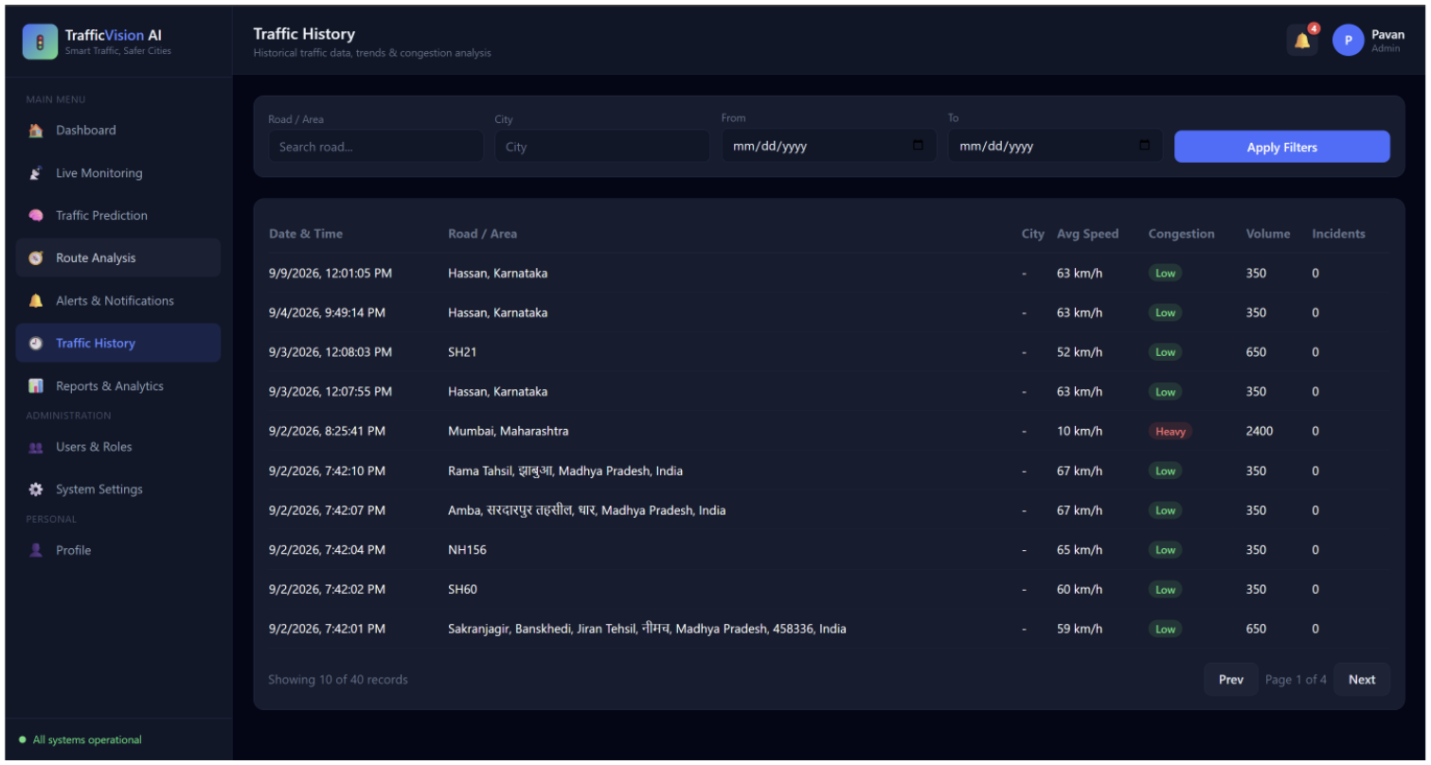
Figure: Traffic History screen

Reports & Analytics
Generates the daily traffic report — total vehicle volume, average congestion, average speed, and total incidents — alongside AI-generated traffic recommendations, a congestion-distribution chart, and a button to download the full PDF report.
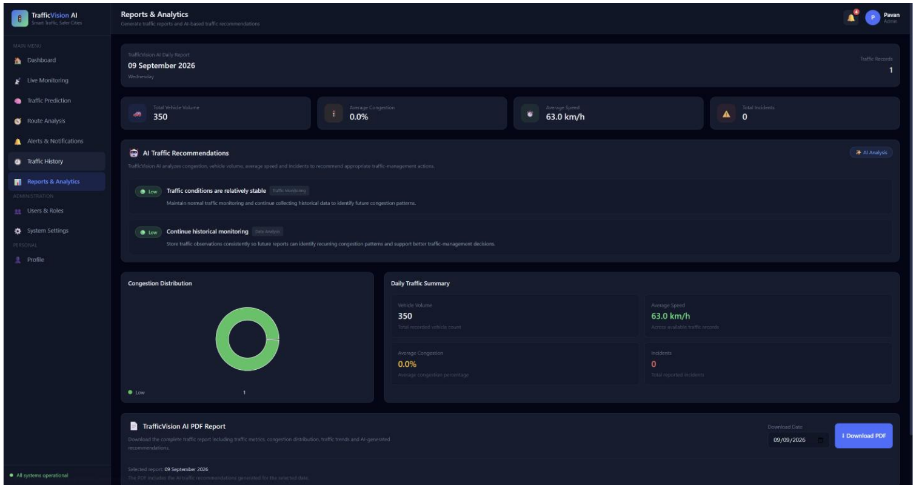
Figure: Reports & Analytics screen

11. GitHub & Version Control

11.1 Repository
GitHub Repository: https://github.com/springboardmentor01092stech/Team_2_Smart_Traffic_AI.git
Main Branch: main (feature development on individual branches, e.g. hemamrutha)
Deployment Link : https://trafficvision-ai-sws2.onrender.com

11.2 Repository Structure
The project follows a modular structure separating backend routes, ML models, and frontend static assets, for example:
- models/ — trained ML artifacts (traffic_model.pkl / .joblib, label_encoder.pkl / .joblib)
- routes/ — Flask route handlers, e.g. routes/dashboard.py
- static/images/ — static assets such as the database schema/ER diagram image

11.3 Version Control Workflow
Standard Git practices were followed throughout development. The commands used to implement and push the authentication, dashboard, and congestion-tracking workflow were:
Git Command | Purpose
git init | Initializes a new Git repository in the project folder, creating a .git directory so Git can start tracking the project.
git checkout -b hemamrutha | Creates a new branch named hemamrutha and switches to it, allowing work without affecting main.
git remote add origin <repo-url> | Connects the local project to the remote GitHub repository so code can be pushed and pulled.
git remote -v | Displays configured remote URLs to verify the local repository is connected to the correct GitHub repository.
git status | Shows the current state of the working directory and staging area — modified, staged, or untracked files.
git add . | Stages all project files for the next commit.
git commit -m "message" | Saves the staged changes as a new commit with a descriptive message.
git push -u origin hemamrutha | Uploads the local hemamrutha branch to GitHub and sets the upstream branch for future pushes.
git log -1 --format="%an <%ae>" | Displays the author name and email of the latest commit, to verify correct authorship.

The commands used to add and push the database schema/ER diagram image were:
Git Command | Purpose
git add static/images/ | Stages the database schema image folder, preparing the new image file for the next commit.
git status | Verifies the image file is staged, showing "new file: static/images/database_schema.png" under changes to be committed.
git commit -m "Added database schema ER diagram image" | Creates a commit containing the staged database schema image.
git push origin hemamrutha | Uploads the committed image changes to the hemamrutha branch on GitHub without affecting main.

12. Error Handling & Security

12.1 Error Handling
The application validates user input during registration, login, and traffic-data updates. Authentication errors (invalid credentials, unauthorized access to protected pages) are handled by Flask-Login, which restricts access to authenticated and appropriately-authorized users. API and database errors are managed at the backend layer, and the frontend maintains loading and error states while communicating with the API.

12.2 Security
- Passwords are never stored as plain text — Flask-Bcrypt converts them into a secure hashed format before storage, and the entered password is compared with the stored hash at login.
- Flask-Login manages user sessions; once logged in, a user remains authenticated until logout, and unauthorized users cannot access protected pages.
- Role-Based Access Control (RBAC) restricts features by role.
- The backend verifies the user's role before allowing access to restricted operations.

Role-Based Access Control (RBAC)
Role | Permissions
Admin | Access the dashboard, manage all users, and update traffic information.
Traffic Operator | Access the dashboard and update traffic data; cannot manage users.
Public User | View the dashboard only; cannot update traffic data or manage users.

13. Testing
The complete application was manually tested by navigating through each page and validating functionality end to end, using the browser and developer tools to inspect navigation, forms, displayed data, and API requests/responses. Major workflows tested included login, dashboard, live traffic monitoring, traffic prediction, traffic history, alerts and notifications, traffic trends, location search, and report generation.
Backend API endpoints were validated directly, with successful responses confirmed for authentication, live traffic, prediction, trends, history, alerts, location search, and reports (including a verified 201 Created response for alert creation). The Alerts & Notifications workflow was tested by verifying alert retrieval, filtering, creation, viewing alert details, marking alerts as read, resolving alerts, and deleting alerts. Socket.IO real-time communication was also tested to confirm live updates between frontend and backend.
The complete workflow was validated from frontend to backend to ensure user actions were correctly processed and appropriate data was returned, confirming that the major modules and workflows were integrated correctly and functioning as expected.

14. Results

14.1 AI/ML Results
Metric | Value
Accuracy | ≈ 85.29% (0.8529198215952702)
Algorithm | Random Forest Classifier
Classes Predicted | Low, Moderate, Heavy

14.2 System Results
The deployed system successfully integrates live traffic monitoring, AI-based congestion forecasting, route recommendation with AI travel-time adjustment, real-time alerts, traffic-trend and peak-congestion analysis, analytics/heatmap visualization, AI-based recommendations, and PDF report generation into a single workflow. UI responsiveness was improved using Tailwind CSS so that dashboards, tables, charts, and maps display correctly across desktop, tablet, and mobile screen sizes, and frontend performance was improved by optimizing API requests and reducing unnecessary repeated operations.

Sample Output
Figure: Live dashboard reflecting real-time system results

15. Deployment
The application was containerized using Docker to ensure a consistent deployment environment, and both the frontend (React) and backend (Flask) were deployed on Render. Environment variables, API URLs, and database configuration were set up for production, and redirect/rewrite rules were configured to support React client-side routing on page refresh.

15.1 Deployment Workflow
- Prepare the application — configure the React frontend, Flask backend, database, environment variables, and required API keys for production.
- Containerize the application — create Docker configuration to package the application and dependencies into a consistent environment.
- Configure cloud deployment — create the required services on Render and connect them to the GitHub repository.
- Deploy the backend — configure environment variables, database connection, and external API settings.
- Deploy the frontend — build and deploy the React application and configure it to use the deployed backend API URL.
- Configure routing — add redirect/rewrite rules so React routes work correctly when individual pages are refreshed.
- Test the deployed system — verify login, dashboard, traffic data, maps, alerts, reports, API communication, and page navigation via the public URL.
- Monitor and fix issues — check deployment logs and API responses, resolve configuration or routing issues, and redeploy when required.
After deployment, all major workflows were verified in the production environment via the public URL, and the deployed frontend and backend communicated correctly.

16. Challenges & Limitations
- Real-time data dependency: live traffic and routing features depend on third-party APIs (TomTom), which introduces external rate limits and availability constraints.
- Accident detection is manual: accidents must currently be reported by an operator rather than detected automatically.
- Model generalization: the prediction model was trained on a fixed historical dataset (Metro Interstate Traffic Volume) and may need retraining/fine-tuning for other cities or regions.
- Ensuring UI responsiveness and consistent real-time updates (Socket.IO) across devices required additional testing and optimization effort.
- Avoiding duplicate alerts required extra logic (e.g. duplicate-prevention for peak-traffic notifications) so the same event does not repeatedly generate alerts.

17. Future Scope
- Integrate live traffic camera feeds or IoT sensors for automated vehicle counting and accident detection.
- Extend the prediction model to more cities/regions and retrain periodically with fresh data.
- Develop a native mobile application for commuters.
- Add push notifications and SMS/email alerts for critical traffic events.
- Integrate traffic signal control recommendations based on AI predictions.
- Expand AI-based recommendations with more granular, location-specific insights and longer-term forecasting.

18. Conclusion
TrafficVision AI successfully demonstrates an end-to-end smart traffic management platform that combines live monitoring, AI-based congestion prediction (≈85.29% accuracy using a Random Forest Classifier), route recommendation with AI travel-time adjustment, real-time alerts, traffic-trend and peak-congestion analysis, analytics and heatmap visualization, AI-generated recommendations, and automated PDF reporting. The system was built with role-based authentication and security best practices, tested thoroughly across its major workflows, made responsive across devices, and successfully deployed to the cloud using Docker and Render. The completed platform meets its core objectives of enabling data-driven, AI-assisted traffic management for smart cities.

19. References
- Metro Interstate Traffic Volume Dataset (UCI Machine Learning Repository).
- Scikit-learn documentation — Random Forest Classifier.
- Flask, Flask-Login, Flask-Bcrypt, and Flask-SocketIO documentation.
- React.js and Tailwind CSS documentation.
- TomTom Traffic Flow API and TomTom Routing API documentation.
- Leaflet.js and React Leaflet documentation; OpenStreetMap.
- ReportLab documentation (PDF generation).
- Docker and Render deployment documentation.

