CITYFLOWX AI
SMART URBAN TRAFFIC MANAGEMENT PLATFORM
AI-powered traffic prediction, congestion management,
route optimization, alerts and analytics

PROJECT GUIDE / MENTOR | U Sravya
TEAM MEMBERS | TEAM MEMBERS  Dinesh Nadipalli  Devansh Singh Jamwal  Bhavya  MAligireddy Sai Brundha  Nagul  Harinisri S  Manvitha Dharavath

Team Project Documentation
Repository: Team_4_Smart_Traffic_AI

2) ABSTRACT
The architecture is designed so that the same traffic information can support different user experiences: civilians receive route and commute information, while controllers receive monitoring, incident and analytics information.
The overall workflow is: user authentication → traffic data collection → backend processing → AI/ML analysis → route/traffic insight generation → dashboard visualization and alerts.
━━━━━━━━━━━━━━━━━━━━━━
CityFlowX AI is an intelligent traffic management platform designed to help civilians and traffic controllers monitor traffic conditions, predict congestion, analyze routes, receive alerts, and use traffic analytics through a web-based application.
The platform combines a modern web frontend, FastAPI backend, traffic-data processing, external mapping and traffic services, and machine-learning models for congestion classification, traffic-volume prediction, and delay estimation.
Project purpose
CityFlowX AI brings monitoring, prediction, route guidance, incident reporting, alerts and analytics into one role-based platform.

3) INTRODUCTION
━━━━━━━━━━━━━━━━━━━━━━
3.1 Background
Urban traffic conditions can change quickly because of peak-hour demand, accidents, weather, road conditions and other incidents. Conventional systems often show the current situation without combining prediction, route analysis, incident reporting and notifications in one platform.
3.2 Problem Statement
Traffic congestion increases travel time and makes route selection difficult for commuters. Traffic authorities also need timely information about congestion, incidents, junction conditions and traffic trends. CityFlowX AI addresses this need through an integrated, data-driven traffic platform.
3.3 Objectives
- Monitor traffic density and congestion.
- Predict traffic conditions using AI/ML models.
- Predict traffic volume and estimate traffic delay.
- Provide route optimization and alternate-route recommendations.
- Allow civilians to report accidents and traffic hazards.
- Generate congestion and accident notifications.
- Provide traffic analytics and visualization.
- Support traffic controllers with data-driven traffic information.
3.4 Justification
An integrated platform is justified because commuters and traffic authorities need traffic awareness, prediction, route guidance, incident reporting, alerts and analytics without switching between disconnected tools.

4) SCOPE
The scope covers the software layer of the traffic-management workflow, from data ingestion and AI analysis to user-facing recommendations and controller dashboards.
━━━━━━━━━━━━━━━━━━━━━━
4.1 In Scope
- User authentication and role-based access.
- Civilian and traffic-controller dashboards.
- Traffic and junction monitoring.
- AI-based congestion classification.
- Traffic-volume prediction and traffic-delay estimation.
- Route optimization and alternate-route recommendations.
- Accident/traffic-hazard reporting.
- Congestion and accident notifications.
- Traffic analytics and visualization.
- Automated traffic-data ingestion.
4.2 Out of Scope
- Physical control of traffic signals.
- Hardware-based traffic infrastructure control.
- Autonomous vehicle control.
- Direct emergency-service dispatch.
- Guaranteed prediction where sufficient live data is unavailable.
- Full city-wide deployment without additional real-time infrastructure.

5) EXISTING SYSTEM & PROPOSED SOLUTION
━━━━━━━━━━━━━━━━━━━━━━
5.1 Existing System
Existing traffic-management approaches may depend on manual monitoring, separate traffic information sources and navigation applications. These approaches can provide current conditions but may not integrate prediction, incident reporting, route optimization, alerts and analytics into one decision-support platform.
5.2 Proposed Solution
CityFlowX AI provides a centralized platform combining traffic monitoring, AI/ML prediction, route analysis, incident reporting, alerts and analytics. Role-specific dashboards connect users to the appropriate traffic information and actions.
5.3 Key Features
The features are connected rather than isolated: monitoring supplies traffic information, AI components analyze it, route services use the results, and alerts/analytics communicate the outcome.
- Role-based dashboards
- Real-time traffic monitoring
- AI congestion prediction
- AI route optimization
- Hazard reporting
- Congestion and accident alerts
- Traffic analytics
- Junction monitoring
5.4 Justification
The proposed solution reduces fragmentation by connecting traffic data, prediction, routing and alerts through a common backend and user interface.

6) TECHNOLOGY STACK
━━━━━━━━━━━━━━━━━━━━━━
6.1 Frontend
React.js / Next.js with Tailwind CSS provides the responsive user interface and reusable dashboard components.
6.2 Backend
Python with FastAPI / Flask provides REST-based services, authentication and integration with application logic and AI components.
6.3 Data Layer
PostgreSQL and MongoDB are used for structured application data and flexible traffic/incident data respectively.
6.4 AI/ML
Scikit-learn models support congestion classification and traffic-volume/delay prediction. The documented system uses Random Forest for structured traffic data.
6.5 Maps, APIs & Deployment
The frontend sends requests to the backend, the backend coordinates database access and external traffic/map services, and AI components process traffic-related inputs. The resulting data is returned to the dashboard, route planner, analytics views or alert workflows.
6.6 Integration Flow
Google Maps, Google Directions and TomTom traffic services support mapping and traffic information. Docker, Docker Compose, Nginx, Render, Vercel and GitHub Actions support deployment and delivery.
6.6 Technology Selection Justification
- React/Next.js: suitable for reusable, responsive dashboard interfaces.
- FastAPI: lightweight REST layer for frontend, services and AI integration.
- PostgreSQL + MongoDB: separates structured access data from flexible/high-volume traffic data.
- Random Forest: effective for structured tabular traffic features and nonlinear relationships.
- Mapping/traffic APIs: provide map visualization, directions and external traffic conditions.
- Docker: creates a consistent deployment environment and simplifies service orchestration.

7) SYSTEM ARCHITECTURE
━━━━━━━━━━━━━━━━━━━━━━
CityFlowX AI follows a layered architecture. Users interact with role-specific web dashboards. The frontend communicates with backend services through REST APIs. The backend connects to databases, external traffic services and AI/ML components. Processed results are returned as traffic information, route recommendations, analytics and alerts.
7.1 Architecture Diagram
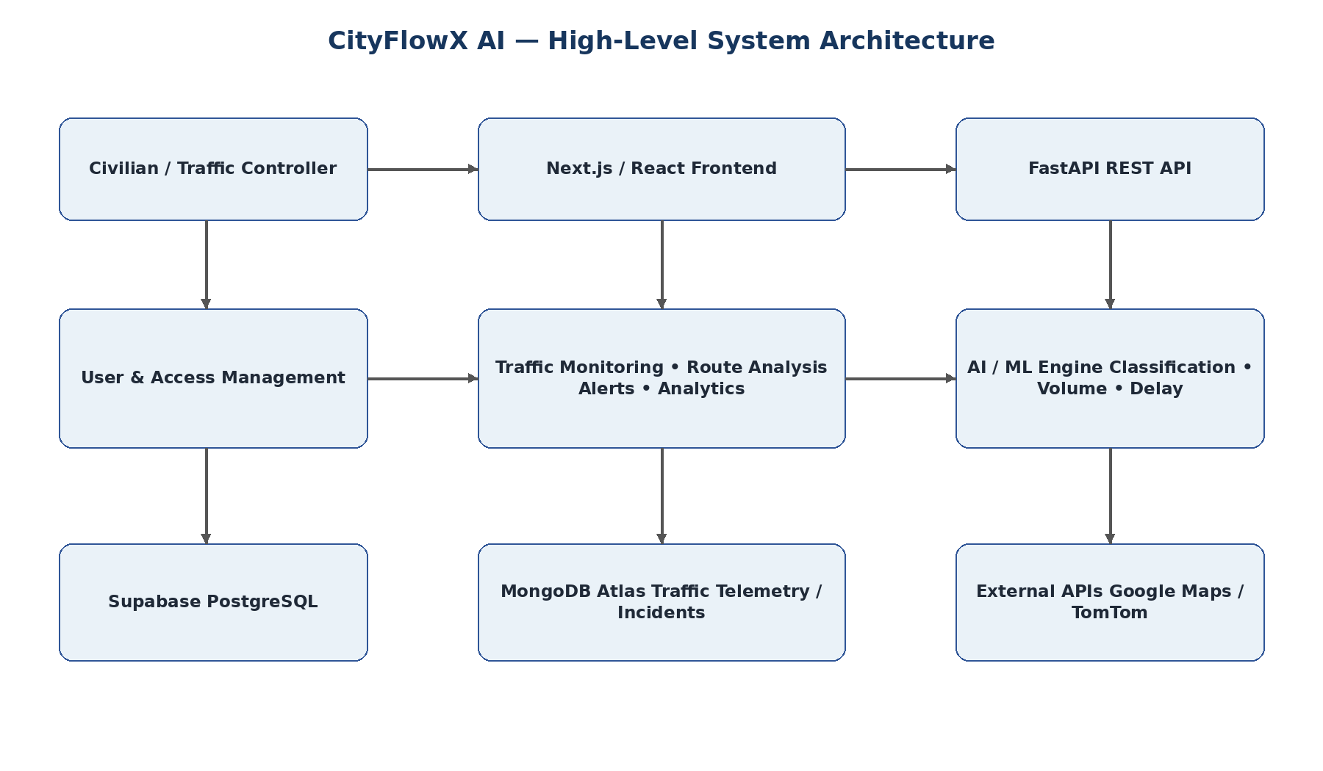
Figure 1. CityFlowX AI high-level architecture
7.2 Architecture Justification
A typical request begins in the web interface, passes through the API layer, is processed using application data and/or AI services, and returns a structured result to the appropriate dashboard. This keeps the interface independent from database and model implementation details.
7.3 Request and Data Flow
The layered design separates presentation, API processing, data storage and AI/ML responsibilities. This improves maintainability, makes testing easier, and allows individual services or data stores to evolve without redesigning the entire application.

8) AI/ML IMPLEMENTATION
━━━━━━━━━━━━━━━━━━━━━━
8.1 Dataset
The project uses the UCI Metro Interstate Traffic Volume Dataset containing historical hourly traffic observations. The documented training and holdout data are used to develop and evaluate traffic prediction components.
8.2 Features Used
- Weather: temperature, rain, snow, clouds and weather category.
- Temporal: hour, day of week and peak-hour status.
- Engineered: previous-hour volume, previous-day volume and rolling averages.
8.3 Model / Algorithm
Random Forest is used for congestion classification and traffic-volume regression because it works well with structured tabular data and nonlinear relationships. A multivariate LSTM benchmark and a delay regression component are also documented.
8.4 Training & Evaluation
During inference, incoming traffic-related features are processed using the same preparation logic used during training. The model output is then used as an input to traffic insight, recommendation and visualization workflows.
8.5 Inference and Decision Support
- Random Forest congestion classifier accuracy: 95.08%.
- Macro/weighted F1: approximately 0.95.
- Random Forest traffic-volume regressor MAE: 107.57 vehicles/hour.
- Random Forest MAPE: 4.38% for volume ≥ 100.
- Random Forest latency: 25.1 ms; LSTM benchmark latency: 98.3 ms.

8.5) AI/ML WORKFLOW
━━━━━━━━━━━━━━━━━━━━━━
The AI workflow moves from traffic input through feature processing and model inference to a traffic insight or route recommendation that can be shown to the user.
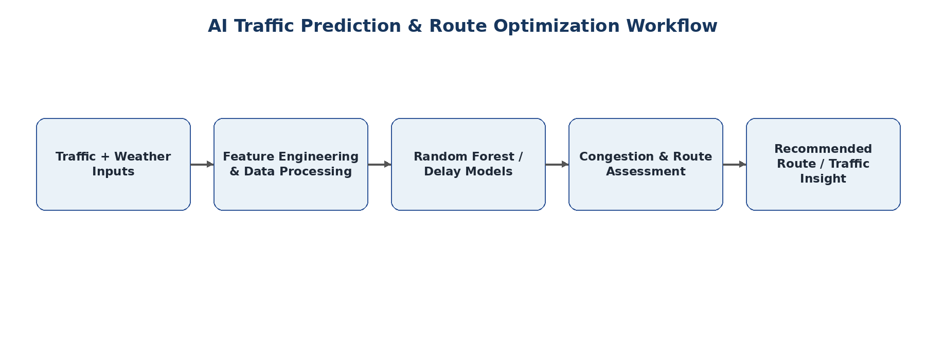
Figure 2. CityFlowX AI traffic prediction and recommendation workflow
Model justification
Random Forest is used because the project works with structured traffic, weather, temporal and engineered features, while the evaluation also shows strong accuracy and lower inference latency than the benchmarked LSTM model.

9) DATABASE & API
━━━━━━━━━━━━━━━━━━━━━━
9.1 Database
PostgreSQL is used for structured user and role information. MongoDB Atlas is used for flexible traffic telemetry, junction logs and active incident alerts.
- Users and roles
- Traffic telemetry
- Junction logs
- Active incident alerts
- Route information
- Traffic analysis data
9.2 Backend & External APIs
- FastAPI: REST API backend.
- APScheduler: automated traffic-data ingestion.
- Google Maps JavaScript API: map visualization.
- Google Directions API: route and direction information.
- TomTom Traffic API: traffic information and conditions.
9.3 Database Justification
The API layer acts as the bridge between the frontend and data/services. Authentication and role checks are applied before protected operations, after which the backend validates inputs, performs the required operation, and returns structured data to the frontend.
9.4 API Processing Flow
A relational store is appropriate for structured authentication and access-control information, while a document-oriented store is suitable for flexible, high-volume traffic telemetry and incident records.

10) USER INTERFACE
━━━━━━━━━━━━━━━━━━━━━━
The web application provides role-specific dashboards for civilians and traffic controllers. The following pages use the actual CityFlowX AI output screens from the project presentation, rather than stock or unrelated images.
10.1) CIVILIAN REGISTRATION & LOGIN
━━━━━━━━━━━━━━━━━━━━━━
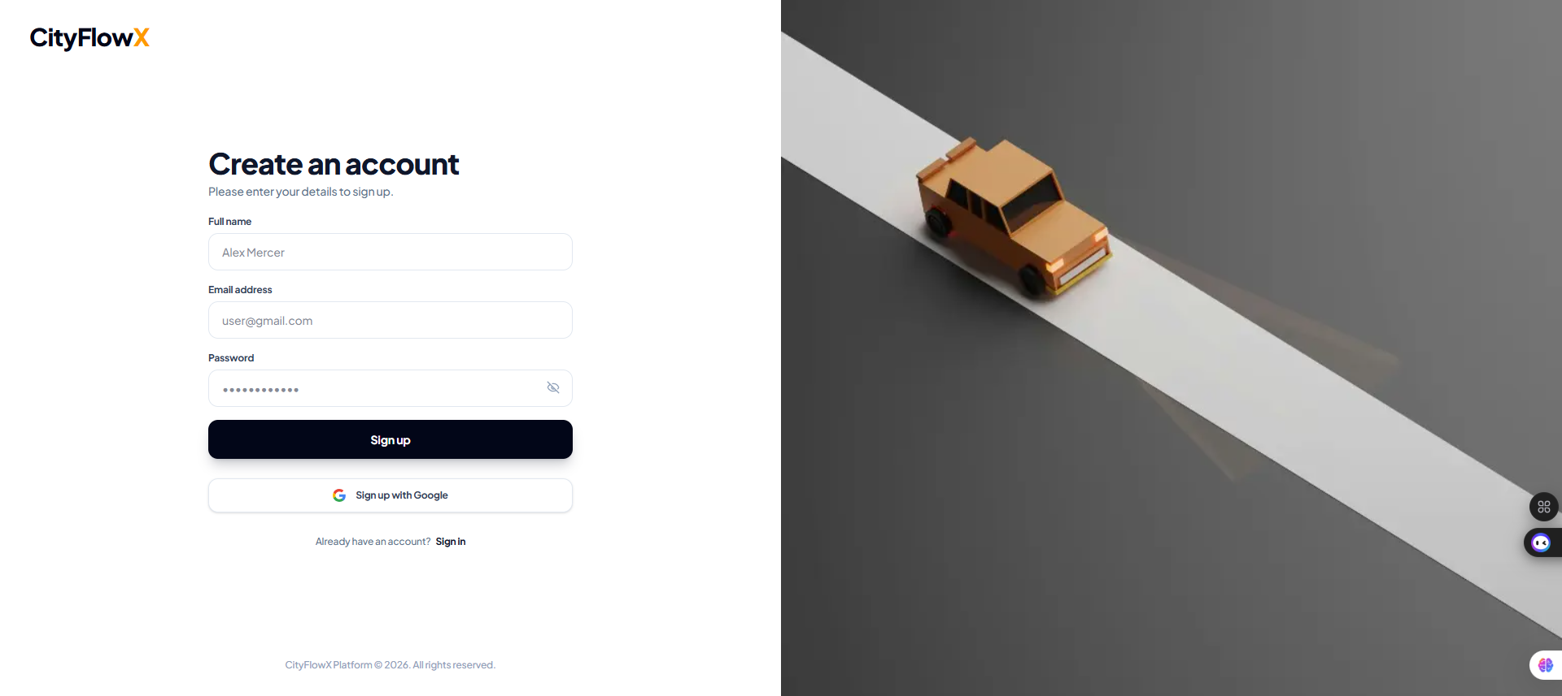
Figure 3. CityFlowX AI civilian registration output
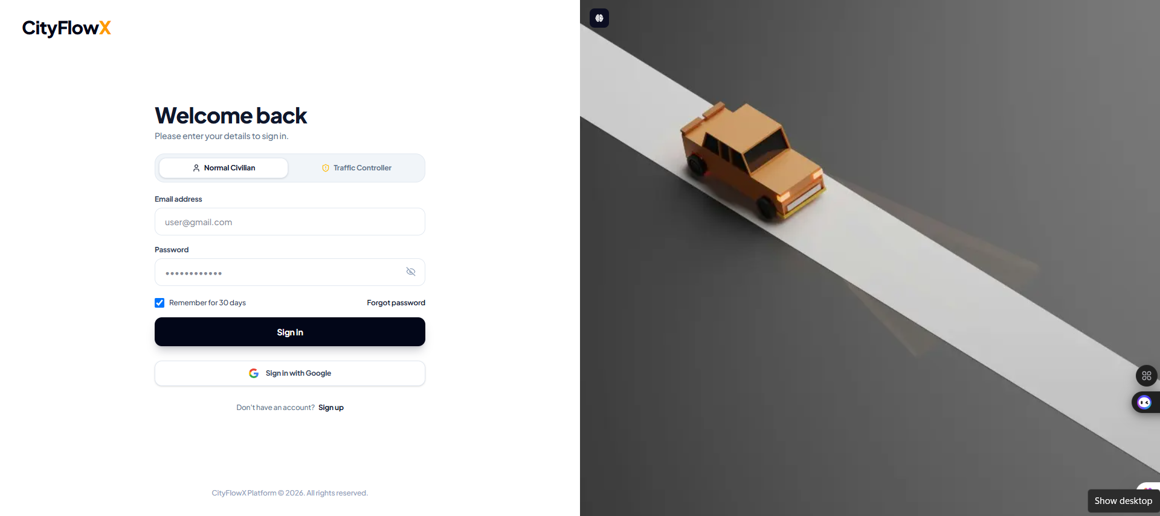
Figure 4. CityFlowX AI secure login output
Users can select the appropriate role and access the platform through the authentication interface.
10.2) CIVILIAN DASHBOARD
━━━━━━━━━━━━━━━━━━━━━━
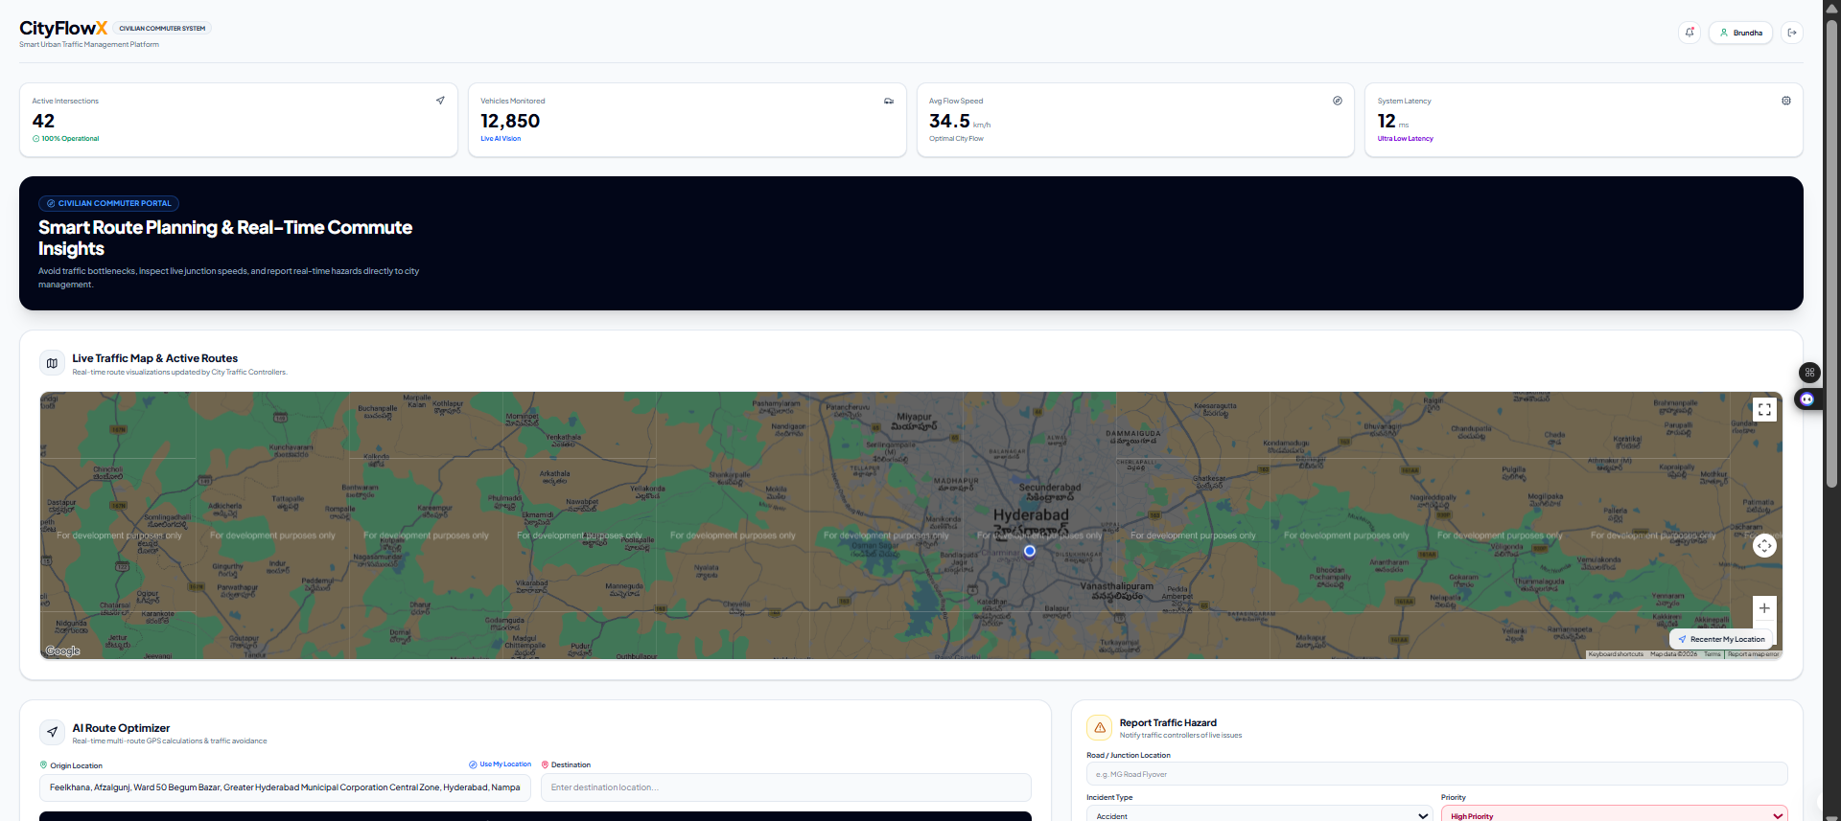
Figure 5. CityFlowX AI live commuter dashboard
The dashboard presents live traffic information and key traffic indicators in a single view.
10.3) AI ROUTE OPTIMIZER
━━━━━━━━━━━━━━━━━━━━━━
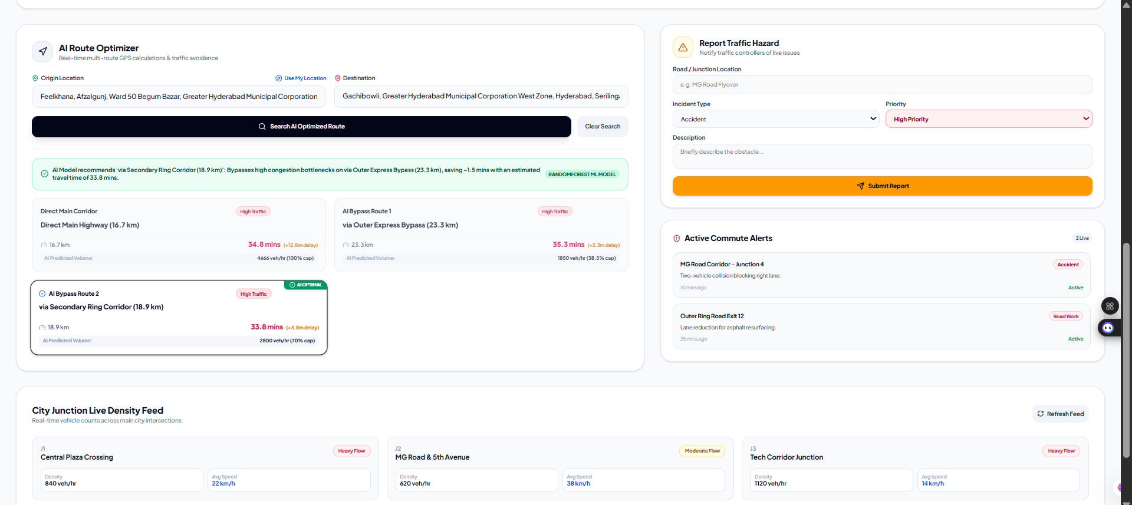
Figure 6. CityFlowX AI route-planning output
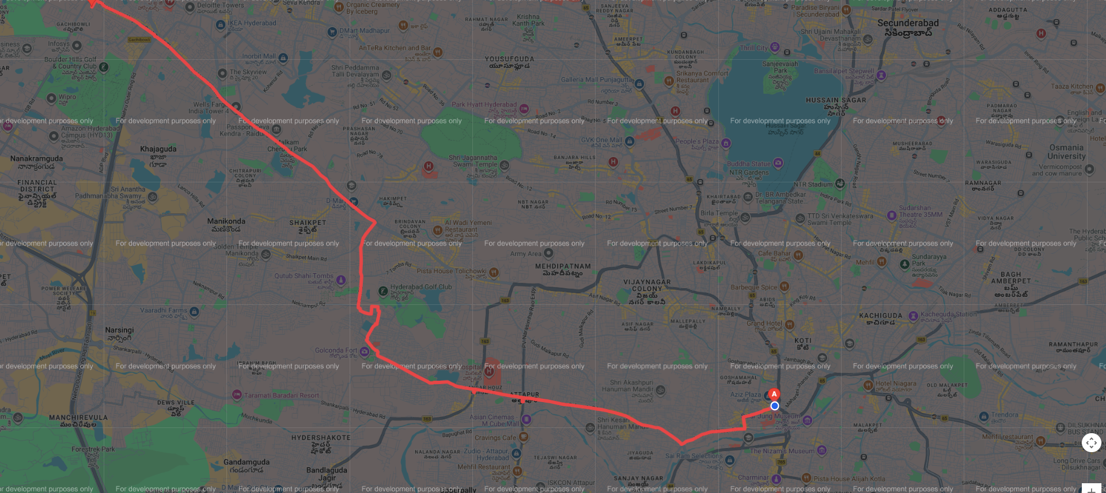
Figure 7. CityFlowX AI live route map output
The route optimizer compares available routes using traffic conditions and presents an AI-assisted recommendation.
10.4) TRAFFIC HAZARD REPORTING & ALERTS
━━━━━━━━━━━━━━━━━━━━━━
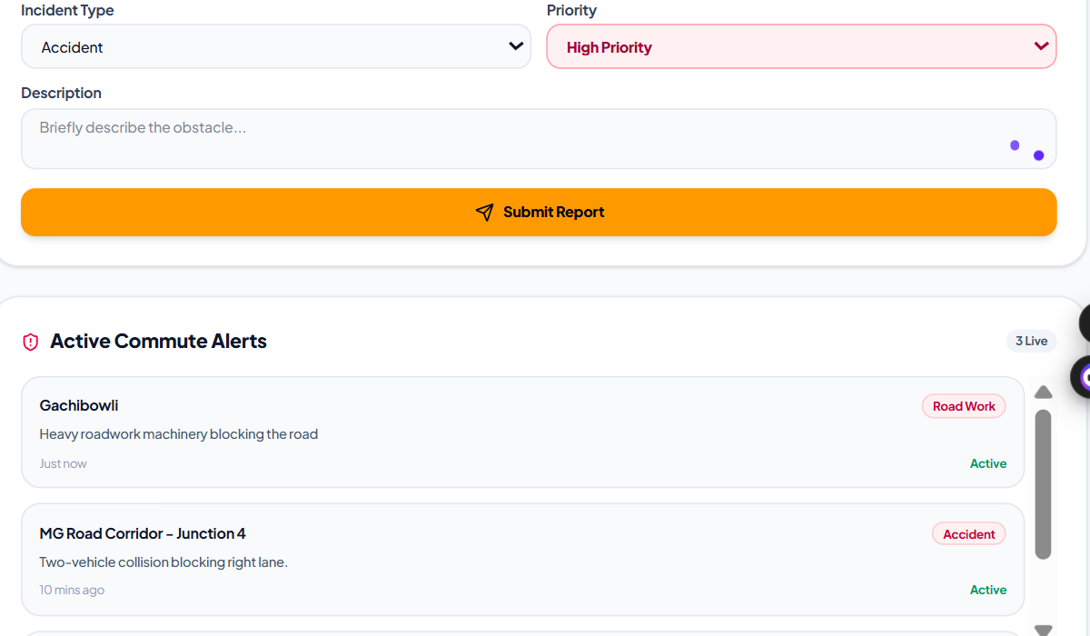
Figure 8. CityFlowX AI hazard reporting and commute alerts output
Commuters can report hazards by location, incident type and priority. Active commute alerts can then communicate relevant traffic incidents.
10.5) TRAFFIC CONTROL CENTER
━━━━━━━━━━━━━━━━━━━━━━
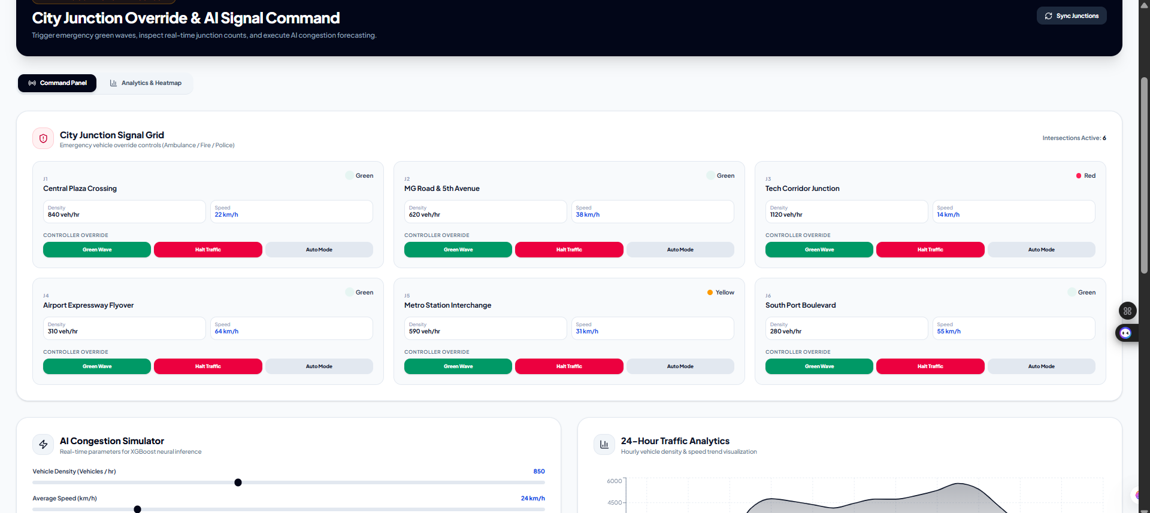
Figure 9. CityFlowX AI traffic controller console
The controller interface provides a citywide view of monitored junctions and supports controller-side traffic management workflows.
10.6) ANALYTICS & HEATMAP
━━━━━━━━━━━━━━━━━━━━━━
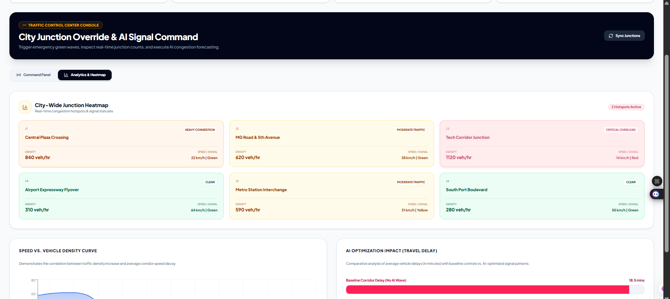
Figure 10. CityFlowX AI congestion analytics output
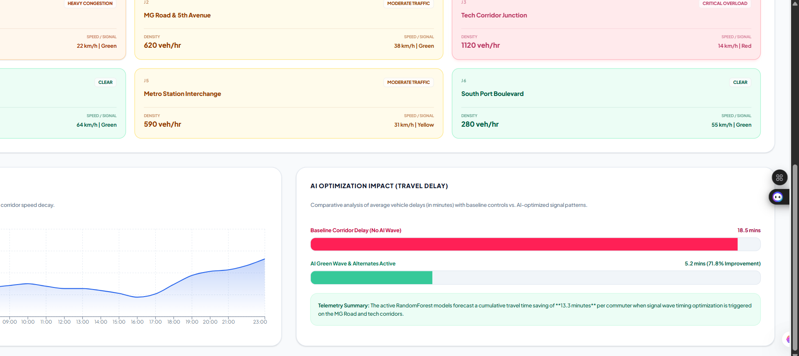
Figure 11. CityFlowX AI heatmap and performance output
Analytics screens summarize traffic trends, congestion patterns and road performance to support data-driven decisions.
10.7) AI ENGINE & OPTIMIZATION OUTPUT
━━━━━━━━━━━━━━━━━━━━━━
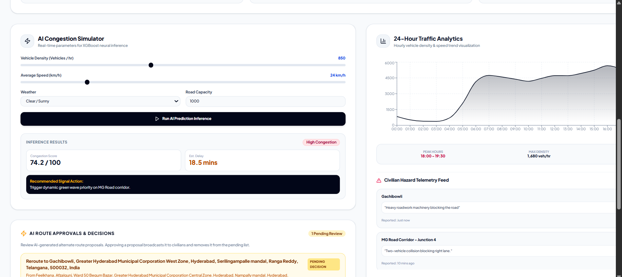
Figure 12. CityFlowX AI simulator / optimization output

11) GITHUB & VERSION CONTROL
━━━━━━━━━━━━━━━━━━━━━━
11.1 Repository
GitHub Repository: Team_4_Smart_Traffic_AI
Main branch: main
11.2 Repository Structure
- frontend/: web application, pages, components and styling.
- backend/: FastAPI application, routes/services, database and AI components.
- Docker configuration: containerization and deployment setup.
- CI/CD configuration: automated build/deployment workflow.
11.3 Version Control
Git and GitHub are used for source-code management and collaboration. Branches and commits support feature development, review and integration.

12) ERROR HANDLING & SECURITY
━━━━━━━━━━━━━━━━━━━━━━
12.1 Error Handling
- Input validation rejects invalid requests before business processing.
- Frontend loading and error states provide user feedback.
- Backend handles database, authentication and AI/ML failures with appropriate API responses.
- AI/ML failures are handled safely so invalid predictions are not presented as valid results.
12.2 Security
- JWT-based authentication and role-based authorization.
- Sensitive API keys and database credentials stored in environment variables.
- Protected backend operations require appropriate authorization.
- Sensitive credentials are not committed to source control.
12.3 Security Justification
Role separation is important because civilian and controller actions have different privileges. Environment-based secrets reduce the risk of exposing credentials in source code.

13) TESTING
Testing focuses on both individual components and complete workflows. Authentication, role access, traffic data, prediction, route optimization, alerts, analytics and frontend-backend communication are checked so that the integrated system behaves consistently.
13.1 Validation Approach
━━━━━━━━━━━━━━━━━━━━━━
Testing was performed across the major application workflows and AI/ML components.
Tests Performed
- User authentication test
- Role-based access test
- Accident/hazard reporting test
- Active alert update test
- Congestion notification test
- Route optimization test
- AI recommendation test
- Frontend-backend API test
- ML classification evaluation
- ML regression evaluation
Testing objective
The purpose was to verify that the main user workflows, API communication, role restrictions and AI outputs behaved as intended.

14) RESULTS
━━━━━━━━━━━━━━━━━━━━━━
14.1 AI/ML Results
METRIC / COMPONENT | RESULT
Random Forest Classifier | 95.08% Accuracy
Classification F1 | 0.95
Random Forest Regressor MAE | 107.57 vehicles/hour
Random Forest MAPE | 4.38%
LSTM Benchmark MAE | 190.13 vehicles/hour
LSTM Benchmark MAPE | 9.84%
Delay Regressor MAE | 0.49 minutes
Random Forest Latency | 25.1 ms
14.2 System Results
The results show that the platform is able to combine traffic monitoring, AI/ML analysis, route optimization, incident workflows and visualization in a single application. The documented model metrics provide measurable evidence for the AI components.
14.3 Overall Outcome
The developed platform integrates traffic monitoring, AI-based congestion analysis, route optimization, hazard reporting, traffic alerts and analytics. The major frontend-backend workflows were implemented and tested.

15) DEPLOYMENT
━━━━━━━━━━━━━━━━━━━━━━
CityFlowX AI uses containerized deployment concepts. Docker and Docker Compose provide reproducible environments for the frontend and backend services, while cloud deployment can be supported through Render/Vercel and CI/CD automation.
- Backend: Dockerized FastAPI service.
- Frontend: web application deployment.
- Containerization: Docker.
- Orchestration: Docker Compose.
- Reverse proxy: Nginx where configured.
- CI/CD: GitHub Actions.
Deployment justification
Containerization reduces environment differences between development and deployment and makes the multi-service application easier to reproduce.

16) CHALLENGES & LIMITATIONS
The project addresses these limitations through structured data processing, consistent model features, modular APIs, role-based access, validation, and separation of frontend, backend, database and AI responsibilities.
16.1 Mitigation Approach
━━━━━━━━━━━━━━━━━━━━━━
- Traffic data availability: consistent real-world traffic data is difficult to obtain for every road and condition.
- AI model integration: training and inference must use consistent feature selection and encoding.
- Frontend-backend integration: multiple APIs require careful handling of requests, responses, authentication and roles.
- Map and system integration: traffic data, prediction, alerts, reports and analytics must remain synchronized.
- External services: mapping/traffic APIs can introduce availability, rate-limit or latency constraints.
- Prediction limitations: model performance depends on the quality and representativeness of the training data.

17) FUTURE SCOPE
The highest-value future improvements are richer live traffic inputs, continuous model validation, stronger forecasting, mobile access and scalable deployment. These additions would move the platform closer to real-world city-scale operation.
17.1 Expansion Priorities
━━━━━━━━━━━━━━━━━━━━━━
- Integrate additional real-time traffic sensors and CCTV feeds.
- Improve congestion forecasting with larger and more diverse datasets.
- Add deeper AI/deep-learning forecasting models.
- Introduce real-time road-closure information.
- Expand emergency-vehicle route prioritization.
- Provide mobile application support for commuters.
- Automate model retraining and continuous validation.
- Scale toward multi-city deployment.
- Add advanced traffic-controller analytics.
Future direction
The current software platform provides a foundation for connecting richer live traffic sources and scaling the architecture to larger deployments.

18) CONCLUSION
━━━━━━━━━━━━━━━━━━━━━━
CityFlowX AI provides an integrated software platform for traffic prediction, congestion management, route optimization, incident reporting, traffic alerts and analytics.
The system combines a modern web interface, FastAPI-based services, database storage, mapping/traffic APIs and AI/ML components to support both commuters and traffic controllers.
Overall, CityFlowX AI demonstrates how traffic management can move from a reactive approach toward a more proactive, data-driven service.
Key takeaway
CityFlowX AI connects traffic data + AI prediction + route guidance + alerts + analytics in one platform.

19) REFERENCES
━━━━━━━━━━━━━━━━━━━━━━
- Hogue, J. (2019). Metro Interstate Traffic Volume Data Set. UCI Machine Learning Repository.
- Breiman, L. (2001). Random Forests. Machine Learning, 45(1), 5–32.
- Hochreiter, S., & Schmidhuber, J. (1997). Long Short-Term Memory. Neural Computation, 9(8), 1735–1780.
- FastAPI documentation and project implementation references.
- Next.js / React documentation and project implementation references.
- Google Maps Platform documentation.
- Scikit-learn documentation – Random Forest classification and regression.
- Supabase / PostgreSQL documentation.
- MongoDB Atlas documentation.
- TomTom Traffic API documentation.
- Docker and Docker Compose documentation.
- GitHub Actions documentation.
- CityFlowX AI project repository: Team_4_Smart_Traffic_AI.

THANK YOU
CITYFLOWX AI
Smart Urban Traffic Management Platform

