TRAFFICVISION AI

MILESTONE 1
Project Initialization, Design & Core Setup
Weeks 1–2 • 22 July – 31 July 2026 • IMPLEMENTED
Milestone Focus | Project Initialization, Design & Core Setup

1. Milestone Objective
Establish the technical foundation of TrafficVision AI, including architecture, database structure, development environments, authentication, role-based access and the first live traffic monitoring workflow.

2. Work Completed / Planned
• Defined project objectives and smart-traffic workflows.
• Designed the system architecture and database schema.
• Planned UI wireframes and application workflows.
• Set up the React/Vite frontend and FastAPI backend environments.
• Implemented registration, login, password hashing and JWT-based authentication.
• Implemented role-based access for Commoner, Operator, Admin and Commissioner users.
• Built live traffic monitoring with traffic points, speed, free-flow speed, travel time and road status.
• Implemented congestion tracking using traffic observations.

3. Milestone Outcomes
• Working authentication and role-based access flow.
• Core live traffic monitoring functionality.
• Initial congestion dashboard and traffic-status tracking.
• Foundation for subsequent prediction, routing, alerts and analytics modules.

4. Implementation & Functional Flow
Registration/Login → API authentication → password verification/hash → JWT token → authenticated requests → role-specific dashboard → live traffic monitoring.

5. Implementation Status
Area | Status | Implementation / Evidence
Architecture & setup | Completed | Frontend/backend environments and core application structure.
Database | Completed | User, traffic and supporting application models established.
Authentication | Completed | Registration, login, bcrypt password handling and JWT token storage.
Role-based access | Completed | Role-aware access using current-user and role dependencies.
Live traffic | Completed | Traffic observations, speed, travel time and road status displayed.
Congestion tracking | Completed | Traffic conditions classified from observed data.
Key implementation files: backend/app/main.py; backend/app/core/security.py; backend/app/core/database.py; backend/app/models/user.py; backend/app/models/traffic.py; frontend/src/pages/Login.jsx; frontend/src/services/api.js

6. Visual Evidence
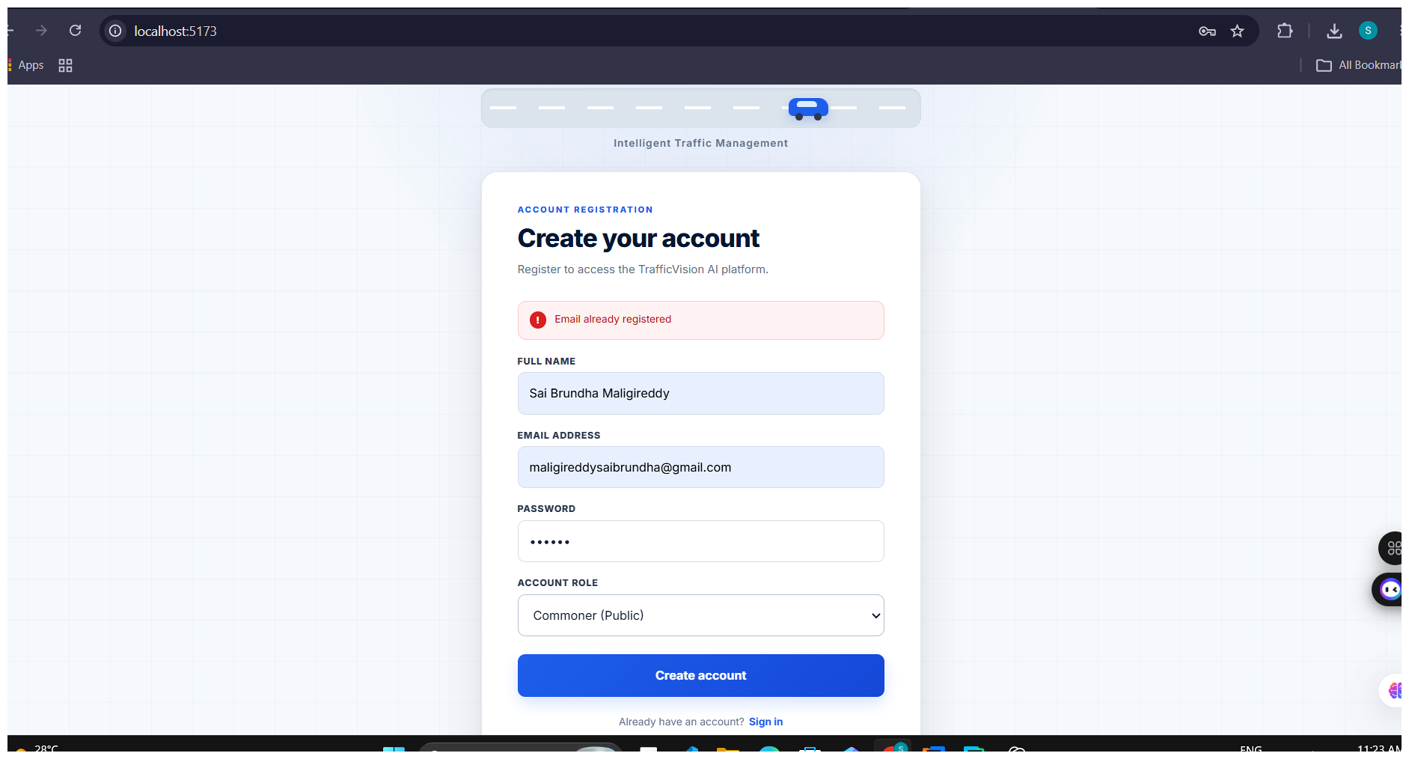
Figure 1. Registration interface used to create a TrafficVision AI account.
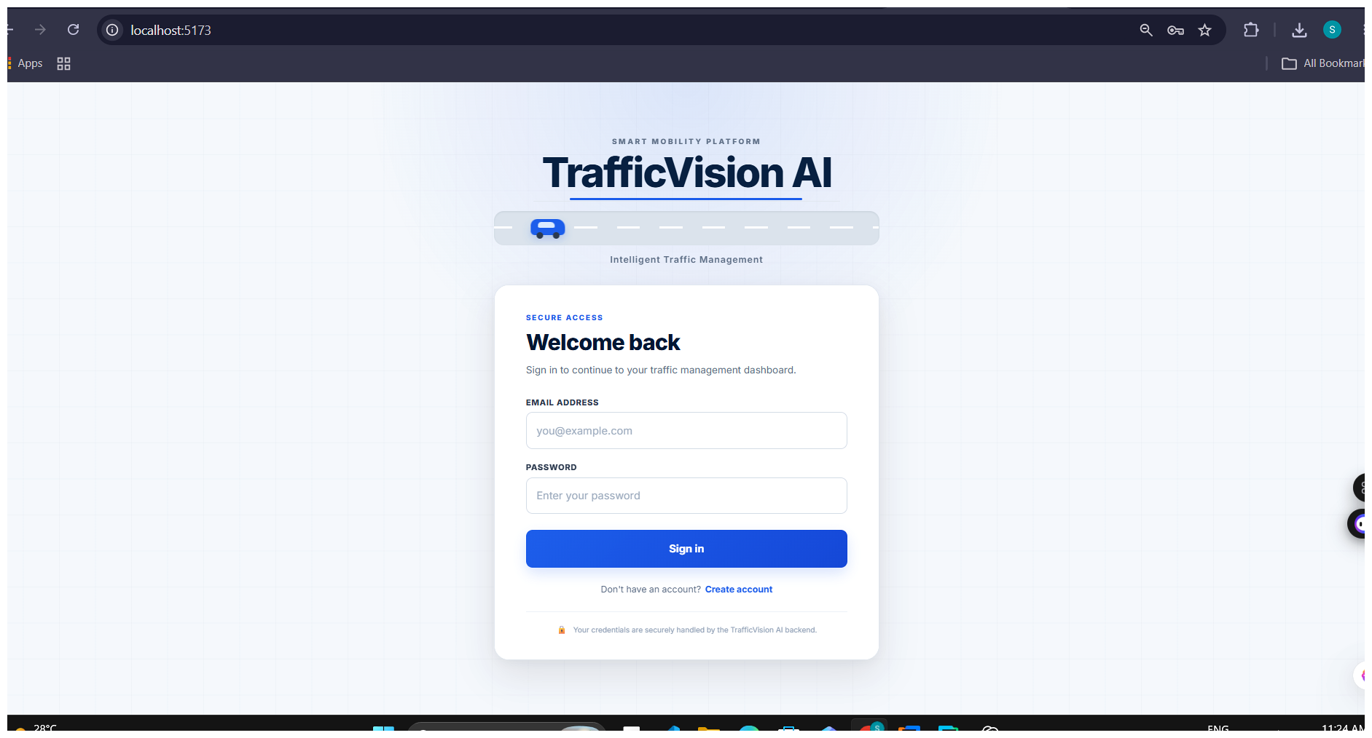
Figure 2. Login interface for secure platform access.
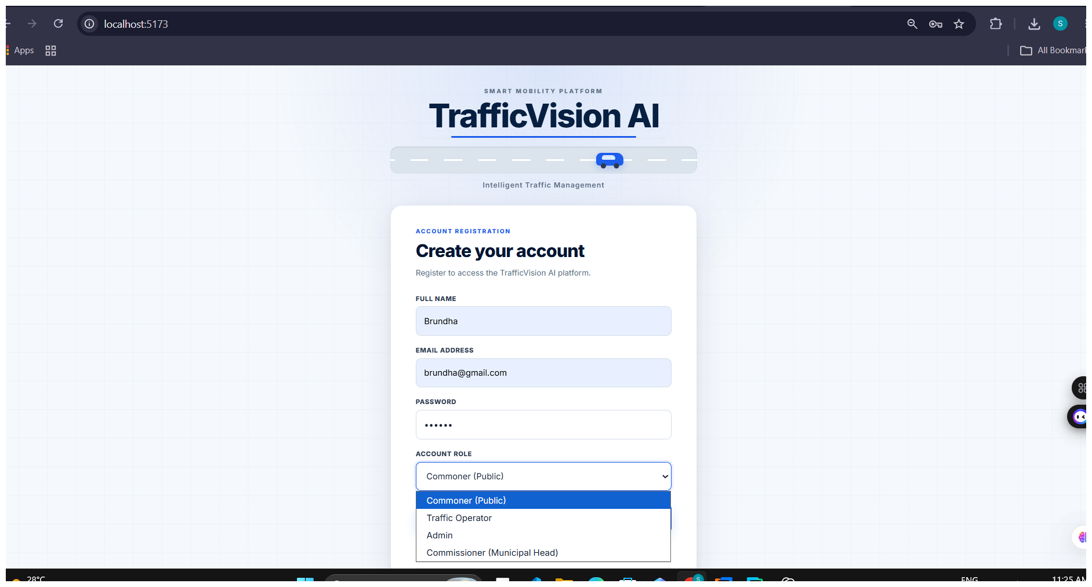
Figure 3. Registration interface with role selection.

7. Documentation Note
This milestone report is based on the TrafficVision AI project documentation, implementation evidence and supplied interface screenshots.

