TRAFFICVISION AI

MILESTONE 2
Traffic Prediction & Route Optimization
Weeks 3–4 • 3 August – 14 August 2026 • IMPLEMENTED / DEMONSTRATED
Milestone Focus | Traffic Prediction & Route Optimization

1. Milestone Objective
Extend TrafficVision AI from monitoring into prediction and route decision support by adding congestion forecasting, prediction reports, map/traffic-service integration, route alternatives and travel-time estimation.

2. Work Completed / Planned
• Developed traffic prediction and congestion forecasting workflows.
• Generated prediction insights and reports.
• Integrated maps and traffic APIs.
• Implemented alternate-route recommendation workflows.
• Added travel-time and traffic-delay estimation.
• Implemented React-based prediction and route-analysis interfaces.

3. Milestone Outcomes
• Traffic prediction and congestion forecasting functionality.
• Map and traffic-service integration.
• Route analysis and alternate-route workflows.
• Real-time prediction and travel-time insights.

4. Implementation & Functional Flow
Prediction inputs → prediction API → Random Forest model or fallback heuristic → congestion level + confidence → prediction UI.
Route optimization flow: Source/Destination → map search → coordinates → traffic-aware routing → ETA/delay → best route + alternatives.

5. Implementation Status
Area | Status | Implementation / Evidence
Prediction model | Completed | scikit-learn Random Forest with a fallback heuristic.
Forecasting | Completed | Uses time/day and traffic-related inputs for congestion prediction.
Prediction reports | Completed | Prediction reporting endpoint and frontend presentation.
Maps & traffic APIs | Completed | TomTom search, traffic and routing services integrated.
Alternate routes | Completed | Traffic-aware route alternatives and travel-time comparison.
Frontend interfaces | Completed | React prediction and route-analysis pages demonstrated.
Key implementation files: traffic_prediction/model.py; traffic_prediction/routes.py; traffic_prediction/service.py; route_analysis/service.py; frontend Prediction.jsx; frontend RoutePlanner.jsx

6. Visual Evidence
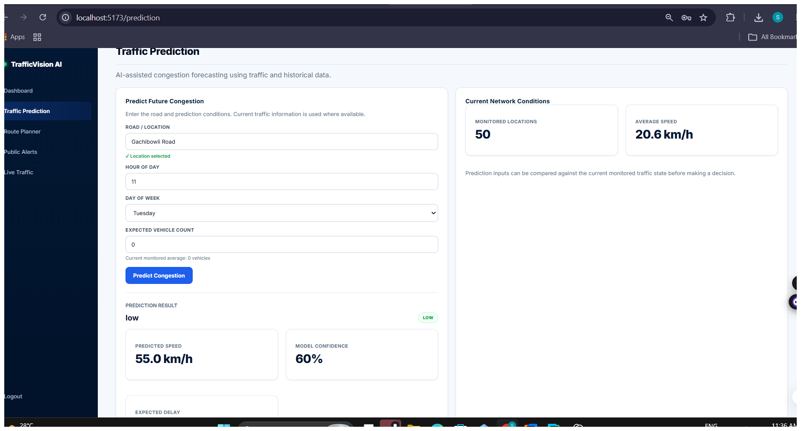
Figure 1. Traffic prediction interface showing prediction inputs and network conditions.
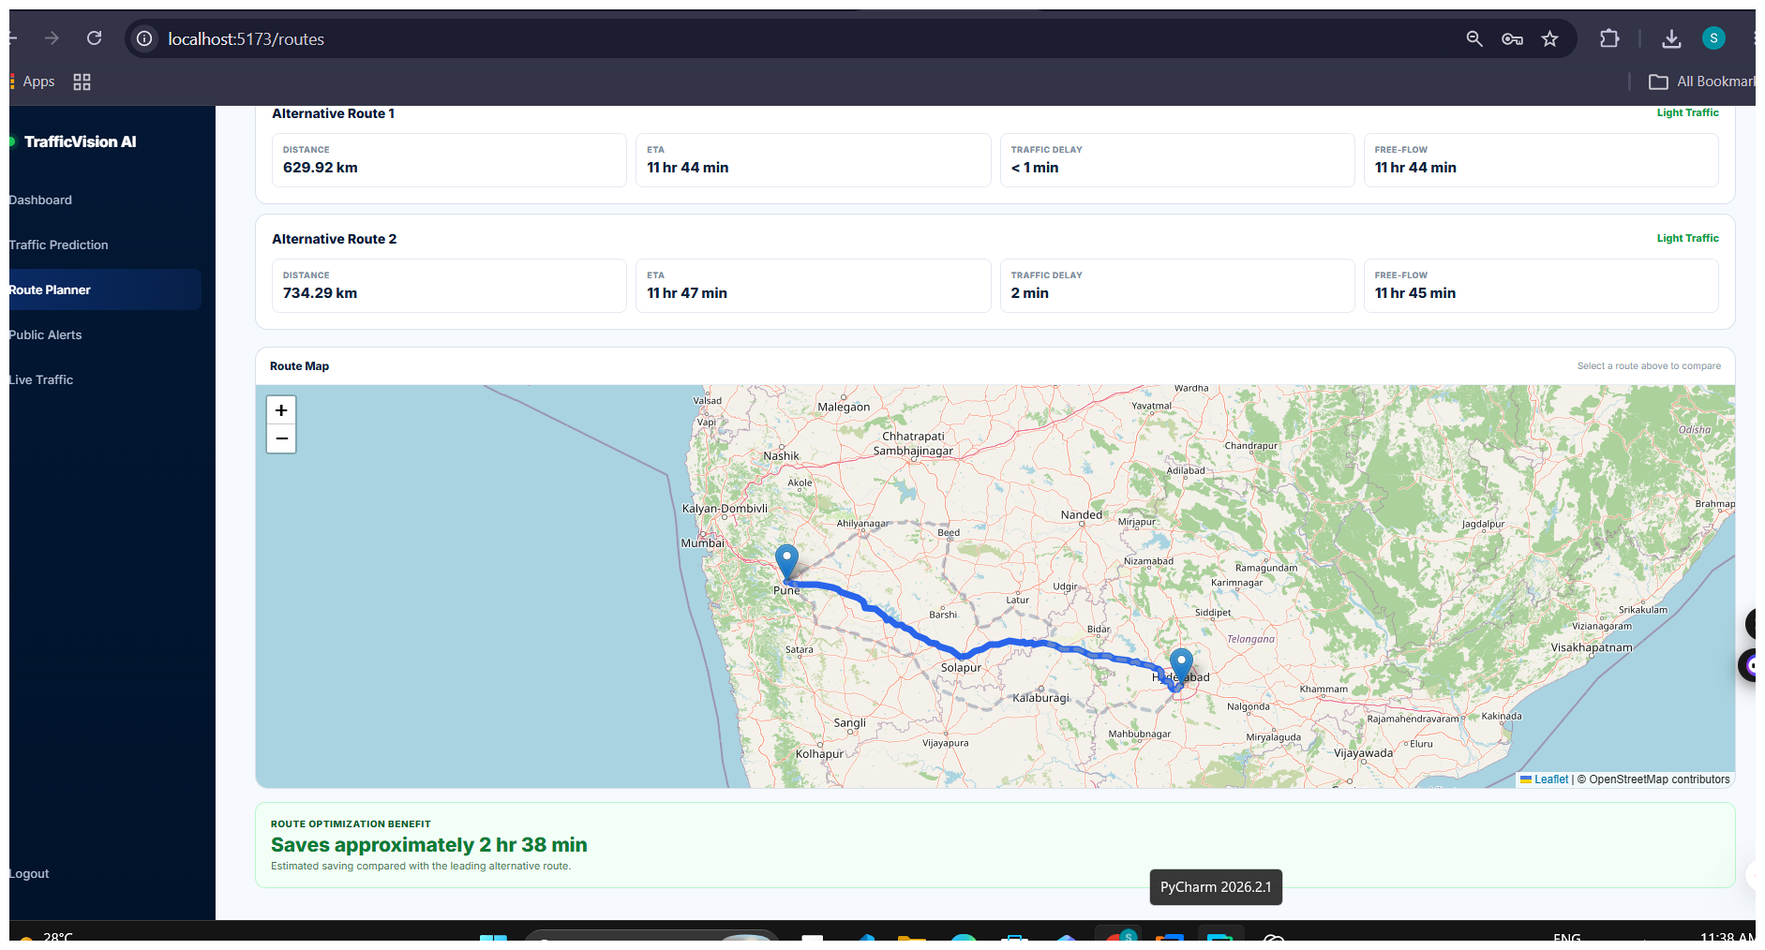
Figure 2. Map-based route visualization.
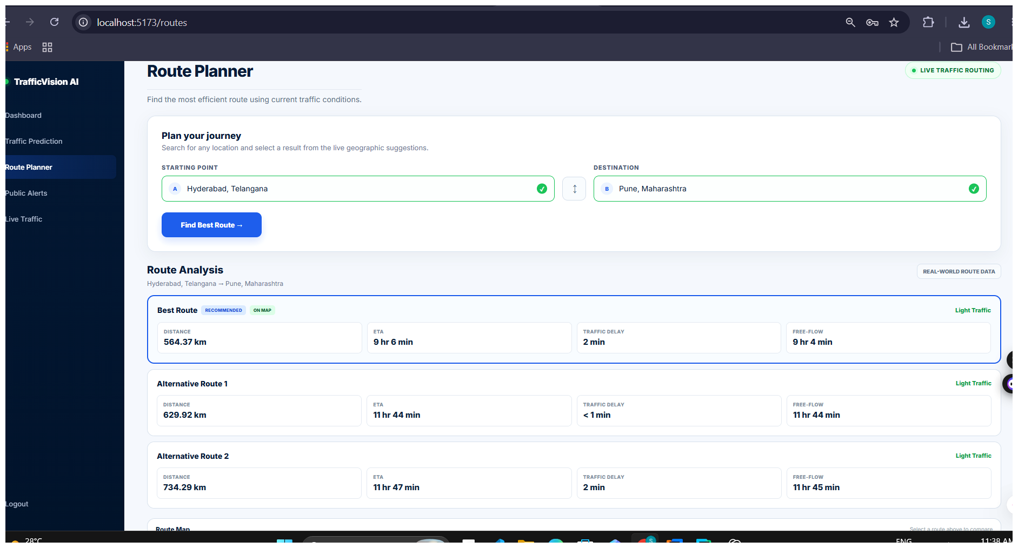
Figure 3. Route Planner showing route analysis and alternatives.

7. Documentation Note
This milestone report is based on the TrafficVision AI project documentation, implementation evidence and supplied interface screenshots.

