TRAFFICVISION AI

MILESTONE 3
Alerts, Analytics & AI Insights
Weeks 5–6 • 17 August – 28 August 2026 • IMPLEMENTED / DEMONSTRATED
Milestone Focus | Alerts, Analytics & AI Insights

1. Milestone Objective
Add operational awareness and decision support through traffic alerts, notifications, analytics, congestion heatmaps, traffic trends and AI-assisted traffic insights.

2. Work Completed / Planned
• Implemented the traffic alert and notification system.
• Generated congestion and traffic notifications.
• Built analytics dashboards and congestion heatmaps.
• Developed traffic trend and road-performance analysis.
• Added AI-assisted traffic recommendations and analysis workflows.
• Integrated alert resolution and analytics-oriented views.

3. Milestone Outcomes
• Operational alert and notification workflow.
• Active and resolved alert lifecycle.
• Analytics and heatmap dashboards.
• Traffic trend and road-performance analysis.
• AI-assisted traffic insights.

4. Implementation & Functional Flow
Traffic records → recent observations → congestion check → duplicate-active-alert check → alert creation → dashboard/notification → resolution → resolved timestamp/state.
Analytics implementation: Heatmap visualization uses congestion-weighted points. Road-performance views summarize average speed and observation counts. Trend views aggregate traffic observations by congestion level.

5. Implementation Status
Area | Status | Implementation / Evidence
Alert system | Completed | Alert model, service, routes and operational dashboard.
Congestion alerts | Completed | Medium/high traffic observations can generate alerts.
Alert lifecycle | Completed | Active alerts can be reviewed and resolved.
Analytics | Completed | Traffic trends, road performance and utilization views.
Heatmap | Completed | Congestion-weighted geographic visualization.
AI insights | Implemented / demonstrated | Prediction and route recommendation workflows provide traffic intelligence.
Key implementation files: models/alert.py; alerts/service.py; alerts/routes.py; analytics/service.py; Alerts.jsx; Analytics.jsx; Dashboard.jsx; TrafficMap.jsx

6. Visual Evidence
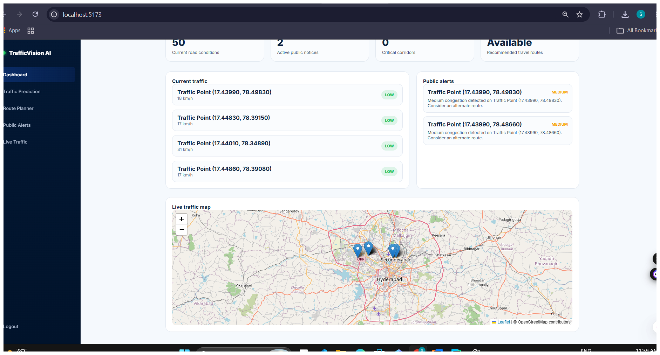
Figure 1. Traffic overview showing monitored traffic points and public alerts.
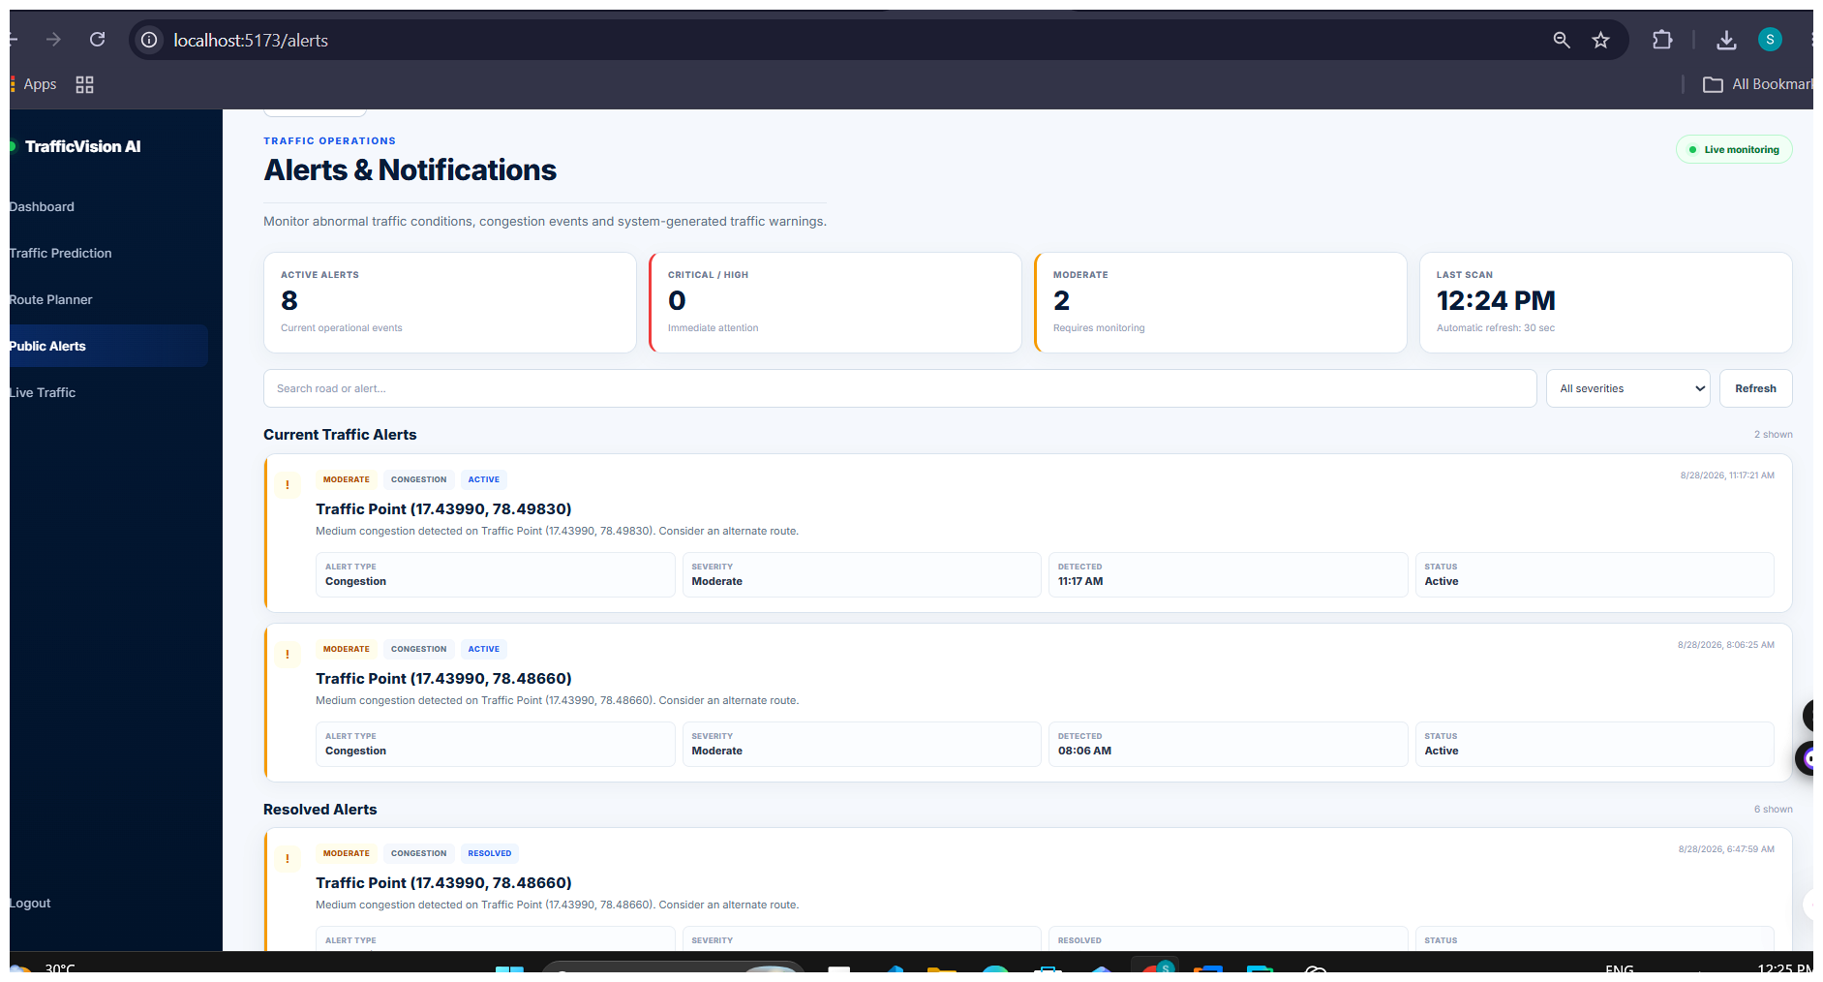
Figure 2. Alerts and Notifications interface showing active and resolved alerts.

7. Documentation Note
This milestone report is based on the TrafficVision AI project documentation, implementation evidence and supplied interface screenshots.

