TRAFFICVISION AI

MILESTONE 4
Testing, Deployment & Documentation
Weeks 7–8 • 31 August – 11 September 2026 • PARTIALLY COMPLETED — DOCKER PENDING
Milestone Focus | Testing, Deployment & Documentation

1. Milestone Objective
Validate the integrated platform, improve usability and stability, prepare deployment, consolidate documentation and produce final demonstration evidence.

2. Work Completed / Planned
• Performed application workflow validation and UI improvements.
• Validated live traffic, role-specific dashboards and alert handling.
• Improved loading states, error handling, reusable UI and responsive behavior.
• Prepared project documentation and presentation material.
• Demonstrated the integrated TrafficVision AI application.
• Prepared deployment configuration; Docker/containerization remains outstanding.

3. Milestone Outcomes
• Major application workflows demonstrated.
• Functional validation evidence collected.
• Professional milestone documentation prepared.
• Containerized deployment remains the principal outstanding task.

4. Implementation & Functional Flow
Integrated workflow testing → issue correction → module validation → deployment preparation → documentation → final demonstration.

5. Implementation Status
Area | Status | Implementation / Evidence
Testing & validation | In progress | Major workflows demonstrated; formal complete test-suite evidence remains incomplete.
Performance & stability | In progress | Timeout/error handling and bounded queries are present; formal load benchmarks are not evidenced.
Docker/containerization | Pending | Dockerfiles/Compose and containerized runtime evidence are not verified in the reviewed implementation.
Cloud deployment | Partially prepared | Deployment configuration exists; successful live deployment still requires runtime evidence.
Documentation | In progress | Architecture, implementation, APIs, database, testing and deployment documentation consolidated.
Final presentation | In progress | Final demonstration should cover all major modules and deployment status.
Key implementation files: Testing_and_Validation.md; Deployment.md; Final_Status.md; architecture documentation; module documentation; deployment configuration

6. Visual Evidence
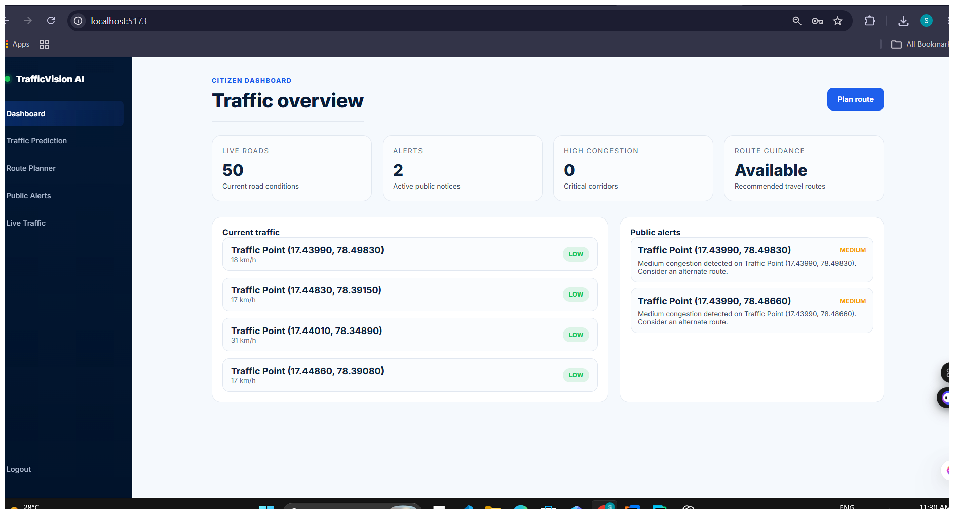
Figure 1. Traffic overview / system-wide traffic interface used for integrated validation.
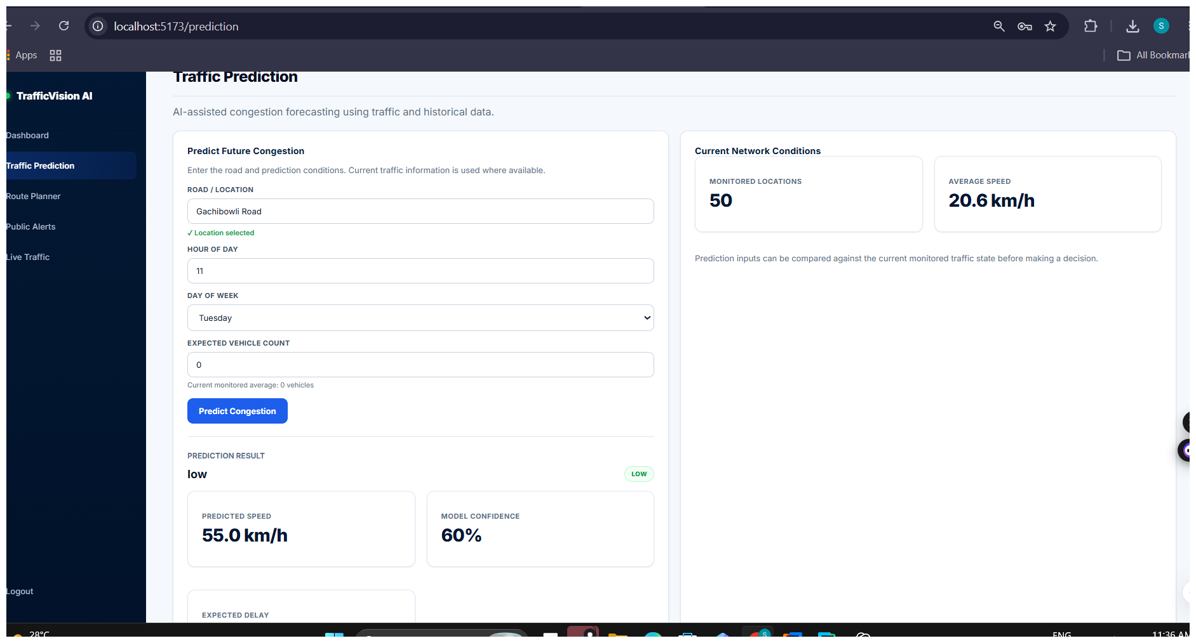
Figure 2. Prediction and traffic-operations interface.
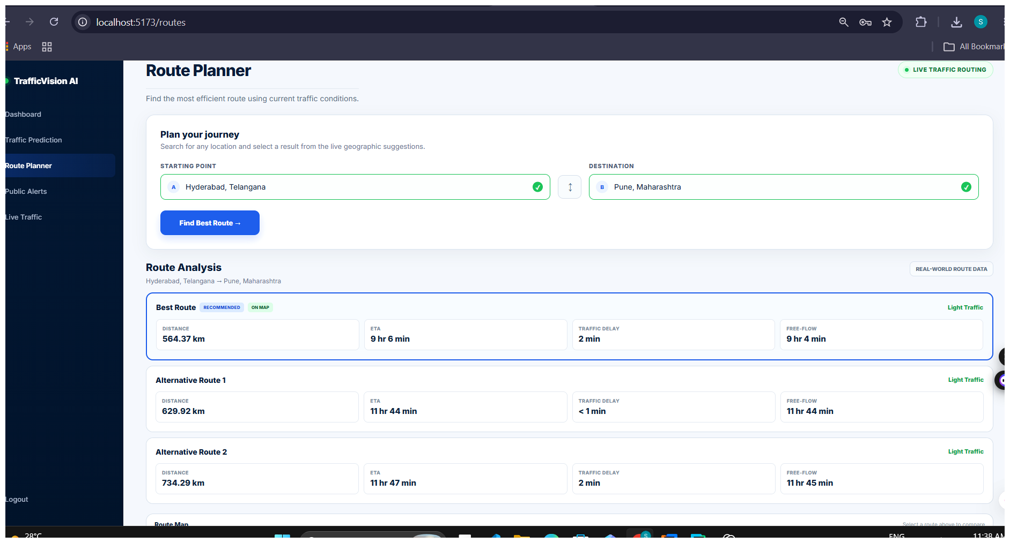
Figure 3. Route Planner and route-analysis interface.
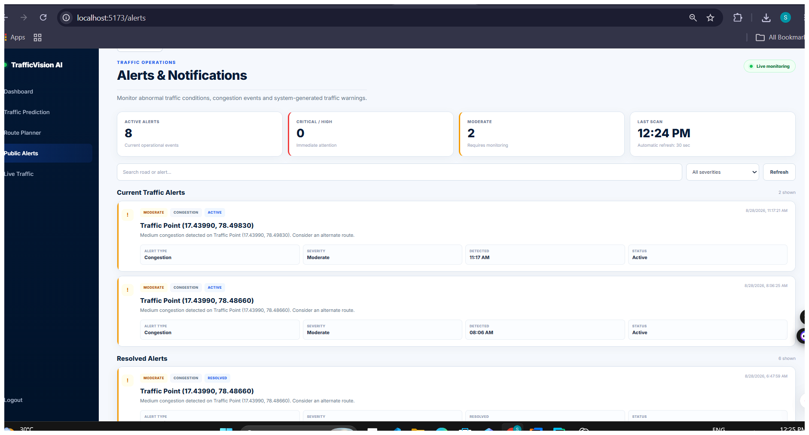
Figure 4. Alert management interface used for validation.

7. Deployment Status Note
Deployment status must be reported accurately: the reviewed documentation explicitly records Docker/containerization as pending. Therefore, this milestone should not claim a completed containerized or production deployment.

