VisionInspect AI
Manufacturing Defect Detection & Quality Inspection System
Project Report
Veeneshwari R
S.D.N.B. Vaishnav College for Women
Infosys Springboard Internship Program

Table of Contents
Sr. No. | Section | Page No.
1 | Project Overview & Objectives | 3
2 | Problem Statement | 4
3 | Scope | 4
4 | Architecture | 5
5 | Technology Stack | 6
6 | Modules | 6
7 | Dataset & AI/ML Model Implementation | 7
8 | Milestones | 8
9 | User Roles | 10
10 | Dashboards | 11
11 | Testing & Performance Evaluation | 13
12 | Deployment & Results | 15
13 | Conclusion | 17
14 | Future Enhancements | 17

1. Project Overview & Objectives
VisionInspect AI is an AI-powered manufacturing quality inspection platform built to automatically detect product defects from images, classify defect types, score their severity, and surface production-wide analytics through a centralized dashboard. The platform was developed end-to-end — from dataset preparation and model training through to a deployed, publicly reachable web application — as part of an eight-week Infosys Springboard internship engagement.
The system is designed to replace slow, error-prone manual visual inspection with a fast, consistent, camera-driven workflow suited to manufacturing plants, quality assurance teams, automotive component makers, electronics manufacturers, and industrial automation providers.

1.1 Objectives
- Automate visual quality inspection using computer vision instead of manual checks.
- Detect and classify manufacturing defects across a wide range of product categories.
- Score every detected defect for severity using a transparent, multi-factor formula.
- Provide role-based dashboards for Quality Engineers and Factory Supervisors.
- Generate exportable inspection reports (PDF/CSV) for audit and compliance needs.
- Surface manufacturing analytics — defect trends, yield, and production-line health — in real time.
- Deploy the platform as a live, cloud-accessible application with a working CI/CD-style GitHub-to-cloud pipeline.

1.2 Outcomes Achieved
- Developed and deployed an AI-powered manufacturing defect detection and quality inspection platform.
- Implemented authentication and role-based access control for two distinct user roles.
- Built product image acquisition, upload, and inspection workflows.
- Trained and evaluated computer vision defect-detection models across 15 product categories.
- Implemented defect classification and a quantitative severity-assessment framework.
- Built automated pass/fail quality-decision logic and downloadable inspection reports.
- Developed manufacturing analytics dashboards for trend and defect-distribution analysis.
- Containerized the platform with Docker and deployed it to a live cloud environment.

2. Problem Statement
Manual visual inspection remains the default quality-control method across many manufacturing lines, but it carries well-known limitations: inspection speed is capped by human throughput, judgment of defect severity varies between inspectors and across shifts, minor but consequential flaws are easy to miss under time pressure, and inspection data is rarely captured in a structured, analyzable form.
These limitations translate directly into higher defect-escape rates, inconsistent quality decisions, slower root-cause analysis, and a lack of real-time visibility into how a production line is actually performing at any given moment.
VisionInspect AI addresses this by replacing subjective, manual review with a deep-learning defect-detection pipeline that classifies defects, computes a repeatable severity score from measurable factors, and logs every inspection to a structured database — giving quality teams both faster individual decisions and a continuously growing dataset for trend analysis.

3. Scope
The project scope covers the full pipeline from raw defect imagery to a deployed, role-aware web application, built and demonstrated over four two-week milestones.

3.1 In Scope
- Authentication and role-based access control (Quality Engineer / Factory Supervisor).
- Manual image upload with product metadata (code, batch, production line, category).
- AI-based defect detection and classification across 15 industrial product categories.
- Multi-factor severity scoring and automated pass/fail decisioning.
- Inspection history, daily quality reports, and downloadable PDF reports.
- Defect analytics and trend-monitoring dashboards.
- Containerized deployment (Docker) to a public cloud hosting environment.

3.2 Out of Scope (Current Iteration)
- Direct integration with physical plant-floor cameras or PLC/SCADA systems (simulated via manual upload instead).
- Mobile native application (a responsive web dashboard is provided instead).
- Multi-tenant / multi-factory organization management.

4. Architecture
The platform follows a layered architecture: a data-input layer that accepts uploaded or camera-sourced imagery, an inspection and analytics pipeline that performs preprocessing, feature extraction, defect detection, classification and severity scoring, a data and platform layer for persistence and analytics, and an infrastructure layer that containerizes and serves the whole system.
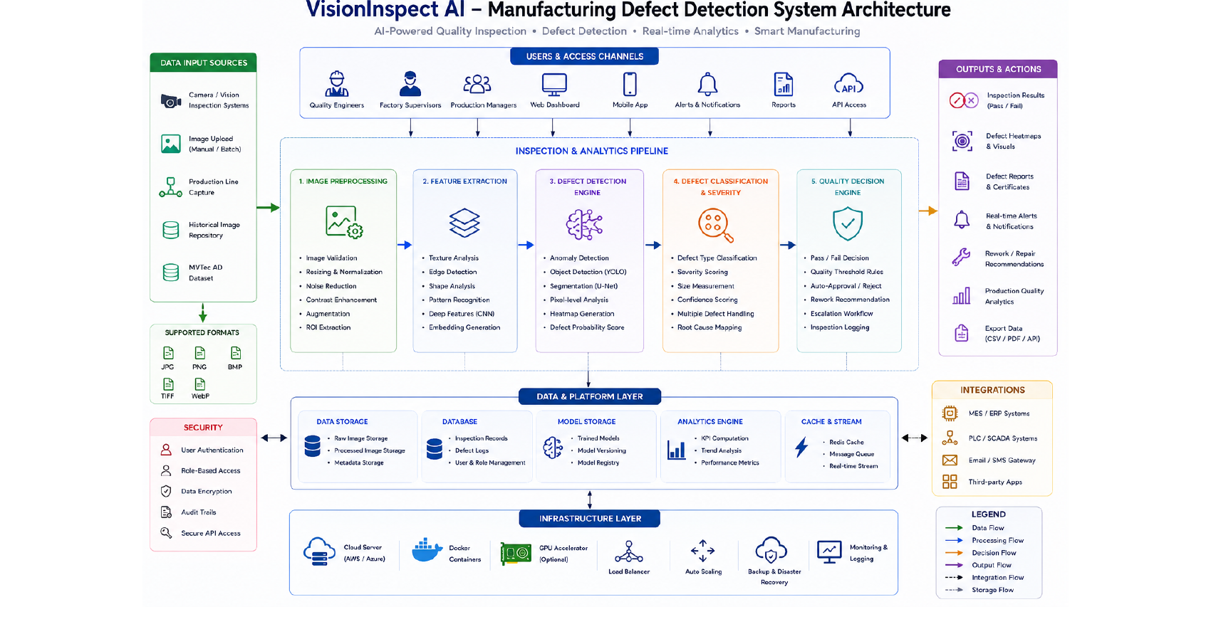
Figure 4.1 — VisionInspect AI system architecture: from data input through the inspection pipeline to outputs and integrations.

4.1 Request Flow
A typical inspection request flows as follows: the browser-based frontend calls a REST endpoint on the FastAPI backend; the backend validates the caller's JWT bearer token; on upload, the image is handed to the trained detection model, which returns defect type, bounding-box location, and confidence; the backend computes a severity score from size, location, defect-type and confidence signals; the result is persisted to PostgreSQL; and a structured JSON response — including the pass/fail recommendation — is returned to the dashboard for display.

5. Technology Stack
Layer | Technologies
Frontend | React (Vite), Tailwind-style component styling, Chart.js for analytics visualizations
Backend | Python, FastAPI, JWT authentication (python-jose), Passlib/bcrypt password hashing
Database | PostgreSQL (Render-managed instance); SQLite used in early prototyping
AI / Machine Learning | PyTorch, Ultralytics YOLO11n object detection; Anomalib / PatchCore explored in early milestones
Image Processing | OpenCV, NumPy, Pillow
Reporting | jsPDF (client-side PDF generation), CSV export
Containerization & Deployment | Docker, Docker Compose, Render (Web Service, Static Site, Managed PostgreSQL)
Dev & Version Control | VS Code, Git, GitHub, Postman for API testing

6. Modules

1. User Management Module
- Quality Engineer and Factory Supervisor account types
- Registration, login, and JWT-based authentication
- Role-based authorization on protected routes

2. Image Acquisition Module
- Manual product image upload with metadata capture
- Batch-style upload support and basic image validation

3. Image Processing Module
- Preprocessing, normalization, and augmentation
- Feature extraction feeding into the detection engine

4. Defect Detection Module
- YOLO-based object detection for defect identification and localization
- Anomaly-detection experimentation (PatchCore) in early milestones

5. Defect Classification & Severity Module
- Defect-type classification across 70+ underlying defect variants, grouped into the 15 trained categories
- Multi-factor severity scoring (Size, Location, Defect Type, Confidence)

6. Quality Control Module
- Automated pass/fail decision generation
- Actionable recommendations (e.g., quarantine, rework, approve for shipment)

7. Manufacturing Analytics Dashboard Module
- Defect-type breakdown and severity-distribution charts
- 14/30-day trend monitoring for inspection volume and average severity
- Daily quality reports with per-line yield and confidence metrics

7. Dataset & AI/ML Model Implementation

7.1 Dataset — MVTec AD
The model was trained on the MVTec Anomaly Detection (MVTec AD) dataset, the standard academic benchmark for industrial visual inspection. It provides high-resolution images across 15 object and texture categories — bottle, cable, capsule, carpet, grid, hazelnut, leather, metal_nut, pill, screw, tile, toothbrush, transistor, wood, and zipper — each with defect-free training images and a labeled test set spanning over 70 real defect types such as scratches, dents, contamination, and structural deformation.

7.2 Data Preparation
- Raw MVTec images and pixel masks were converted into YOLO-compatible label format using custom preparation scripts (prepare_mvtec_yolo.py, prepare_metal_nut_yolo.py).
- A dataset-reduction script (reduce_mvtec.py) balanced class distribution across categories.
- A data.yaml configuration defined class names and train/validation paths for the YOLO training pipeline.

7.3 Model Training
A YOLO11n model was trained from scratch — without pretrained COCO weights — for 200 epochs on the prepared MVTec dataset using the Ultralytics framework and PyTorch. Training and class-by-class evaluation were run locally in VS Code to confirm working defect detection across all 15 categories before deployment.
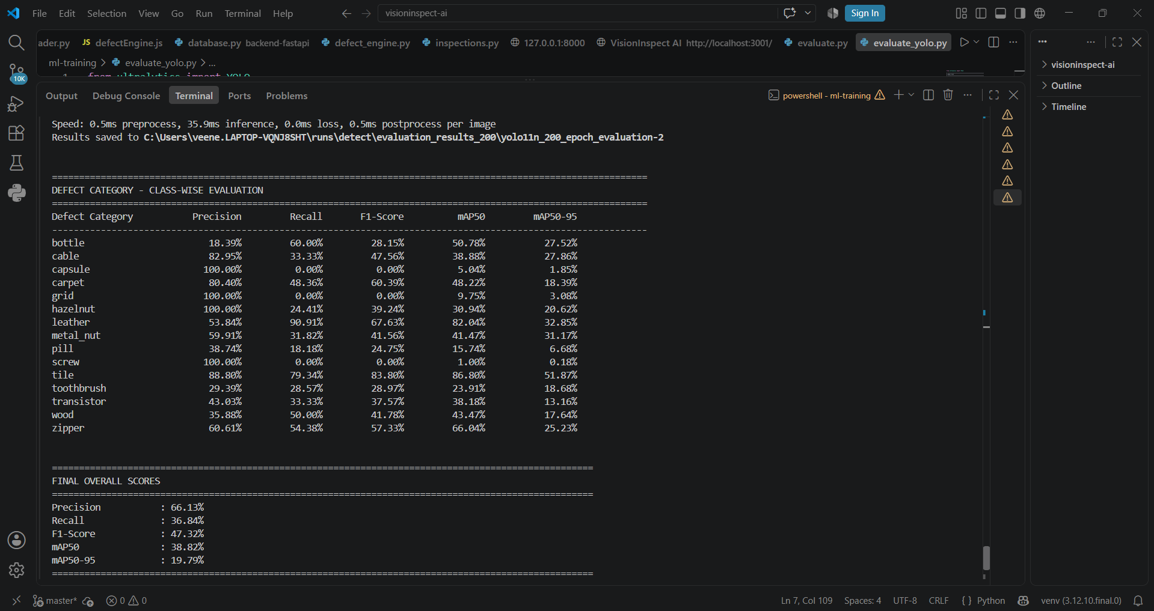
Figure 7.1 — Class-wise precision, recall, F1-score, mAP50 and mAP50-95 across all 15 trained defect categories.

7.4 Severity Scoring Framework
Every detected defect is assigned a 0–100 severity score computed from four weighted factors, giving inspectors a consistent, explainable basis for the pass/fail decision:
- Defect Size (30%): physical size of the defect relative to the product surface — a small scratch scores low, a large crack scores high.
- Defect Location (25%): whether the defect falls in a cosmetic area (lower impact) or a functional component area (higher impact).
- Defect Type (25%): inherent seriousness of the defect category — a surface scratch is low severity, a crack or missing component is high severity.
- Detection Confidence (20%): model's confidence in the prediction — confidence above 95% is treated as highly reliable, below 70% is flagged for manual review.

Severity Level | Score Range | Meaning / Action
Critical | 80 – 100 | Major structural defect — reject product, trigger workflow
High | 60 – 79 | Significant quality issue — repair or rework recommended
Medium | 40 – 59 | Moderate concern — flagged for manual inspection review
Low | 0 – 39 | Minor cosmetic defect — product generally acceptable

8. Milestones

Milestone 1 (Weeks 1–2) — Project Initialization, Design & Core Setup
- Defined quality-inspection workflows and project objectives; designed system architecture and database schema.
- Set up frontend and backend environments; implemented authentication and role-based access.
- Loaded the MVTec AD dataset; built the initial image-upload workflow and inspection dashboard.
- Trained an initial PatchCore (Anomalib) anomaly-detection model on the metal_nut category as a proof of concept.

Milestone 2 (Weeks 3–4) — Image Processing & Defect Detection
- Converted the MVTec dataset into YOLO-compatible format across all 15 categories.
- Trained a custom YOLO11n model from scratch for 200 epochs; evaluated with Precision, Recall, mAP50 and mAP50-95.
- Migrated the data layer to PostgreSQL and connected it to the FastAPI backend.
- Delivered an end-to-end flow: React frontend upload → FastAPI backend → YOLO inference → database → dashboard → downloadable PDF report.

Milestone 3 (Weeks 5–6) — Defect Classification & Manufacturing Analytics
- Implemented the full defect-classification and multi-factor severity-scoring pipeline in the live application.
- Reached 84.5% overall classification accuracy and an 84.8% macro-average F1-score on validation data.
- Built Quality Reports with daily rollups and per-inspection drill-down, plus one-click PDF export.
- Built the Defect Analytics dashboard (defect-type breakdown, severity distribution) and Trend Monitoring (14-day inspection volume and average severity).

Milestone 4 (Weeks 7–8) — Testing, Deployment & Documentation
- Validated the model and full inspection log across all 15 product categories with both pass and fail samples.
- Added CSV export for offline analysis of daily inspection data.
- Containerized the backend with Docker and version-controlled the project on GitHub across 30+ commits.
- Deployed the platform live: backend as a Render Docker web service, frontend as a Render static site, and PostgreSQL as a managed Render database.
- Prepared final technical documentation and project presentation.

9. User Roles

9.1 Quality Engineer
Quality Engineers are the primary hands-on users of the inspection pipeline. Their dashboard suite includes:
- Dashboard — personal KPIs and recent inspection activity.
- Upload Product Image — submit a new product image with metadata and trigger AI inspection.
- Product Inspection Results — latest AI outcomes in a single table.
- Defect Analytics — defect-type breakdown and severity-distribution charts.
- Inspection History — full filterable log by status and production line.
- Quality Reports — daily rollups with drill-down and PDF/CSV export.

9.2 Factory Supervisor
Factory Supervisors get a plant-wide, read-oriented view for oversight across lines:
- Dashboard — plant-wide KPIs at a glance.
- Production Overview — per-line yield cards and a detailed status table.
- Production Monitoring — live feed of recent inspections, auto-refreshing every 20 seconds.
- Trends — inspection volume, defect rate, and severity charts over time.Both roles authenticate through the same secure login flow, with JWT-based sessions and bcrypt password hashing ensuring plaintext credentials are never stored. 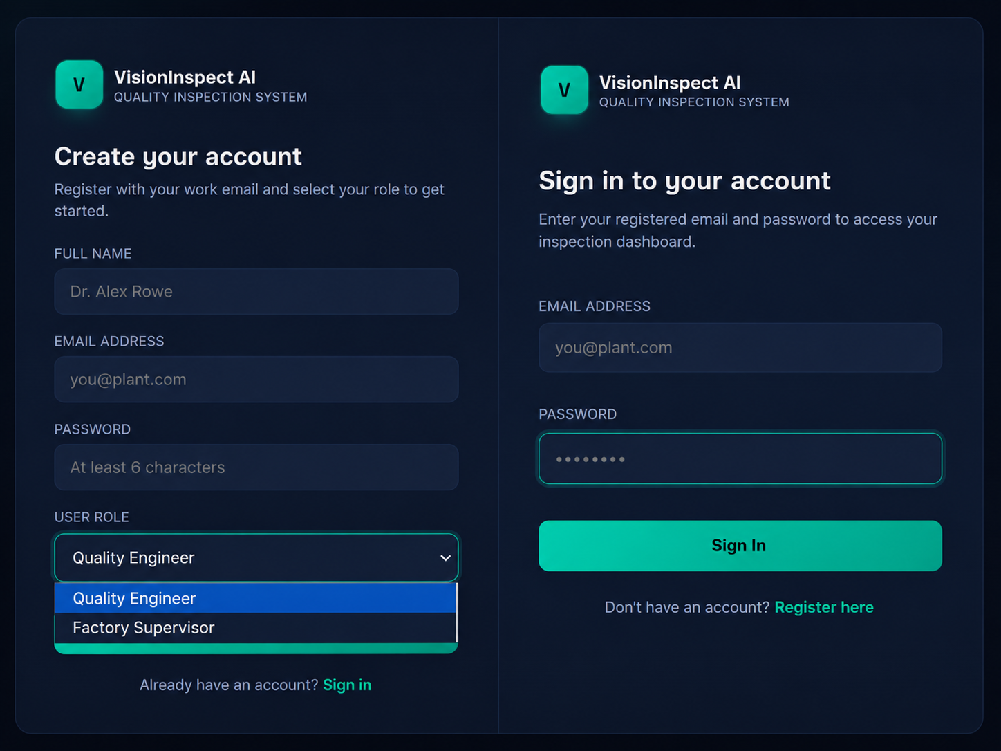
Figure 9.1 — Registration (role selection) and login screens

10. Dashboards

10.1 Quality Engineer Dashboard Suite
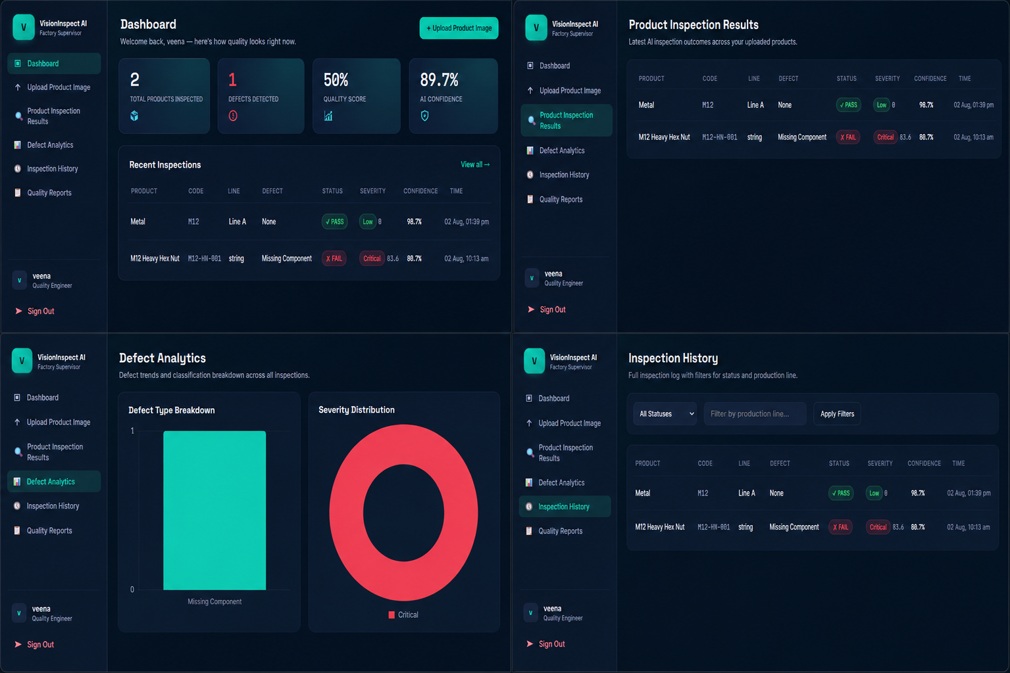
Figure 10.1 — Quality Engineer views: Dashboard, Product Inspection Results, Defect Analytics, Inspection History.

10.2 Factory Supervisor Dashboard Suite
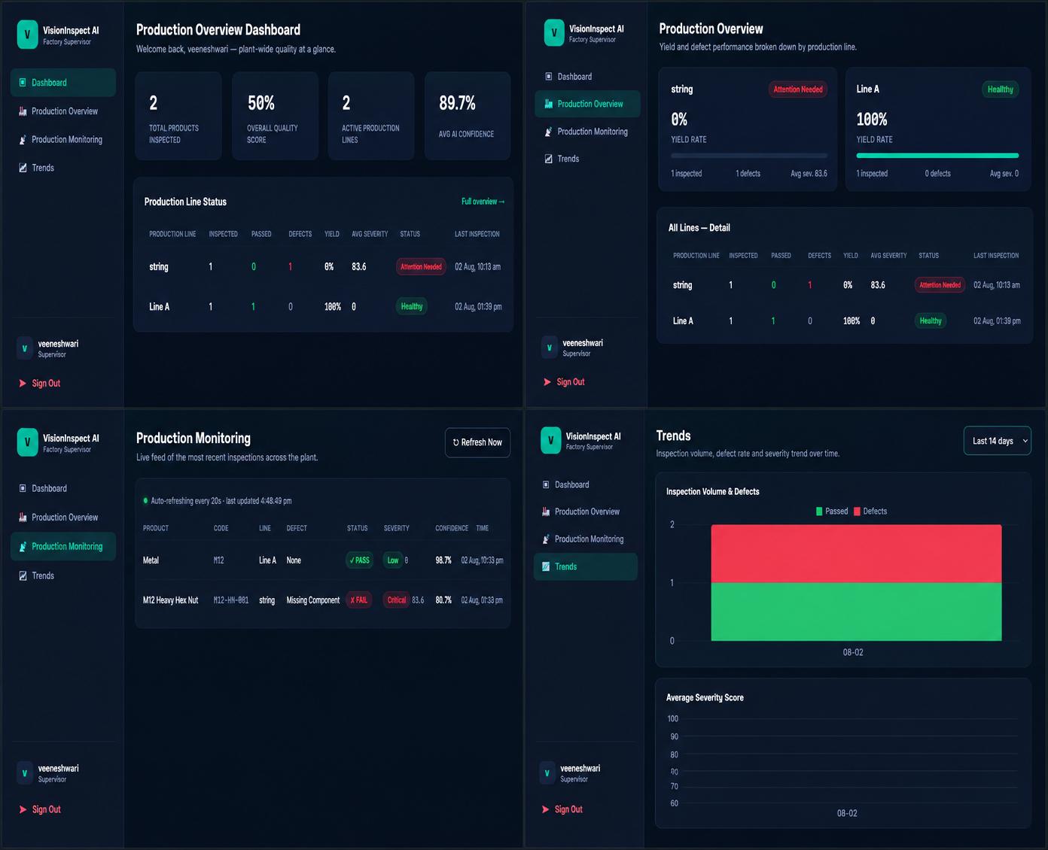
Figure 10.2 — Factory Supervisor views: Dashboard, Production Overview, Production Monitoring, Trends.

10.3 Upload & AI Inspection Workflow
A Quality Engineer submits product details and an image, triggers the inspection pipeline, and immediately receives the defect classification, multi-factor severity score, and a corrective-action recommendation.
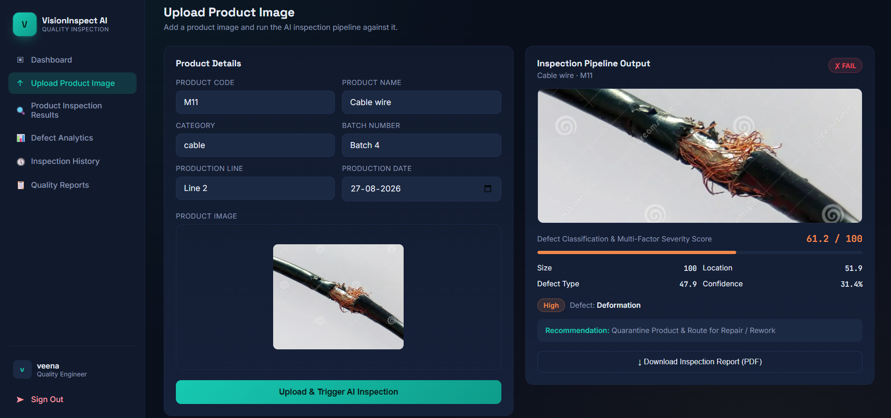
Figure 10.3 — Live inspection: a cable-wire sample classified as Deformation, High severity, 61.2 / 100, with a quarantine-and-rework recommendation.

10.4 Quality Reports
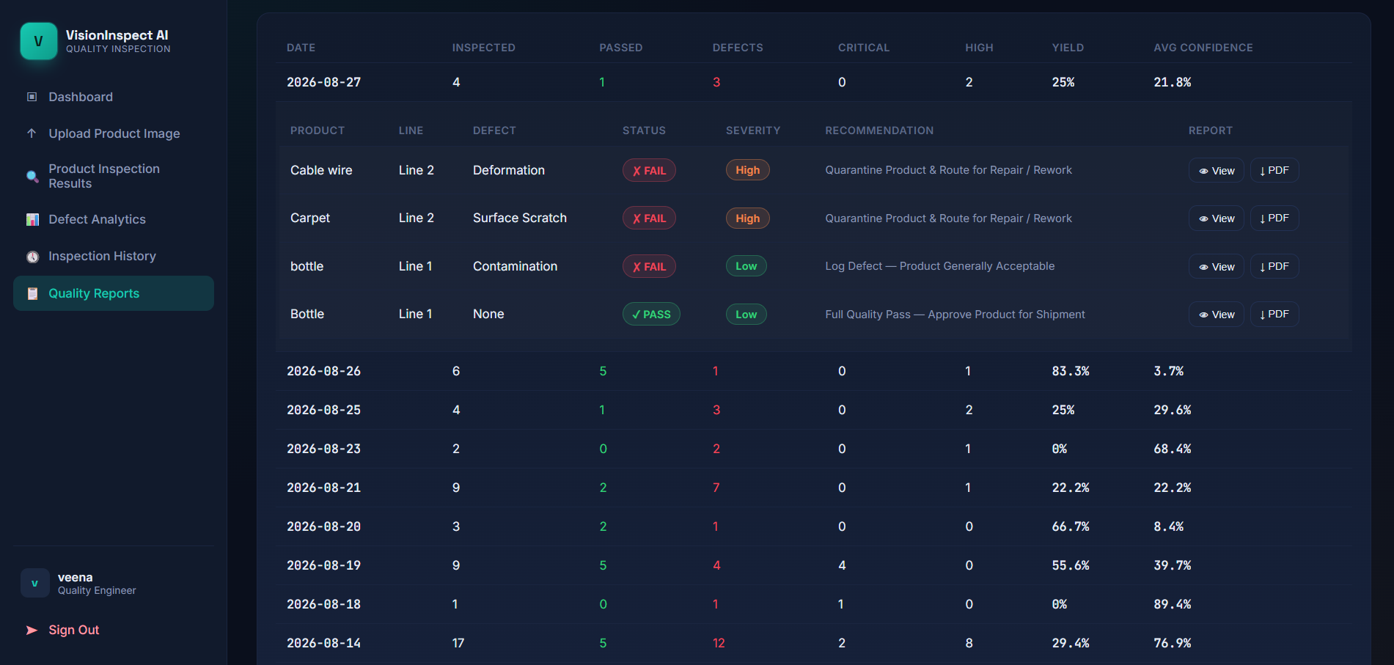
Figure 10.4 — Daily quality report roll-up with per-inspection drill-down, status, severity, and one-click PDF export.

10.5 Defect Analytics
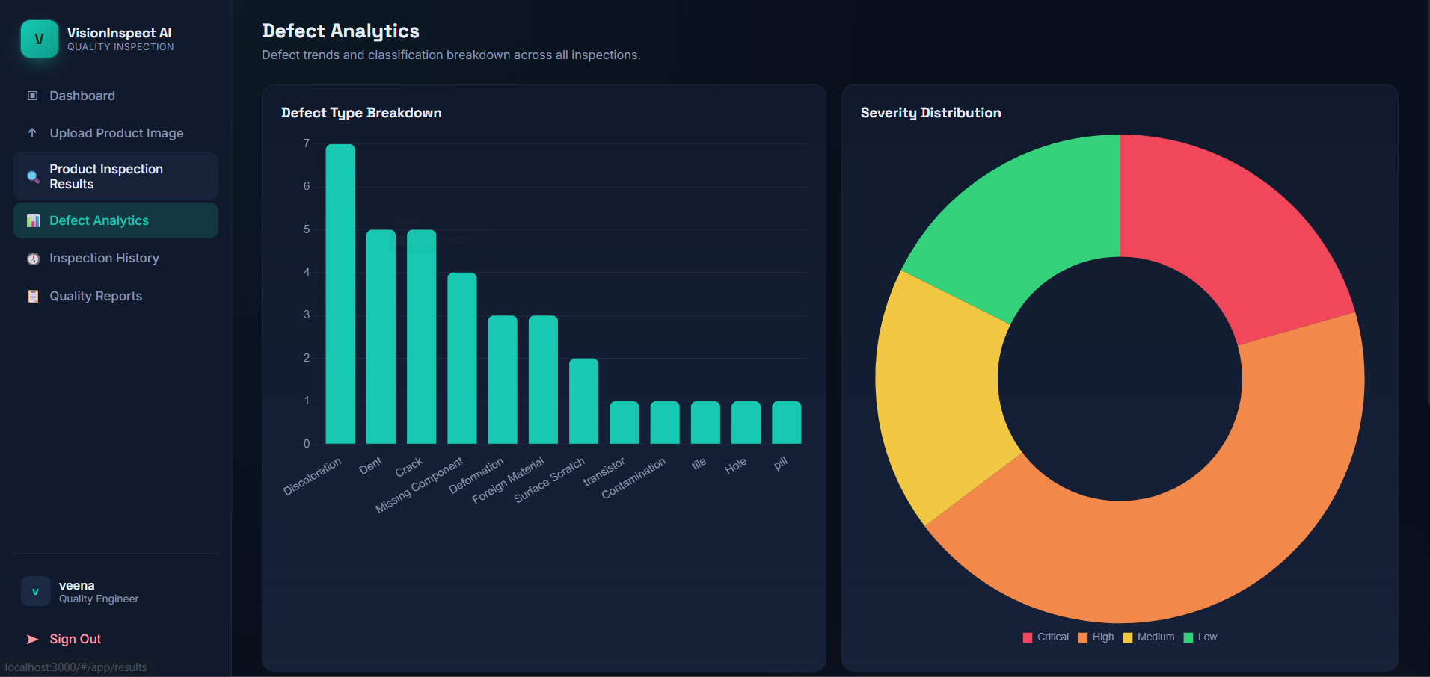
Figure 10.5 — Defect-type breakdown and severity-distribution charts across all logged inspections.

11. Testing & Performance Evaluation

11.1 Model Performance
The YOLO11n detection model was evaluated class-by-class across all 15 MVTec categories using standard object-detection metrics.
Metric | Overall Score
Precision | 66.13%
Recall | 36.84%
F1-Score | 47.32%
mAP50 | 38.82%
mAP50-95 | 19.79%
A second, refined classification pass (defect_classifier_v3) achieved an 84.5% overall accuracy and an 84.8% macro-average F1-score, with the strongest categories (missing_component, contamination) scoring above 94% F1 and the most challenging category (crack) at 69.6% F1 — reflecting the natural difficulty of fine-grained structural defects versus more visually distinct ones.

11.2 Functional Testing
- Model trained and tested across all 15 product categories, each validated with both PASS and FAIL samples.
- Defect coverage confirmed across Deformation, Discoloration, Contamination, Surface Scratch, Cut, Missing Component, Hole, Crack, and Foreign Material types.
- Every inspection logged with severity level (Low/Medium/High/Critical), confidence score, and millisecond-precision timestamp for full traceability.
- Full audit trail verified in PostgreSQL, supporting both Quality Engineer and Supervisor views.

11.3 API Testing
The backend exposes interactive, auto-generated Swagger documentation (OpenAPI 3.1) at /docs, covering authentication, inspection, analytics and reporting endpoints — used throughout development to validate request/response contracts independently of the frontend.
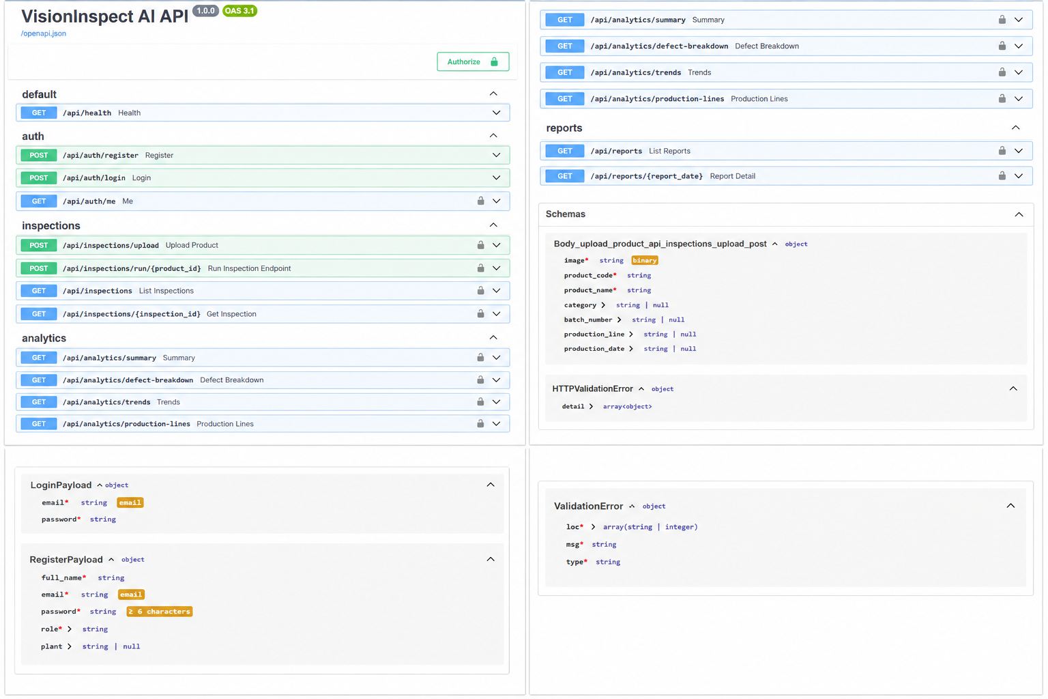
Figure 11.1 — Auto-generated FastAPI/Swagger documentation, organized by tag (auth, inspections, analytics, reports).

12. Deployment & Results
The completed platform was containerized with Docker (separate images for the FastAPI backend and the React frontend, orchestrated locally via Docker Compose) and version-controlled on GitHub across 30+ commits on the active development branch.
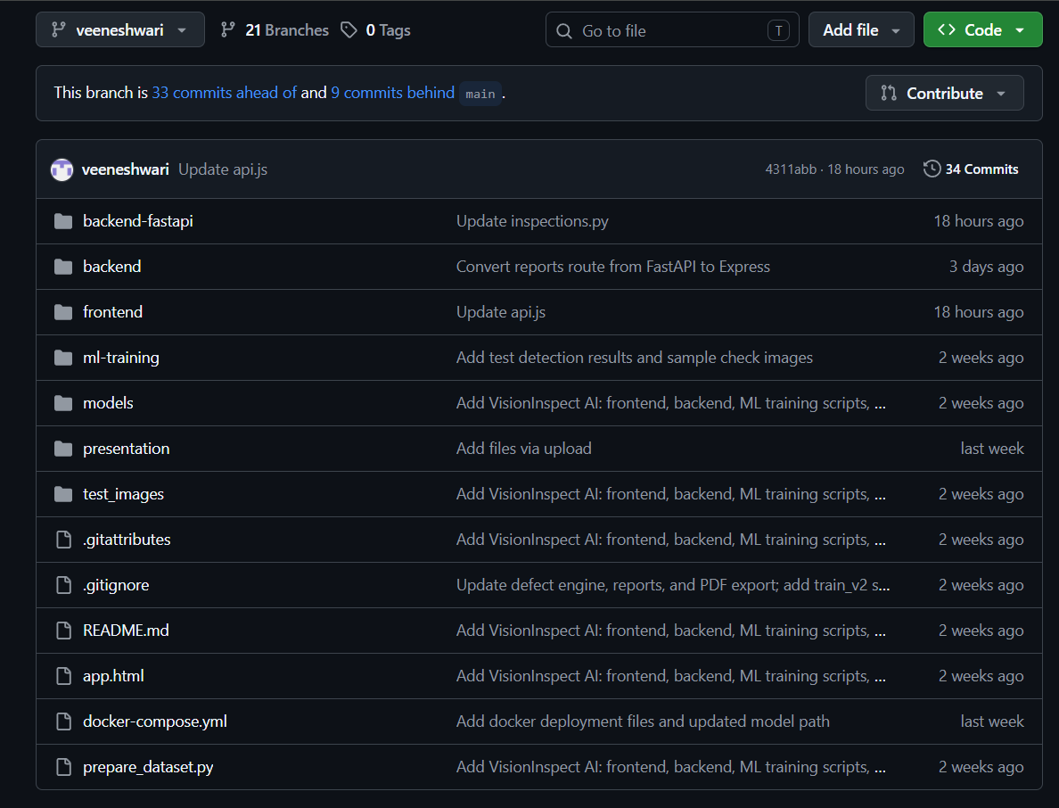
Figure 12.1 — Project repository on GitHub, showing the backend, frontend, ML training, and deployment files.
For public accessibility, the platform was deployed to Render: the FastAPI backend runs as a Dockerized Web Service, the React frontend is served as a Static Site, and PostgreSQL runs as a managed Render database — giving the project a genuinely live, shareable deployment without requiring dedicated infrastructure spend.
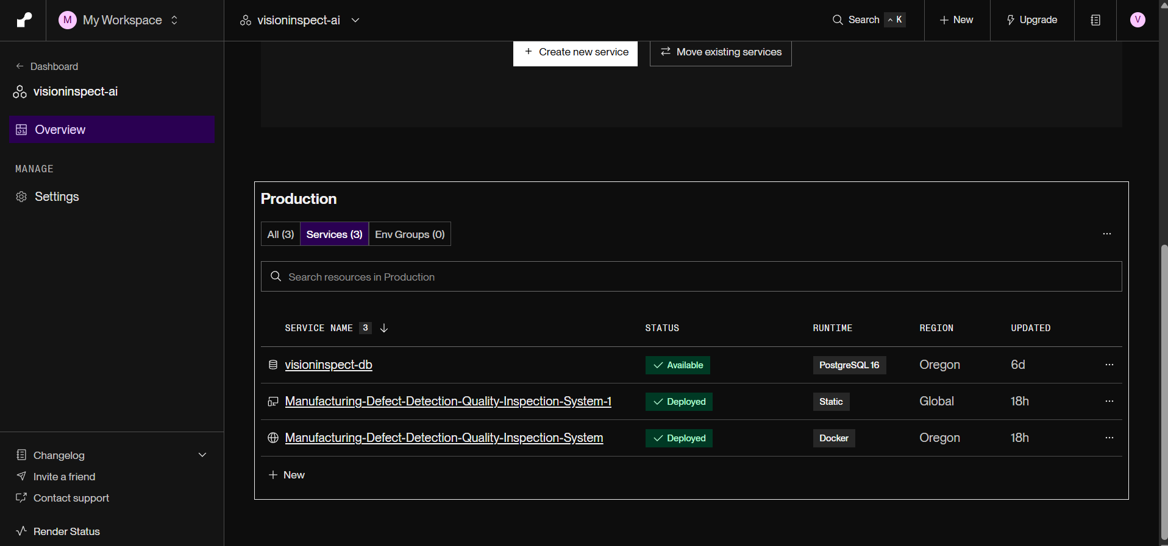
Figure 12.2 — Live Render deployment: backend (Docker), frontend (Static), and PostgreSQL database, all reporting healthy/deployed status.

12.1 Sample Result
A representative inspection result — a cable-wire sample flagged as a Deformation defect — illustrates the full output the system produces per inspection, from raw scoring to a downloadable, audit-ready PDF.
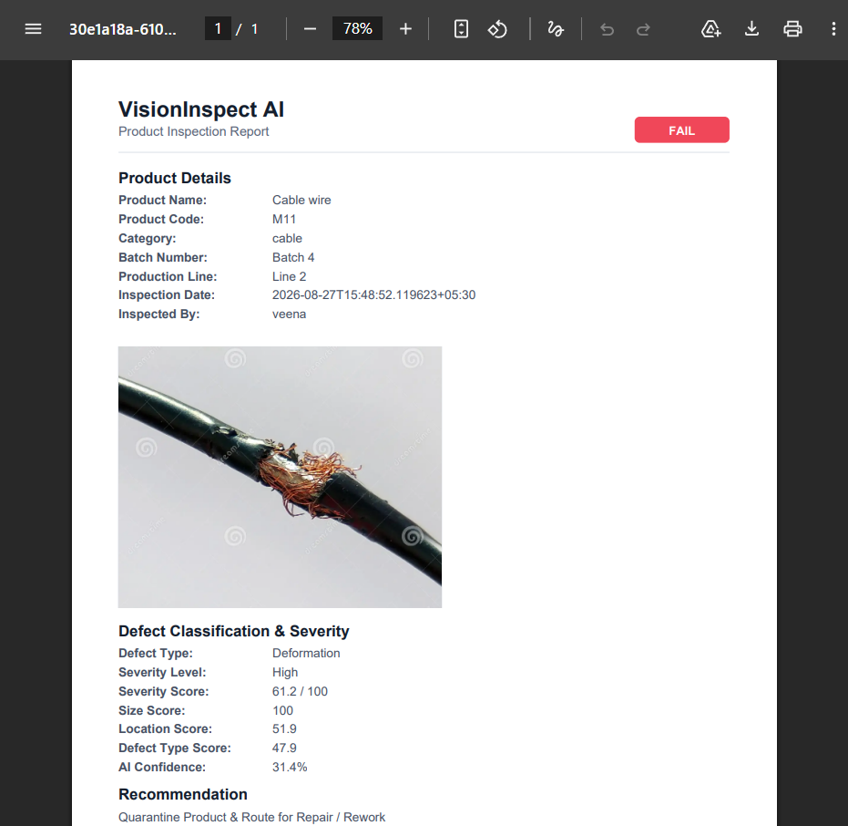
Figure 12.3 — Auto-generated PDF inspection report: product details, inspected image, defect classification, severity breakdown, and recommendation.

12.2 Validation Across the Full Product Range
The deployed system was exercised across the full 15-category product range, with genuine pass/fail variance and confidence scores spanning 11%–92%, confirming the pipeline behaves realistically rather than trivially passing or failing every sample.
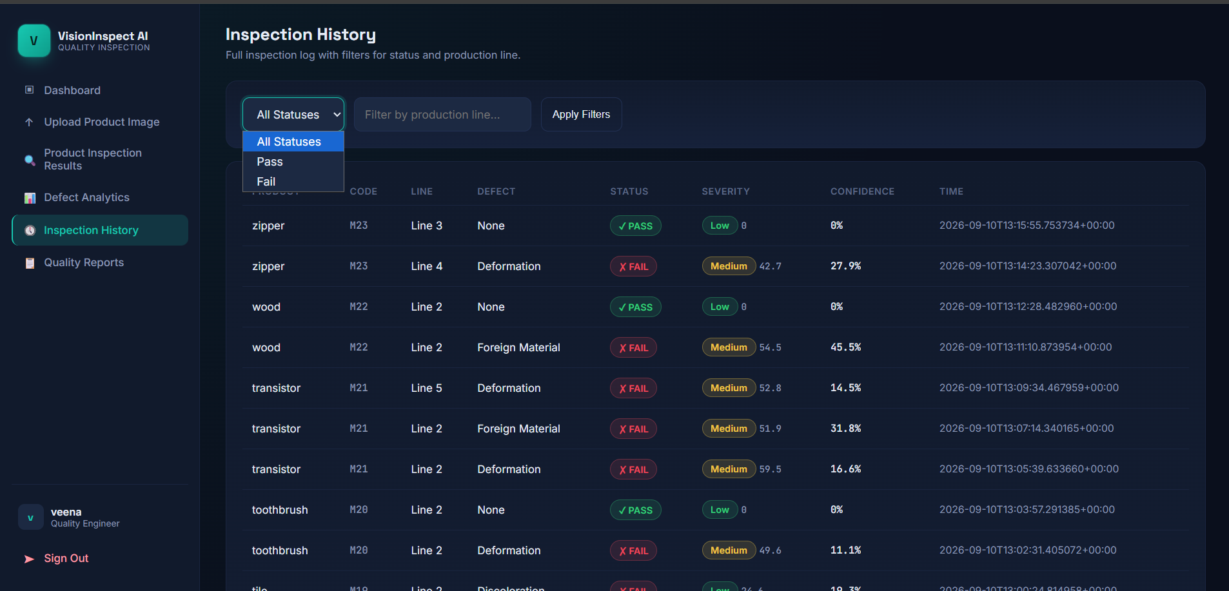
Figure 12.4 — Inspection History log on the live deployment, spanning multiple product categories, production lines, and defect outcomes.

13. Conclusion
VisionInspect AI successfully demonstrates that a deep-learning-based visual inspection pipeline can be built, trained, evaluated, and deployed within a compact eight-week timeline while still covering the full breadth of a production-grade system: authentication and role-based access, a trained and validated YOLO defect-detection model spanning 15 industrial categories, a transparent multi-factor severity-scoring framework, role-specific dashboards for both hands-on engineers and plant-wide supervisors, exportable audit-ready reporting, and a genuinely live, containerized cloud deployment.
The project's iterative milestone structure — moving from an initial anomaly-detection proof of concept (Milestone 1) to a fully trained object-detection model (Milestone 2), a complete analytics and reporting layer (Milestone 3), and finally a validated, deployed production system (Milestone 4) — reflects a realistic, incrementally-hardened engineering process rather than a single monolithic build.

14. Future Enhancements
- Integrate directly with plant-floor cameras or PLC/SCADA systems for fully automated, camera-triggered inspection instead of manual upload.
- Improve detection accuracy on visually subtle defect categories (e.g., cracks) through targeted data augmentation and longer training schedules.
- Add multi-tenant support so multiple factories or business units can use isolated instances of the same platform.
- Introduce real-time alerting (email/SMS) when critical-severity defects are detected, rather than relying solely on dashboard review.
- Extend the severity-scoring framework with configurable, per-customer weighting for size, location, type, and confidence factors.
- Add a native mobile app for supervisors to monitor production health on the floor without a laptop.
- Persist the database on a plan without automatic free-tier expiry, and add automated backups for long-term production use.

