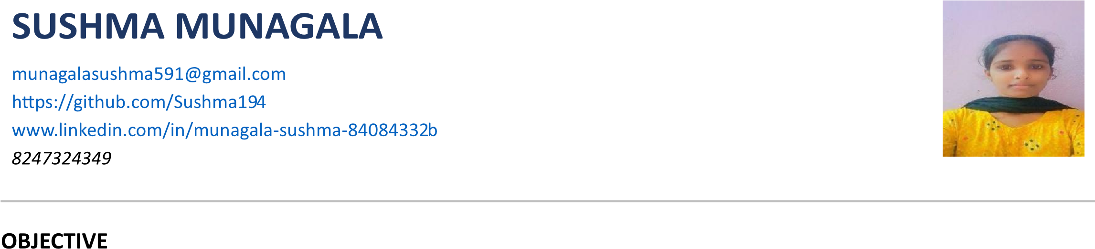

I am a final-year Computer Science Engineering student with knowledge of Python, SQL, Data Analysis, and Machine Learning. Through my internship and academic projects, I have gained hands-on experience in working with data and solving real-world problems. I am looking for an opportunity at Nova Technology where I can apply my analytical skills, learn from experienced professionals, and contribute to the organization's growth while building a successful career in Data Analytics.

EDUCATION

Degree | Institution | Year of Passing | CGPA/Percentage
Bachelor of Technology in Computer Science | Narasaraopeta Engineering College, Narasaraopet | 2027 | 8.34
Intermediate | Vignan Girls Junior College, Guntur | 2023 | 92%
Secondary School Education | ZPHS, Pulallacheruvu | 2021 | 10.0

TECHNICAL SKILLS
- Programming Languages: Python, Java
- Web Technologies: HTML, CSS
- Tools & Frameworks: VS Code, Git
- Database: MySQL
- Operating System: Windows

CERTIFICATIONS
- Introduction to Internet of Things – NPTEL
- SQL (Basic) – HackerRank
- Python (Basic) – HackerRank
- Business Communication – HP LIFE
- Java Programming Fundamentals – Infosys Springboard
- Appreciation Award – IDE Bootcamp Phase 1
- Completed Ignite Bootcamp – Wadhawani Foundation

INTERNSHIPS
- Data Science with AI Intern | DataValley Inc.
- Infosys Springboard Internship 7.0 (ongoing)
- Pragathi: Path to Future – Cohort 9 (ongoing)

PROJECTS

1.AI-Powered Healthcare Prediction & Resource Management System

• Developed an AI-based healthcare management system for disease prediction and resource optimization.

• Built predictive models, dashboards, and healthcare management modules using Python and ML

2. Smart Recruitment Assistant

• Developed an AI-driven recruitment system for resume screening and candidate analysis.

• Automated candidate evaluation and improved recruitment efficiency.

3. Customer Churn Prediction

• Built a machine learning model to predict customer attrition using historical customer data.

• Performed data preprocessing, model training, and performance evaluation.

EXTRA-CURRICULAR ACTIVITIES
- Completed professional certification courses through Infosys Springboard.
- Participated in collaborative software development projects using GitHub.
- Attended technical workshops and webinars.
- Continuously improving programming and problem-solving skills through online learning.

PERSONAL DETAILS
- Name: Sushma Munagala
- Address: Thellagatla , Markapuram(Dist)
- Phone no: 8247324349
- Date of Birth: August 9, 2006
- Nationality: Indian
- Languages: English, Telugu, Hindi

DECLARATION
"I confirm that the information provided in this resume is truthful and accurate to the best of my knowledge. I understand that any discrepancies found may affect my eligibility for the position."
Place: Narasaraopeta Date:
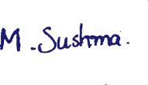
MUNAGALA SUSHMA

