🧠 What is NLP (Natural Language Processing)?
Natural Language Processing (NLP) is a branch of Artificial Intelligence (AI) that enables computers to understand, interpret, and generate human language (text or speech).
In simple words:
👉 NLP helps machines talk with humans in human language.
Examples of NLP in real life
- Chatbots (AgroBot, customer support bots)
- Voice assistants (Alexa, Google Assistant)
- Google Translate
- Spam email detection
- Sentiment analysis (positive / negative reviews)

🔍 Why NLP is Important
Humans communicate using language, but computers understand only numbers.
NLP acts as a bridge between human language and machine language.

🧩 NLP Working – Block Diagram
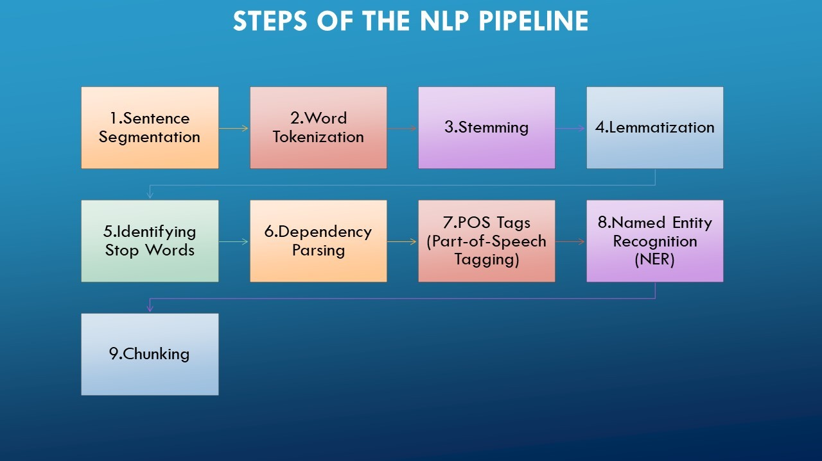

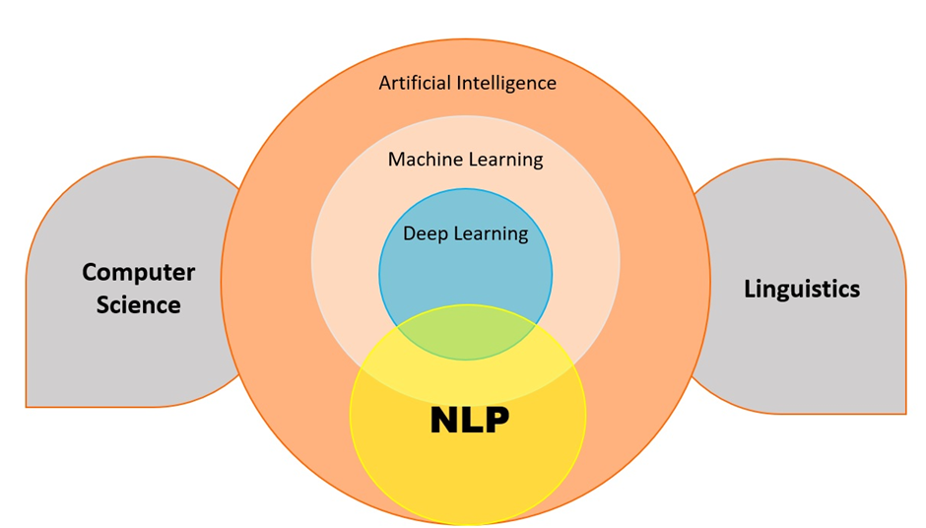
4

🔄 NLP Diagram – Step-by-Step Explanation
Let’s understand each block clearly 👇

1️⃣ Human Language Input
This is the raw text or speech given by the user.
📌 Example:
- “Tomato leaf has brown spots”
- “What crop is suitable for black soil?”

2️⃣ Text Preprocessing
This step cleans and prepares the text for understanding.
Common preprocessing tasks:
- Tokenization – Split sentence into words
“Tomato leaf brown spots” → [Tomato, leaf, brown, spots]
- Lowercasing – Convert text to lowercase
- Stopword Removal – Remove words like is, the, has
- Stemming / Lemmatization – Reduce words to base form
“growing” → “grow”
📌 Purpose: Remove noise and keep only meaningful words

3️⃣ NLP Processing / Understanding
This is the brain of NLP 🧠
Important NLP tasks:
- Intent Detection – What does the user want?
  - Disease identification
  - Crop recommendation
- Named Entity Recognition (NER) – Identify important words
  - Crop: Tomato
  - Symptom: Brown spots
- Context Understanding – Understand meaning, not just words
📌 Example:
“brown spots on tomato leaf” → Disease related query

4️⃣ Machine Learning / AI Model
Now the processed text is given to an AI/ML model.
The model:
- Matches the query with trained data
- Predicts disease / answer
- Uses knowledge base or APIs (like Gemini)
📌 Example Output:
- Disease: Early blight
- Cause: Fungal infection
- Solution: Spray recommended fungicide

5️⃣ Natural Language Generation (NLG)
Here the system converts the result into human-friendly language.
📌 Example:
“Your tomato plant may be affected by Early Blight.
It is caused by a fungal infection.
Use neem oil or recommended fungicide.”

6️⃣ Final Output to User
The response is shown as:
- Text message
- Chatbot reply
- Voice response (optional)

🌾 NLP Example in AI-AgroBot
Farmer Input:
“My rice leaves are turning yellow, what should I do?”
NLP Processing:
- Crop → Rice
- Symptom → Yellow leaves
- Intent → Problem & solution
Output:
“Yellowing of rice leaves may be due to nitrogen deficiency.
Apply urea fertilizer in recommended quantity.”

