BuildTrack Project Explanation Guide
Construction Project Management and Site Monitoring Platform
A complete technical and demonstration guide for explaining the project to a faculty or project guide
Prepared by | Release | Date
Anushka | Complete local milestone implementation | 10 October 2026

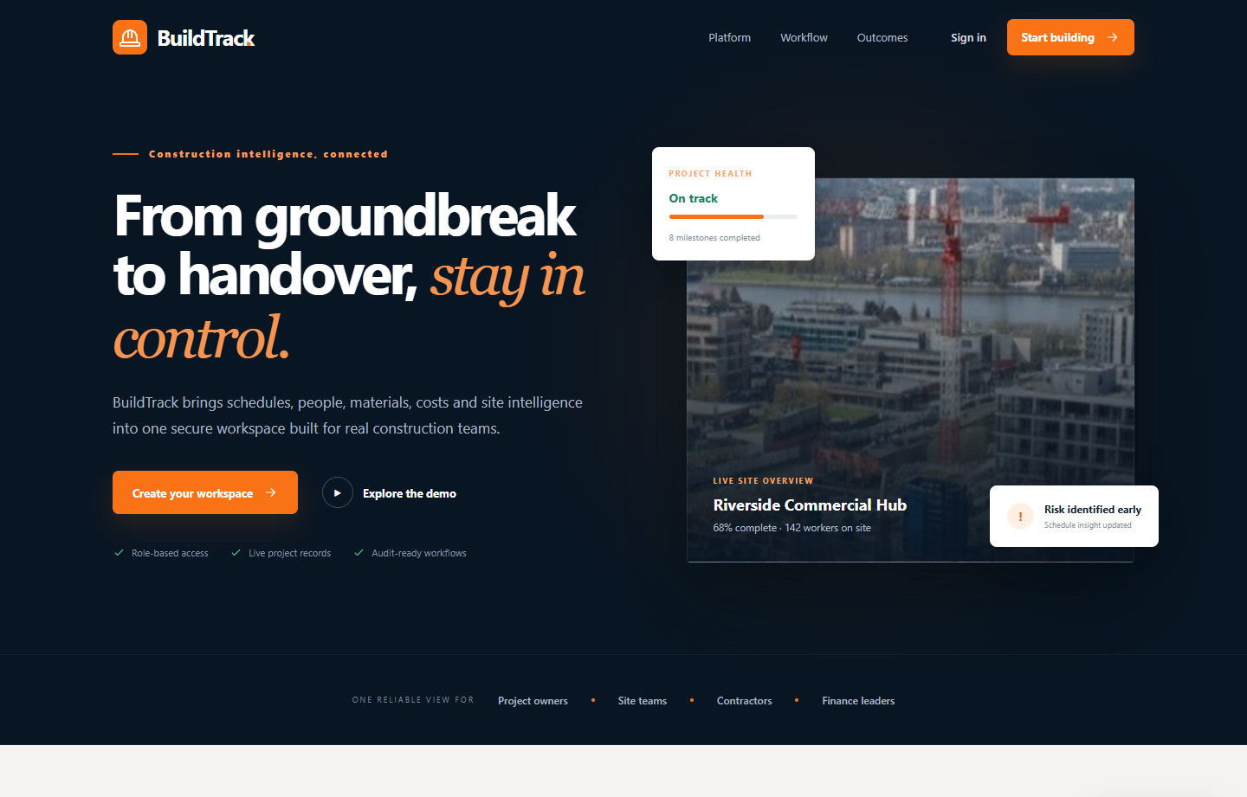
Figure 1 BuildTrack public landing page
Repository springboardmentor079 team 001 | Branch develop

How to use this document
This document explains what BuildTrack solves, how the system is designed, how each module works, how data moves from the Angular interface to PostgreSQL, and how the machine learning features use organization data. It also provides a demonstration sequence and concise answers to likely guide questions.

Ninety second project introduction
BuildTrack is a full stack construction project management and site monitoring platform. It brings project schedules, site reports, equipment, inventory, workforce, procurement, budgets, documents, notifications, analytics and machine learning into one role based system. The frontend is built with Angular, the backend uses Express and TypeScript, Prisma manages PostgreSQL, and every protected request is checked for authentication, permission, organization ownership and project membership. The ML module supports decisions by estimating schedule delay probability, material demand, final project cost and equipment failure risk. It never changes operational records automatically. The current local release implements all twelve planned milestones and is verified through backend, frontend and browser tests.

Recommended explanation order
1. Begin with the construction coordination problem and the users affected by it.
2. Show the landing page and sign in as the Administrator.
3. Explain the architecture and role based access before opening business modules.
4. Demonstrate one connected workflow from project creation to analytics.
5. Explain the four ML methods, their training data and their safeguards.
6. Finish with testing evidence, present limitations and production next steps.

Document map
Part | What it explains
1 to 3 | Problem, objective, scope and architecture
4 to 7 | Roles, modules, workflows and data model
8 to 10 | Progress calculation, machine learning and security
11 to 13 | Testing, setup and live demonstration
14 to 16 | Questions, limitations and conclusion

1 Project problem and objective

Problem being solved
Construction information is often split across spreadsheets, messages, paper site logs and separate accounting records. This makes it difficult to know whether work is late, equipment is underused, material stock is sufficient, attendance is approved, purchasing is complete, or the project is moving beyond budget. Different participants also need different levels of access.

Project objective
BuildTrack provides one controlled workspace in which construction teams can plan, execute, record and review work. The system preserves operational history and derives current indicators from stored records rather than using hardcoded dashboard values.

Main goals
- Centralize project, site, resource, stock, workforce, purchasing and financial records.
- Give six construction roles only the information and actions they are permitted to use.
- Enforce workflow rules such as dependency completion, stock limits, shift conflicts and project closure checks.
- Produce reports and analytics from the same PostgreSQL source of truth.
- Use machine learning as decision support while keeping human control over operational changes.

Current scope
All twelve implementation milestones are represented in the local application. The system is suitable for project demonstration and local evaluation. Production deployment still requires managed infrastructure, durable file storage, configured email, TLS, backups, monitoring and an operational security review.

2 Users and value
Role | Primary responsibility | Typical BuildTrack use
Administrator | Organization control | Manage users, roles, all projects, resources, reports and settings
Project Manager | Delivery control | Manage assigned projects, schedule, resources, procurement and finance
Site Engineer | Site execution | Update milestones, reports, delays, inspections, attendance and allocations
Contractor | Assigned work | View assigned projects and submit site, material and procurement requests
Worker | Personal work record | View own workforce, attendance and shift information
Client | Controlled visibility | View assigned project progress, reports and approved documents

The API is authoritative. Hiding a menu item in Angular improves usability, but the backend independently rejects unauthorized requests and applies organization and project scope to database queries.

3 System architecture
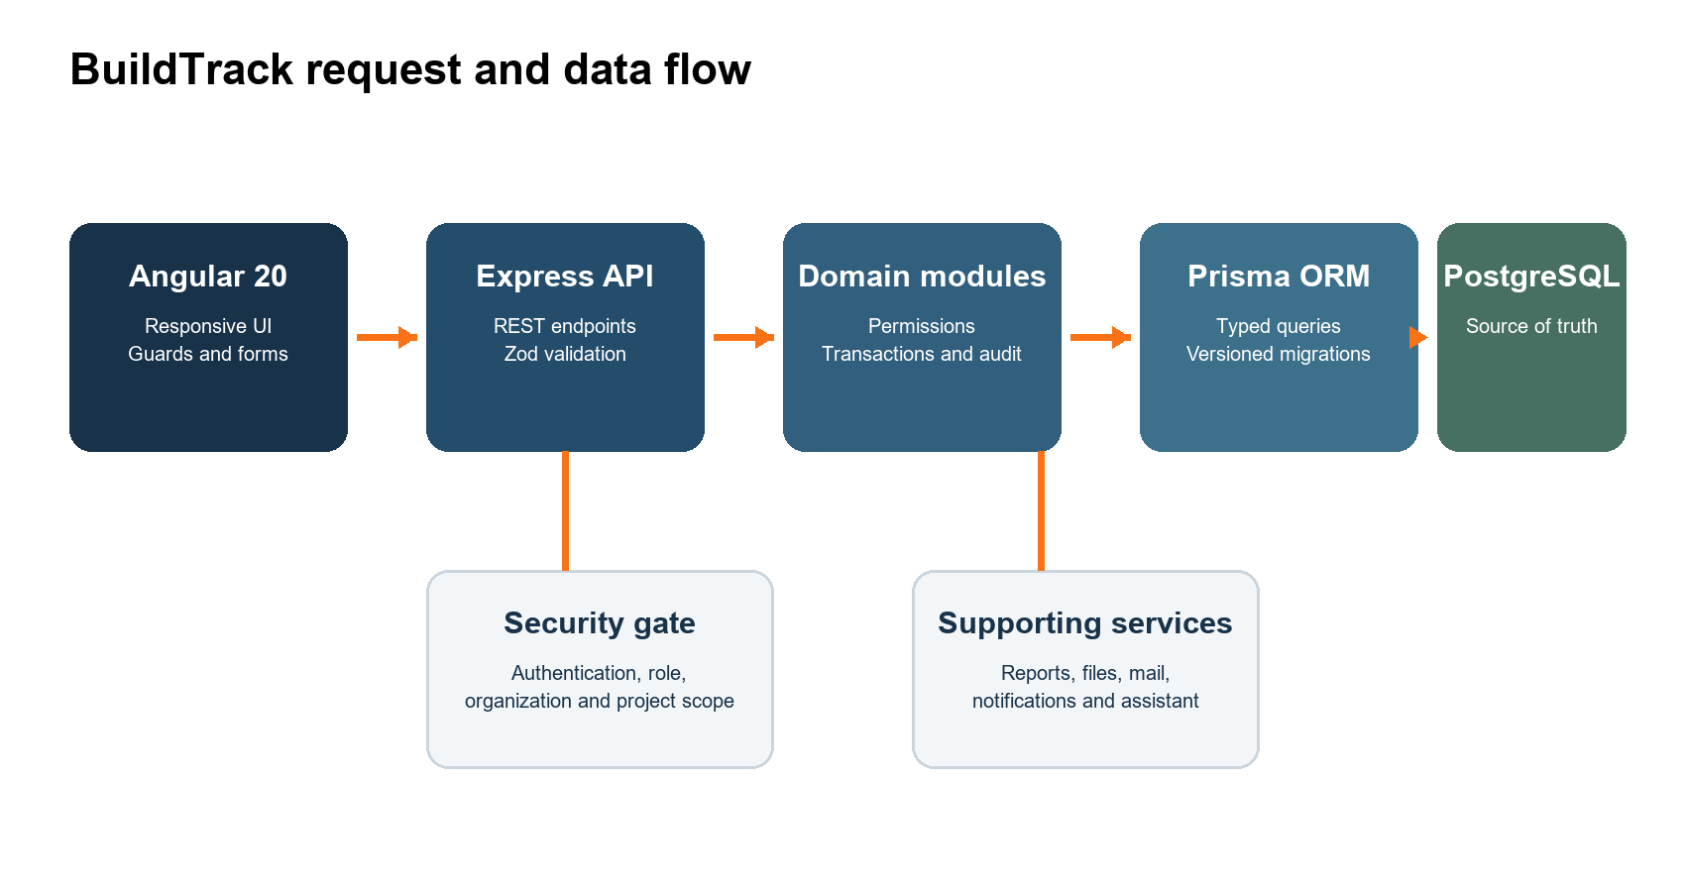
Figure 2 BuildTrack modular monolith and request flow

Architecture choice
BuildTrack uses a modular monolith. Angular provides a responsive single page application, while one Express API owns the business workflows. Prisma provides typed database access and versioned schema migrations. PostgreSQL stores all authoritative data. This structure keeps cross module transactions practical while allowing the codebase to remain organized by business domain.

Request lifecycle
1. Angular collects validated form input and sends a typed HTTP request.
2. Express applies CORS, security headers, request limits and route matching.
3. Authentication verifies the access token, session and active account.
4. Authorization checks the permission, organization and assigned project.
5. Zod validates the payload and rejects unknown or invalid fields.
6. The domain route executes transactions and Prisma queries.
7. The API returns a consistent success or error envelope for the UI.

Technology stack
Layer | Technology | Reason
Frontend | Angular 20 and TypeScript | Standalone components, lazy routes, reactive forms and typed UI logic
Backend | Express 5 and TypeScript | Modular REST API with explicit middleware and validation
Validation | Zod | Runtime request validation and strict payload contracts
Database | PostgreSQL 18 | Transactions, constraints, indexing and relational integrity
ORM | Prisma 6 | Typed queries, migrations and repeatable seed data
Testing | Jest, Vitest and Playwright | Backend integration, frontend unit and real browser workflows
Exports | PDFKit and ExcelJS | Database backed PDF and XLSX reports
Documentation | Swagger OpenAPI | Interactive API reference at api docs

4 User experience and dashboards
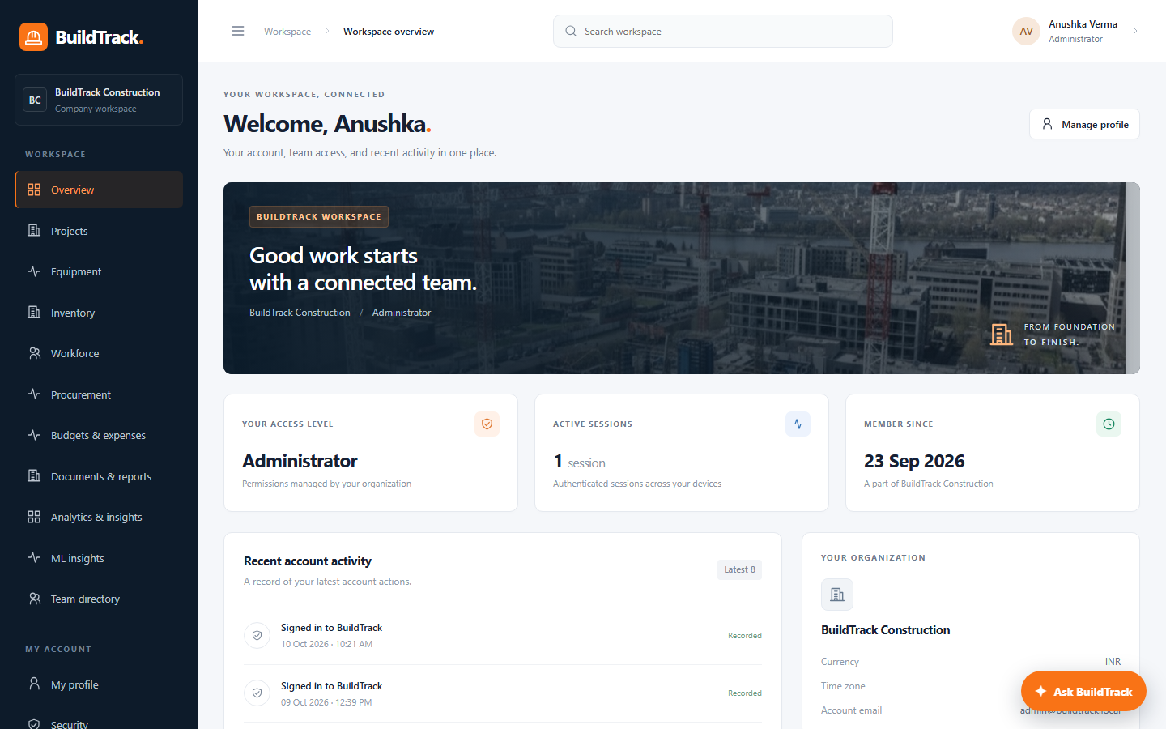
Figure 3 Authenticated workspace and role aware navigation
All users enter the same workspace route after sign in. The visible navigation and data change according to server supplied permissions. This avoids maintaining six disconnected applications while still giving each role a focused dashboard.

Authentication experience
- Public registration creates a separate organization and a Client account.
- Administrators create other role accounts from the Team directory.
- A temporary password can require a password change at first login.
- Forgot password uses one time expiring reset links delivered through local mail in development or SMTP when configured.
- Access tokens stay in memory and refresh credentials use an HTTP only cookie.

Responsive design
The interface uses a desktop sidebar and a mobile navigation drawer. Shared page headings, status tags, forms, cards, tables, loading states and error messages provide a consistent experience across modules. The public landing page and BuildTrack Assistant are available before sign in, while authenticated assistant answers may use authorized workspace counts.

5 Core project and site modules
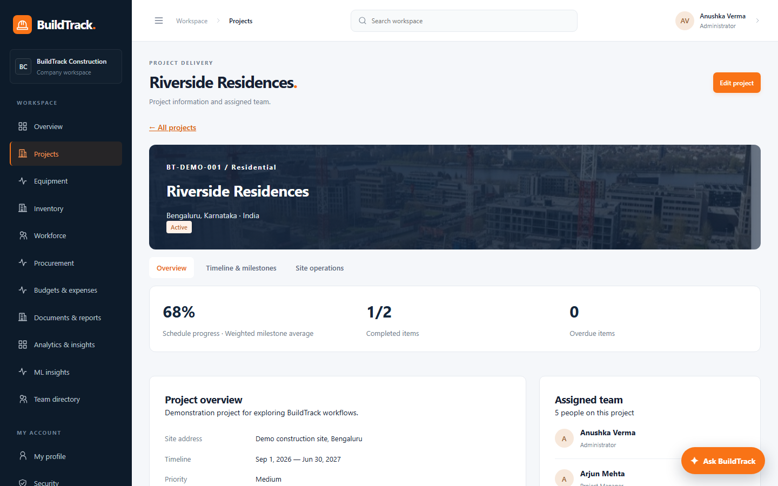
Figure 4 Project detail view with calculated schedule indicators

Projects
Projects contain identity, category, location, priority, planned dates, budget, estimate, notes and explicit team membership. Lists support searching, status filtering, sorting and pagination. Valid status transitions protect the lifecycle, and closure is blocked until schedule items are complete.

Schedule and milestones
Work items can be milestones or tasks. Each item stores dates, status, progress, weight, original baseline, responsible user and an optional dependency. A dependent item cannot record progress until its predecessor is completed. Completed items must have 100 percent progress, and not started items must remain at 0 percent.

Site operations
Site engineers and permitted users record daily reports, worker counts, completed work, material and equipment use, safety observations, delays and inspections. Attachments are validated and downloaded through protected endpoints. Open delays and unresolved failed or conditional inspections contribute to project risk analytics.

6 Operations and commercial modules

Equipment and resource control
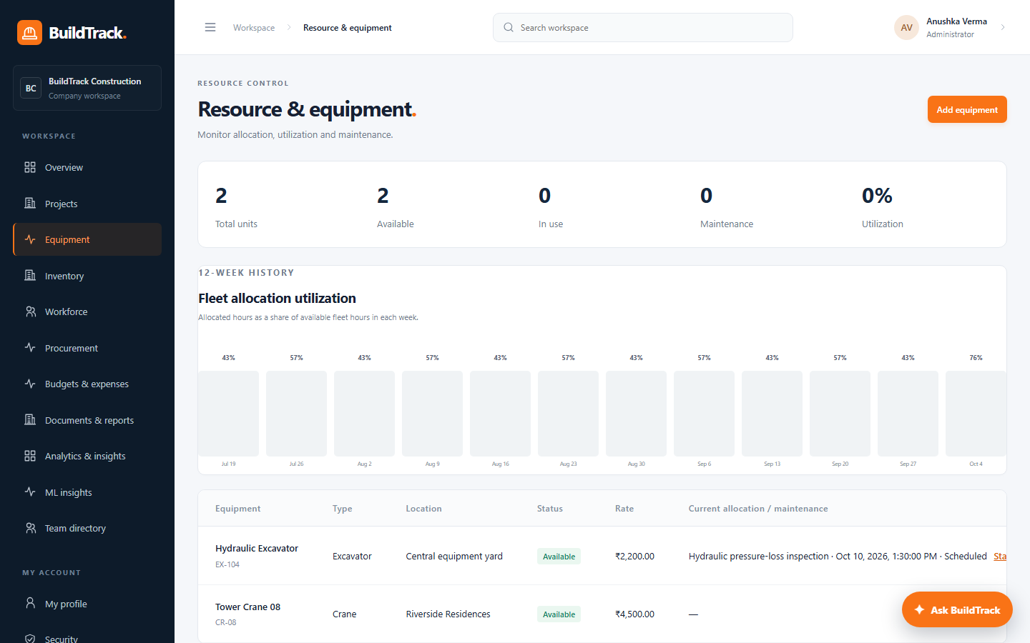
Figure 5 Fleet allocation utilization derived from allocation history
Equipment records hold status, location, hourly rate, commissioning date and service interval. Allocation logic prevents overlapping reservations, release keeps history, and maintenance blocks conflicting use. The 12 week utilization chart is calculated from allocation time overlaps. The demonstration data currently produces weekly values from 43 to 81 percent rather than a hardcoded series.

Inventory
Materials store SKU, unit, stock, allocated quantity, safety levels, unit cost and supplier. Every adjustment creates a stock movement. Material requests follow controlled states, and transactional checks prevent negative or oversubscribed stock.

Workforce
Worker profiles connect people to projects. The module records assignments, attendance, shifts and an approved hours payroll estimate. It prevents duplicate attendance and overlapping shifts. Workers receive only their own scoped view.

Procurement
Procurement links vendors, requests, approvals, purchase orders, partial receipts and invoices. Receiving is idempotent, so retrying the same receipt cannot add stock twice. Totals are derived from validated records and the status transitions require the correct permission.

Finance
Finance records category allocations and expenses with decimal money fields and project currency. The system reconciles approved or paid expenses, paid invoices and outstanding purchase order commitments. Forecast equals actual cost plus outstanding commitment, and budget utilization is calculated from the stored values.

7 Documents reports notifications and analytics

Documents and versions
Users with permission can upload project documents, retain immutable versions, preview files through authorized endpoints and delete document records. Files are not exposed through a public static directory. Production should replace the local storage adapter with durable object storage.

Reports and notifications
The report center generates real PDF and XLSX output from scoped application data. Notifications are persisted per recipient. Development password reset delivery writes protected local mail files, while production requires an SMTP provider with TLS.

Cross module analytics
Analytics combines schedule progress, overdue work, critical delays, unresolved inspections, approved workforce hours and financial exposure. Risk is explainable: 12 points per overdue item, 25 per critical delay, 20 per unresolved failed or conditional inspection, and 20 when forecast reaches 90 percent of budget, capped at 100.
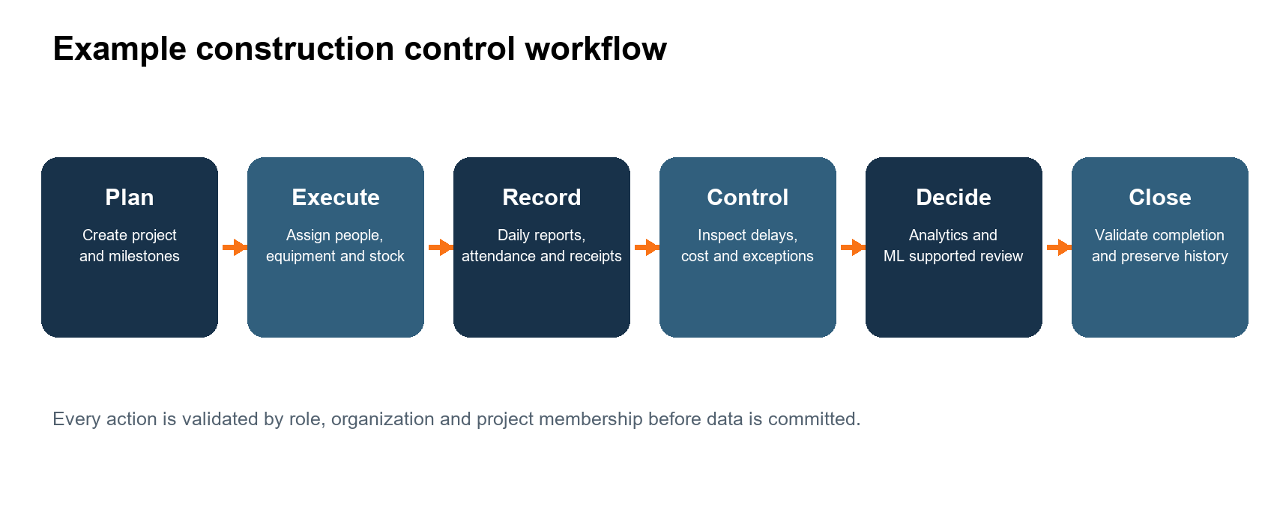
Figure 6 An end to end construction control workflow

8 Database design and integration
PostgreSQL is the single source of truth. The current schema contains 33 models and 15 versioned migrations. UUID primary keys, foreign keys, indexes, decimal money fields, date or timezone aware timestamp fields, uniqueness constraints and transaction boundaries protect consistency.
Domain | Representative tables | Important relationship
Identity | organizations, users, auth sessions, reset tokens, audit logs | Every user belongs to an organization
Projects | projects, project members, work items | Members control project visibility
Site | site reports, attachments, delays, inspections | Every record belongs to a project
Resources | equipment, allocations, maintenance | Allocation connects equipment and project
Inventory | materials, requests, stock movements | Movements preserve the stock ledger
Workforce | workers, assignments, attendance, shifts | Attendance links worker, project and date
Commercial | vendors, requests, orders, receipts, invoices | Receipts update purchase progress and stock
Finance | budget allocations, expenses | Financial records reconcile at project level
Content | documents, versions, notifications | Versions preserve document history

Frontend backend database integration
Angular never connects directly to PostgreSQL. Components call relative API routes through the Angular development proxy. Express authenticates and validates the request, Prisma executes the database operation, and the response updates Angular signals and forms. This boundary prevents browser users from bypassing business rules or supplying a privileged role in a payload.

Transactions and concurrency
Operations that can conflict use database transactions and row locks. Examples include team authority changes, equipment allocation, inventory issue, purchase receipt processing and schedule dependencies. Version fields support optimistic concurrency so an outdated form cannot silently overwrite a newer change.

9 How progress and utilization are calculated

Project progress
The application calculates progress from saved work data. It selects milestones when a project has milestones; otherwise it uses tasks. Each percentage is multiplied by its weight and divided by the total weight. This makes a major structural milestone contribute more than a small administrative task.
Project progress = sum of milestone progress x weight / sum of milestone weights
The three operational demonstration projects currently show 68 percent, 16 percent and 53 percent. Synthetic completed projects used for ML training are marked as training data and stay hidden from operational project, finance and analytics screens.

Fleet utilization
For each of the last 12 weeks, the API intersects every equipment allocation with the week boundaries, totals allocated hours and divides by available fleet hours. Released allocations remain in history. The current chart is therefore generated from database dates and durations.

Why progress is not predicted by ML
Recorded progress is a factual operational value and should remain auditable. Machine learning estimates future risk, demand, cost and failure probability. It does not replace measured completion or automatically change a milestone. This separation keeps the dashboard explainable and gives the project team final control.

10 Machine learning implementation
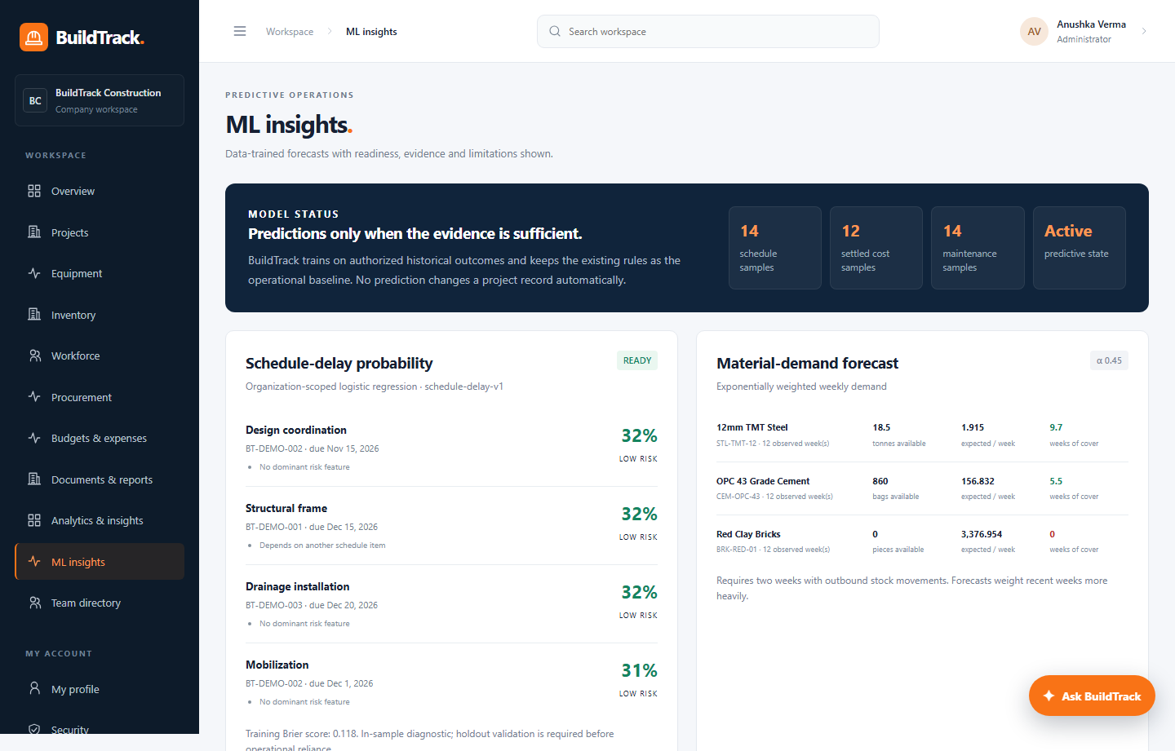
Figure 7 ML Insights page with model readiness and predictions
Every model is trained inside the signed in organization scope. If the minimum history is missing, the API returns insufficient data instead of a fabricated prediction. Current demonstration history is explicitly labelled so it can be replaced with verified organization data later.
Use case | Method | Training data | Output and purpose
Schedule delay | Binary logistic regression | 14 completed work outcomes; late versus on time | Delay probability and Low Medium High band for open work
Material demand | Exponentially weighted forecast alpha 0.45 | 12 weekly outbound observations for each of three materials | Expected weekly demand, stock cover and stockout date
Cost at completion | Ridge regression | 12 closed projects with settled costs | Model estimate, expected completion cost and variance
Equipment failure | Binary logistic classifier | 14 completed maintenance outcomes | Failure probability, service date and risk reasons

Schedule delay classifier
Features include planned duration, dependency presence, task or milestone type, high project priority and recorded delay count. Logistic regression converts the weighted feature score into a probability between 0 and 1. Training requires at least 12 completed items with at least three late and three on time outcomes.

Material demand forecasting
Outbound stock movements are grouped by week. Exponential smoothing gives more influence to recent demand while retaining historical behavior. Alpha 0.45 means the newest observation contributes 45 percent of the updated forecast. Available stock divided by forecast demand gives weeks of cover.

Cost at completion regression
Ridge regression learns a cost ratio from project estimate to budget, duration and priority. Regularization reduces unstable weights when features overlap. The result is compared with actual cost and committed purchase orders, and the expected completion value never drops below money already spent or committed.

Predictive maintenance classifier
Features include time since service relative to the service interval, recent allocation, equipment age and open high priority maintenance. The model learns from failure related and preventive completed maintenance records. It presents the probability and the reasons that contributed to the review.

How future real data can replace demonstration data
1. Import completed schedule items with planned and actual completion dates.
2. Record every material issue so weekly demand reflects actual consumption.
3. Close projects only after final approved expenses and invoices are settled.
4. Record preventive and failure related maintenance consistently, including downtime.
5. Keep enough examples from both outcome classes and evaluate on later unseen data before operational reliance.

11 Security and business controls
Control | Implementation
Password security | 12 to 72 characters, uppercase, lowercase and number; bcrypt cost 12
Sessions | 15 minute access JWT plus rotated hashed refresh credential
Refresh replay | Consumed token reuse revokes the session family
Cookies | HTTP only, SameSite Strict and Secure in production
Authorization | Central permission map plus organization and project membership filters
Input validation | Strict Zod schemas reject invalid and unexpected fields
API protection | Helmet, exact CORS origin, body limits and rate limiting
Audit | Sensitive actions create audit records without storing secrets
Files | Validated uploads and protected preview or download endpoints
Data isolation | Every operational query is scoped to the signed in organization

12 Verification and quality evidence
The release was verified after the latest progress and utilization fixes. The same commit was pushed to the completion branch and develop, and both GitHub Actions workflows completed successfully.
Check | Result | What it verifies
Backend integration | 27 passed | Authentication, roles, workflows, transactions and PostgreSQL behavior
Frontend unit | 7 passed | Authentication service, guards and component behavior
Browser end to end | 20 passed | Real login and complete management workflows in the browser
Lint and type check | Passed | Code quality and TypeScript contracts
Production build | Passed | Compilable Angular and Express output
GitHub Actions | Passed on both branches | Repeatable CI environment and regression workflow

Representative browser scenarios
- Six roles sign in, restore sessions and see permitted navigation.
- A new account registers, updates its profile, resets its password and signs in again.
- An administrator creates, edits, resets and deactivates a team member.
- Project, equipment, inventory, workforce, procurement, finance and document workflows persist correctly.
- Analytics reconciles stored project controls and clearly labels demo or unconfigured providers.

Latest repository state
The current implementation commit is ecab11f. It separates ML training projects from operational dashboards and supplies database backed fleet allocation history. Both the develop branch and codex completion branch passed the BuildTrack checks workflow.

13 Running and demonstrating the project

Start on this computer
cd C:\Users\Anushka\OneDrive\Desktop\Infosys
powershell -ExecutionPolicy Bypass -File scripts/start.ps1
Open http://localhost:4200. Use localhost exactly because it is the configured browser origin. Swagger is available at http://localhost:4300/api/docs.

Demo accounts
Role | Email | Password
Administrator | admin@buildtrack.local | BuildTrackDemo2026!
Project Manager | manager@buildtrack.local | BuildTrackDemo2026!
Site Engineer | engineer@buildtrack.local | BuildTrackDemo2026!
Contractor | contractor@buildtrack.local | BuildTrackDemo2026!
Worker | worker@buildtrack.local | BuildTrackDemo2026!
Client | client@buildtrack.local | BuildTrackDemo2026!

Suggested 12 minute demonstration
Time | Screen | What to explain
1 minute | Landing and login | Explain the product goal and sign in as Administrator.
1 minute | Role access | Open Team directory and explain the six roles and server permissions.
2 minutes | Project | Open Riverside Residences and explain weighted progress, team and status.
2 minutes | Site and schedule | Show dependencies, site report, delay and inspection records.
2 minutes | Operations | Show equipment utilization, inventory, workforce and procurement.
1 minute | Finance and documents | Explain actual, commitment, forecast and protected files.
2 minutes | Analytics and ML | Show explainable risk, four models, samples and safeguards.
1 minute | Quality | Show Swagger, test counts and GitHub Actions success.

14 Likely guide questions and concise answers
Why did you choose a modular monolith?
It keeps transactions across project, stock, purchasing and finance simple while separating code by domain. It is appropriate for the current scale and can be split later if measured load requires it.
How do frontend and backend integrate?
Angular sends HTTP requests to the Express API. The API validates identity and input, uses Prisma for PostgreSQL, and returns typed response envelopes. Angular never accesses the database directly.
Is the dashboard hardcoded?
No. Project progress is calculated from weighted work items, utilization from allocation overlaps, finance from expenses and commitments, and risk from stored exceptions. Seed data only provides demonstration records.
Why not use ML for progress?
Progress is a factual, auditable measurement. ML is used to estimate future uncertainty such as delay, demand, final cost and failure risk.
How is tenant security handled?
Users belong to an organization. Protected queries include organization scope, and non administrators also require project membership. Permissions are checked again on the API.
What happens with insufficient ML data?
The endpoint reports insufficient data and does not emit a probability. Each model publishes its minimum sample requirement.
Can I train with my own data?
Yes. Replace the labelled synthetic history by recording or importing verified outcomes using the same database fields. Retraining happens from organization scoped records.
How do you avoid duplicate stock receipt?
The receipt workflow uses an idempotency key and a database transaction so retrying the request does not repeat the stock movement.
How is concurrency handled?
Transactions, row locks, conditional updates and version fields protect allocation, stock and stale edits.
Is it production ready?
The implemented application and tests are complete for local evaluation. Production still requires managed storage, real SMTP, TLS, backups, monitoring, deployment review and replacement of the licensed demonstration image.

15 Limitations and future work
Current limitation | Recommended next step
Local filesystem uploads | Use encrypted durable object storage with lifecycle and backup policies
Local mail sink | Configure and test a TLS SMTP or transactional email provider
Demo weather and no camera feed | Add reviewed provider adapters, credentials and failure handling
Synthetic ML history | Replace with verified historical outcomes and perform time based holdout validation
Local deployment | Deploy behind TLS with managed PostgreSQL, monitoring and restore drills
Rule based assistant | Integrate an approved generative model with grounding, privacy controls and evaluation
Single organization per identity | Design invitations and multi organization membership if required

ML evaluation roadmap
- Collect verified outcomes with consistent definitions and timestamps.
- Split training and evaluation by time so later projects test earlier learning.
- Measure classification calibration and regression error by project category.
- Monitor drift and retrain only after sufficient new outcomes exist.
- Keep a human approval step for every operational decision.

16 Conclusion
BuildTrack demonstrates a complete, integrated construction management workflow rather than a collection of independent screens. Angular, Express, Prisma and PostgreSQL work together through validated APIs and permission scoped data. The operational modules share one source of truth, the analytics explain how their values are calculated, and the ML layer provides four practical decision support models without taking control away from the project team.
The strongest points to emphasize to a guide are the breadth of connected modules, the server enforced six role access model, transaction based business rules, data derived progress and utilization, transparent ML safeguards, and the full regression evidence. The remaining work is deployment and real provider configuration rather than missing core local functionality.

Source references inside the repository
- README.md for setup, routes, credentials and release status
- docs/PROJECT_ARCHITECTURE.md for architecture and design rationale
- docs/BUSINESS_RULES.md for implemented validation and workflow rules
- docs/ML_OPPORTUNITIES.md for models, samples and safeguards
- docs/VERIFICATION.md for executed quality checks
- backend/prisma/schema.prisma for the authoritative data model
- backend/src/shared/permissions.ts for the role permission map

