CONTRACTIQ
Contract Obligation Tracking & Compliance Management Platform
Sprint 3 – Database Design
By Anshika Kumari
PostgreSQL • SQLAlchemy • FastAPI • Angular

1. Purpose of the Database
The ContractIQ database is designed around the contract lifecycle implemented by the application: authenticated users manage contracts, contracts contain trackable obligations and renewal information, compliance is calculated from obligation status, notifications communicate important events, reports provide analytics and exports, and audit logs provide traceability.
The database uses PostgreSQL with SQLAlchemy ORM. Integer identifiers and foreign-key relationships are used for consistent integration with the FastAPI backend. Date and timestamp fields support lifecycle tracking, while status fields support dashboard analytics and operational workflows.
The design is intentionally modular so that each business responsibility is represented separately while relationships preserve the connection between a contract and its related operational data.

2. Database Tables & Application Modules
# | Table / Layer | Project Purpose
1 | users | Authentication, user identity, role and account status
2 | contracts | Central contract master records and lifecycle status
3 | contract_versions | Contract document/version history
4 | obligations | Contractual duties, deadlines, assignment and status
5 | renewals | Renewal dates, expiry information and renewal status
6 | notifications | User-specific alerts and notification state
7 | audit_logs | Traceability of important system actions
8 | activities | Operational timeline for contract/obligation activity
9 | reports / analytics layer | Report generation and analytics; current implementation exposes report APIs and PDF/Excel exports

Implementation note: ContractIQ currently generates analytics and PDF/Excel exports through the reporting service and API layer. A dedicated reports metadata table can be retained as an extensibility option, but it is not required for the current export workflow.

3. Core Database Schema

3.1 users
Stores platform users used for authentication, authorization, contract ownership and assignment.
Column | Data Type | Key / Constraint | Project Purpose
id | INTEGER | PK | Unique user ID
full_name | VARCHAR(100) | NOT NULL | User full name
email | VARCHAR(255) | UNIQUE, NOT NULL | Login/contact email
password | VARCHAR(255) | NOT NULL | Stored password value used by the current backend authentication model
role | VARCHAR(50) | NOT NULL | User role
is_active | BOOLEAN | NOT NULL | Account availability
created_at | TIMESTAMP | NOT NULL | Account creation timestamp
updated_at | TIMESTAMP | NOT NULL | Last update timestamp

3.2 contracts
Central business entity. Most contract lifecycle information is linked to this table.
Column | Data Type | Key / Constraint | Project Purpose
id | INTEGER | PK | Unique contract ID
contract_number | VARCHAR(100) | UNIQUE, NOT NULL | Unique contract reference
title | VARCHAR(255) | NOT NULL | Contract title
category | VARCHAR(255) | NOT NULL | Contract category
description | TEXT | NULL | Contract description
party_name | VARCHAR(255) | NOT NULL | Other contracting party
start_date | DATE | NOT NULL | Contract start date
end_date | DATE | NOT NULL | Contract expiry date
status | VARCHAR(50) | NOT NULL | Draft, Under Review, Approved, Active, Expired, Terminated
owner_id | INTEGER | FK → users.id | Primary contract owner
assigned_to | INTEGER | FK → users.id, NULL | Assigned user
reviewed_at | TIMESTAMP | NULL | Review timestamp
approved_at | TIMESTAMP | NULL | Approval timestamp
created_at | TIMESTAMP | NOT NULL | Creation timestamp
updated_at | TIMESTAMP | NOT NULL | Last update timestamp

3.3 obligations
Tracks contractual responsibilities and provides the main input for compliance calculation.
Column | Data Type | Key / Constraint | Project Purpose
id | INTEGER | PK | Unique obligation ID
contract_id | INTEGER | FK → contracts.id | Associated contract
title | VARCHAR(255) | NOT NULL | Obligation title
description | TEXT | NULL | Detailed obligation description
obligation_type | VARCHAR(100) | NOT NULL | Payment, delivery, reporting, renewal, SLA, legal compliance, etc.
due_date | DATE | NOT NULL | Obligation deadline
assigned_to | INTEGER | FK → users.id | Responsible user
status | VARCHAR(50) | NOT NULL | Pending, In Progress, Completed, Delayed, Overdue
completion_date | DATE | NULL | Completion date
created_at | TIMESTAMP | NOT NULL | Creation timestamp
updated_at | TIMESTAMP | NOT NULL | Last update timestamp

3.4 renewals
Tracks renewal events and connects contract expiry with renewal management.
Column | Data Type | Key / Constraint | Project Purpose
id | INTEGER | PK | Unique renewal ID
contract_id | INTEGER | FK → contracts.id | Contract being renewed
renewal_date | DATE | NOT NULL | Renewal date
previous_expiry_date | DATE | NOT NULL | Previous expiry date
new_expiry_date | DATE | NOT NULL | New expiry date
status | VARCHAR(50) | NOT NULL | Renewal lifecycle status
assigned_to | INTEGER | FK → users.id | Responsible user
notes | TEXT | NULL | Renewal notes
created_at | TIMESTAMP | NOT NULL | Creation timestamp
updated_at | TIMESTAMP | NOT NULL | Last update timestamp

3.5 notifications
Stores user-scoped alerts related to contracts, obligations and system events.
Column | Data Type | Key / Constraint | Project Purpose
id | INTEGER | PK | Unique notification ID
user_id | INTEGER | FK → users.id | Notification recipient
contract_id | INTEGER | FK → contracts.id, NULL | Related contract
obligation_id | INTEGER | FK → obligations.id, NULL | Related obligation
notification_type | VARCHAR(100) | NOT NULL | Notification category
title | VARCHAR(255) | NOT NULL | Notification title
message | TEXT | NOT NULL | Notification message
status | VARCHAR(50) | NOT NULL | Notification status
scheduled_at | TIMESTAMP | NULL | Scheduled time
sent_at | TIMESTAMP | NULL | Sent time
read_at | TIMESTAMP | NULL | Read time
created_at | TIMESTAMP | NOT NULL | Creation timestamp
updated_at | TIMESTAMP | NOT NULL | Last update timestamp

3.6 audit_logs
Captures important actions for accountability and traceability.
Column | Data Type | Key / Constraint | Project Purpose
id | BIGINT | PK | Unique audit event
user_id | INTEGER | FK → users.id, NULL | Actor; may be null for system actions
action | VARCHAR(100) | NOT NULL | Action such as CREATE or UPDATE
entity_type | VARCHAR(100) | NOT NULL | Affected entity
entity_id | INTEGER | NULL | Affected record ID
old_values | JSONB | NULL | Previous state
new_values | JSONB | NULL | New state
ip_address | VARCHAR(45) | NULL | Origin IP when captured
created_at | TIMESTAMP | NOT NULL | Event timestamp

4. Supporting Tables & Extensibility

4.1 contract_versions
The project design reserves contract_versions for maintaining historical document versions. A contract can have multiple versions, each connected back to contracts.id and the user who created the version.
- contract_id → contracts.id
- version_number identifies the sequence of a contract version
- file_path stores the document reference
- change_summary describes changes made in the version
- created_by → users.id identifies the creator

4.2 activities
The activity model supports a chronological operational timeline for contracts and obligations. It can capture actions such as comments, assignments, uploads and status changes.
- user_id → users.id
- contract_id → contracts.id (optional)
- obligation_id → obligations.id (optional)
- activity_type and description provide the human-readable event information
- created_at provides chronological ordering

4.3 Reports / Analytics
In the current implementation, reports are primarily produced through the FastAPI reporting service. The application exposes contract, obligation, renewal, compliance and risk analytics and supports PDF and Excel exports. This keeps report generation reusable without requiring a stored report record for every download.

5. Primary Keys & Foreign Keys
Table | Primary Key | Foreign Keys
users | id | —
contracts | id | owner_id → users.id; assigned_to → users.id
contract_versions | id | contract_id → contracts.id; created_by → users.id
obligations | id | contract_id → contracts.id; assigned_to → users.id
renewals | id | contract_id → contracts.id; assigned_to → users.id
notifications | id | user_id → users.id; contract_id → contracts.id; obligation_id → obligations.id
audit_logs | id | user_id → users.id
activities | id | user_id → users.id; contract_id → contracts.id; obligation_id → obligations.id

6. Relationships Between Tables
Parent | Child | Relationship | Explanation
users | contracts | 1 : N | One user can own or be associated with multiple contracts.
contracts | contract_versions | 1 : N | One contract can have multiple document versions.
contracts | obligations | 1 : N | One contract can contain multiple obligations.
users | obligations | 1 : N | One user can be assigned multiple obligations.
contracts | renewals | 1 : N | One contract can have multiple renewal records.
users | renewals | 1 : N | One user can be responsible for multiple renewals.
users | notifications | 1 : N | One user can receive multiple notifications.
contracts | notifications | 1 : N | A contract can have multiple related notifications.
obligations | notifications | 1 : N | An obligation can have multiple related notifications.
users | audit_logs | 1 : N | A user can generate multiple audit events.
contracts | activities | 1 : N | A contract can have multiple activity events.
obligations | activities | 1 : N | An obligation can have multiple activity events.

7. Entity Relationship Diagram
The diagram below reflects the ContractIQ domain model: users provide ownership, assignment and audit references; contracts act as the central business entity; obligations and renewals extend the contract lifecycle; notifications connect operational events to users; and audit/activity records provide traceability.
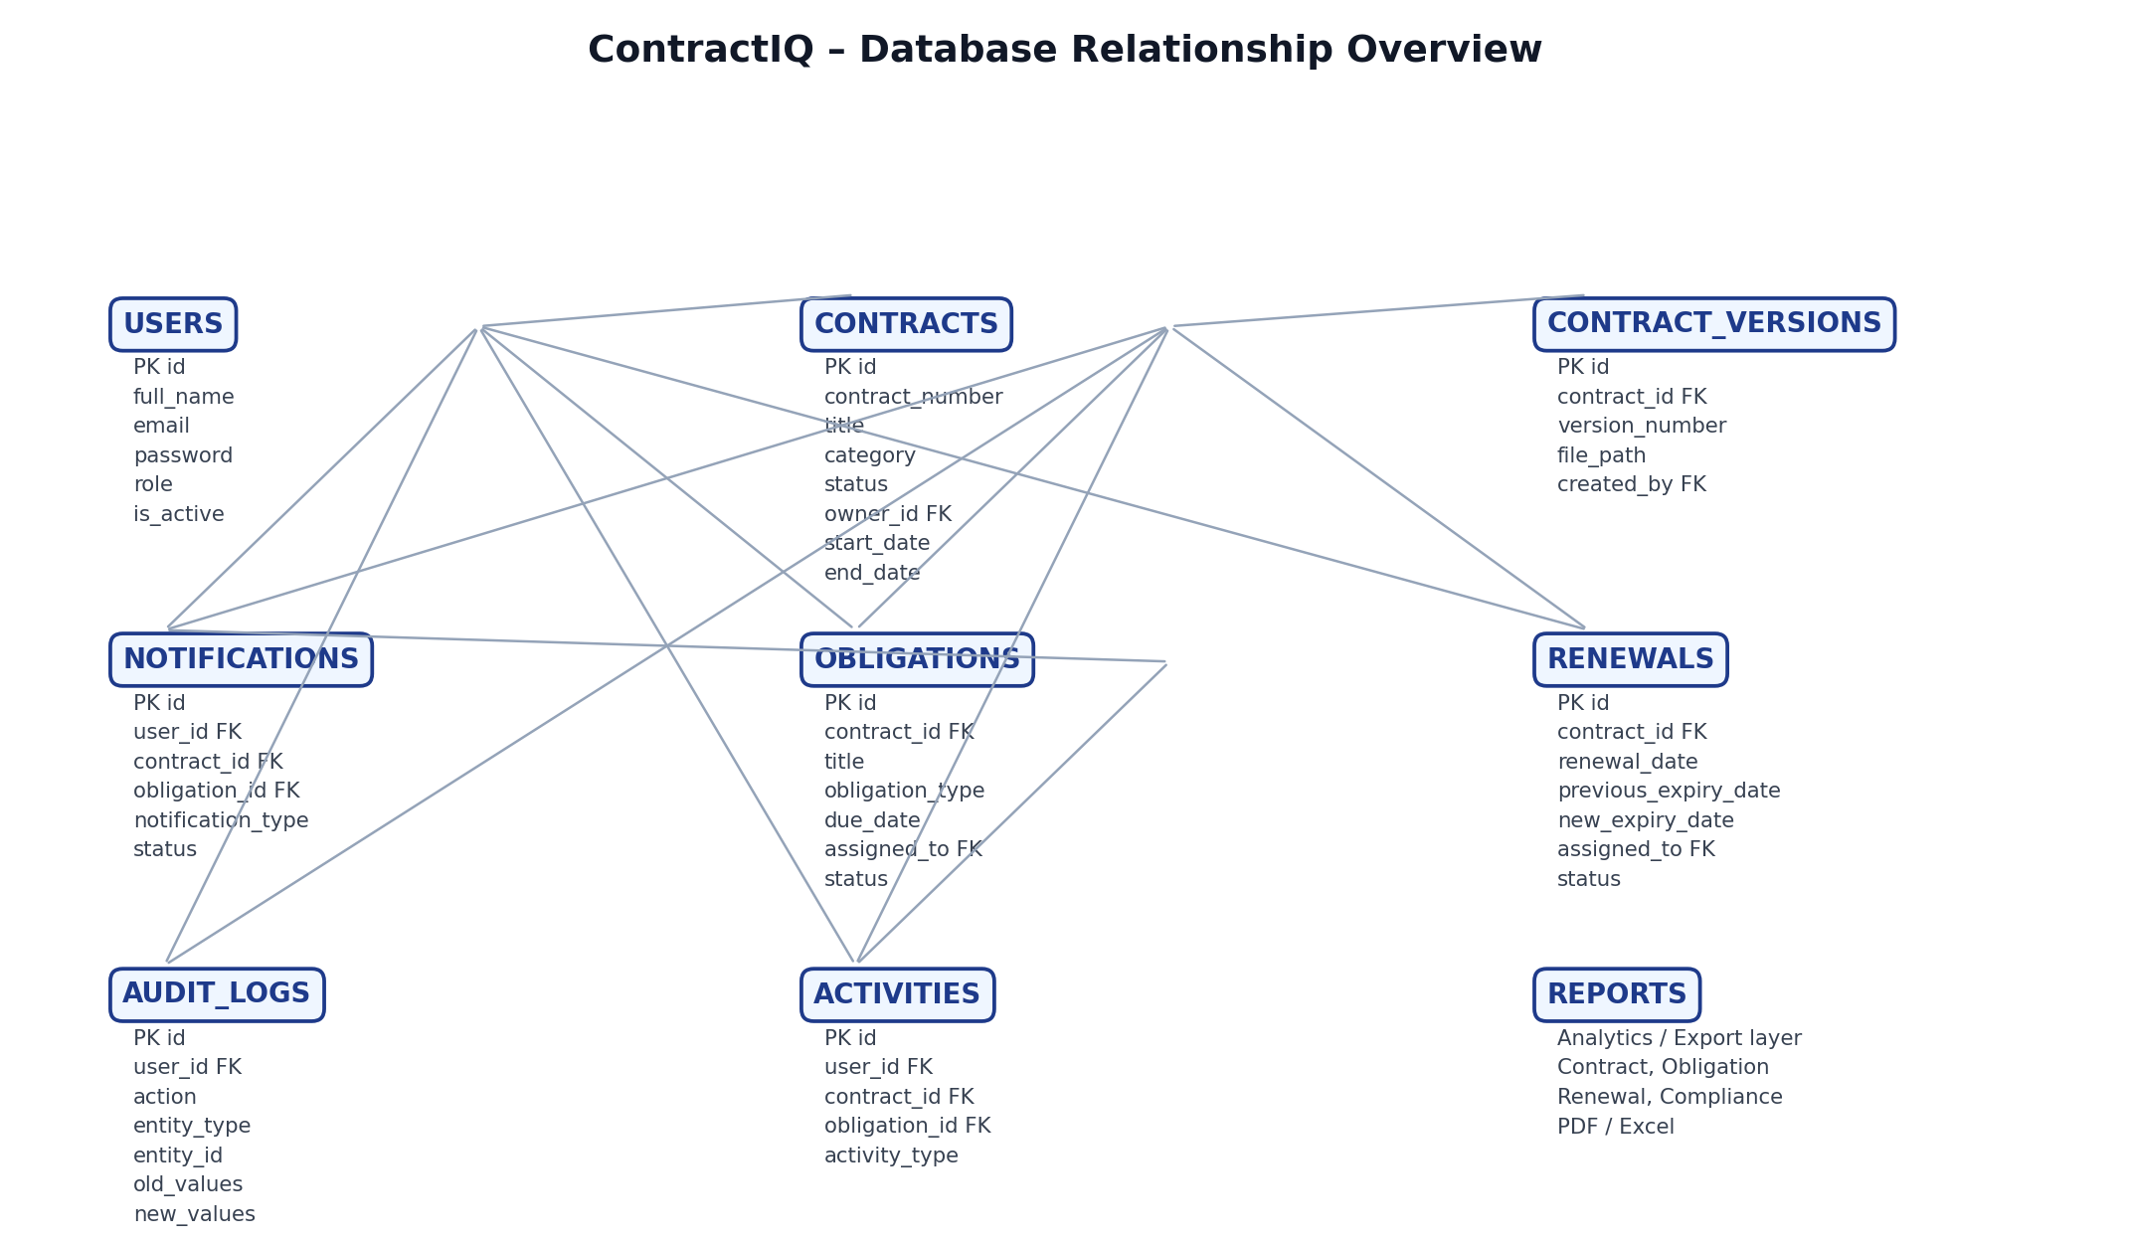

8. Functional Interaction of the Database
ContractIQ follows a contract-centered data flow. A user authenticates and accesses protected application modules. Contracts are created and maintained as the central records. Obligations are attached to contracts and assigned to users. Obligation completion and overdue status feed compliance analysis. Renewals track future contract lifecycle events. Notifications communicate relevant information to users. Dashboard and reporting APIs aggregate these records for analytics. Audit logs provide a traceable record of important actions.

8.1 Application Data Flow
- User → authentication and protected application access
- Contract → master record containing lifecycle and ownership information
- Obligation → operational task linked to a contract and responsible user
- Renewal → future lifecycle event linked to the contract
- Compliance → derived analysis from contract obligations
- Notification → user-facing communication linked to relevant records
- Dashboard / Reports → aggregated analytics and export layer
- Audit History → traceability of important application actions

9. Constraints & Design Decisions
- contract_number must be unique so that each contract has a stable business reference.
- Contract start and end dates represent the lifecycle period and should be logically consistent.
- Foreign-key columns should be indexed where frequently used for joins and lookups.
- Obligation and renewal status values are restricted through application validation.
- Audit records should be treated as append-only from the application layer.
- Passwords must not be stored as plaintext; authentication should use secure password handling.
- Notification records are scoped to users so that one user does not access another user's notifications.
- Sensitive configuration such as database credentials and JWT secrets belongs in environment variables, not source control.

10. Database-to-Backend Integration
The database is accessed through SQLAlchemy models and a FastAPI service/router architecture. Pydantic schemas validate request and response data, while the reporting and compliance services transform database records into application-level analytics.
Domain | Backend Layer | Purpose
Contracts | Contract model / router | Create, read, update and lifecycle tracking
Obligations | Obligation model / router | Create, update, status and completion workflows
Renewals | Renewal model / router | Create, update, status and renewal workflows
Compliance | Compliance service / router | Contract compliance and risk calculations
Notifications | Notification model / router | User notification retrieval and read actions
Reports | Report service / router | Analytics, PDF and Excel generation
Audit | AuditLog model / audit router | Authenticated audit history retrieval

11. Alignment with the Implemented ContractIQ Application
This database design is aligned with the current full-stack ContractIQ implementation. The Angular frontend consumes FastAPI APIs through dedicated services, while the FastAPI backend uses SQLAlchemy and PostgreSQL for persistence. Dashboard and reporting values are derived from backend data rather than hardcoded frontend values.
- PostgreSQL is the primary relational database.
- FastAPI provides the REST API layer.
- SQLAlchemy provides ORM-based database access.
- JWT authentication protects application APIs and frontend routes.
- Contract, obligation, renewal, compliance and notification modules are integrated across the application.
- Reporting supports analytics plus PDF and Excel export.
- Audit History provides a frontend view of audit log records.
- The Department Performance requirement is not represented as a database feature because the current schema does not contain department / department_id data.

12. Conclusion
The ContractIQ database design provides a normalized, relationship-driven structure for contract lifecycle management. Contracts remain the central business entity, while obligations, renewals, notifications, compliance analysis, reporting and audit history extend the platform without mixing unrelated responsibilities. The design supports the current FastAPI + Angular implementation and leaves clear extension points for document versioning, activity timelines, department analytics and richer report metadata.

