Sprint 3 — Database Design Document

Contract Obligation Tracking & Compliance Management Platform
- Prepared for: Backend / SQLAlchemy Model Implementation

- Status: Design & Planning — No API Implementation in Scope

- Prepared By: Rathnam Mekala

1. Introduction & Objective
This document presents the complete database design for ContractIQ, a platform that helps legal and business teams track contract obligations, manage renewals, and stay compliant. The goal of Sprint 3 is to define the tables, columns, keys, and relationships needed to support the platform's core modules — contract lifecycle management, obligation tracking, renewal alerts, notifications, reporting, and auditing — before backend (SQLAlchemy) models are implemented in the next sprint.

1.1 Tables Covered
Table | Description
users | Manages platform accounts, roles, and permissions.
contracts | Master record for each contract and its lifecycle status.
contract_versions | Version history of uploaded contract documents.
obligations | Deliverables, deadlines, and compliance duties per contract.
renewals | Renewal windows, notice periods, and renewal outcomes.
notifications | Alerts sent to users about obligations, renewals, and updates.
reports | Metadata for generated compliance and summary reports.
audit_logs | System-wide audit trail of create/update/delete actions.
activities | Business-facing activity/comment feed per contract.

2. Table Schemas, Keys & Purpose

1. users
Purpose: Stores every person who interacts with ContractIQ (Admins, Legal/Contract Managers, Approvers, Viewers). It is the anchor table for authentication, role-based access control, and accountability — almost every other table references it to record who owns, uploads, actions, or is notified about something.
Column | Data Type | Key | Description
user_id | INT / UUID | PK | Unique identifier for the user.
name | VARCHAR(150) |  | Full name of the user.
email | VARCHAR(150) | UNIQUE | Login email; used for notifications.
password_hash | VARCHAR(255) |  | Hashed password for authentication.
role | VARCHAR(30) |  | Admin, Legal, Manager, Approver, Viewer, etc.
department | VARCHAR(100) |  | Business unit the user belongs to.
is_active | BOOLEAN |  | Whether the account is currently active.
created_at / updated_at | TIMESTAMP |  | Record creation / last update time.

2. contracts
Purpose: The core business entity of the platform. Each row represents one legal contract/agreement with a counterparty and holds its high-level metadata, lifecycle status, and ownership. Obligations, renewals, versions, notifications, and activities all revolve around a contract.
Column | Data Type | Key | Description
contract_id | INT / UUID | PK | Unique identifier for the contract.
title | VARCHAR(255) |  | Contract name/title.
contract_type | VARCHAR(50) |  | NDA, MSA, Lease, Vendor, Employment, etc.
counterparty_name | VARCHAR(150) |  | The other party to the agreement.
status | VARCHAR(30) |  | Draft, Active, Expired, Terminated, Renewed.
start_date / end_date | DATE |  | Effective and expiry dates of the contract.
contract_value | DECIMAL(14,2) |  | Monetary value of the agreement.
owner_id | INT | FK → users.user_id | Business owner responsible for the contract.
created_by | INT | FK → users.user_id | User who created the contract record.
current_version_id | INT | FK → contract_versions.version_id | Pointer to the latest active document version.
created_at / updated_at | TIMESTAMP |  | Record creation / last update time.

3. contract_versions
Purpose: Tracks every uploaded revision of a contract document, preserving a full version history (redlines, amendments, signed copies). This supports document traceability and lets users compare or roll back to earlier drafts without losing history.
Column | Data Type | Key | Description
version_id | INT / UUID | PK | Unique identifier for the version record.
contract_id | INT | FK → contracts.contract_id | Contract this version belongs to.
version_number | INT |  | Sequential version number (1, 2, 3 …).
file_url | VARCHAR(500) |  | Storage path/URL of the uploaded document.
summary | TEXT |  | Notes on what changed in this version.
uploaded_by | INT | FK → users.user_id | User who uploaded this version.
uploaded_at | TIMESTAMP |  | Date/time the version was uploaded.
is_current | BOOLEAN |  | Flags the currently active version.

4. obligations
Purpose: Captures the individual deliverables, deadlines, and compliance duties that arise from a contract (e.g., payments, deliverables, SLA checkpoints). This table drives the compliance-tracking and task-assignment features that are central to ContractIQ.
Column | Data Type | Key | Description
obligation_id | INT / UUID | PK | Unique identifier for the obligation.
contract_id | INT | FK → contracts.contract_id | Contract the obligation belongs to.
title | VARCHAR(255) |  | Short name of the obligation.
description | TEXT |  | Detailed description of what must be done.
obligation_type | VARCHAR(50) |  | Payment, Delivery, Compliance, Reporting, etc.
due_date | DATE |  | Date by which the obligation must be fulfilled.
responsible_user_id | INT | FK → users.user_id | User accountable for completing it.
status | VARCHAR(30) |  | Pending, Completed, Overdue, Waived.
priority | VARCHAR(20) |  | Low, Medium, High, Critical.
created_at / updated_at | TIMESTAMP |  | Record creation / last update time.

5. renewals
Purpose: Manages the renewal lifecycle of a contract — notice periods, auto-renewal terms, and renewal outcomes — so the business never misses a renewal or termination window. It works closely with the notifications table to trigger advance reminders.
Column | Data Type | Key | Description
renewal_id | INT / UUID | PK | Unique identifier for the renewal record.
contract_id | INT | FK → contracts.contract_id | Contract being renewed.
renewal_type | VARCHAR(20) |  | Auto-renewal or Manual renewal.
notice_period_days | INT |  | Days of advance notice required before renewal/expiry.
renewal_date | DATE |  | Date the renewal decision is due.
new_end_date | DATE |  | New contract end date if renewed.
status | VARCHAR(30) |  | Upcoming, Notified, Renewed, Expired, Cancelled.
reminder_sent | BOOLEAN |  | Whether the renewal reminder has been sent.
created_at / updated_at | TIMESTAMP |  | Record creation / last update time.

6. notifications
Purpose: Stores in-app / email alerts sent to users for upcoming obligation deadlines, renewal windows, approvals, or status changes. It links back to the relevant contract and/or obligation so a user can jump directly to the source record.
Column | Data Type | Key | Description
notification_id | INT / UUID | PK | Unique identifier for the notification.
user_id | INT | FK → users.user_id | Recipient of the notification.
related_contract_id | INT | FK → contracts.contract_id (nullable) | Contract the alert relates to, if any.
related_obligation_id | INT | FK → obligations.obligation_id (nullable) | Obligation the alert relates to, if any.
type | VARCHAR(20) |  | Email, In-App, SMS.
message | TEXT |  | Notification content.
is_read | BOOLEAN |  | Whether the user has viewed the notification.
sent_at | TIMESTAMP |  | Date/time the notification was sent.

7. reports
Purpose: Stores metadata for generated compliance, obligation-summary, and renewal-forecast reports so users can regenerate, re-download, or audit which reports were produced, by whom, and with what filters, without re-running the underlying query every time.
Column | Data Type | Key | Description
report_id | INT / UUID | PK | Unique identifier for the report.
report_name | VARCHAR(150) |  | Display name of the report.
report_type | VARCHAR(50) |  | Compliance, Obligation Summary, Renewal Forecast, Audit.
generated_by | INT | FK → users.user_id | User who generated the report.
filters_json | JSON / TEXT |  | Filter criteria used (date range, department, status).
file_url | VARCHAR(500) |  | Storage path/URL of the generated file (PDF/Excel).
generated_at | TIMESTAMP |  | Date/time the report was generated.

8. audit_logs
Purpose: Provides an immutable, system-wide audit trail of create/update/delete actions across the platform, for compliance and security purposes. This is a system-of-record table used for investigations, regulatory audits, and change history.
Column | Data Type | Key | Description
log_id | INT / UUID | PK | Unique identifier for the log entry.
user_id | INT | FK → users.user_id | User who performed the action.
entity_type | VARCHAR(50) |  | Table/entity affected (Contract, Obligation, User…).
entity_id | INT |  | Primary key of the affected record.
action | VARCHAR(20) |  | Create, Update, Delete, Login, Export.
old_value | JSON / TEXT |  | Snapshot of the record before the change.
new_value | JSON / TEXT |  | Snapshot of the record after the change.
ip_address | VARCHAR(45) |  | IP address the action originated from.
timestamp | TIMESTAMP |  | Date/time the action occurred.

9. activities
Purpose: Captures a human-readable feed of contract-related events (comments, status changes, uploads, approvals) used to power a contract's 'Activity Timeline' in the UI. Unlike audit_logs (which is a technical/security record), activities is a business-facing collaboration log.
Column | Data Type | Key | Description
activity_id | INT / UUID | PK | Unique identifier for the activity entry.
user_id | INT | FK → users.user_id | User who performed the activity.
contract_id | INT | FK → contracts.contract_id (nullable) | Contract the activity relates to.
activity_type | VARCHAR(30) |  | Comment, StatusChange, Upload, Approval.
description | TEXT |  | Human-readable description of the event.
created_at | TIMESTAMP |  | Date/time the activity occurred.

3. Table Relationships
All relationships in the ContractIQ schema are One-to-Many, radiating from two central tables — users and contracts. No Many-to-Many relationships are required at this stage; if future features (e.g., multiple approvers per contract, shared obligations across contracts) demand it, a junction table can be introduced without disrupting this design.
Relationship | Type | Description
users → contracts | One-to-Many | One user can own / create many contracts (owner_id, created_by).
users → contract_versions | One-to-Many | One user can upload many contract document versions.
contracts → contract_versions | One-to-Many | One contract has many versions; contracts.current_version_id points back to the active one.
contracts → obligations | One-to-Many | One contract can have many obligations (payments, deliverables, compliance tasks).
users → obligations | One-to-Many | One user can be responsible for many obligations.
contracts → renewals | One-to-Many | One contract can have multiple renewal cycles over its lifetime.
users → notifications | One-to-Many | One user can receive many notifications.
contracts / obligations → notifications | One-to-Many | A contract or obligation can trigger many notifications.
users → reports | One-to-Many | One user can generate many reports.
users → audit_logs | One-to-Many | One user's actions can produce many audit log entries.
users / contracts → activities | One-to-Many | One user or contract can be associated with many activity entries.

4. Entity Relationship (ER) Diagram
The diagram below shows all nine tables with their primary keys (PK), foreign keys (FK), and the one-to-many relationships that connect them.
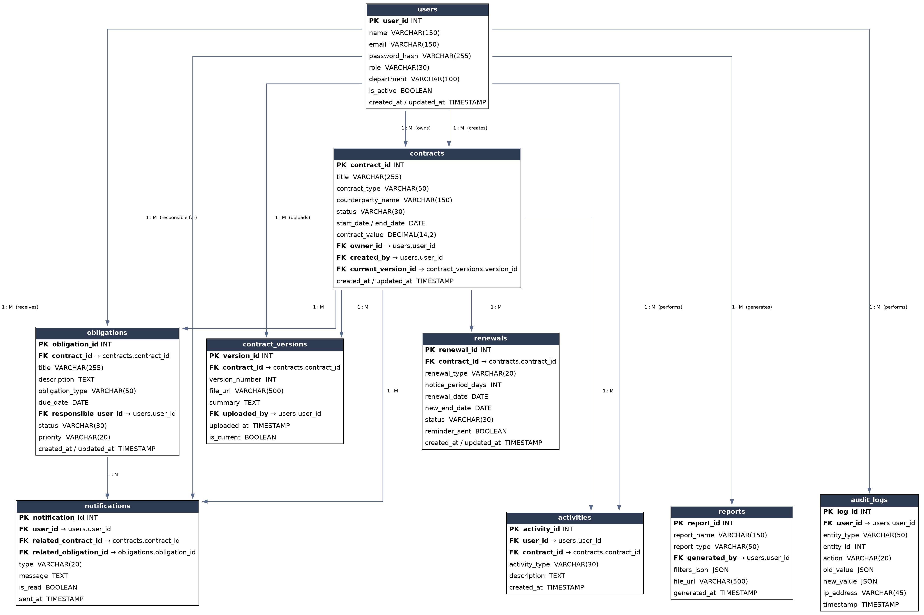

How the Tables Work Together

At the center of the schema sits the contracts table, which represents each legal agreement and links outward to everything that happens over its lifecycle. Every uploaded document is versioned in contract_versions, so amendments and signed copies are never overwritten. Each contract's real-world commitments — payments, deliverables, and compliance checkpoints — are tracked as individual rows in obligations, each assigned to a responsible user. As contract end dates approach, renewals records the notice period and renewal outcome for that contract, working together with notifications to alert the right people (via the users table) before deadlines or renewal windows are missed.
The users table underpins the entire system: it owns contracts, uploads versions, is assigned obligations, receives notifications, generates reports, and performs the actions captured in audit_logs and activities. audit_logs gives the platform a tamper-evident, system-level history of every change (for compliance and security), while activities provides a lighter, business-facing timeline of comments and status updates that users see directly on a contract's page. Finally, reports draws on data across contracts, obligations, and renewals to produce point-in-time compliance and forecast summaries, with each generated report traceable back to the user and filters that created it. Together, these nine tables give ContractIQ a single, well-normalized source of truth for contract data, obligation tracking, and compliance reporting.

