ContractIQ: Contract Obligation Tracking & Compliance Management Platform
Sprint 3 – Database Design
Prepared by: Mohana Kumari
Date: August 2026

1. Introduction
ContractIQ is a platform used to manage contracts and track their important details. It helps organizations store contracts, track obligations, monitor renewal and expiry dates, check compliance, and receive notifications.
This document describes the database design of ContractIQ, including the required tables, columns, primary keys, foreign keys, and relationships. The design will provide a basic structure for developing the backend of the application.

2. Database Design Objectives
The main objectives of the ContractIQ database are:
- To store and manage contract information.
- To track contract obligations, renewals, and expiry dates.
- To manage contract documents and their versions.
- To support notifications and reminders.
- To maintain records of user activities and changes.
- To keep the data organized, secure, and connected.
- To provide a database structure that supports future development.

3. Database Tables Overview
The ContractIQ application requires the following nine primary database tables:
No. | Table Name | Purpose
1 | users | Stores application users and their roles
2 | contracts | Stores the main information about contracts
3 | contract_versions | Stores different versions of contracts
4 | obligations | Stores and tracks contractual obligations
5 | renewals | Stores contract renewal information
6 | notifications | Stores notifications and reminders
7 | reports | Stores information about generated reports
8 | audit_logs | Stores important system changes and audit records
9 | activities | Stores user and system activity information

4. Detailed Database Schema

4.1 Users Table

Purpose: The users table stores information about users who access the ContractIQ application. It supports user registration, authentication, profile management, and role-based access control.

Schema:
Column | Data Type | Key | Nullable | Description
id | INTEGER | PK | No | Unique identifier for the user
full_name | VARCHAR(100) | — | No | Full name of the user
email | VARCHAR(255) | UNIQUE | No | User's email address
password | VARCHAR(255) | — | No | Hashed user password
role | VARCHAR(50) | — | No | Role assigned to the user
is_active | BOOLEAN | — | No | Indicates whether the account is active
created_at | TIMESTAMP | — | No | Account creation timestamp
updated_at | TIMESTAMP | — | Yes | Last update timestamp
Primary Key: id
A Primary key is a unique ID card for a single row in a database table.
A Foreign key is a field in one table that connects to the primary key of another table, building a bridge between them

4.2 Contracts Table

Purpose: The contracts table stores the main information about contracts managed by the organization. It acts as the central table for contract-related information.
The ContractIQ project supports contract creation, editing, approval, review, assignment, status management, document storage, and document categorization.

Schema:
Column | Data Type | Key | Nullable | Description
id | INTEGER | PK | No | Unique contract identifier
title | VARCHAR(255) | — | No | Name/title of the contract
contract_number | VARCHAR(100) | UNIQUE | No | Unique contract reference number
category | VARCHAR(100) | — | No | Category of the contract
description | TEXT | — | Yes | Description of the contract
start_date | DATE | — | No | Contract start date
end_date | DATE | — | Yes | Contract expiry date
status | VARCHAR(50) | — | No | Current contract status
owner_id | INTEGER | FK | No | User responsible for the contract
created_at | TIMESTAMP | — | No | Contract creation timestamp
updated_at | TIMESTAMP | — | Yes | Last update timestamp
Primary Key: id
Foreign Key: owner_id → users.id

4.3 Contract Versions Table

Purpose: The contract_versions table stores different versions of a contract. When a contract is modified, a new version can be created while preserving previous versions.

Schema:
Column | Data Type | Key | Nullable | Description
id | INTEGER | PK | No | Unique version identifier
contract_id | INTEGER | FK | No | Contract associated with the version
version_number | INTEGER | — | No | Version number
file_path | VARCHAR(500) | — | No | Location of the contract document
change_summary | TEXT | — | Yes | Description of changes made
created_by | INTEGER | FK | No | User who created the version
created_at | TIMESTAMP | — | No | Version creation timestamp
Primary Key: id
Foreign Keys:
- contract_id → contracts.id
- created_by → users.id
4.4 Obligations Table
Purpose: The obligations table stores contractual obligations associated with contracts. It allows the system to track obligation deadlines, responsible users, completion status, and compliance status.
Schema:
Column | Data Type | Key | Nullable | Description
id | INTEGER | PK | No | Unique obligation identifier
contract_id | INTEGER | FK | No | Contract associated with the obligation
title | VARCHAR(255) | — | No | Obligation title
description | TEXT | — | Yes | Details of the obligation
obligation_type | VARCHAR(100) | — | No | Type of obligation
due_date | DATE | — | No | Deadline for the obligation
assigned_to | INTEGER | FK | No | User responsible for the obligation
status | VARCHAR(50) | — | No | Completion status
compliance_status | VARCHAR(50) | — | No | Compliance condition
completed_at | TIMESTAMP | — | Yes | Time when obligation was completed
created_at | TIMESTAMP | — | No | Obligation creation timestamp
Primary Key: id
Foreign Keys:
- contract_id → contracts.id
- assigned_to → users.id

4.5 Renewals Table

Purpose: The renewals table stores information related to contract renewals. It supports renewal tracking, expiry monitoring, renewal approval, reminder scheduling, and renewal history.

Schema:
Column | Data Type | Key | Nullable | Description
id | INTEGER | PK | No | Unique renewal identifier
contract_id | INTEGER | FK | No | Contract associated with the renewal
renewal_date | DATE | — | No | Date on which renewal is processed
new_expiry_date | DATE | — | Yes | New expiry date after renewal
status | VARCHAR(50) | — | No | Current renewal status
notes | TEXT | — | Yes | Additional renewal information
approved_by | INTEGER | FK | Yes | User who approved the renewal
created_at | TIMESTAMP | — | No | Renewal record creation timestamp
Primary Key: id
Foreign Keys:
- contract_id → contracts.id
- approved_by → users.id

4.6 Notifications Table

Purpose: The notifications table stores alerts and reminders sent to users. Notifications can be generated for upcoming renewals, obligation deadlines, compliance events, and contract approval activities.

Schema:
Column | Data Type | Key | Nullable | Description
id | INTEGER | PK | No | Unique notification identifier
user_id | INTEGER | FK | No | User receiving the notification
contract_id | INTEGER | FK | Yes | Related contract
obligation_id | INTEGER | FK | Yes | Related obligation
notification_type | VARCHAR(100) | — | No | Type of notification
message | TEXT | — | No | Notification message
channel | VARCHAR(50) | — | No | Delivery channel
is_read | BOOLEAN | — | No | Indicates whether notification was read
sent_at | TIMESTAMP | — | Yes | Notification sending timestamp
created_at | TIMESTAMP | — | No | Notification creation timestamp
Primary Key: id
Foreign Keys:
- user_id → users.id
- contract_id → contracts.id
- obligation_id → obligations.id

4.7 Reports Table

Purpose: The reports table stores information about reports generated by the ContractIQ system.

Reports can support contract analysis, compliance monitoring, renewal tracking, obligation tracking, and audit activities.

Schema:
Column | Data Type | Key | Nullable | Description
id | INTEGER | PK | No | Unique report identifier
name | VARCHAR(255) | — | No | Name of the report
report_type | VARCHAR(100) | — | No | Type of report
generated_by | INTEGER | FK | No | User who generated the report
file_path | VARCHAR(500) | — | Yes | Location of generated report
format | VARCHAR(20) | — | No | Report format
created_at | TIMESTAMP | — | No | Report generation timestamp
Primary Key: id
Foreign Key: generated_by → users.id

4.8 Audit Logs Table

Purpose: The audit_logs table records important system actions and changes. It supports security monitoring, contract history, approval logs, audit reporting, and change history.

Schema:
Column | Data Type | Key | Nullable | Description
id | BIGINT | PK | No | Unique audit log identifier
user_id | INTEGER | FK | Yes | User who performed the action
action | VARCHAR(100) | — | No | Action performed
entity_type | VARCHAR(100) | — | No | Type of affected entity
entity_id | INTEGER | — | Yes | Identifier of affected record
old_value | JSONB | — | Yes | Previous value
new_value | JSONB | — | Yes | Updated value
ip_address | VARCHAR(45) | — | Yes | IP address of the user
created_at | TIMESTAMP | — | No | Audit event timestamp
Primary Key: id
Foreign Key: user_id → users.id

4.9 Activities Table

Purpose: The activities table stores user and system activities. It can be used to display recent activities on dashboards and maintain a history of actions performed within the system.

Schema:
Column | Data Type | Key | Nullable | Description
id | BIGINT | PK | No | Unique activity identifier
user_id | INTEGER | FK | Yes | User who performed the activity
contract_id | INTEGER | FK | Yes | Related contract
activity_type | VARCHAR(100) | — | No | Type of activity
description | TEXT | — | No | Description of the activity
created_at | TIMESTAMP | — | No | Activity timestamp
Primary Key: id
Foreign Keys:
- user_id → users.id
- contract_id → contracts.id

5. Table Relationships
The main relationships between the database tables are as follows:
Parent Table | Child Table | Relationship | Explanation
users | contracts | One-to-Many | One user can manage multiple contracts
contracts | contract_versions | One-to-Many | One contract can have multiple versions
users | contract_versions | One-to-Many | One user can create multiple contract versions
contracts | obligations | One-to-Many | One contract can contain multiple obligations
users | obligations | One-to-Many | One user can be responsible for multiple obligations
contracts | renewals | One-to-Many | One contract can have multiple renewal records
users | renewals | One-to-Many | One user can approve multiple renewals
users | notifications | One-to-Many | One user can receive multiple notifications
contracts | notifications | One-to-Many | One contract can generate multiple notifications
obligations | notifications | One-to-Many | One obligation can generate multiple notifications
users | reports | One-to-Many | One user can generate multiple reports
users | audit_logs | One-to-Many | One user can generate multiple audit records
users | activities | One-to-Many | One user can perform multiple activities
contracts | activities | One-to-Many | One contract can have multiple activities

6. Entity Relationship Diagram
The Entity Relationship Diagram (ER Diagram) represents the structure of the ContractIQ database and shows how the nine tables are connected through primary keys and foreign keys.
The ER diagram should contain the following tables:
- users
- contracts
- contract_versions
- obligations
- renewals
- notifications
- reports
- audit_logs
- activities
The diagram should clearly display:
- Table names
- Important columns
- Primary keys
- Foreign keys
- One-to-Many relationships

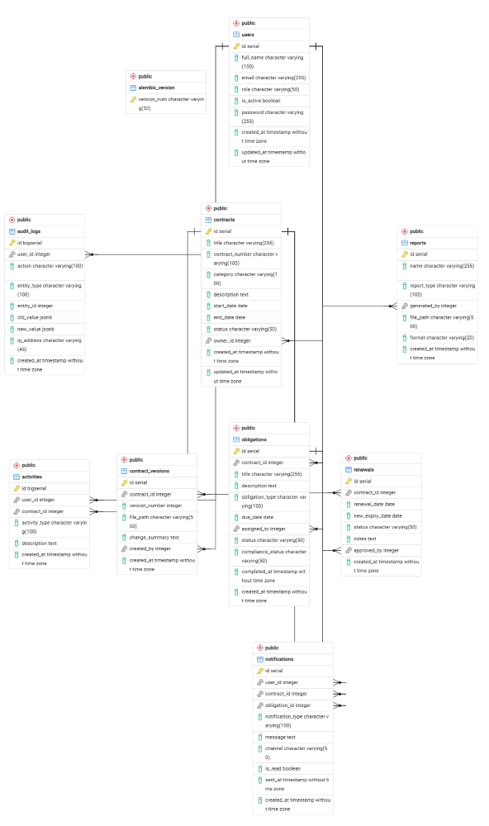

7. Database Design Explanation:

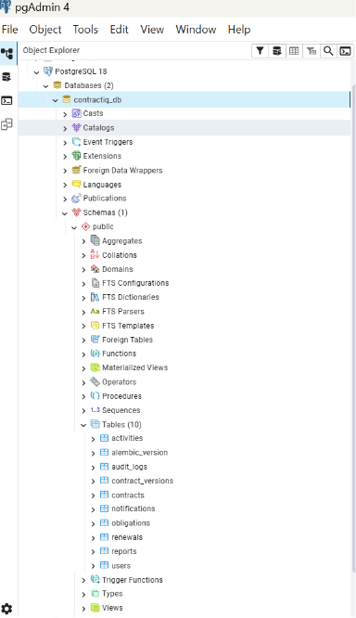
The workflow starts with Users, who manage Contracts in the system. Each contract can have multiple Contract Versions and Obligations. The system also tracks Renewals for contracts and sends Notifications for important dates and activities. The information from these modules can be used to generate Reports.
Activities record actions performed by users on contracts. Audit Logs maintain important records of these activities and changes, helping the system keep track of what happened.
Conclusion:
The database design provides a simple and organized structure for the ContractIQ application. The tables are connected to manage users, contracts, obligations, renewals, notifications, reports, and activity records efficiently. This design will serve as a foundation for developing the database and backend features in future sprints.

