CONTRACTIQ
Sprint 3 – Database Design
Contract Obligation Tracking & Compliance Management Platform
By Shrrivathsan S

1. Purpose of the Database
The ContractIQ database supports the complete contract lifecycle implemented in the attached FastAPI / SQLAlchemy / Alembic backend: contract creation and approval, document versioning, obligation tracking, renewal management, notifications, compliance evaluation, reporting, collaboration activity, and audit tracking. Each responsibility is kept in its own relational table, so information is not duplicated across modules.
This revision aligns the design with the current codebase in contractiq.zip: table and column names match the SQLAlchemy models and the Alembic migrations exactly (for example contract_number rather than contract_code, and hashed_password rather than password_hash), integer auto-incrementing primary keys are used throughout, and a new compliance_records table has been added to retain the history produced by the compliance evaluation service introduced later in the project.
The schema targets PostgreSQL and follows a consistent snake_case naming style. Timestamp, status, and foreign-key columns provide lifecycle tracking and traceability across modules.

2. Core Tables
- users – identities, roles, and account status
- contracts – master contract records and approval workflow
- contract_versions – document/version history
- obligations – duties, deadlines, and completion status
- renewals – renewal planning and outcomes
- notifications – alerts and reminders
- reports – generated report records
- compliance_records – stored compliance/risk evaluations for a contract
- audit_logs – traceability of sensitive actions
- activities – operational timeline and collaboration events

3. Proposed Schema

3.1 users
Stores platform users and access-related information.
Column | Data Type | Key / Constraint | Purpose
id | INTEGER | PK | Unique user ID
full_name | VARCHAR(150) |  | User's full name
email | VARCHAR(255) | UNIQUE, indexed | Login/contact email
hashed_password | VARCHAR(255) |  | One-way password hash
role | VARCHAR(40) | default 'Employee', indexed | Administrator, Legal Manager, Compliance Officer, Contract Manager, Department Head, Employee
is_active | BOOLEAN | default true | Account availability
created_at | TIMESTAMP |  | Account creation time
updated_at | TIMESTAMP |  | Last profile update

3.2 contracts
Stores the main business record and approval workflow state for every contract.
Column | Data Type | Key / Constraint | Purpose
id | INTEGER | PK | Unique contract ID
title | VARCHAR(255) |  | Contract title
contract_number | VARCHAR(80) | UNIQUE, indexed | Internal contract reference
category | VARCHAR(80) |  | Service, vendor, NDA, lease, etc.
description | TEXT | nullable | Free-text contract description
start_date | DATE |  | Effective date
end_date | DATE |  | Expiry date
status | VARCHAR(30) | default 'Draft', indexed | Draft, Under Review, Approved, Active, Expired, Terminated
created_by | INTEGER | FK → users.id | User who created the contract
assigned_to | INTEGER | FK → users.id, nullable | User currently responsible for the contract
reviewed_at | TIMESTAMP | nullable | When the contract entered review
approved_at | TIMESTAMP | nullable | When the contract was approved
created_at | TIMESTAMP |  | Creation timestamp
updated_at | TIMESTAMP |  | Last update timestamp

3.3 contract_versions
Keeps previous document versions and change history.
Column | Data Type | Key / Constraint | Purpose
id | INTEGER | PK | Unique version ID
contract_id | INTEGER | FK → contracts.id, ON DELETE CASCADE, indexed | Parent contract
version_number | INTEGER |  | Sequential version number
file_path | VARCHAR(500) | nullable | Controlled storage reference for the uploaded file
change_summary | TEXT | nullable | Summary of modifications
created_by | INTEGER | FK → users.id | Uploader
created_at | TIMESTAMP |  | Upload timestamp

3.4 obligations
Tracks contractual duties, ownership, deadlines, and completion.
Column | Data Type | Key / Constraint | Purpose
id | INTEGER | PK | Unique obligation ID
contract_id | INTEGER | FK → contracts.id, ON DELETE CASCADE, indexed | Related contract
title | VARCHAR(255) |  | Short obligation title
description | TEXT | nullable | Full obligation description
obligation_type | VARCHAR(80) |  | Category of obligation
due_date | DATE | indexed | Completion deadline
assigned_to | INTEGER | FK → users.id | Responsible user
status | VARCHAR(30) | default 'Pending', indexed | Pending, In Progress, Completed, Overdue (derived when a past due date is still incomplete)
completion_date | DATE | nullable | Date the obligation was completed
created_at | TIMESTAMP |  | Creation timestamp
updated_at | TIMESTAMP |  | Last update timestamp

3.5 renewals
Manages renewal schedules and renewal decisions.
Column | Data Type | Key / Constraint | Purpose
id | INTEGER | PK | Unique renewal ID
contract_id | INTEGER | FK → contracts.id, ON DELETE CASCADE, indexed | Contract being renewed
renewal_date | DATE |  | Planned renewal date
previous_expiry_date | DATE |  | Expiry date prior to renewal
new_expiry_date | DATE | nullable | New expiry date once renewed
status | VARCHAR(30) | default 'Upcoming', indexed | Upcoming, In Progress, Renewed, Expired, Cancelled
assigned_to | INTEGER | FK → users.id, nullable | Responsible user
notes | TEXT | nullable | Renewal comments
created_at | TIMESTAMP |  | Record creation time
updated_at | TIMESTAMP |  | Last update timestamp

3.6 notifications
Stores reminders and alerts delivered to users.
Column | Data Type | Key / Constraint | Purpose
id | INTEGER | PK | Unique notification ID
user_id | INTEGER | FK → users.id, ON DELETE CASCADE, indexed | Recipient
contract_id | INTEGER | FK → contracts.id, ON DELETE SET NULL, nullable | Related contract, if applicable
obligation_id | INTEGER | FK → obligations.id, ON DELETE SET NULL, nullable | Related obligation, if applicable
notification_type | VARCHAR(50) |  | Deadline, renewal, overdue, system
title | VARCHAR(255) |  | Notification heading
message | TEXT |  | Notification details
status | VARCHAR(20) | default 'Unread', indexed | Unread / Read
scheduled_at | TIMESTAMP | nullable | When the notification should fire
sent_at | TIMESTAMP | nullable | Delivery time
read_at | TIMESTAMP | nullable | When it was read
created_at | TIMESTAMP |  | Creation timestamp
updated_at | TIMESTAMP |  | Last update timestamp

3.7 reports
Stores metadata for reports produced from contract and compliance data.
Column | Data Type | Key / Constraint | Purpose
id | INTEGER | PK | Unique report ID
report_type | VARCHAR(60) |  | Compliance, obligations, renewals, audit
title | VARCHAR(255) |  | Report name
generated_by | INTEGER | FK → users.id | Report creator
file_path | VARCHAR(500) | nullable | Generated file reference
parameters | TEXT | nullable | Filters/parameters used to generate the report
created_at | TIMESTAMP |  | Generation timestamp

3.8 compliance_records
Retains the history produced by the compliance evaluation service, so a contract's risk posture over time can be reviewed rather than only its current status.
Column | Data Type | Key / Constraint | Purpose
id | INTEGER | PK | Unique compliance record ID
contract_id | INTEGER | FK → contracts.id, ON DELETE CASCADE, indexed | Evaluated contract
status | VARCHAR(30) |  | Compliant, Pending, Delayed, Non-Compliant
compliance_score | NUMERIC(5,2) |  | completed / total obligations × 100
risk_level | VARCHAR(20) |  | Low, Medium, High
completed_count | INTEGER | default 0 | Completed obligations at evaluation time
pending_count | INTEGER | default 0 | Pending/in-progress obligations at evaluation time
overdue_count | INTEGER | default 0 | Overdue obligations at evaluation time
notes | TEXT | nullable | Evaluator remarks
evaluated_at | TIMESTAMP |  | When the evaluation ran
created_at | TIMESTAMP |  | Record creation time
updated_at | TIMESTAMP |  | Last update timestamp

3.9 audit_logs
Records important changes and security-relevant actions.
Column | Data Type | Key / Constraint | Purpose
id | INTEGER | PK | Unique audit event
user_id | INTEGER | FK → users.id, ON DELETE SET NULL, nullable | Actor; nullable for system actions
action | VARCHAR(100) |  | create, update, delete, login, upload
entity_type | VARCHAR(80) |  | Affected entity/table
entity_id | INTEGER | nullable | Affected record ID
old_values | JSON | nullable | Previous state
new_values | JSON | nullable | New state
ip_address | VARCHAR(45) | nullable | Origin IP, if captured
created_at | TIMESTAMP |  | Event timestamp

3.10 activities
Provides a timeline for reviews, comments, assignments, uploads, and status changes.
Column | Data Type | Key / Constraint | Purpose
id | INTEGER | PK | Unique activity ID
user_id | INTEGER | FK → users.id, ON DELETE SET NULL, nullable | User performing the activity
activity_type | VARCHAR(80) |  | comment, review, assignment, upload, status_change
description | TEXT |  | Human-readable activity summary
entity_type | VARCHAR(80) | nullable | Type of entity the activity relates to
entity_id | INTEGER | nullable | Related record ID
created_at | TIMESTAMP |  | Activity timestamp

4. Keys and Relationships
Parent | Child | Cardinality | Foreign-Key Mapping
users | contracts | One to many | users.id → contracts.created_by
users | contracts | One to many | users.id → contracts.assigned_to
users | contract_versions | One to many | users.id → contract_versions.created_by
contracts | contract_versions | One to many | contracts.id → contract_versions.contract_id
contracts | obligations | One to many | contracts.id → obligations.contract_id
users | obligations | One to many | users.id → obligations.assigned_to
contracts | renewals | One to many | contracts.id → renewals.contract_id
users | renewals | One to many | users.id → renewals.assigned_to
users | notifications | One to many | users.id → notifications.user_id
contracts | notifications | One to many | contracts.id → notifications.contract_id
obligations | notifications | One to many | obligations.id → notifications.obligation_id
users | reports | One to many | users.id → reports.generated_by
contracts | compliance_records | One to many | contracts.id → compliance_records.contract_id
users | audit_logs | One to many | users.id → audit_logs.user_id
users | activities | One to many | users.id → activities.user_id
5. E-R Diagram: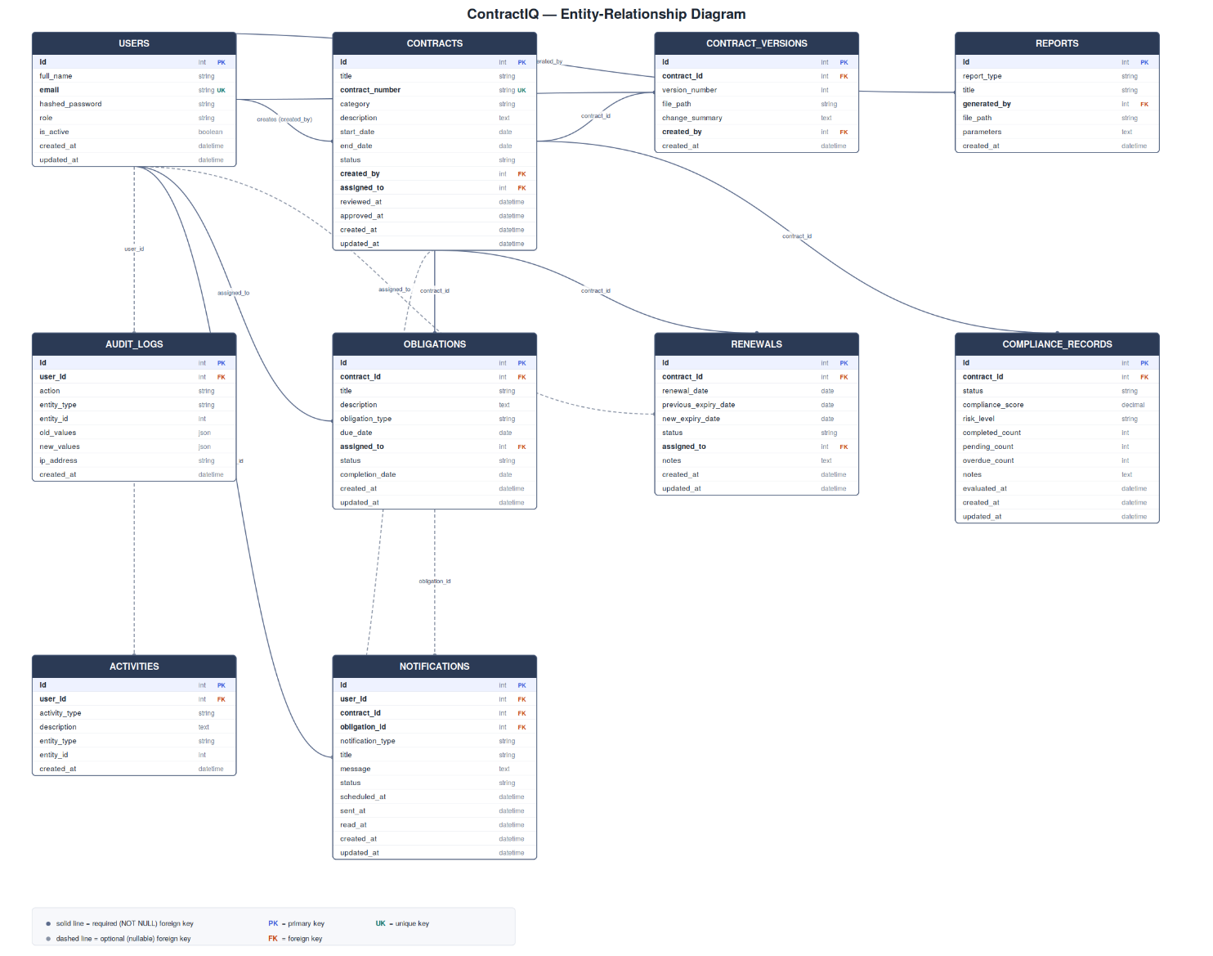

5. Functional Interaction of the Tables
A user creates a contract, which moves through the approval workflow (Draft → Under Review → Approved → Active → Expired/Terminated) tracked on the contracts.status, reviewed_at and approved_at columns. The contract becomes the parent record for its versions, obligations, renewals, notifications, compliance evaluations, reports, and activities.
contract_versions preserves the evolution of the source documents. obligations turn contractual requirements into trackable tasks with an owner, due date, type, and status; the service layer treats an incomplete obligation with a past due_date as Overdue. renewals record upcoming renewal decisions and, on completion, update the associated contract's expiry date while the renewal record is retained for history.
compliance_records stores the output of the rule-based compliance evaluation service — status, risk_level, and a compliance_score derived from completed vs. total obligations — so a contract's risk posture can be reviewed over time rather than only in its current state. notifications connect users to contracts, obligations, and renewals for deadline, renewal, overdue, and system alerts. reports store metadata for generated compliance/obligation/renewal/audit reports. activities provide a collaboration timeline, while audit_logs capture sensitive state changes for traceability. Foreign keys connect these modules while keeping each table focused on a single responsibility.

6. Constraints and Design Decisions
- contract_number is unique and indexed across the system.
- users.email is unique and indexed for login.
- A contract version number should be unique per contract — recommended as a future UNIQUE(contract_id, version_number) constraint; not yet enforced at the database level in the current migrations.
- Application logic should reject an end_date earlier than start_date; this is currently validated in the service layer rather than with a database CHECK constraint.
- compliance_score is stored as NUMERIC(5,2) and is expected to stay within 0–100.
- Obligation, renewal, contract, notification and compliance status values are restricted through application/Pydantic validation rather than database ENUM types, keeping the workflow easy to extend.
- audit_logs should be treated as append-only from the application layer.
- Passwords are never stored in plaintext; only users.hashed_password has persisted.
- Foreign-key columns are indexed (see the Alembic migrations) because they are frequently used for joins and filtering, along with the status columns used for dashboards and queues.
- Document references (contract_versions.file_path, reports.file_path) point to controlled storage rather than storing files directly in the database.
- contracts.assigned_to, renewals.assigned_to, notifications.contract_id/obligation_id and audit_logs.user_id are nullable with ON DELETE SET NULL, so history is preserved if a related user or record is removed; contract-owned child tables (contract_versions, obligations, renewals, compliance_records) cascade on contract deletion.

