ContractIQ: Contract Obligation Tracking & Compliance Management Platform

Database Tables Required
- Users
- Contracts
- Contract Versions
- Obligations
- Renewals
- Notifications
- Reports
- Audit Logs
- Activities

Database Schema

Users
: Stores registered users
Column | Data Type
id | INTEGER
full_name | VARCHAR(100)
email | VARCHAR(255)
password | VARCHAR(255)
role | VARCHAR(50)
is_active | BOOLEAN
created_at | TIMESTAMP
updated_at | TIMESTAMP
Primary Key: id
Foreign Keys: None

Contracts
Stores contract details
Column | Data Type
id | INTEGER
title | VARCHAR(255)
contract_number | VARCHAR(100)
vendor_name | VARCHAR(255)
start_date | DATE
end_date | DATE
contract_value | DECIMAL(12,2)
status | VARCHAR(50)
created_by | INTEGER
created_at | TIMESTAMP
Primary Key: id
Foreign Keys: created_by -> users.id

Contract Versions
: Stores versions
Column | Data Type
id | INTEGER
contract_id | INTEGER
version_number | INTEGER
file_path | TEXT
uploaded_by | INTEGER
uploaded_at | TIMESTAMP
Primary Key: id
Foreign Keys: contract_id -> contracts.id; uploaded_by -> users.id

Obligations
: Stores obligations
Column | Data Type
id | INTEGER
contract_id | INTEGER
title | VARCHAR(255)
description | TEXT
due_date | DATE
priority | VARCHAR(20)
status | VARCHAR(50)
assigned_to | INTEGER
Primary Key: id
Foreign Keys: contract_id -> contracts.id; assigned_to -> users.id

Renewals
: Stores renewals
Column | Data Type
id | INTEGER
contract_id | INTEGER
renewal_date | DATE
reminder_days | INTEGER
status | VARCHAR(50)
Primary Key: id
Foreign Keys: contract_id -> contracts.id

Notifications
: Stores reminders
Column | Data Type
id | INTEGER
user_id | INTEGER
contract_id | INTEGER
message | TEXT
notification_type | VARCHAR(50)
is_read | BOOLEAN
sent_at | TIMESTAMP
Primary Key: id
Foreign Keys: user_id -> users.id; contract_id -> contracts.id

Reports
: Stores reports
Column | Data Type
id | INTEGER
generated_by | INTEGER
report_name | VARCHAR(255)
report_type | VARCHAR(100)
file_path | TEXT
generated_at | TIMESTAMP
Primary Key: id
Foreign Keys: generated_by -> users.id

Audit Logs
: Stores audit history
Column | Data Type
id | INTEGER
user_id | INTEGER
action | VARCHAR(255)
table_name | VARCHAR(100)
record_id | INTEGER
action_time | TIMESTAMP
Primary Key: id
Foreign Keys: user_id -> users.id

Activities
: Stores user activities
Column | Data Type
id | INTEGER
user_id | INTEGER
contract_id | INTEGER
activity | TEXT
activity_time | TIMESTAMP
Primary Key: id
Foreign Keys: user_id -> users.id; contract_id -> contracts.id

Table Relationships
Parent | Child | Relationship
Users | Contracts | One-to-Many
Users | Notifications | One-to-Many
Users | Reports | One-to-Many
Users | Audit Logs | One-to-Many
Users | Activities | One-to-Many
Contracts | Contract Versions | One-to-Many
Contracts | Obligations | One-to-Many
Contracts | Renewals | One-to-One
Contracts | Notifications | One-to-Many
Contracts | Activities | One-to-Many

ER Diagram
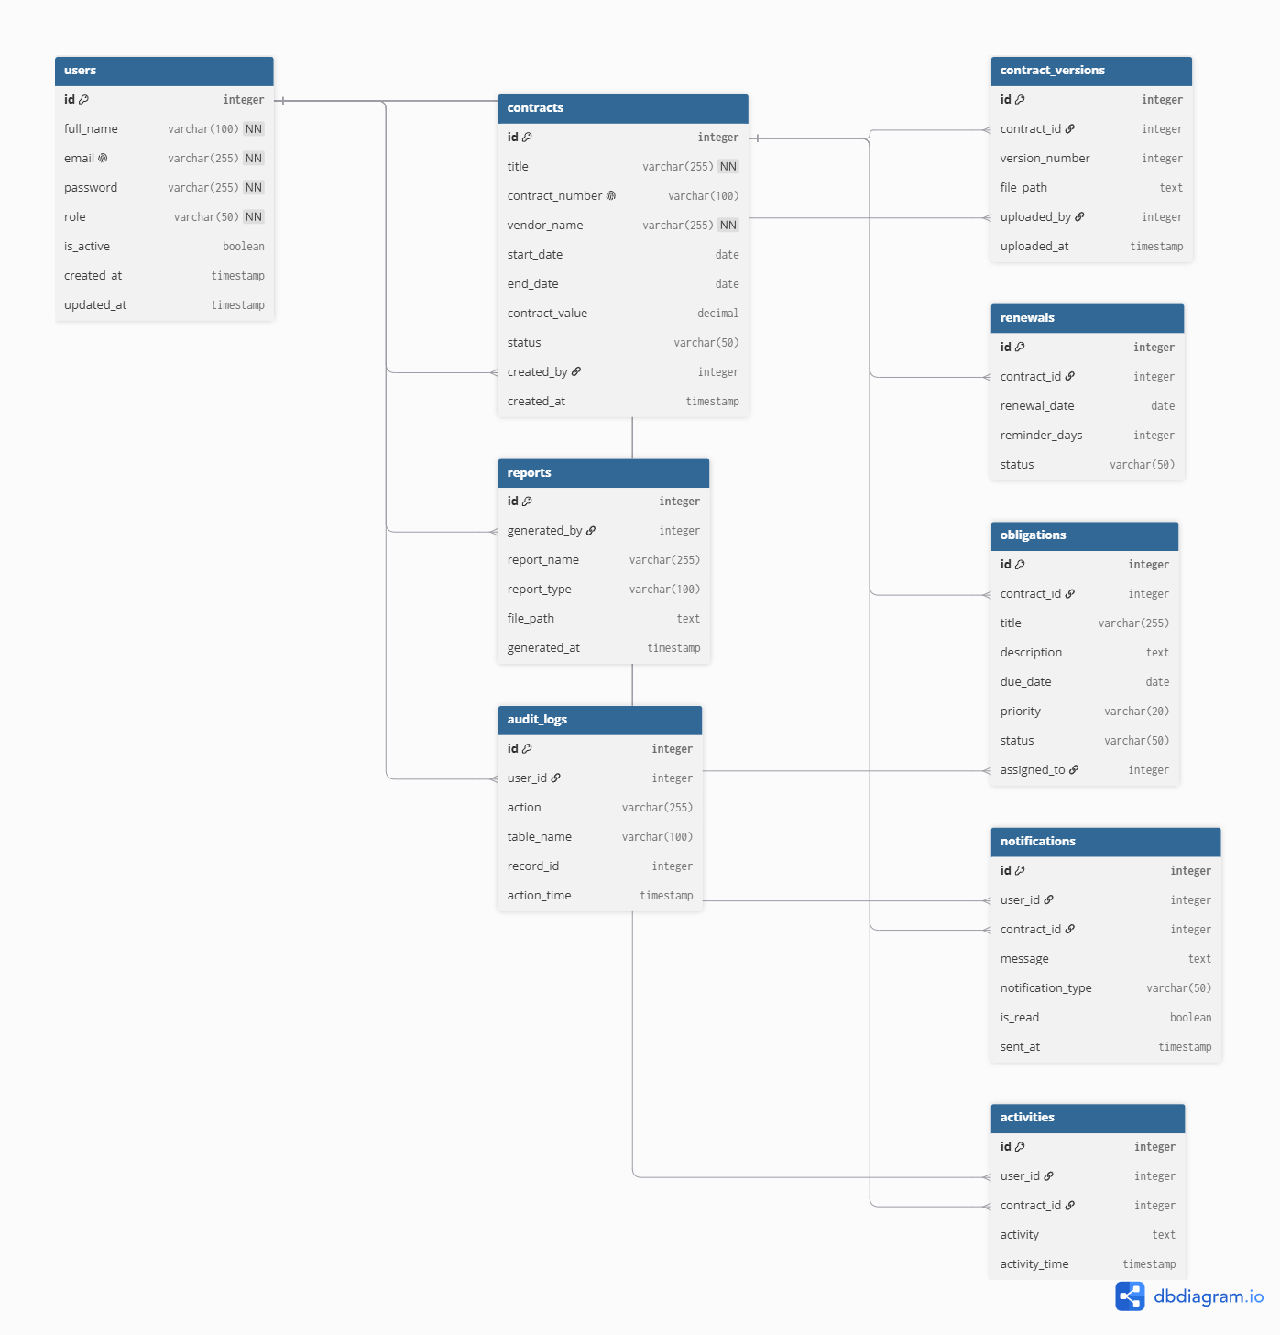

How the Tables Work Together
The Users table stores information about all the users who use the ContractIQ system. Users can create and manage contracts. The Contracts table is the main table because it stores all contract details. Each contract can have different versions, obligations (tasks to complete), notifications, activities, and renewal information.
The Reports table stores generated reports, the Audit Logs table keeps a record of important actions performed in the system, and the Activities table records the daily actions of users. All these tables work together to help manage contracts, track important deadlines, maintain records, and ensure compliance.

