MedTrack_DV
Hospital Operations & Patient Analytics
Milestone 3: Dashboard Development
Modules Covered:
- Module 5: Hospital Overview & Patient Flow
- Module 6: Department Analytics & Resource Utilization
Tools Used:
- Microsoft Power BI
- DAX
- Power Query
Dataset:
Hospital Operations & Patient Analytics Dataset
Dashboard 1:Hospital Overview
The Hospital Overview dashboard provides a high-level view of hospital operations and patient performance. It includes key performance indicators, admission trends, occupancy monitoring, readmission analysis, revenue trends, and department-level comparisons.
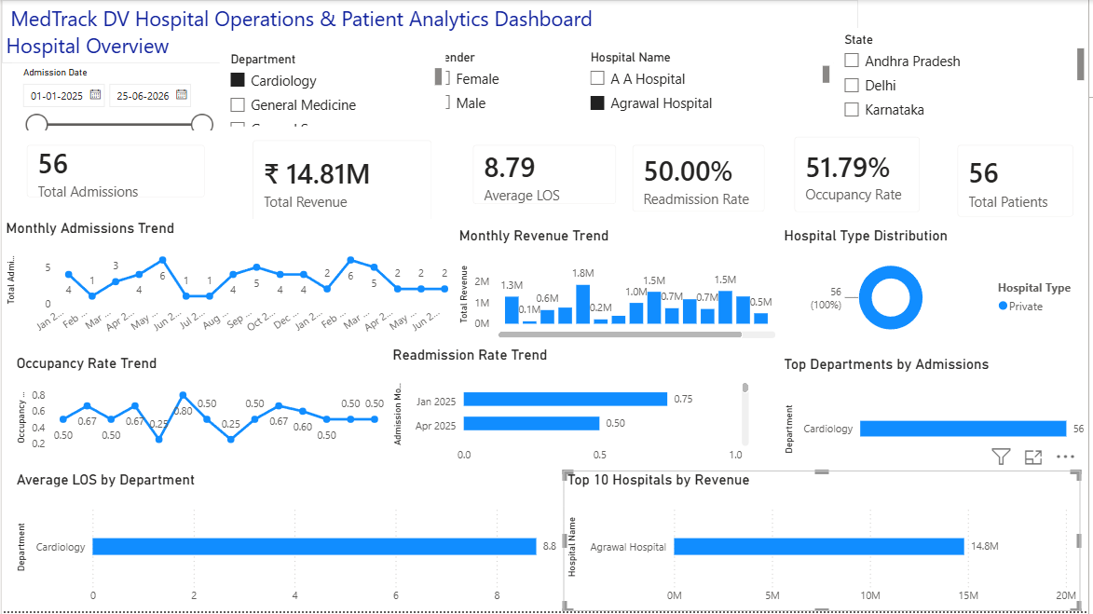

Dashboard 2: Patient Flow
The Patient Flow dashboard focuses on patient admissions, discharges, average length of stay, patient movement, and patient volume trends. It helps provide an overview of patient flow patterns across the hospital.
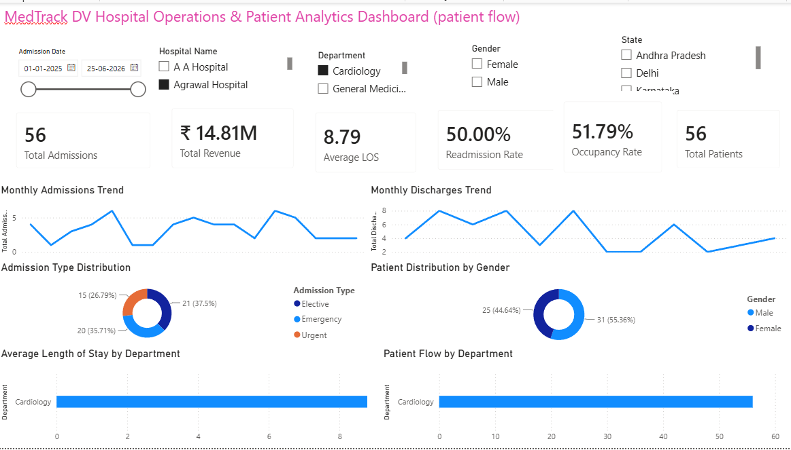

Dashboard 3: Department Analytics
The Department Analytics dashboard compares departments based on patient volume, readmission rate, average length of stay, occupancy, revenue, and other operational indicators. It helps identify differences in departmental performance.
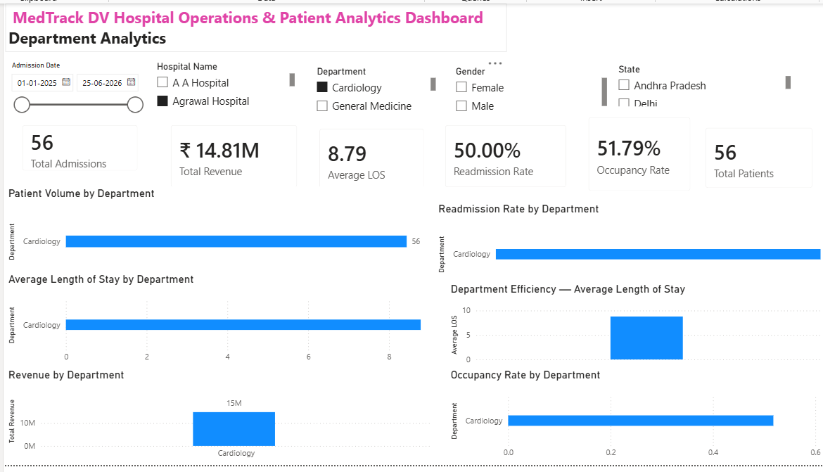
Dashboard 4: Resource Utilization
The Resource Utilization dashboard focuses on hospital capacity and resource availability. It provides insights into bed occupancy, available beds, ICU capacity, staff allocation, occupied beds, and resource availability across departments.
