MedTrack DV
Hospital Operations & Patient Analytics Dashboard — Project Documentation

1. Overview
MedTrack DV is a hospital operations and patient analytics dashboard suite built for hospital administrators, healthcare managers, medical staff, and policymakers. It transforms raw hospital and patient admission data into KPI-driven insights across four interactive dashboards, supporting patient flow monitoring, department performance evaluation, resource optimization, and data-driven decision-making.

2. Dashboards
- Hospital Overview — admissions, occupancy, and readmission trends
- Patient Flow — admission/discharge tracking and patient movement
- Department Analytics — performance and efficiency by department
- Resource Utilization — bed, staff, and equipment utilization

3. Project Pipeline
Collect Hospital Datasets
↓
Data Cleaning & Transformation
↓
Healthcare KPI Engineering
↓
Dashboard Development
↓
Dashboard Integration
↓
Testing & Validation
↓
Documentation & Delivery

4. Project Structure
/scripts → data collection, cleaning, and KPI engineering notebooks
/data → raw and processed datasets
/dashboard → dashboard build files and storyboard
/docs → project documentation

5. KPIs
KPI | Description
Total Admissions | Count of patient admissions
Occupancy Rate | Occupied beds ÷ total available beds
Average Length of Stay | Mean days between admission and discharge
Readmission Rate | Share of admissions that are readmissions
Bed Utilization Rate | Beds in use relative to total capacity
Department Efficiency Score | Composite score combining throughput, LOS, and readmissions

6. Tech Stack
Area | Tools
Data Collection | Python, hospital & patient admission datasets
Data Processing | pandas, NumPy
Visualization | Power BI Desktop
Documentation | Markdown, GitHub

7. Dashboard
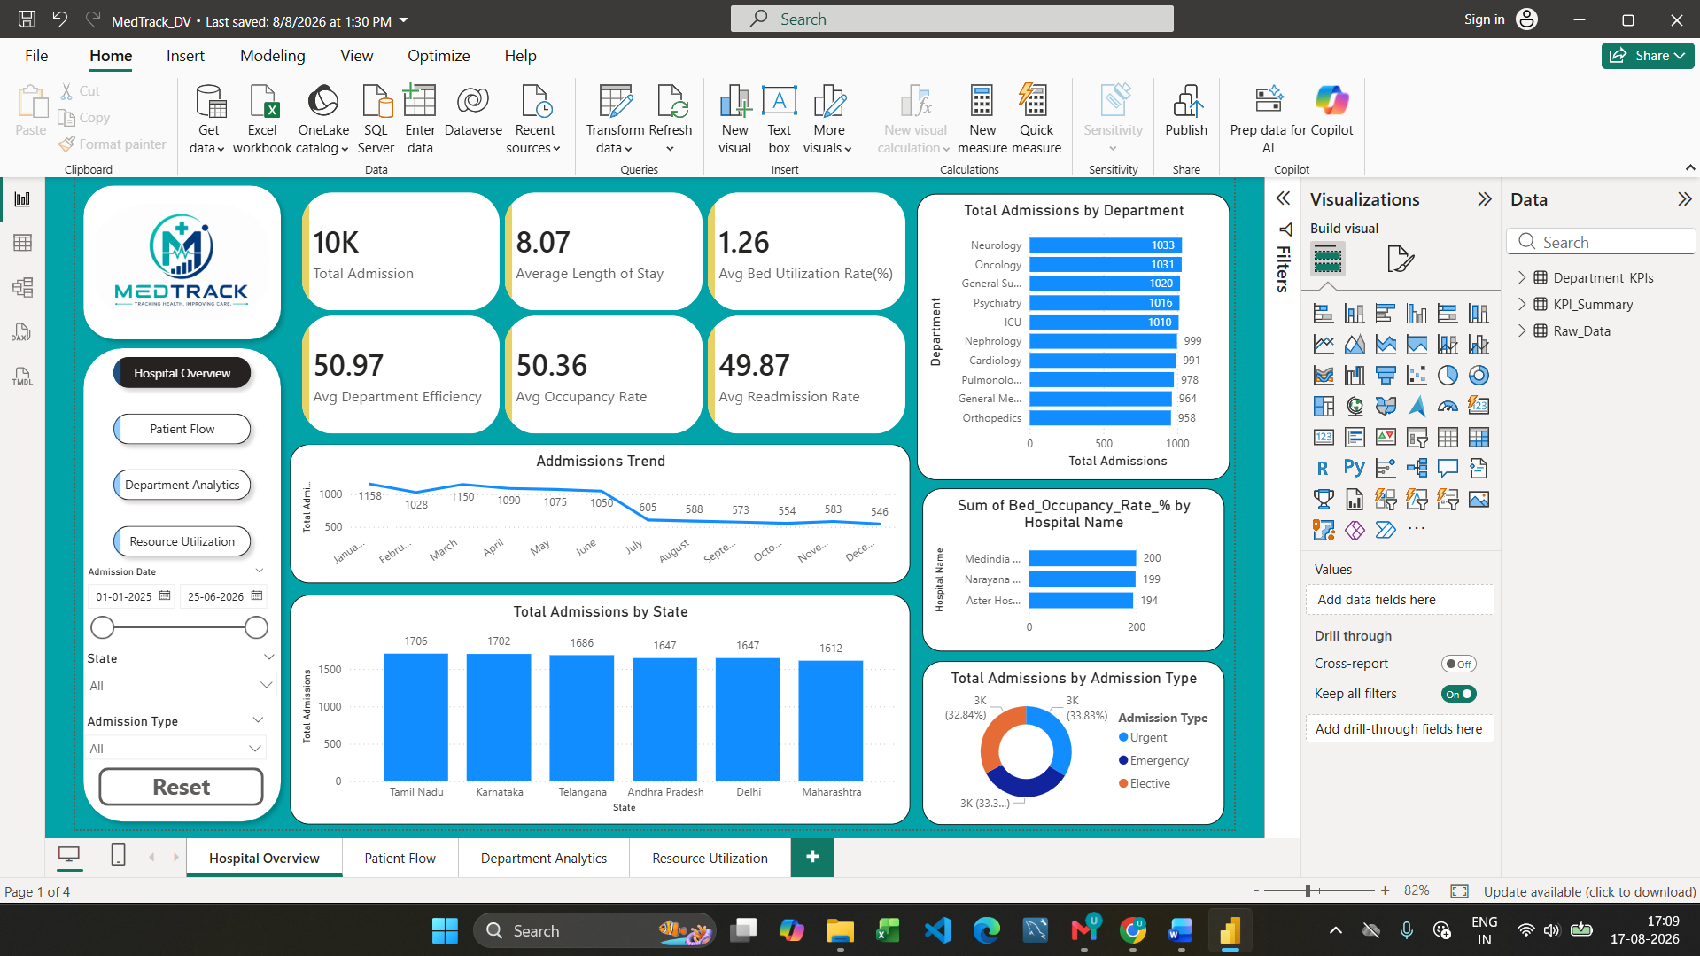

8. Deliverables
- Cleaned, KPI-engineered hospital dataset
- Four interactive dashboards

